9 September 2024

Mr Sean Turner
Committee Secretary
Senate Standing Committees on Economics
PO Box 6100
Parliament House
Canberra ACT 2600

Dear Committee Secretary,
inquiry into the financial regulatory framework and home ownership
The National Housing Supply and Affordability Council thanks the Senate Economics References Committee for inviting a submission to the inquiry into the financial regulatory framework and home ownership.
The Council wishes to draw attention to its report on Barriers to Institutional Investment, Finance and Innovation in housing, which focused on what can be done to increase the supply of secure homes in a rental format for more Australians, including in the affordable sector, via institutional investment.
Secondly, the Council wishes to draw attention to its inaugural State of the Housing System report, which references the Council’s vision for Australia’s housing system and outlines an avenue for the way forward.
Lastly, the Council wishes to highlight my address at the National Press Club, delivered on 4 September 2024. The transcript to my address can be found here and I address some of the matters raised in the inquiry’s Terms of Reference.
Yours sincerely

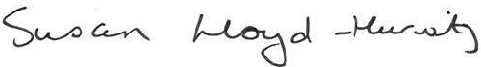

Ms Susan Lloyd-Hurwitz
Chair, National Housing Supply and Affordability Council

