State of the Housing System
  - 2026
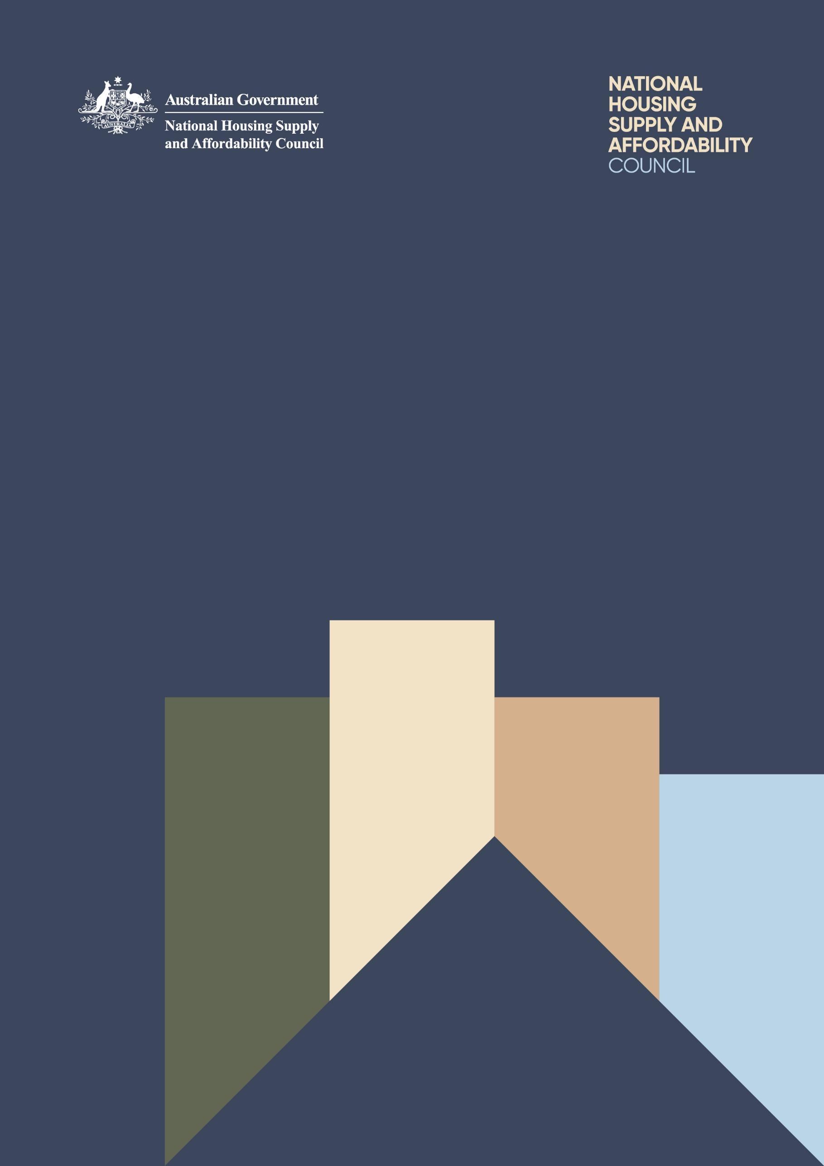

State of the Housing System
  - 2026

© Commonwealth of Australia 2026
ISBN: 978-1-923278-39-4
This publication is available for your use under a Creative Commons Attribution 4.0 International licence, with the exception of the Commonwealth Coat of Arms, the National Housing Supply and Affordability Council logo, photographs, images, third party materials, materials protected by a trademark, signatures and where otherwise stated. The full licence terms are available from creativecommons.org/licenses/by/4.0/legalcode.
Use of National Housing Supply and Affordability Council material under a Creative Commons Attribution 4.0 International licence requires you to attribute the work (but not in any way that suggests that National Housing Supply and Affordability Council endorses you or your use of the work).
National Housing Supply and Affordability Council material used ‘as supplied’
Provided you have not modified or transformed National Housing Supply and Affordability Council material in any way including, for example, by changing the National Housing Supply and Affordability Council text; calculating percentage changes; graphing or charting data; or deriving new statistics from published National Housing Supply and Affordability Council statistics – then National Housing Supply and Affordability Council prefers the following attribution:
Source: National Housing Supply and Affordability Council
Derivative material
If you have modified or transformed National Housing Supply and Affordability Council material, or derived new material from those of the National Housing Supply and Affordability Council in any way, then National Housing Supply and Affordability Council prefers the following attribution:
Based on National Housing Supply and Affordability Council data.
Use of the Coat of Arms
The terms under which the Coat of Arms can be used are set out on the Department of the Prime Minister and Cabinet website (see www.pmc.gov.au/government/commonwealth-coat-arms).
Other uses
Enquiries regarding this licence and any other use of this document are welcome at:
Office of the National Housing Supply and Affordability Council at enquiries@nhsac.gov.au.
Internet
A copy of this document is available at www.nhsac.gov.au.
Data finalisation
This report was finalised on 20 April 2026 and includes data released up to and including 9 April 2026.
Acknowledgement of Country
The National Housing Supply and Affordability Council acknowledges the Traditional Custodians of country throughout Australia and their connections to land, sea and community. We pay our respects to their Elders past and present and extend that respect to all Aboriginal and Torres Strait Islander peoples today.

Contents
Foreword vii
Executive summary ix
Chapter 1 Towards better housing outcomes for all Australians 1
1.1 Housing should be affordable, fit for purpose and secure for all Australians 2
1.2 The burden of rising housing costs falls unevenly across households 3
1.3 Worsening housing affordability exacerbates intergenerational inequality 4
1.4 More housing is needed from both the market and non-market sectors 5
1.5 An outcomes framework will help guide effective housing policy 8
Chapter 2 Housing system conditions 19
2.1 Growth in housing prices and rents was strong 20
2.2 Building approvals grew in 2025, although completions remained steady 27
2.3 Construction cost growth in 2025 was below recent peak growth rates 30
2.4 Demand for housing remained strong 42
2.5 Conditions in non-market housing and homelessness services remain challenging 47
Chapter 3 Housing affordability 53
3.1 Housing affordability worsened for many people in 2025 54
3.2 Rental affordability deteriorated to record‍-low levels 55
3.3 Home purchase affordability deteriorated to record-low levels 57
3.4 Mortgage repayment affordability improved slightly, but costs remain elevated 60
Chapter 4 Housing system outlook 63
4.1 Housing market conditions are highly uncertain 64
4.2 National housing supply 64
4.3 Indicators of housing supply and demand for early 2026 outlook 68
Chapter 5 First Nations housing 77
5.1 Assessment of the current situation 78
5.2 Factors impacting First Nations housing 81
5.3 Actions underway to improve First Nations housing outcomes 83
5.4 Targeted intervention to improve First Nations housing outcomes 88
Appendix A Glossary 91
Appendix B The Council’s work over the year 95
Appendix C Report Methodology 101
Appendix D References 105
Appendix E Selected housing data financial year, 2019–20 to 2024–25 116

Foreword
Housing should be affordable, fit for purpose and secure for all households of all incomes and in all locations. Housing is fundamental to economic participation, wellbeing and social inclusion. The issues examined in this report – housing supply and demand, affordability, and the housing outcomes of various cohorts – remain central to the prosperity of future generations.
This report provides an independent assessment of current housing system conditions and the factors shaping outcomes for households. It brings together data, analysis and stakeholder insights to support informed decision-making and to identify where policy settings can be strengthened to improve supply, affordability and access.
The Council intends for the report to inform policy development and support constructive debate across governments, industry, not-for-profits and the community. In this vein, the report contains a proposed Outcomes Framework for the housing system.
On behalf of the Council, I give thanks to the many stakeholders who provided feedback throughout the development of the report, including through roundtable discussions and bilateral meetings. Those consulted included representatives from the Australian, state and territory governments; the planning sector; the residential construction and development sector; the community housing sector; the First Nations housing sector; and the academic community.
I extend my gratitude to my fellow Council members, who have provided invaluable guidance, and the Office of the Council, for providing continued advice, analysis and support to the Council. Thank you for your dedication.
On behalf of the Council, I am pleased to submit the State of the Housing System 2026.
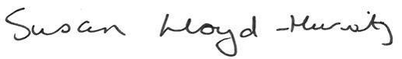
Ms Susan Lloyd-Hurwitz AM
Chair, National Housing Supply and Affordability Council

Executive summary
For decades Australia’s housing system has not kept up with demand. It has not delivered the homes Australians need and at prices many Australians can afford. For too long, Australia’s housing system has worked for some Australians rather than for all Australians. This must change to improve equity across and within generations.
While current governments have inherited rather than created this challenge, they are responding with reforms, policies and programs that are helping to deliver more homes more quickly through the National Housing Accord. These initiatives take time and effort to improve housing supply outcomes.
The Council has been seeing improvement in the outlook for housing supply in early 2026. Recent approvals and commencements were higher compared to the period prior to the Accord and implementation of reforms underway. Based on data to early 2026 and before recent global disruptions to commodity prices and supply chains, the Council estimates around 980,000 new homes could have been expected in the Accord period, an increase of 42,000 homes from the previous State of the Housing System Report. In addition, the 1.2 million new homes had been on track to be reached by September 2030.
Against the backdrop of indicators of underlying improvement, the conflict in the Middle East now brings heightened uncertainty to the outlook for housing supply. Higher fuel and petrochemical prices are expected to have flow-on impacts on transport and material costs for construction, and place pressure on product availability and the operation of small businesses.
At the time of writing this report, there is significant uncertainty in the scale and length of the conflict. In this context, the report illustrates the potential impact of the Middle East conflict on housing construction costs and, in turn, housing supply. These scenarios are guided by two oil price scenarios discussed by the Treasurer in mid-March 2026. For a shorter-term scenario assuming the sector faces a 6 per cent peak increase in construction costs in the middle of the year, it is estimated dwelling completions could be 10,000 lower to mid-2029. For a more prolonged scenario assuming the sector faces a 10 per cent peak increase in construction costs, it is estimated dwelling completions could be 33,000 lower to mid-2029. The Council notes there is significant uncertainty in the outlook and potential broader impacts on housing conditions, meaning that there is the possibility of greater downside risk than these scenarios show.
The Council notes governments are working together, including through the National Fuel Security Plan, and implementing initiatives to ease pressure on small business and families. Given the housing affordability challenge already facing Australia, all industry participants will need to play a role managing these cost pressures.
Current events also highlight the importance of continuing to boost the responsiveness and resilience of housing supply. The Council continues to recommend governments focus on improving construction sector capacity and productivity; and applying best practice reform to planning systems and ensuring more developable and serviceable land is made available. These areas are critical for improving both the near-term and long-term responsiveness of the housing construction sector. The Council also sees the tax system as having an important role to support housing supply and affordability, and considers that all Australian governments should review whether tax settings are inappropriately impacting the behaviour of households when it comes to buying, selling, or renting a home.
In addition, investment in social and affordable housing and supporting better renter security should be prioritised to ensure all households see an improvement in housing outcomes. This will support greater diversity and resilience in Australia’s housing system.
Structural reforms are difficult and require ongoing cooperation across all levels of government and industry. To support this cooperative effort, the Council has developed a new Housing Outcomes Framework, which monitors the health of the housing system using a comprehensive set of indicators. The Council believes this framework can help align policy goals across levels of government, support better policy design, and enhance transparency and accountability.
The framework shows that some parts of the housing system saw clear improvements in 2025. The pace of homebuilding picked up, completion times improved and energy efficiency of new dwellings rose. These indicators suggest clear improvements in the ability of the housing system to supply enough high-quality homes.
However, other indicators worsened in 2025. Rental affordability and purchase affordability deteriorated further, adding to growing concerns about intergenerational housing inequality. In addition, social housing has been declining as a share of the dwelling stock over time and is around 4 per cent.
New investment in social and affordable housing is underway. The Council recognises the Commonwealth Government’s $10 billion investment in the Housing Australia Future Fund, with many of the projects to become available to tenants over the next 3 years. The Council recommends that governments and industry work on a long-term approach for sustainable investment in social and affordable housing, recognising the need for greater resilience and diversity in the housing system. The Council also recommends that improving housing outcomes for renters continues to be a focus.
The Council recognises that housing indicators are significantly worse for First Nations people, who experience lower rates of home ownership and higher rates of overcrowding and homelessness compared to non-Indigenous people. While some progress has been made in closing the gap in housing outcomes, including $600 million in dedicated funding for projects delivered by or in genuine partnership with First Nations housing organisations under Round 3 of the Housing Australia Future Fund, much more needs to be done.
The Council urges governments, communities and industry to continue to build on the work already underway to deliver better housing outcomes for Australians. The Council encourages governments and the community to make use of the Housing Outcomes Framework in this report to monitor progress and identify priorities for further action.
As a starting point, the Council recommends caution on further demand-side policies, as these can place upward pressure on prices across the system. In summary, the Council recommends focusing on the 5 key policy areas for housing reform outlined in its 2025 Report. These include increasing investment in social and affordable housing; improving construction sector capacity and productivity; applying best practice principles to planning systems and ensuring developable land is made available; supporting better outcomes for renters; and ensuring the tax system supports housing supply and affordability.

- Towards better housing outcomes for all Australians

Chapter description
This chapter discusses the Council’s vision for the housing system. It presents recommendations for key reforms and introduces a Housing Outcomes Framework to help guide governments, industry and not-for-profits towards achieving better housing outcomes for Australians.
Key points
- The housing system is currently falling short of the Council’s vision for housing to be affordable, fit for purpose and secure for households of all incomes and in all locations.
- The shortage of affordable, fit for purpose and secure housing has negative economic and social consequences. This is particularly the case for Australia’s most vulnerable households, although the broader consequences of poor housing affordability affect all Australians.
- While more market and non-market housing is needed, the Council does commend the significant progress made to date towards improving housing supply across both the market and non-market sectors. Improved coordination across Australian governments has been a welcome development.
- The Council has developed a Housing Outcomes Framework to guide governments, industry and not-for-profits towards further improvements in housing outcomes for Australians.
- The Framework builds on the 8 goals for the housing system outlined by the Council in the State of the Housing System 2025, and suggests how progress toward each outcome can be assessed. While the metrics are often imperfect, it is a useful starting point for a holistic measurement of housing outcomes that can be improved over time.
- Under the Framework, progress has been made towards many housing outcomes, including improvements in the delivery and quality of new homes. However, progress has been more limited for other housing outcomes, which include better access to home ownership, improved housing affordability, and increased social housing and specialist homelessness services.

  - Housing should be affordable, fit for purpose and secure for all Australians
The Council’s vision for the housing system is for housing to be affordable, fit for purpose and secure for households of all incomes and in all locations.
There is progress towards achieving elements of this vision. Since the start of the National Housing Accord period in June 2024, all states and territories have introduced reforms to improve housing supply and affordability. Key initiatives include reforms to boost housing density, streamline planning approvals, boost construction sector capacity and productivity, and increase social housing investment. The Council’s first Quarterly Report outlines in more detail the progress states and territories are making towards the National Housing Accord target (NHSAC 2026).
The Commonwealth Government has also implemented reforms to improve housing outcomes that align with the Council’s vision. The Housing Support Program should improve planning capability, deliver enabling infrastructure and build more social housing. Reforms to the Environmental Protection and Biodiversity Conservation (EPBC) Act are also supporting the delivery of thousands of new homes. The impact of these reforms on housing supply and affordability is expected to take time.
While these government actions represent positive progress towards the Council’s vision, continued and coordinated effort is needed to achieve a well-functioning housing system. Fundamentally, more housing is needed – in both the market and non-market housing sectors (see Box 1.1).
To achieve the Council’s vision, market housing needs to be more efficient and responsive to demand. While the market supplies housing for most people, it is still failing to provide enough homes. Barriers to new housing must be addressed to ensure sufficient market housing is delivered.
Achieving the Council’s vision also requires a well-functioning non-market housing sector. Non-market housing is essential infrastructure needed to ensure all Australians – regardless of income or location – are appropriately housed. An effective non-market housing sector should complement an efficient private housing market to provide affordable housing that supports community wellbeing. To this end, the Council recognises the Commonwealth Government’s investment in the Housing Australia Future Fund, with many projects to become available to tenants over the next 3 years.
To support further progress towards its vision, the Council outlines in this report a Housing Outcomes Framework. This is intended to guide governments (Commonwealth, state and territory, and local), industry and not-for-profits towards improving housing outcomes for all Australians, supporting the broader wellbeing of households and communities.
  - The burden of rising housing costs falls unevenly across households
The burden of rising housing costs continues to fall unevenly across the community, with the most vulnerable households facing the largest impact. The Council is concerned these pressures could spread and more Australians will be affected by the negative economic and social outcomes of poor affordability in the future.
Younger people face an increasingly insecure housing future. The number of years needed to save for a home deposit has increased from 9.0 years in 2015 to 11.2 years in 2025, driven by rising housing costs (see Chapter 3 Housing affordability). Rental affordability has also deteriorated sharply, with a record 33.1 per cent of median income required to service the median rent in 2025. The increase in housing costs over time has coincided with a decline in homeownership among younger households. The homeownership rate for households aged 25-34 fell from 61 per cent in 1981 to 43 per cent in 2021 (DPS 2025).
Lower-income renters, including many retiree renters, face rising levels of rental stress and are increasingly at risk of homelessness. The share of renter households in rental stress – defined as households in the lowest 2 income quintiles spending more than 30 per cent of income on rent – rose from 24.9 per cent in 2014 to a record-high 29.5 per cent in 2024 (see Chapter 3 Housing affordability). The increase in rental stress has coincided with an increase in the share of specialist homelessness service (SHS) clients who report housing stress as the main reason for seeking SHS support (AIHW 2025a). Among retiree renters, few can meet rent payments and still afford other essentials (Coates et al. 2025a). Overall, access to social housing has become more difficult for many lower-income renters due to the long-term decline in social housing as a share of the housing stock.
Many women, particularly single mothers and elderly single women, face difficult housing conditions. Single parent families – of which over 80 per cent are headed by a single mother – face the highest rates of housing stress and financial stress of any family type, and are most likely to be in poverty after deducting housing costs (Laß et al. 2025). Homelessness is also rising faster for women than for men among people accessing SHS support. Domestic and family violence is the leading cause of homelessness for women and children accessing SHS support (AIHW 2025a). Older women also often retire with fewer financial resources than men, placing them at higher risk of poverty and housing stress (Coates et al. 2025a).
First Nations people experience significant barriers to accessing appropriate and affordable housing (see Chapter 5 First Nations housing). First Nations people have lower rates of home ownership, are more likely to live in overcrowded housing, and are almost 9 times more likely to be experiencing homelessness when compared to non-Indigenous people. First Nations people in remote areas face additional housing challenges (see Chapter 5 First Nations housing).
  - Worsening housing affordability exacerbates intergenerational inequality
Higher housing costs relative to income growth can reduce or delay access to homeownership for young Australians, which means that fewer households will be able to reap the security, investment and taxation benefits of homeownership (Daley et al. 2018). This threatens the future economic outcomes of many of today’s young Australians. The wealth accumulation benefits of homeownership experienced by many older homeowners will be more limited for younger people with reduced homeownership opportunities (Daley et al. 2018).
Rising housing prices also increase the wealth of those with housing assets relative to those without housing assets, such as renters (Daley et al. 2018). Over time, as housing wealth is passed on from one generation to the next, there is a risk that housing wealth inequality between households with or without housing assets becomes entrenched.
Poor housing affordability affects the economic conditions experienced by future generations. Higher housing costs negatively affect how and where people work, which lowers productivity and innovation, limiting economic growth and household incomes (Daley et al. 2018; NSW PC 2024). Along with historical patterns of housing development, it pushes households further away from city centres where jobs and services are located (NSW PC 2024). The longer commute times that result increase transport emissions and lower the wellbeing of households. Fiscal costs are also increased for governments that need to build new services on the peripheries of cities (NSW PC 2023).
  - More housing is needed from both the market and non-market sectors
The housing market has a persistent, through-the-cycle inability to supply sufficient housing to meet underlying demand. In addition, there has been an insufficient level of sustained investment in non-market housing to address the housing needs of vulnerable people and low- and moderate-income households. Structural constraints and external shocks have amplified the challenges in the market and non-market housing sectors to provide sufficient housing.
Structural factors that limit the supply of market housing include restrictive regulations and tax settings, comparatively low productivity growth in the construction industry, and misaligned responsibilities across different levels of government. For example, the administration of planning and building controls for new housing is unnecessarily complex, causing significant delays and limiting housing development in locations with high demand. Furthermore, the land development and housing construction industries display limited innovation, and are beset with challenges in the supply and cost of labour (see Chapter 2 Housing system conditions). The Council notes that the timely provision of land and infrastructure for housing construction has also been held back by inefficient funding arrangements and a lack of coordination across governments.
External shocks also have an effect on housing supply, with the timing and breadth outside of the control of governments, industry and community organisations. Events in the Middle East are impacting the housing construction sector. Higher prices for fuel and petrochemicals are having flow on impacts and raising freight and transportation costs, as well as some operating costs (for example, heavy equipment that uses diesel) and plastic construction material costs (for example, PVC pipes).
Depending on the length of the conflict in the Middle East, which is highly uncertain at the time of this report, higher costs may affect the operations of some construction firms and reduce the commercial feasibility of some projects. Construction materials that rely on petrochemicals may also become harder to access, which may push out completion times. Finally, household demand for new homes and renovations may also decline because of greater global and domestic economic uncertainty (see Chapter 4 Housing system outlook). These shocks demonstrate the importance of governments, industry and not-for-profits working together towards a better housing system; one that has the foundations in place to support the supply of housing across cyclical and uncertain economic conditions.
For many vulnerable Australian households, it is unlikely the market alone can supply housing at rents or prices that are affordable. For this reason, increasing the stock of non-market housing is essential. However, non-market housing has seen long-term neglect and underfunding, and the supply of non-market housing has not kept pace with housing need. While social housing has declined as a share of the housing stock in recent decades (see Chapter 2 Housing system conditions), programs such as the Housing Australia Future Fund and Social Housing Accelerator are making significant investments that will contribute to social housing uplift.
Box 1.1 The Council’s priorities for housing reform
The Council identified 5 key policy areas in the State of the Housing System 2025 and reiterates the importance of focusing reform in these areas.
The Council acknowledges that governments are taking significant action in a range of policy areas and commends the increased housing policy collaboration observed between Commonwealth, state and territory, and local governments. Governments must build on this progress to address the shortcomings of the housing system by increasing the depth of their collaboration, focusing on long-term policy development and undertaking more ambitious structural and institutional reforms.
The policy response to Australia’s housing crisis has occurred mainly via discrete initiatives focused on housing supply at the Commonwealth, state and territory, and local government levels. For the most part, these initiatives have been warranted and welcome, and early interventions are beginning to yield positive results. However, the nation is still in need of an overarching, long-term strategy for the transformation of the housing system to deliver priority housing reforms.
Broad consensus on such a strategy across the nation’s many housing system stakeholders would allow: better coordination of their efforts, increased effectiveness and help assure the community that an improvement in housing outcomes is a priority.
The key policy areas listed below cover both the market and non-market housing sectors. Reducing structural barriers in the private market should be a key focus of governments at all levels. However, governments must simultaneously develop a comprehensive non-market housing strategy to support people with unmet housing need.
- Increasing investment in social and affordable housing through proven mechanisms, and reviewing regulatory frameworks for the social and affordable housing sector
The Council acknowledges that supply-side solutions to the affordability crisis may take years to place significant downward pressure on market prices. Further, there are socially important dimensions of the housing system that market reforms cannot fix. Australian governments are making significant commitments, but existing programs do not provide the confidence to support the long-term viability of the sector. To support households that cannot afford to purchase or rent a home at market prices, and individuals who are homeless or at risk of homelessness, significantly more non-market housing and housing assistance is required. The Council believes the Commonwealth must work with state and territory governments, alongside the community housing sector and private investors, to develop a comprehensive non-market housing strategy for the next 15 years to enable the significant increase in investment required.
- Improving construction sector capacity and productivity
Governments and industry are working together to improve construction sector productivity. This includes work to streamline and modernise the National Construction Code and facilitate modern methods of construction. Governments need to continue this ambition in future reform of building regulations. In addition, coordinated action is needed to address chronic labour shortages in the construction sector, which continue to be bottlenecks to the supply of new housing. Governments should also better coordinate the pipeline of infrastructure needed to support new housing in well-located areas, where there is access to high-quality services and community amenities.
continued on next page

Box 1.1 The Council’s priorities for housing reform (continued)
- Applying best practice principles to planning systems and ensuring developable land is made available
Governments are taking significant action in regulatory reform, by improving the efficiency of planning systems and promoting greater housing density through zoning reforms. In addition, improved coordination across levels of government and industry is necessary to ensure urban growth is strategically planned and supported by enabling infrastructure.
- Supporting better outcomes for renters
Governments are taking coordinated action through ‘A Better Deal for Renters’ to improve the quality and security of tenure in the private rental market. However, the Council urges the Commonwealth to hold jurisdictions that are lagging behind on reforms to account. Governments need to continue building on their successful coordinated action by assessing the performance of ‘A Better Deal for Renters’ and consider further initiatives that may be necessary to improve outcomes for renters.
- Ensuring the tax system supports housing supply and affordability
All levels of government need to review distortions in the housing market created by the tax system that affect the behaviour of owner-occupiers, investors and renters in different ways, and limit the efficient exchange of the housing stock. This includes improving tenure neutrality (that is, making the tax treatment of housing the same for owners and renters) and transitioning from transaction taxes toward a broad-based land tax. The Council also supports reviewing and reforming elements of the tax system which entrench intergenerational inequality for housing and economic outcomes.
- First Nations housing
The Council acknowledges that First Nations housing outcomes are a critical public policy concern requiring sustained effort from all governments and housing providers. The Council outlines targeted interventions to improve First Nations housing outcomes and focus government efforts in the First Nations Housing Chapter (see section 5.4 Targeted intervention to improve First Nations housing outcomes).

  - An outcomes framework will help guide effective housing policy
In this section, the Council presents a Housing Outcomes Framework (see Table 1.1) to guide governments, industry and not-for profits towards improved housing outcomes for Australians. The framework consists of 8 housing outcomes, and reflects the Council’s vision of the housing system as one that provides affordable, fit for purpose and secure housing for households of all incomes and in all locations. These 8 housing outcomes were first described in the State of the Housing System 2025 (NHSAC 2025).
For each housing outcome, the framework identifies several metrics that can be used to measure progress at a national level over time. Generally, progress for each metric is assessed by measuring the direction of change in the two most recent annual data points (described as either ‘improving’, ‘worsening’, or remaining ‘stable’). The metrics are designed to be accessible and based on publicly available data where available, although some remain imperfect due to limited data availability and frequency. The Council welcomes feedback on the metrics, which will be reviewed annually and may be revised. This will ensure the framework remains relevant and based on the most up-to-date data.
The framework will help guide governments towards effective housing policy by identifying which outcomes are being achieved, and which outcomes are not. The Council recognises that progress toward achieving housing outcomes differs across jurisdictions, as do barriers to achieving these outcomes. The Council also recognises that progress toward some housing outcomes may hinder progress toward others, at least in the short term (OECD 2024). These trade-offs are an inherent part of the housing system.
The framework does not put forward specific policy recommendations. Rather, it is a tool that can be used to monitor a set of housing outcomes and the aggregate effect of policy on the housing system. Policy recommendations for housing reform have been made separately (see Box 1.1). These reforms, including further policy action, will be integral to achieving outcomes under the framework.
Progress towards achieving the outcomes in the framework has been mixed. Metrics for the delivery of new housing supply show signs of progress. Metrics relating to the physical safety and energy efficiency of housing have also improved. In contrast, more work is needed to improve affordability outcomes, as metrics show a continued deterioration in home purchase and rental affordability.
The Council acknowledges that elements of the housing system are already incorporated into various outcomes frameworks used by Australian governments. For example, housing indicators are included in the Measuring What Matters Statement (2023), the National Agreement on Social Housing and Homelessness (2024), the National Agreement on Closing the Gap (2020), and Australia’s Disability Strategy 2021–31 (2024). In contrast to these frameworks, the Council’s Housing Outcomes Framework is designed to focus on identifying and measuring housing outcomes across the entire housing system.
                - Housing Outcomes Framework
Outcome | Sub-outcome | Progress metric
1: The housing system delivers the homes that Australians need | Quantity of new homes meets demand | Increase in the ratio of net dwelling stock growth relative to net population growth
 | Location of new homes meets demand | Decrease in commute times
 | Delivery of new homes is timely | Decrease in house completion times
2: Housing is safe and environmentally sustainable | Homes are physically safe | Decrease in share of dwellings with major structural problems
2: Housing is safe and environmentally sustainable | Homes are accessible | Increase in share of people with disability whose home is suitable and accessible
2: Housing is safe and environmentally sustainable | Homes are energy efficient | Increase in share of new dwellings meeting NatHERS 7-star rating
3: There is efficient use and exchange of the existing housing stock | Homes are appropriately sized | Decrease in share of households that are overcrowded  Decrease in share of households with 2 or more spare bedrooms
 | There is efficient exchange of housing | Increase in the rate of housing turnover
4: There is fair access to the benefits of homeownership | Homeownership is accessible | Increase in homeownership rate for younger households
4: There is fair access to the benefits of homeownership | Homeownership is affordable | Decrease in price-to-income ratio
5: Renters have access to affordable and secure housing | Renting is affordable | Decrease in rent-to-income ratio
5: Renters have access to affordable and secure housing | Rental tenure is secure | Decrease in share of renters forced to move  Increase in tenure length of private renters
6: There is sufficient social and affordable housing infrastructure to support the wellbeing of all communities | Quantity of social and affordable housing meets housing need | Increase in social housing stock as a proportion of total housing stock
 | Social housing tenants are satisfied | Increase in rate of tenant satisfaction across all social housing programs
7: Homelessness is brief and non-recurring | Homelessness is reduced | Decrease in homelessness rate
7: Homelessness is brief and non-recurring | Homelessness is non-recurring | Decrease in share of SHS clients in persistent homelessness
7: Homelessness is brief and non-recurring | Homelessness services can adequately meet client needs | Increase in share of SHS clients who achieve a stable housing outcome
8: The gap is closed between Aboriginal and Torres Strait Islander people’s and non-Indigenous people’s housing and homelessness outcomes | Homelessness is reduced | Decrease in the gap in the homelessness rate between First Nations people and non-Indigenous Australians
 | Homeownership rates increase | Decrease in the gap in the homeownership rate between First Nations and non-Indigenous households
 | Homes are appropriately sized | Decrease in the gap in overcrowding rate between First Nations and non-Indigenous households (in line with Closing the Gap Target 9a)
 | Housing quality in remote communities improves | Increase in the share of First Nations households in remote communities in dwellings of an acceptable standard
    - The housing system delivers the homes that Australians need
A well-functioning housing system should respond to the changing needs of the population. At its core, this means providing a sufficient number of homes, in places where people want to live, in a timely manner. This outcome is driven by the performance of the housing supply process, including the planning system, the construction industry and the availability of inputs such as land and labour. The Council proposes 3 sub-outcomes and 3 metrics to measure progress towards this outcome.
- The quantity of new homes meets demand.
Australia faces a shortfall of new housing relative to demand (see Chapter 4 Housing system outlook). Since the early 2000s, housing demand has been driven by strong population growth, alongside other factors such as income growth, the ageing population and hybrid work arrangements (Coates et al. 2025b). The Council suggests measuring progress towards this sub-outcome by tracking the publicly available data on the annual ratio of net dwelling stock growth relative to net population growth. An increase in this ratio indicates enough housing is being built to reduce the shortfall in new housing relative to population growth.
- The location of new homes meets demand.
Australia also faces a shortfall of housing where people most want to live – nearby to jobs, transport, schools and amenities (Coates et al. 2025b). The Council suggests measuring progress towards this sub-outcome through a decrease in the average commute time. Shorter commute times can indicate that people are living closer to their workplaces or have improved transport options. However, one caveat with this metric is that it also reflects the incidence of working from home, which has been elevated since the pandemic (Laß et al. 2025).
- The delivery of new homes is timely.
A more productive construction industry can deliver homes more efficiently, allowing the industry to respond quickly to changes in demand. The Council suggests initially measuring progress toward this sub outcome through a decrease in the average completion time for new houses, as measured from building approval to completion. While this metric does not account for average building size or quality, a decrease in house completion times would generally suggest a more efficient building process. Another potential future metric for this
sub-outcome could be an annual measurement of residential construction sector productivity, for example by extending recent estimates produced by the Productivity Commission (2025).
Sub-outcome | Metric | Current level | Progress
Quantity of new homes meets demand | Increase in the ratio of net dwelling stock growth relative to net population growth | 0.4 in September 2025  (ABS Value of Dwellings; ABS National, State and Territory Population) | Improving  Increase from Sep 2024
Location of new homes meets demand | Decrease in commute times | 52 minutes in 2023  (Laß et al. 2025) | Stable  Unchanged from 2022
Delivery of new homes is timely | Decrease in house completion times | 11.5 months in 2024–25  (ABS Building Activity) | Improving  Decrease from 2023–24
    - Housing is safe and environmentally sustainable
Housing quantity must be balanced with housing safety, accessibility and sustainability. As the housing stock has aged, issues in dwelling quality have become more apparent (Daniel et al. 2024). The Council proposes 3 sub-outcomes and 3 metrics to measure progress towards this outcome.
- Homes are physically safe.
Dwelling quality should not pose a risk to the safety of households. The Council suggests measuring progress towards this sub-outcome through a fall in the share of dwellings with major structural problems, including plumbing issues or cracks in walls and roofs. While most dwellings are in good condition, major structural problems are particularly prevalent for renters in public housing (ABS 2022a). A decline in the share of dwellings with major structural problems would indicate that more households are living in safely built and maintained dwellings.
- Homes are accessible.
There is an insufficient supply of accessible housing for Australians with disability. The Council supports the existing outcome in Australia’s Disability Strategy 2021–2031, which aims for an increase in the share of people with disability whose home is suitable and accessible (DSS 2024). The Council would also like to see an increase in the share of new builds that comply with the Livable Housing Design Standard, to better meet the needs of the community, including for older people and people with mobility limitations (ABCB 2022). The Council calls for continued monitoring of the uptake of the Livable Housing Design Standard, which is now a minimum requirement in the National Construction Code (NCC).
- Homes are energy efficient.
Energy efficient housing reduces the cost of cooling and heating, making it easier for households to maintain thermal comfort. Energy efficient housing also helps build resilience to climate change, reduces carbon emissions, and supports the transition to net zero emissions by 2050 (Wilson 2026; NatHERS 2026). The Council suggests measuring progress towards this sub-outcome through an increase in the share of new dwellings that meet or exceed the 7-star Nationwide House Energy Rating Scheme (NatHERS) rating. The 7-star benchmark is the minimum rating required in the NCC, although some states and territories allow exemptions (NHSAC 2025). While this metric only applies to new housing, ongoing work by governments may also enable better monitoring of energy performance for the existing housing stock.
Sub-outcome | Metric | Current level | Progress
Homes are physically safe | Decrease in share of dwellings with major structural problems | 11.5% in 2019–20  (ABS Survey of Income and Housing) | Improving  Decrease from 2013–14
Homes are accessible | Increase in share of people with disability whose home is suitable and accessible | 83% in 2024  (AIHW 2026) | Status not known  Data first collected in 2024
Homes are energy efficient | Increase in share of new dwellings meeting NatHERS 7 star rating | 66% in 2025  (CSIRO) | Improving  Increase from 2024

    - There is efficient use and exchange of the existing housing stock
A well-functioning housing system should allow households to occupy dwellings that best meet their needs. While households often require different types of dwellings at different life stages, barriers to residential mobility mean many households are unable to find dwellings that are fit for purpose. The Council proposes 2 sub-outcomes and 3 metrics to measure progress towards this outcome.
- Homes are appropriately sized.
Around 311,000 households were overcrowded in 2021, while almost 4 million households reported having 2 or more spare bedrooms, as defined using the Canadian National Occupancy Standard (NHSAC 2024). This mismatch indicates an inefficient use of the existing housing stock. The Council suggests 2 metrics for measuring progress towards this sub-outcome: a decrease in the share of households that are overcrowded; and a decrease in the share of households with 2 or more spare bedrooms. The Council notes the limitations with using spare bedrooms as a metric, as many households prefer to maintain multiple spare bedrooms for lifestyle reasons, and measuring this preference is difficult.
- There is efficient exchange of housing.
Households should be able to ‘right-size’ to dwellings that best meet their needs without facing unnecessary relocation costs. However, transaction costs such as stamp duty act as key barriers to residential mobility. These costs can result in fewer housing transactions than would otherwise take place (Garvin et al. 2024). The Council suggests measuring progress towards this sub-outcome through an increase in the rate of housing turnover, defined as the number of dwellings transacted over the past year as a share of the total dwelling stock. Higher housing turnover would generally be consistent with an increase in the efficient exchange of housing, such as through reducing transaction costs such as stamp duty.
Sub-outcome | Metric | Current level | Progress
Homes are appropriately sized | Decrease in share of households that are overcrowded | 3.4% in 2021  (ABS Census) | Improving  Decrease from 2016
Homes are appropriately sized | Decrease in share of households with 2 or more spare bedrooms | 42.6% in 2021  (ABS Census) | Worsening  Increase from 2016
There is efficient exchange of housing | Increase in the rate of housing turnover | 4.9% in 2025  (ABS Total Value of Dwellings) | Stable  Unchanged from 2024

    - There is fair access to the benefits of homeownership
All households should be able to access the benefits of home ownership. While home ownership is the preferred tenure for most people (Stone et al. 2020), rising housing costs have prevented people from becoming homeowners and accessing the associated financial and non-financial benefits. The Council proposes 2 sub-outcomes and 2 metrics to measure progress towards this outcome.
- Homeownership is accessible.
The homeownership rate of younger people has fallen markedly over the past several decades, despite demand for homeownership from this cohort remaining strong. In 2021, 43 per cent of households aged 25-34 owned a home, compared to 61 per cent in 1981 (DPS 2025). The Council suggests measuring progress towards this sub-outcome through an increase in the homeownership rate for households aged 25-34. For the purpose of this outcome, home ownership also includes tenures that offer security of occupancy and effective control over home modification and decoration, such as co-operatives.
- Homeownership is affordable.
Dwelling prices are unaffordable for too many Australians. The Council suggests measuring progress towards this sub-outcome through a decline in the dwelling price-to-income ratio, which rose to a record-high level of 8.4 in December 2025 (see Chapter 3 Housing affordability). A decline in the dwelling price-to-income ratio means households would need less time to save to purchase a home than otherwise.
Sub-outcome | Metric | Current level | Progress
Homeownership is accessible | Increase in homeownership rate for younger households | 43% for 25–34 year olds in 2021  (ABS Census) | Stable  Unchanged from 2016
Homeownership is affordable | Decrease in price-to-income ratio | 8.4 in Dec 2025  (Cotality, ANU) | Worsening  Increase from Dec 2024

    - Renters have access to affordable and secure housing
Renters should have access to affordable and secure housing. As home ownership has become less affordable, a growing share of households have become renters (NHSAC 2025). However, the rental system has not developed commensurately to support the needs of renters over time (Baker et al. 2024), and rental affordability has deteriorated sharply (see Chapter 3 Housing affordability). The Council proposes 2 sub-outcomes and 3 metrics to measure progress towards this outcome.
- Renting is affordable.
Rents have risen sharply since the pandemic, which has driven a decline in rental affordability (see Chapter 3 Housing affordability). Rental affordability deteriorated to its worst level on record in December 2025, with 33.1 per cent of median household income needed to afford the median advertised rent. The Council believes that the rent-to-income ratio is too high for too many Australians, and suggests measuring progress toward this sub-outcome through a decline in the ratio of median advertised rents to median household income. A lower rent-to-income ratio would alleviate rental stress for many renters (see Chapter 3 Housing affordability).
- Rental tenure is secure.
Households in the rental market should have greater security of tenure. Since 2023, all state and territory governments have agreed to improve the security of tenure for renters through ‘A Better Deal for Renters’ reforms, which has included the removal of ‘no grounds’ eviction (Albanese 2023). The Council suggests measuring progress toward this sub-outcome through a decline in the share of renters who are forced to move each year. Forced rental mobility is associated with poor wellbeing outcomes, and is defined as being due to either evictions, forced moves from government housing, or properties being no longer available (Ong ViforJ et al. 2022). The Council also suggests measuring progress toward this sub-outcome through an increase in the share of private renters who have lived in their home for 2 or more years. Longer rental tenures for private renters can reflect an improvement in tenure security.
Sub-outcome | Metric | Current level | Progress
Renting is affordable | Decrease in rent-to-income ratio | 33.1% in Dec 2025  (Cotality, ANU) | Worsening  Increase from Dec 2024
Rental tenure is secure | Decrease in share of renters forced to move | 5.5% in 2024  (NHSAC, HILDA) | Improving  Decrease from 2023
 | Increase in tenure length of private renters | 51.2% of private renters had lived in their home for 2 or more years in 2019–20  (ABS Survey of Income and Housing) | Improving  Increase from 2013–14

    - There is sufficient social and affordable housing infrastructure to support the wellbeing of all communities
Social and affordable housing is essential infrastructure that reduces homelessness and poverty rates; supports economic and social participation; and fosters more cohesive, diverse and sustainable communities (NHSAC 2025). The Council believes the current level of social and affordable housing is insufficient, and proposes 2 sub-outcomes and 2 metrics to measure progress towards this outcome. The Council notes a broader range of social housing indicators is also included in the NASHH National Outcomes Framework (Council on Federal Financial Relations 2024).
- The quantity of social and affordable housing meets housing need.
The number of people experiencing homelessness and rental stress has continued to rise (see Chapter 2 Housing system conditions), indicating the quantity of social and affordable housing is increasingly insufficient. The Council suggests measuring progress towards this sub-outcome through an increase in social housing as a share of the housing stock.
- Social housing tenants are satisfied.
The Council wants all renters to be satisfied with their living situation, and for social housing tenants to be satisfied with the security, condition and location of their home. The Council suggests measuring progress towards this sub-outcome through a rise in self-reported tenant satisfaction across all social housing programs. In 2021 and 2023, structural problems in dwellings were a highly significant factor in tenant satisfaction (AIHW 2024).
Sub-outcome | Metric | Current level | Progress
Quantity of social and affordable housing meets housing need | Increase in social housing stock as a share of total housing stock | 4.0% in June 2024  (PC Report on Government Services; ABS Value of Dwellings) | Stable  Unchanged from June 2023
Social housing tenants are satisfied | Increase in rate of tenant satisfaction across all social housing programs | 68.9% in 2023  (AIHW National Social Housing Survey) | Worsening  Decrease from 2021

    - Homelessness is brief and non-recurring
Homelessness is a complex and multifaceted problem that represents the most extreme form of housing stress (NHSAC 2024). A well-functioning housing system should be able to provide shelter to all Australians, meaning that any instances of homelessness should be brief and non-recurring. The Council proposes 3 sub-outcomes and 3 metrics to measure progress towards this outcome. The Council notes a broader range of homelessness indicators are also included in the NASHH National Outcomes Framework (Council on Federal Financial Relations 2024).
- Homelessness is reduced.
This is a clear aim for any housing system, and is tied to improvements in affordability and supply across the whole housing system, including an increase in non-market housing. Around 122,000 people experienced homelessness in 2021, or 48 people in every 10,000 (ABS 2023). The Council suggests measuring progress towards this sub-outcome through a decrease in the rate of homelessness reported in the Census. Although this metric may not cover all people experiencing homelessness, it is the most accurate data source available (AIHW 2025b).
- Homelessness is non-recurring.
It is unlikely that all forms of homelessness are eliminated in practice, but when homelessness does occur, it should be a one-off occurrence. Recurring homelessness is linked to long-term and compounding disadvantages such as chronic mental and physical health issues, social isolation, and rough sleeping (AIHW 2025a). The Council suggests measuring progress towards this sub-outcome through a decrease in the share of specialist homelessness services (SHS) clients who experience persistent homelessness. This occurs when an SHS client experiences homelessness for more than 7 months over a 24 month period.
- Homelessness services can adequately meet client needs.
People who experience homelessness should be able to receive support that meets their needs. The Council suggests measuring progress towards this sub-outcome through an increase in the share of SHS clients who achieve a stable housing outcome (situated in public, community or market housing) at the end of a client service period. This sub-outcome does not reflect the performance of SHS support, which typically assists clients in emergency situations who are experiencing or at risk of homelessness, but rather the ability of the housing system to provide stable and secure housing for vulnerable households.
Sub-outcome | Metric | Current level | Progress
Homelessness is reduced | Decrease in homelessness rate | 48 people per 10,000 in 2021  (ABS Census) | Improving  Decrease from 2016
Homelessness is non-recurring | Decrease in share of SHS clients who experience persistent homelessness | 27.4% in 2024–25  (AIHW SHS Annual Report) | Worsening  Increase from 2023–24
Homelessness services can adequately meet client needs | Increase in share of SHS clients who achieve a stable housing outcome | 61.6% in 2024–25  (AIHW SHS Annual Report) | Worsening  Decrease from 2023–24
    - The gap is closed between Aboriginal and Torres Strait Islander people’s and non-Indigenous people’s housing and homelessness outcomes
The Council recognises that First Nations people experience significant barriers to accessing appropriate and affordable housing, leading to poorer housing outcomes than those of non-Indigenous Australians (see Chapter 5 First Nations housing). Closing this gap in First Nations housing outcomes is an essential policy objective.
The National Agreement on Closing the Gap is an agreement between all levels of government and Aboriginal and Torres Strait Islander representatives to establish a long-term government-community partnership model and priority reform agenda for improving First Nations socioeconomic outcomes. Housing outcomes form part of this agreement, acknowledging the important role that housing plays in improving life outcomes for First Nations Australians (Australian Government 2020). Outcome 9 states Aboriginal and Torres Strait Islander people will have access to secure, appropriate, affordable housing that is aligned with their priorities and needs.
The Council expands upon the Closing the Gap housing outcome with 4 sub-outcomes alongside 4 metrics to measure progress towards improving First Nations housing outcomes.
- Homelessness is reduced.
At the 2021 Census, First Nations people were almost 9 times more likely to be experiencing homelessness than non-Indigenous people, and First Nations people in remote areas were over 11 times more likely to be experiencing homelessness than those in capital cities (see Chapter 5 First Nations housing). Homelessness levels clearly need to fall for First Nations people. The Council suggests measuring progress towards this sub-outcome through a decrease in the gap in the homelessness rate between First Nations people and non-Indigenous Australians.
- Homeownership rates increase.
First Nations people are not accessing home ownership at the same level as non-Indigenous people due to a range of challenges (see Chapter 5 First Nations housing). The Council suggests measuring progress towards this sub-outcome through a decrease in the gap in the homeownership rate between First Nations and non-Indigenous households.
- Homes are appropriately sized.
Under Outcome 9 of the National Agreement on Closing the Gap, Target 9a aims to increase the proportion of Aboriginal and Torres Strait Islander people living in appropriately sized (not overcrowded) housing to 88 per cent by 2031 (see Chapter 5 First Nations housing). The Council incorporates this target as a sub-outcome and suggests measuring progress towards it through a decrease in the gap between First Nations and non-Indigenous households. Progress towards Target 9a can also reduce homelessness, as severe overcrowding – defined as a dwelling needing four or more extra bedrooms to house its occupants under the Canadian National Occupancy Standard – is considered a form of homelessness.
- Housing quality in remote communities improves.
A significant share of First Nations households live in remote communities, and Target 9b of the National Agreement on Closing the Gap aims to address gaps with respect to essential services in these communities (for further discussion, see section 5.3.2 Governments are improving measurement of First Nations housing need). However, progress against this target has hitherto been unreported due to a lack of data on households receiving essential services. As an alternative, the Council suggests measuring housing quality in remote communities through an increase in the share of First Nations households in remote communities living in dwellings of an acceptable standard. A dwelling is of an acceptable standard if there are 4 working facilities (for washing people, for washing clothes or bedding, for storing and preparing food, and sewerage) and no more than 2 major structural problems.
Sub-outcome | Metric | Current level | Progress
Homelessness is reduced | Decrease in the gap in the homelessness rate between First Nations people and non-Indigenous Australians | Gap of 272 people per 10,000 in 2021  (ABS Census) | Improving  Decrease from 2016
Homeownership rates increase | Decrease in the gap in the homeownership rate between First Nations and non-Indigenous households | Gap of 25.6 percentage points in 2021  (ABS Census) | Improving  Decrease from 2016
Homes are appropriately sized | Decrease in the gap in overcrowding rate between First Nations and non-Indigenous households (in line with CtG 9a) | Gap of 12.1 percentage points in 2021  (ABS Census) | Improving  Decrease from 2016
Housing quality in remote communities improves | Increase in the share of First Nations households in remote communities in dwellings of an acceptable standard | 64.2% in 2022–23  (ABS National Aboriginal and Torres Strait Islander Health Survey) | Stable  Slight decline from 2018–‍19

- Housing system conditions

Chapter description
This chapter discusses supply and demand conditions in the housing market and recent trends observed in housing prices, rents and construction sector activity. It also discusses conditions in non-market housing and specialist homelessness services. It focuses on the period between January 2025 and up to March 2026, with the outlook after March 2026 covered in Chapter 4 Housing system outlook.
Key points
- Housing prices grew strongly through 2025, supported by lower interest rates. However, the pace of monthly price growth began to moderate in early 2026, with the Reserve Bank of Australia increasing the cash rate in February and March.
- Rent growth remained historically high in 2025, but lower than recent peaks, reflecting persistently tight vacancy rates and ongoing shortfalls in rental supply.
- Building approvals and commencements picked up in 2025, particularly for higher-density projects. Dwelling completions remained steady.
- Strong housing prices supported construction project feasibility and the uptick in the dwelling supply pipeline. However, construction costs remain high and labour shortages continue to place upward pressure on costs, particularly for higher-density projects.
- Demand for housing was strong in 2025. Effective demand strengthened due to lower interest rates and rising household incomes, while underlying demand from population growth continued to ease from recent peaks.
- Need for non-market housing (including social and affordable housing) and specialist homelessness services remained elevated in 2025, while the supply of social housing stagnated. However, recent government investment is expected to improve conditions gradually.

  - Growth in housing prices and rents was strong
    - Housing prices
National dwelling prices grew strongly in 2025 and early 2026 (see Chart 2.1 and Chart 2.2). Dwelling prices rose by 8.8 per cent over 2025, and by a further 2.1 per cent over the first 3 months of 2026. This represents a faster pace of housing price growth relative to 2024, when prices rose by 5.2 per cent, as well as a faster growth rate than the 15-year pre-pandemic annual average of 4.2 per cent.
The acceleration in housing prices was broadly based across houses and units. House prices rose by 10.6 per cent, while unit prices increased by 7.3 per cent through the year to March 2026 (see Chart 2.1 and Chart 2.2).
Chart 2.1 Median housing prices, by dwelling type | Chart 2.2 Housing price growth, by dwelling type
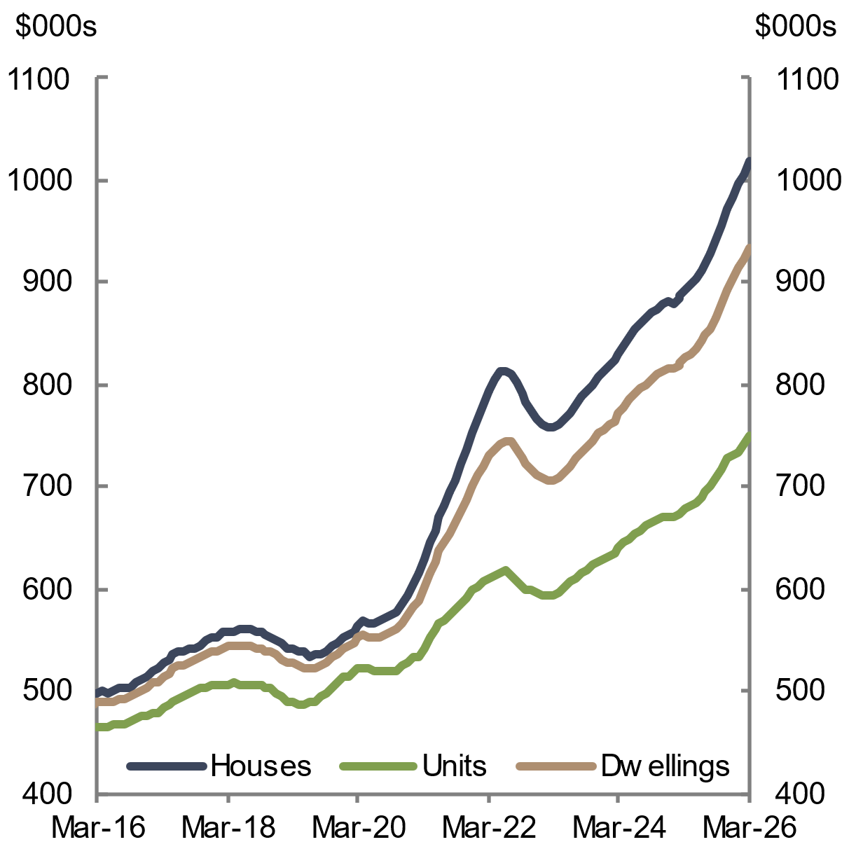 | 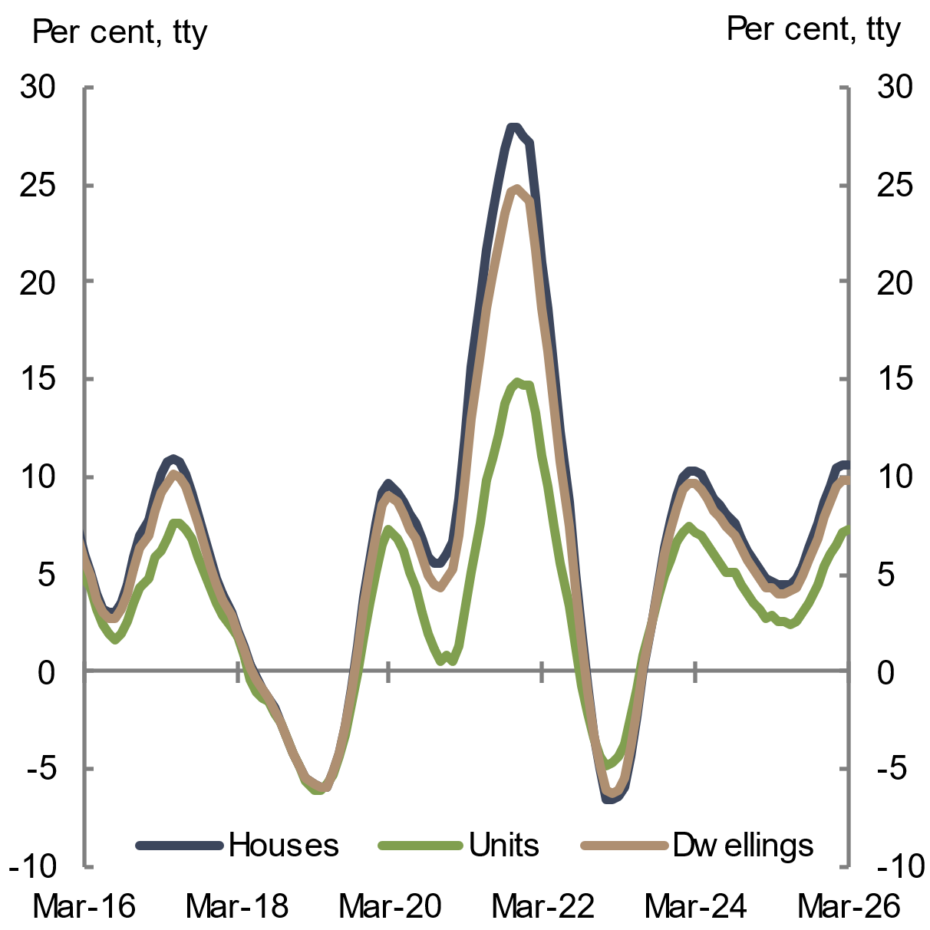
Note: Median value is the middle-estimate value of all residential properties derived through the hedonic regression methodology that underlies the Cotality Hedonic Home Value Index.  Source: Cotality 2026 | Source: Cotality 2026

Growth in housing prices over 2025 broadly reflected an increase in demand for housing driven by a reduction in interest rates. The Reserve Bank of Australia (RBA) lowered the cash rate three times in 2025, which was largely passed on by banks, expanding the borrowing and spending capacity of households (see section 2.4 Demand for housing remained strong). Other drivers of demand included government policies, rising household income, and investor credit growth. Population growth also supported demand for housing, despite moderating from its post-pandemic peak (see section 2.4 Demand for housing remained strong).
Weak levels of new housing supply relative to demand have also continued to place upward pressure on housing prices. The recent uptick in dwelling approvals has not yet translated into an increase in dwelling completions. Around 263,000 dwellings were completed in the first 18 months of the Housing Accord period, resulting in around 232,000 net new dwelling completions. This remains below new underlying demand for housing, which is estimated at around 287,000 over the same period (see section 2.2.1 New dwelling supply, by dwelling type and Chapter 4 Housing system outlook).

States and territories
Australia does not have a single national housing market, but many local housing markets with differing dynamics. Broadly, a two-speed housing market continued across Australia over the past year. Housing price growth in the mid-sized states of Western Australia, Queensland and South Australia outpaced the other states and territories, with the exception of the Northern Territory.
Western Australia (up 23.8 per cent), Queensland (up 17 per cent) and South Australia (up 11.5 per cent) saw strong housing price growth through the year to March 2026 (see Chart 2.3). This trend partly reflects strong population growth combined with low levels of new supply in recent years (see section 2.4.1 Population and section 2.2.2 New housing supply, by state and territory).
Housing price growth was also particularly strong in the Northern Territory, with dwelling prices rising by 17.1 per cent through the year to March 2026 (see Chart 2.4). This largely reflects limited housing supply and greater investment activity in Darwin (Cotality 2025a). In particular, the Northern Territory Government’s increased infrastructure spending is supporting strong population growth (see section 2.4.1 Population) (NT Government 2022; Territory Coordinator 2025a).
Housing price growth was lower in New South Wales (up 5.7 per cent), Victoria (up 4.1 per cent), the Australian Capital Territory (up 6.1 per cent) and Tasmania (up 9.4 per cent) through the year to March 2026. Both Victoria and the Australian Capital Territory have reported stronger new housing supply relative to population growth, which has placed downward pressure on housing prices (see section 2.2.2 New housing supply, by state and territory). Victoria’s slower price growth also reflects recent policy reform, such as land tax changes and rental reforms, which have curtailed investor demand (Slade 2026). In New South Wales, affordability constraints in Sydney have likely prevented housing prices from growing as quickly as in the mid-sized states (Cotality 2025b).
Chart 2.3 Housing price growth, by state | Chart 2.4 Housing price growth, by state
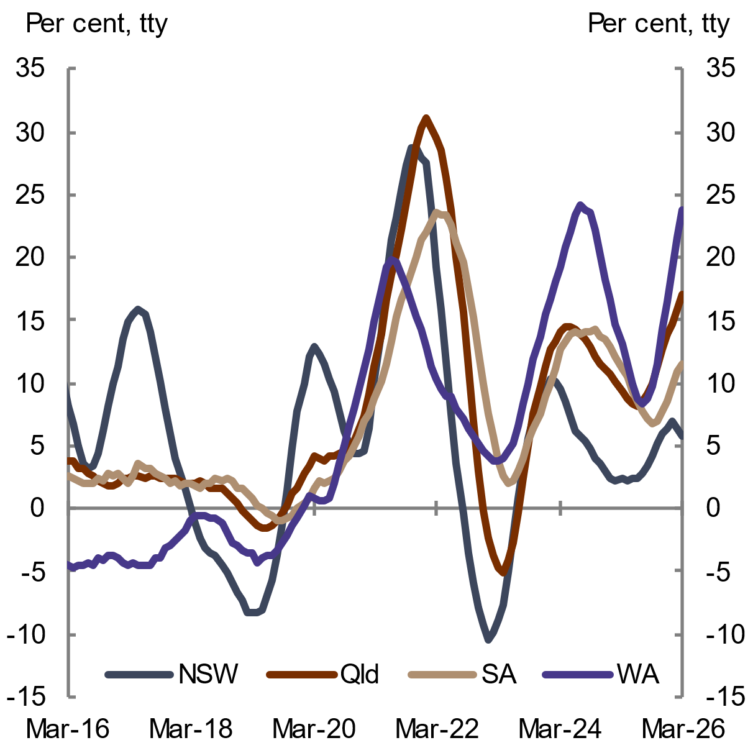 | 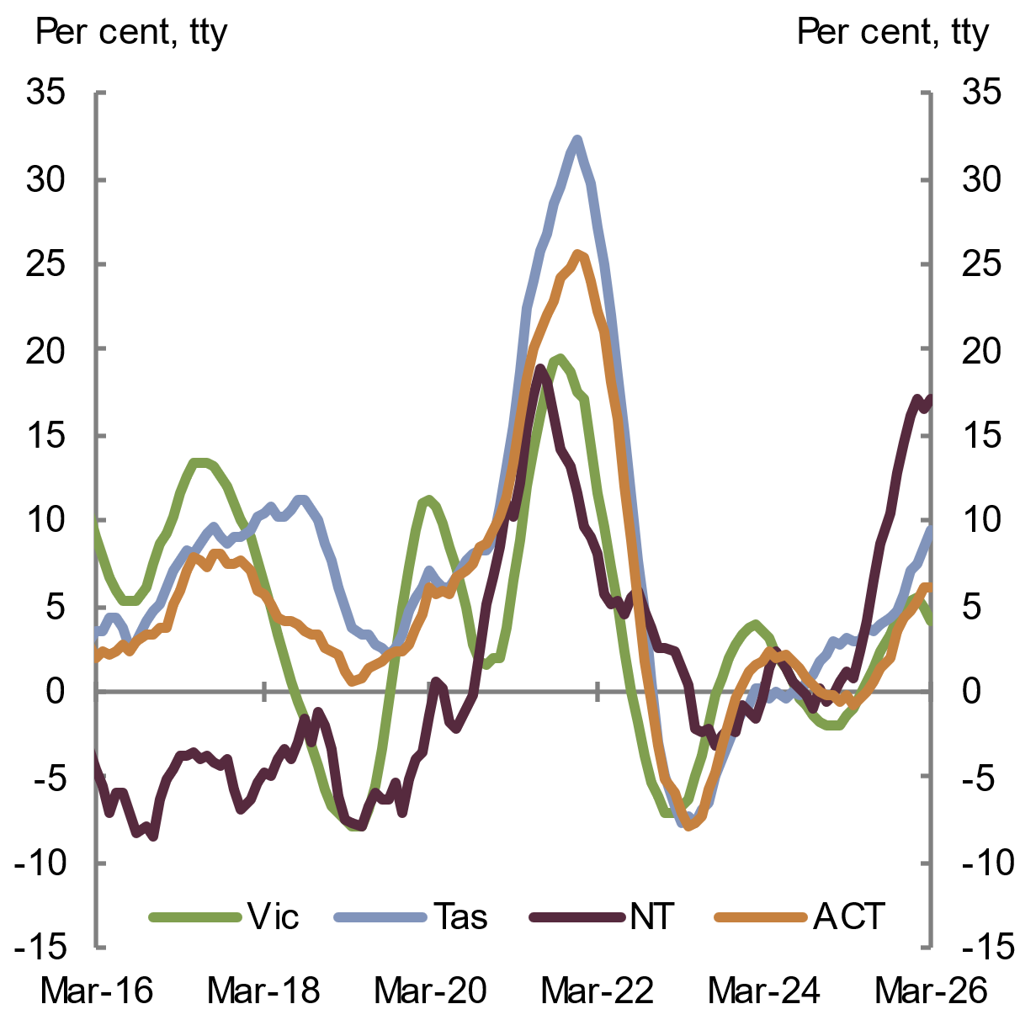
Source: Cotality 2026 | Source: Cotality 2026
Housing price growth in capital cities has tracked closely with growth in their respective states and territories. Across Australia, Sydney remains the most expensive capital city by a wide margin, while Darwin remains the least expensive (see Chart 2.5 and Chart 2.6). Rapid housing price growth in Perth and Adelaide has resulted in these cities’ median housing prices overtaking that of Canberra in 2025.
Chart 2.5 Housing prices, by capital city | Chart 2.6 Housing prices, by capital city
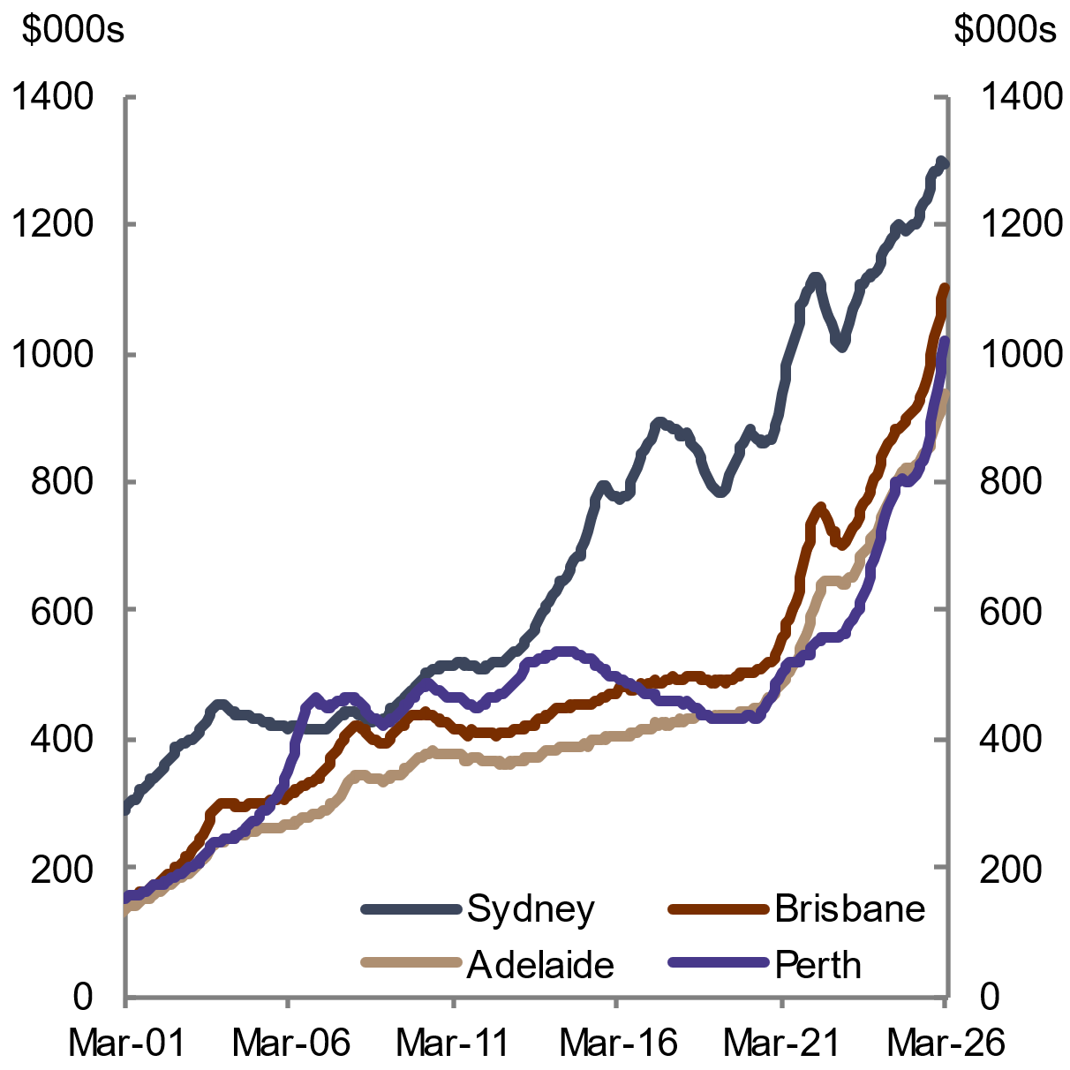 | 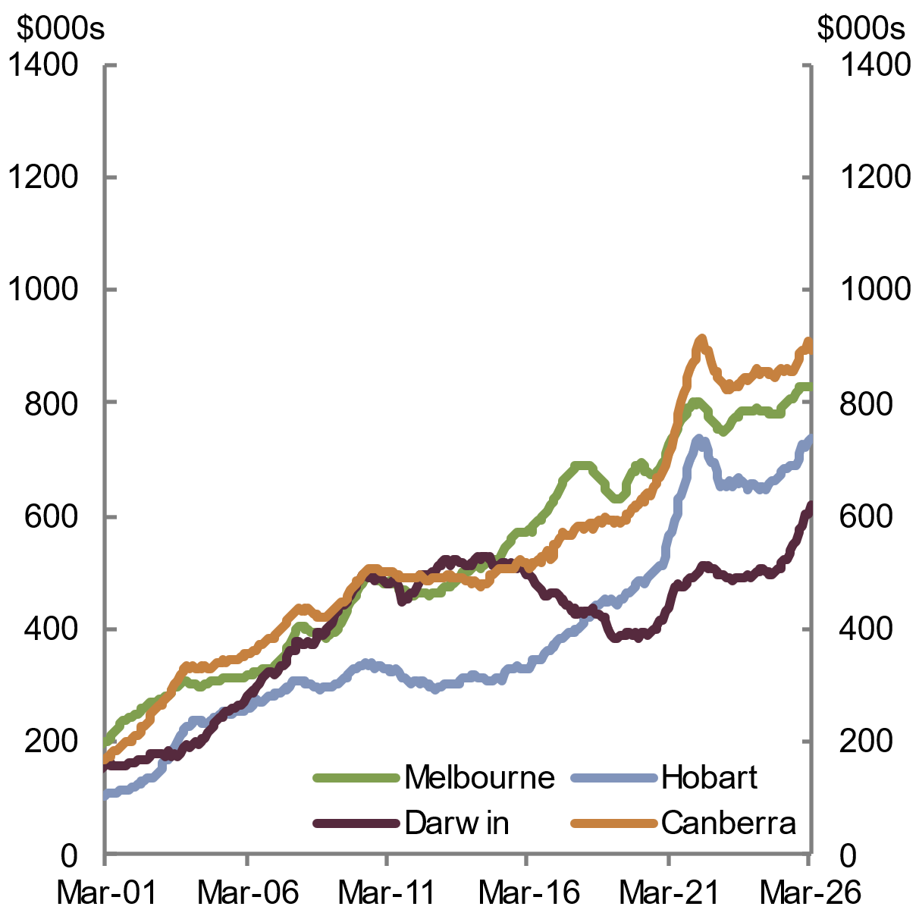
Note: Median value is the middle-estimate value of all residential properties derived through the hedonic regression methodology that underlies the Cotality Hedonic Home Value Index.  Source: Cotality 2026 | Note: Median value is the middle-estimate value of all residential properties derived through the hedonic regression methodology that underlies the Cotality Hedonic Home Value Index.  Source: Cotality 2026
House price growth has generally outpaced unit price growth across the states and territories over the past year. This was the case in New South Wales and Victoria (see Chart 2.7 and Chart 2.8). In contrast, Queensland saw similar price growth across houses and units. Relatively strong unit price growth in Queensland reflects rising demand for higher-density living in south-east Queensland, amid relatively low higher-density building approvals (Domain Insight 2025).
Chart 2.7 House price growth, by selected states | Chart 2.8 Unit price growth, by selected states
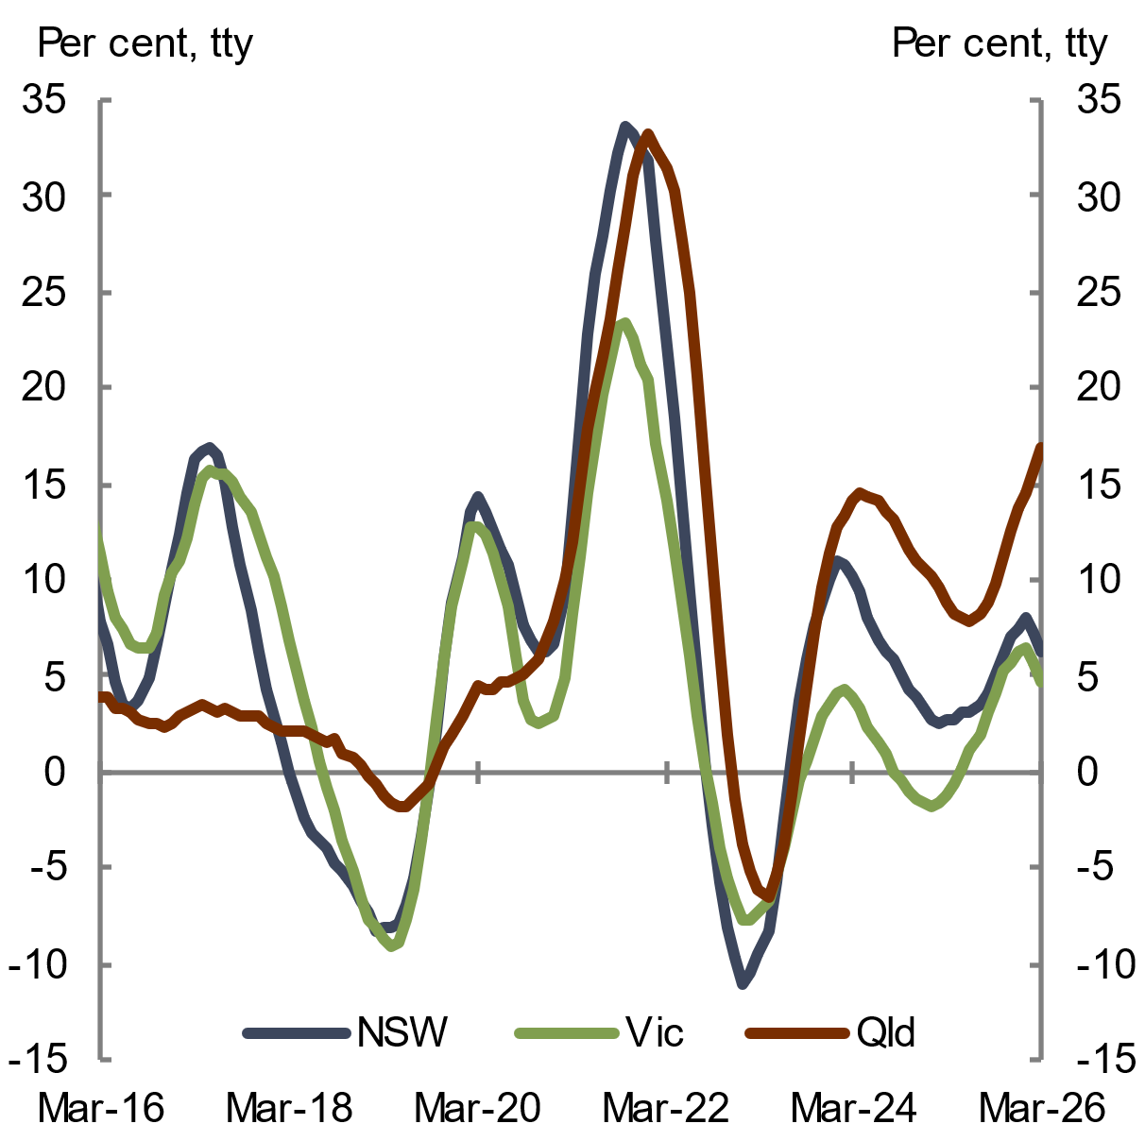 | 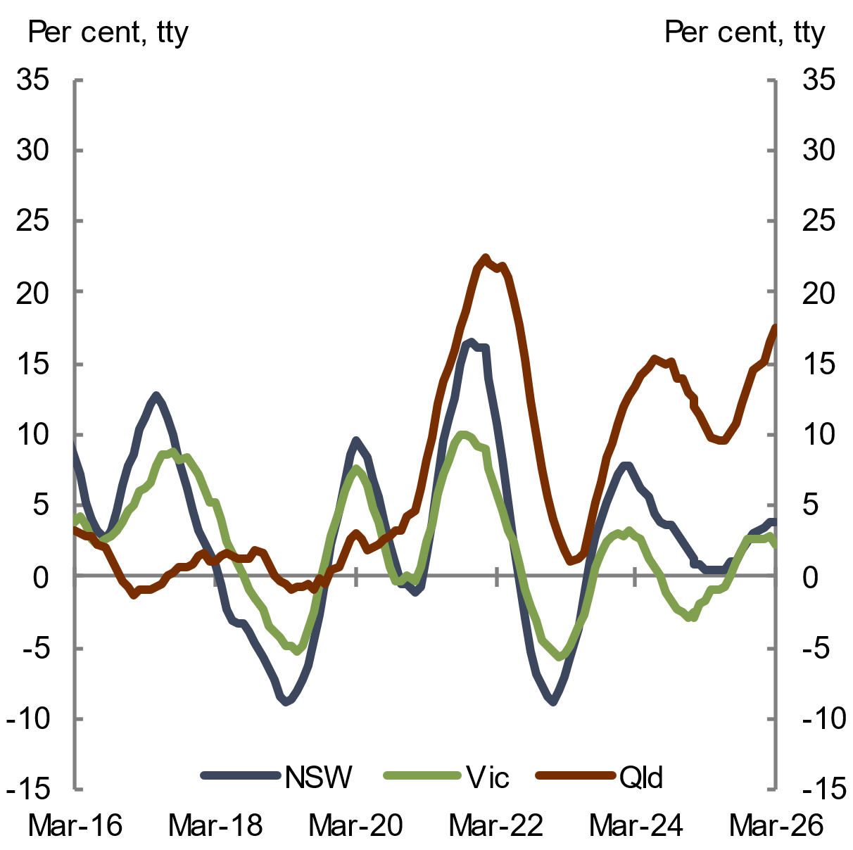
Source: Cotality 2026 | Source: Cotality 2026

Regional Australia and price segments
Dwelling price growth was stronger in regional areas than capital cities over the year to March 2026. Regional dwelling prices rose by 11.7 per cent, while capital city dwelling prices rose by 9.3 per cent (see Chart 2.9). While regional areas have historically recorded lower dwelling prices than capital cities, regional areas have recently experienced strong price growth, supported by heightened demand for homes at relatively more affordable price points than in capital cities (Cotality 2026a).
Across housing market price segments, lower-priced dwellings recorded stronger price growth than higher-priced dwellings. The value of lower-priced dwellings increased by 12.8 per cent over the year to March 2026 (see Chart 2.10). By contrast, the value of higher-priced dwellings rose by 6.6 per cent.
Chart 2.9 Dwelling price growth, by region | Chart 2.10 Dwelling price growth, by price segment
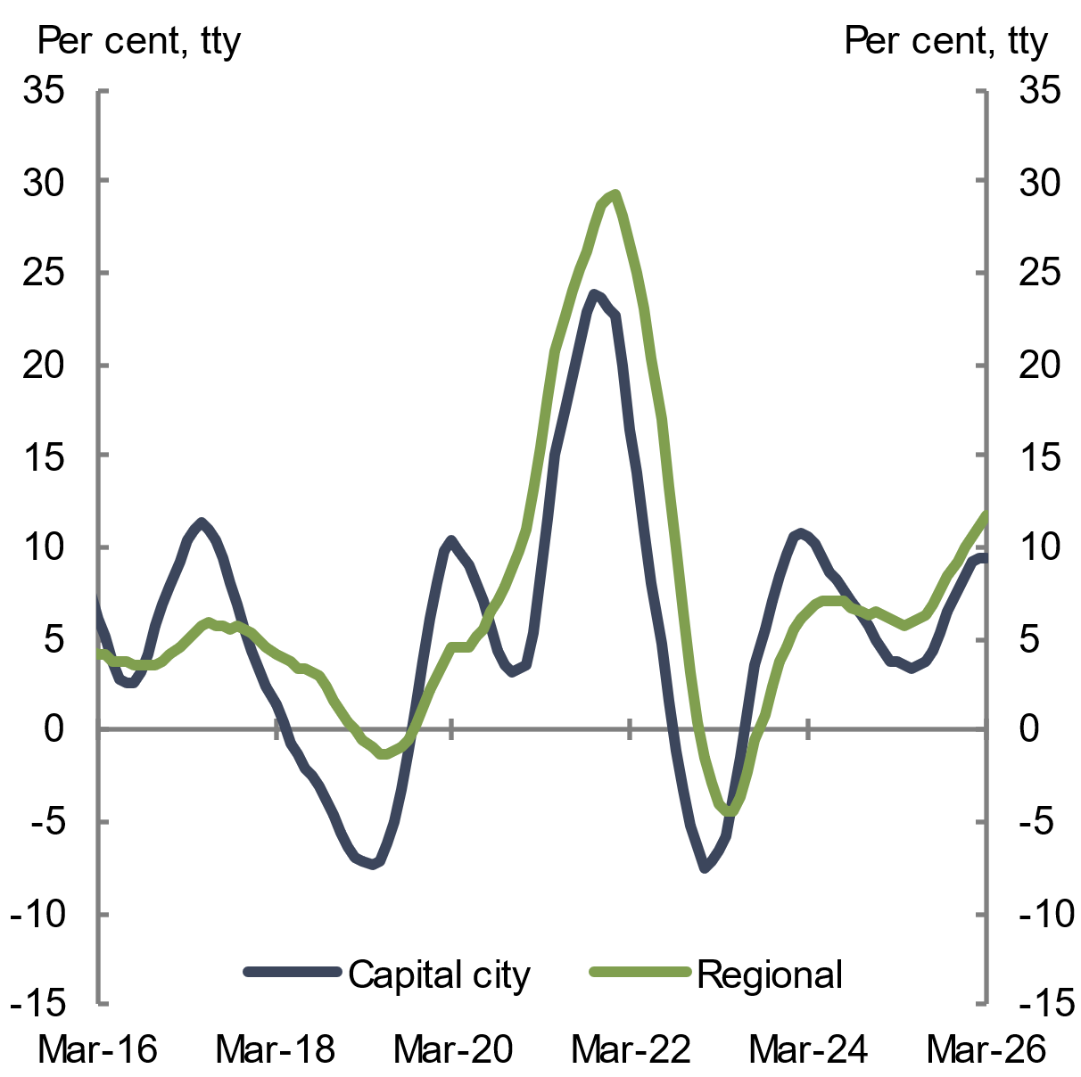 | 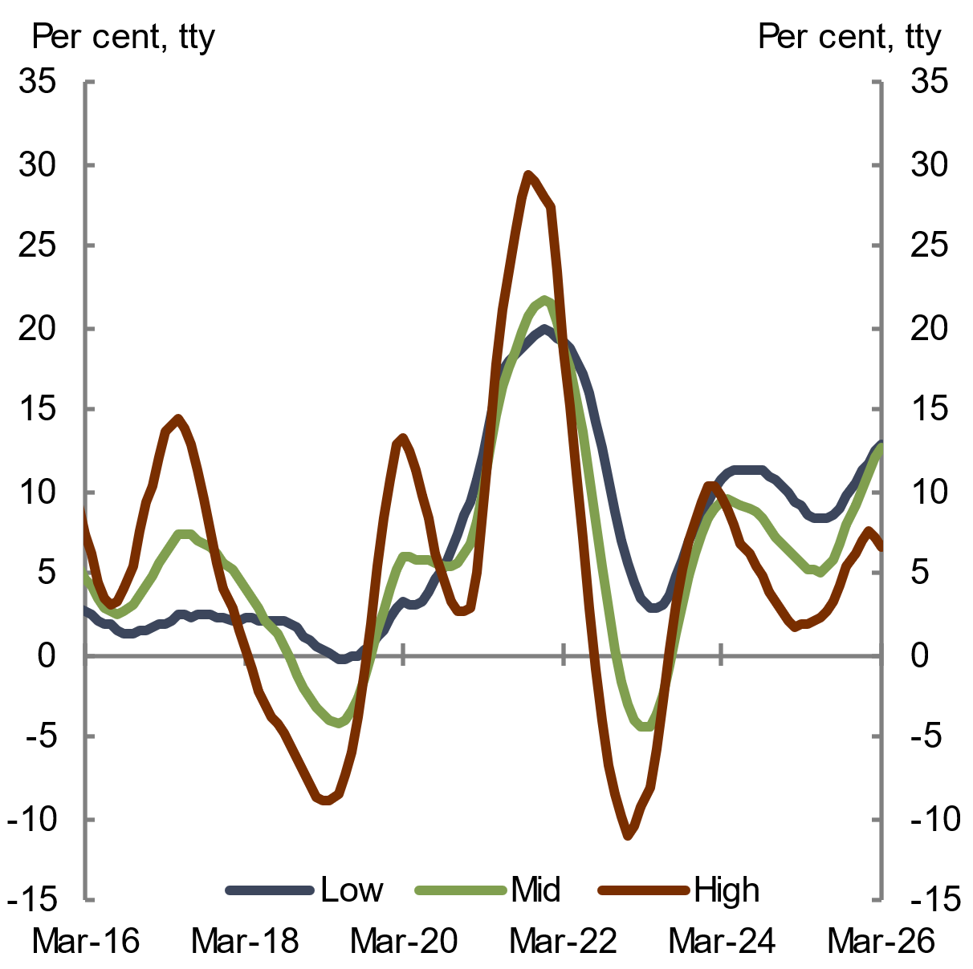
Source: Cotality 2026 | Note: ‘Low’, ‘Mid’ and ‘High’ refer to the 25th, 50th, and 75th percentile hedonic values, respectively.  Source: Cotality 2026

    - Rents and vacancy rates
Rental markets remained tight in 2025, with vacancy rates in most capital cities continuing to sit below their long-run averages (see Chart 2.11 and Chart 2.12). While rent growth eased from its peak in mid-2024, it remained historically high throughout 2025 at rates well above those observed prior to the pandemic (see Chart 2.13).
The rental market remains tight. Vacancy rates remain low across most of the country but showed improvement in 2025. The Real Estate Institute of Australia (REIA) national vacancy rate was 2 per cent in the December quarter 2025, up slightly from 1.8 per cent in the December quarter 2024, but still below its 15-year average of 2.4 per cent. While vacancy rates have risen from their trough of 1.4 per cent in March 2024, current levels indicate that rental markets remain tight by historical standards (see Chart 2.12).
Chart 2.11 Rental vacancy rate, by capital city | Chart 2.12 Rental vacancy rate, weighted average of capital cities
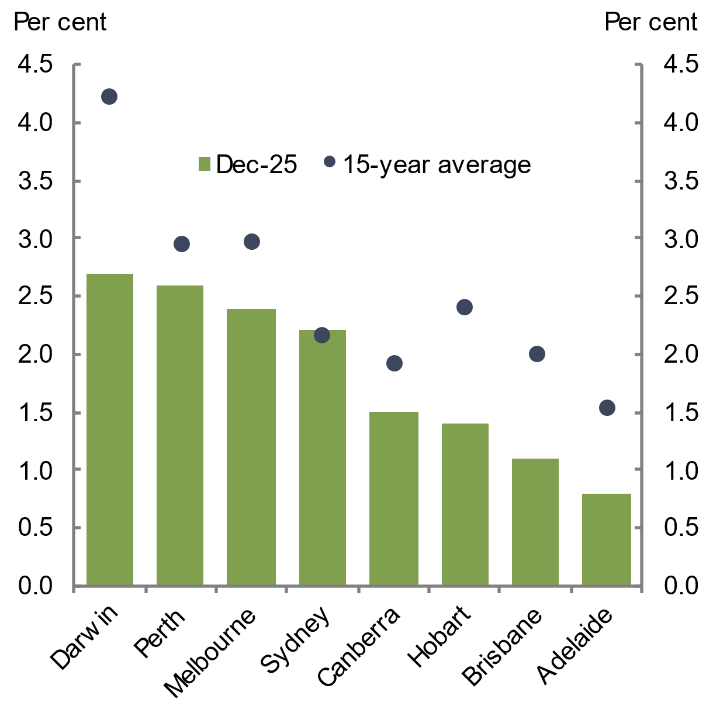 | 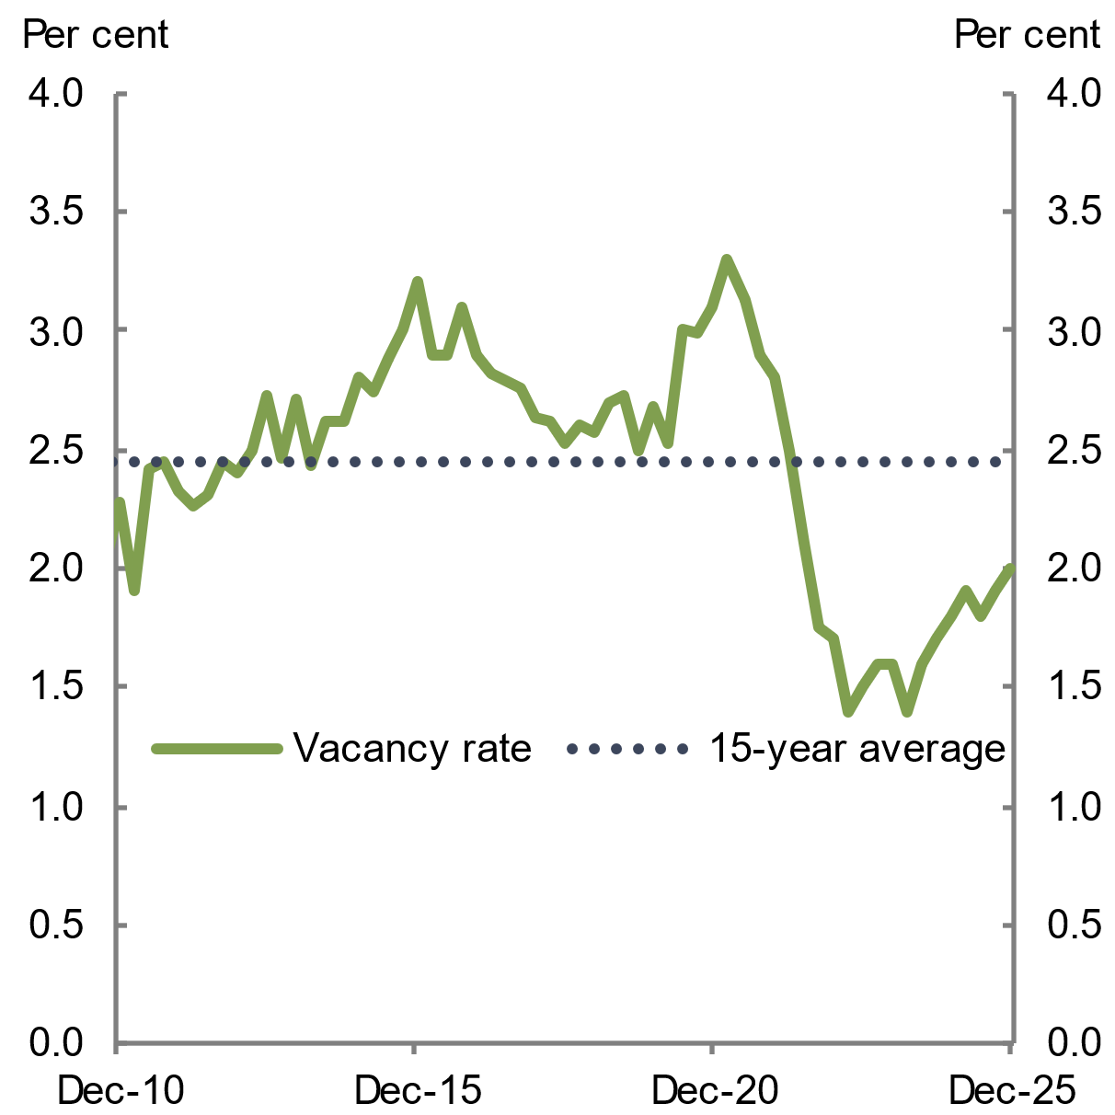
Note: The weighted average capital city vacancy rate.  Source: Real Estate Institute of Australia (REIA) 2025 | Note: The weighted average capital city vacancy rate.  Source: REIA 2026
Advertised weekly rents, which refers to rents for currently listed and prospective rental properties, rose by 5.7 per cent over the year to March 2026 (see Chart 2.13) to a national median of $650 per week. This was the largest annual increase since late 2024 and is significantly higher than the national median of $420 per week recorded in March 2020. Advertised rent growth eased in the first half of 2025, but picked up again toward the end of 2025 and into 2026. Advertised rent growth remains above pre-pandemic levels, consistent with ongoing tightness in the rental market and weighing on rental affordability (see Chapter 3 Housing affordability).
Consumer Price Index (CPI) rents grew by 3.8 per cent over the year to February 2026, which was a slower rate of growth than in 2025 (see Chart 2.13). CPI rents measures actual rental costs paid by both new and existing tenants and incorporates housing support payments received. CPI rent growth has moderated below its recent peak growth period between June 2023 and June 2024 where increases were around 7 per cent each quarter.
Chart 2.13 Annual growth in advertised and CPI rents | Chart 2.14 Annual growth in advertised rents, by region
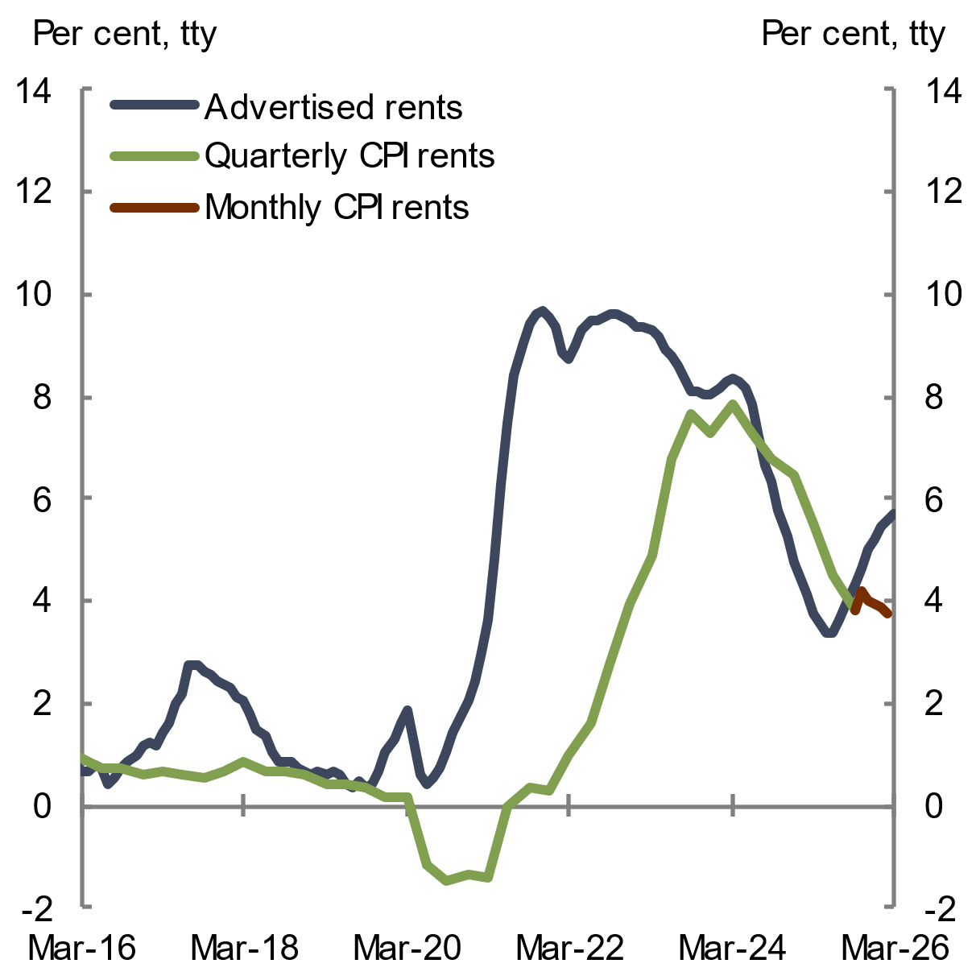 | 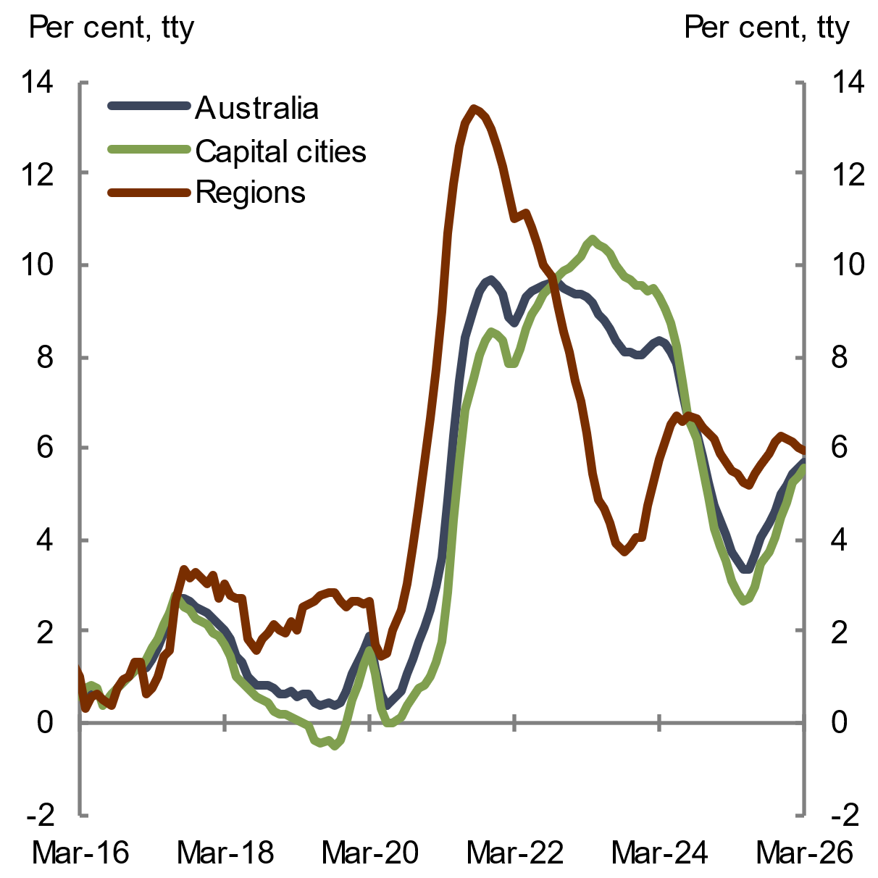
Note: The CPI measures out-of-pocket rental costs and is therefore be impacted by changes in rental subsidies. From October 2025 the ABS uses complete monthly CPI as its primary measure of inflation instead of the quarterly frequency.  Source: ABS Consumer Price Index 2026; Cotality 2026 | Source: Cotality 2026
Rental conditions have varied across Australia over the past year. Advertised rents rose slightly more rapidly in regional areas (up 6 per cent) compared to capital cities (up 5.6 per cent) over the year to March 2026, although capital cities have gained momentum in recent months (see Chart 2.14).
Rental pressures also varied across capital cities over the past year, broadly mirroring price patterns in the established housing market. CPI rents increased in all capital cities over the year to February 2026. The largest growth in CPI rents occurred in Perth, Brisbane and Adelaide, which were the cities that also saw the largest growth in housing prices. In contrast, CPI rent growth was lowest in Hobart and Canberra (see Chart 2.15). In level terms, advertised rents were most expensive in Sydney and least expensive in Hobart in March 2026 (Chart 2.16).
Chart 2.15 Annual growth in CPI rents, by capital city, February 2026 | Chart 2.16 Median advertised weekly rents, by capital city, March 2026
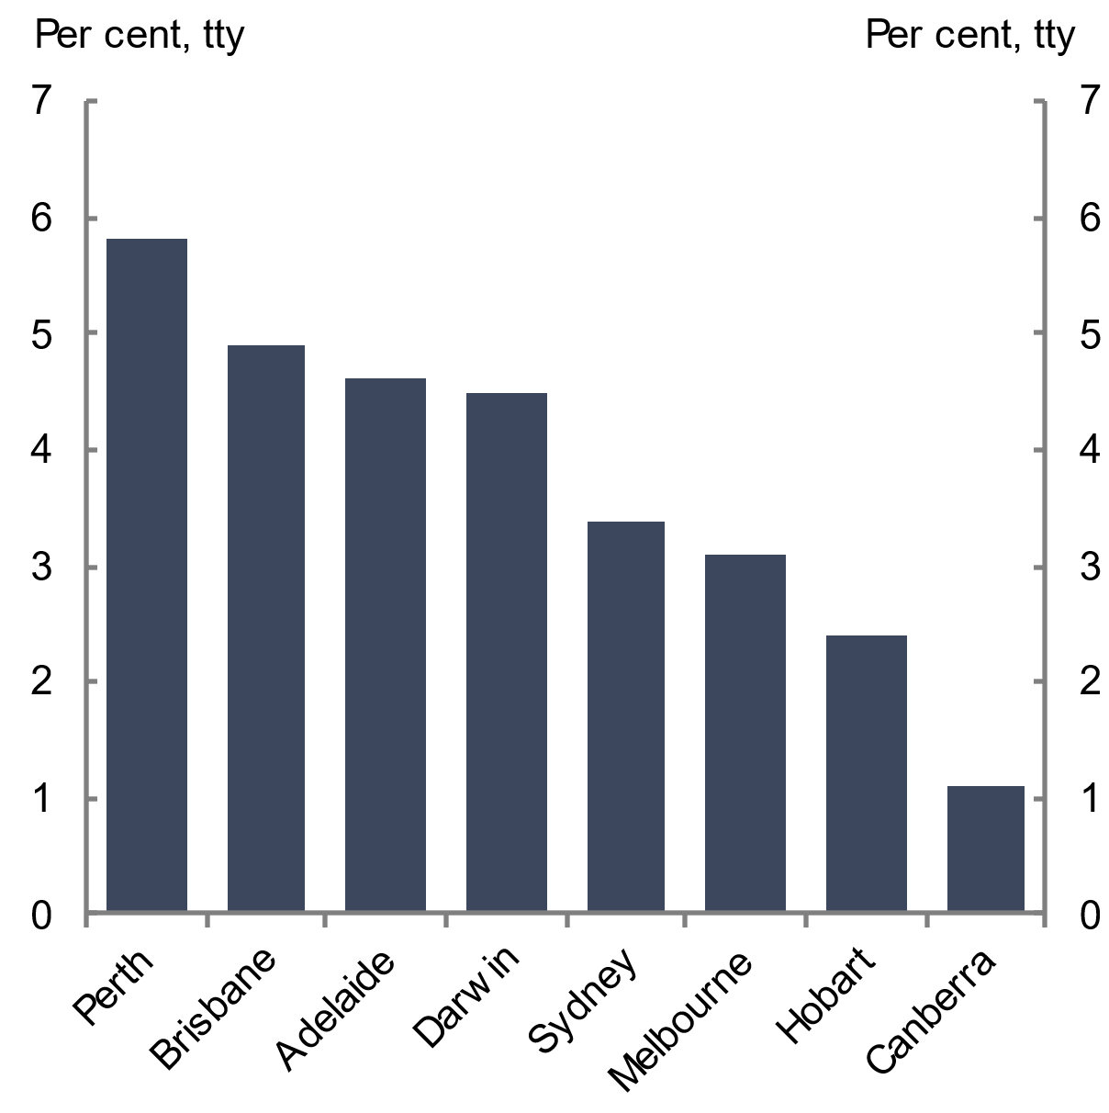 | 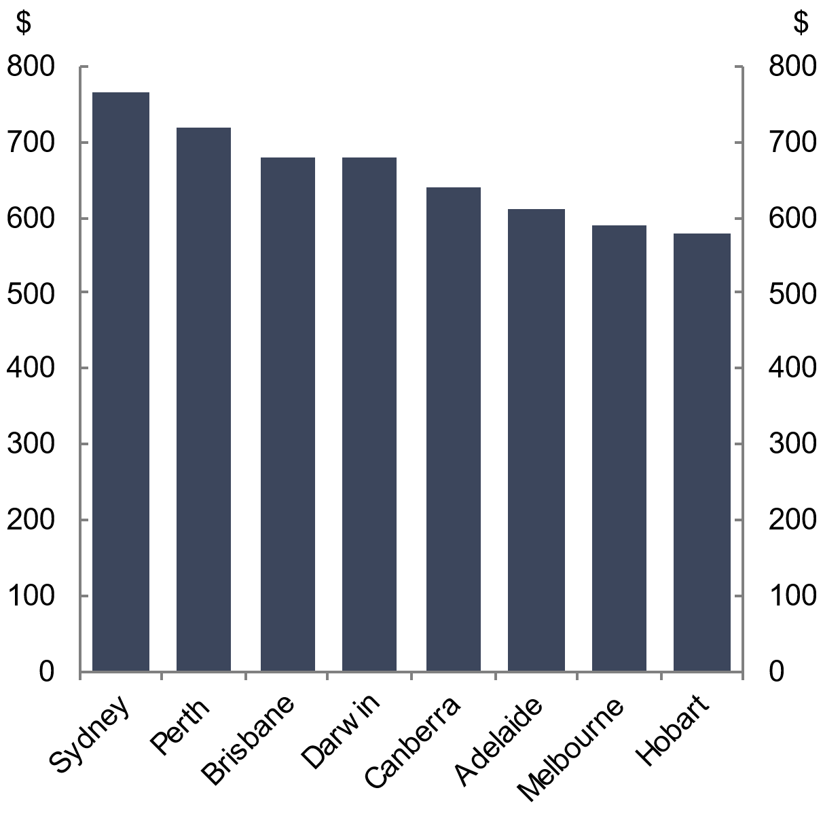
Source: ABS Consumer Price Index 2026 | Note: The median rent over a rolling 3-month period.  Source: Cotality 2026
  - Building approvals grew in 2025, although completions remained steady
    - New housing supply, by dwelling type
Dwelling completions remained steady in 2025. Around 173,000 dwellings were completed in 2025, slightly lower than in 2024 and well below their peak of 219,000 in 2018 (see Chart 2.17). In contrast, both approvals and commencements have risen above long-run average levels. There were 196,000 building approvals in the year to February 2026, alongside 196,000 dwelling commencements in 2025. Historically, 97.8 per cent of approved dwellings are completed, suggesting an improvement in the outlook for housing supply (see Chapter 4 Housing system outlook).
The uptick in dwelling approvals and commencements likely reflects improved commercial feasibility. The easing of interest rates in 2025 drove an uptick in dwelling price growth, while construction costs grew at a slower pace. This incentivised investors and spurred momentum in building approvals (see Box 4.1). Recent policies implemented by the Commonwealth, state and territory governments have also likely boosted the pipeline of new dwellings under construction.
Higher-density dwelling completions remained low in 2025, with only 62,000 higher-density dwellings completed. This was 41.4 per cent below the peak of 106,000 completions in the year to September 2017 (see Chart 2.17). In contrast, higher-density dwelling approvals strengthened through 2025 and into early 2026. A total of 81,000 higher-density dwellings received building approval in the year to February 2026, representing an annual increase of 18.9 per cent and broadly in line with the 15-year annual average. Indeed, the recent uplift in aggregate dwelling approvals has been largely driven by higher-density dwellings, signalling a growing pipeline of higher-density construction.
Detached dwelling completions and building approvals remained broadly consistent with historical levels. Around 110,000 detached dwellings were completed in the year to December 2025, while approximately 115,000 detached dwellings received building approval in the year to February 2026. Although detached dwelling building approvals remained below their pandemic-era peak in September 2021, they were broadly in line with long-run average levels (see Chart 2.18).
Although dwelling renovations do not directly add to housing supply, they account for around 40 per cent of residential construction activity (ABS 2026a). In the environment of strong dwelling price growth, some owners are choosing to renovate their existing homes rather than upgrade to another dwelling (Malo 2026). Housing Industry Australia (HIA) forecasts this trend will continue, which will likely continue contributing to existing labour pressures in the construction of new dwellings (Malo 2026).
Chart 2.17 Dwelling completions, by type | Chart 2.18 Dwelling approvals, by type
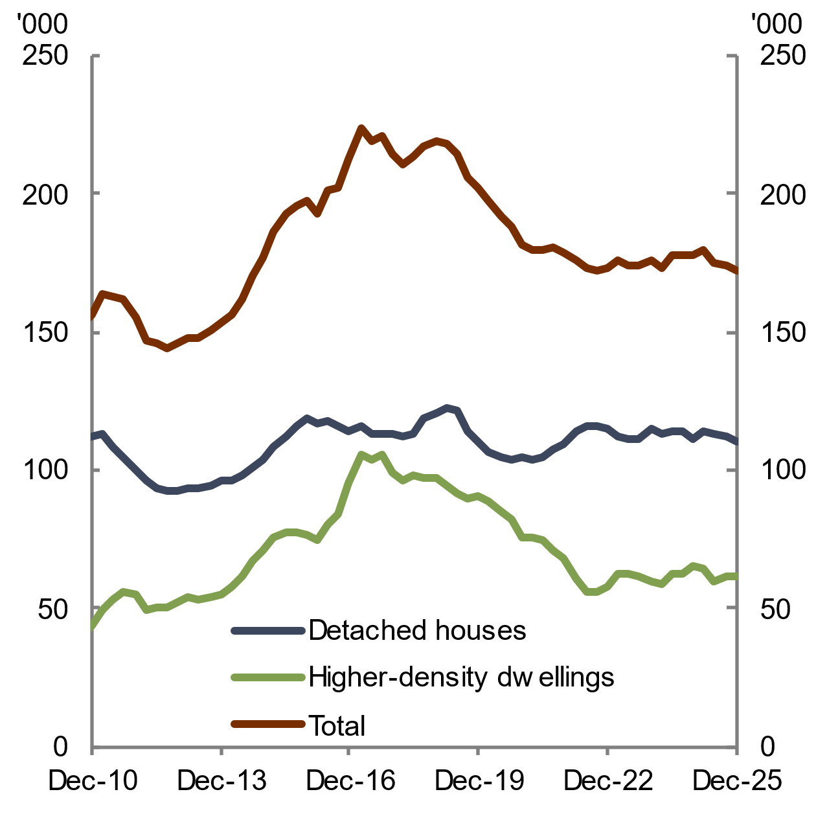 | 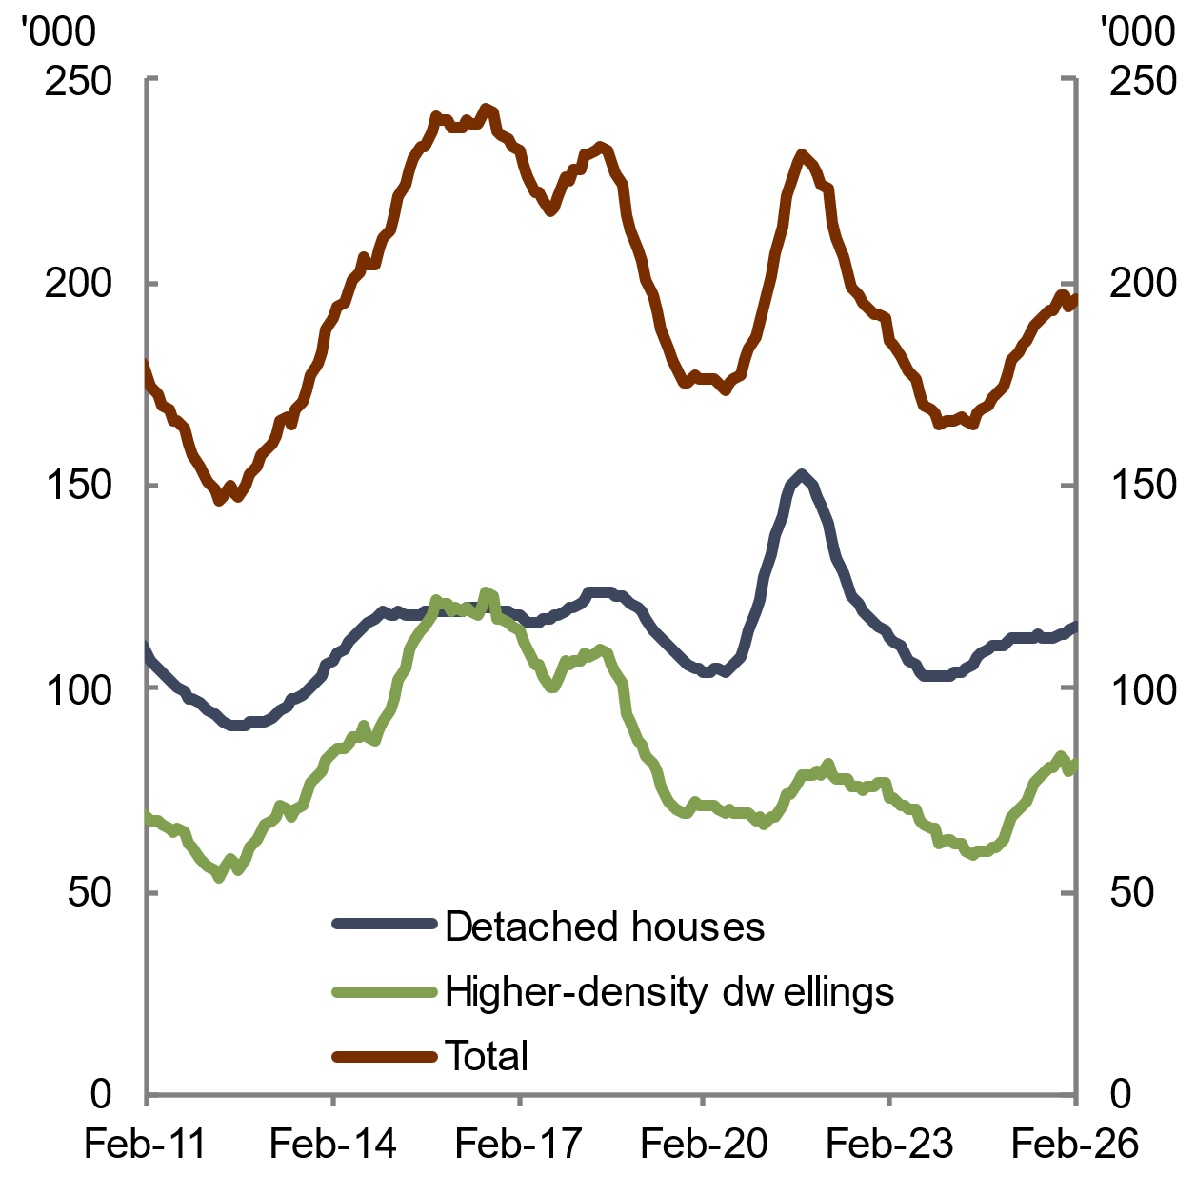
Note: Annual rolling sum of dwelling completions in the private and public sectors.  Source: ABS Building Activity 2026 | Note: The annual rolling sum of dwelling approvals in the private and public sectors.  Source: ABS Building Approvals 2026

    - New housing supply, by state and territory
Growth of new housing supply varied across the states and territories in 2025, reflecting different economic and demographic conditions across the country (see Chart 2.19 and Chart 2.20). Growth was strongest in South Australia, which saw a 13.2 per cent increase in annual dwelling completions in 2025, driven by higher-density housing. Over 2025, growth in dwelling completions was also strong in the Northern Territory, up 8.8 per cent, while completions were weaker in Tasmania (down 18.4 per cent), the Australian Capital Territory (down 18 per cent) and Victoria (down 10.6 per cent).
Chart 2.19 Dwelling completions, by state | Chart 2.20 Dwelling completions, by state
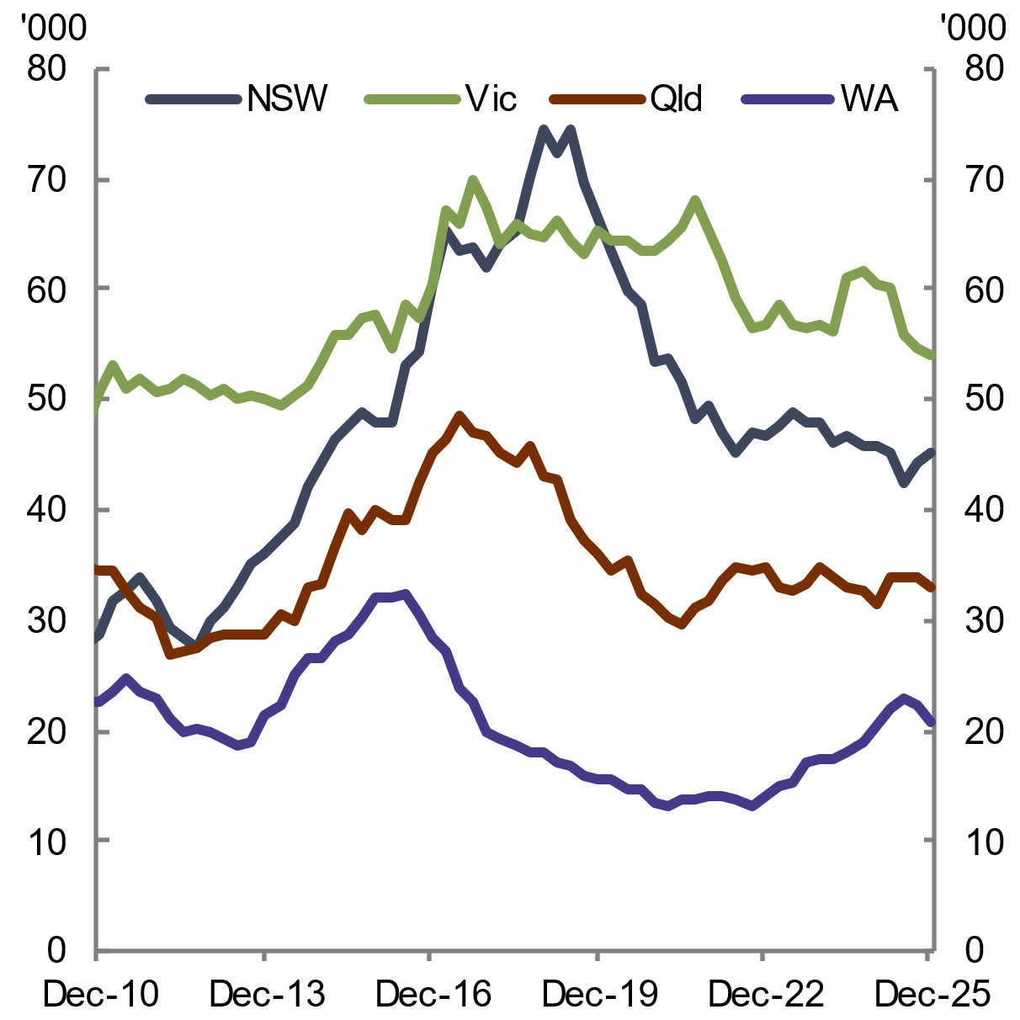 | 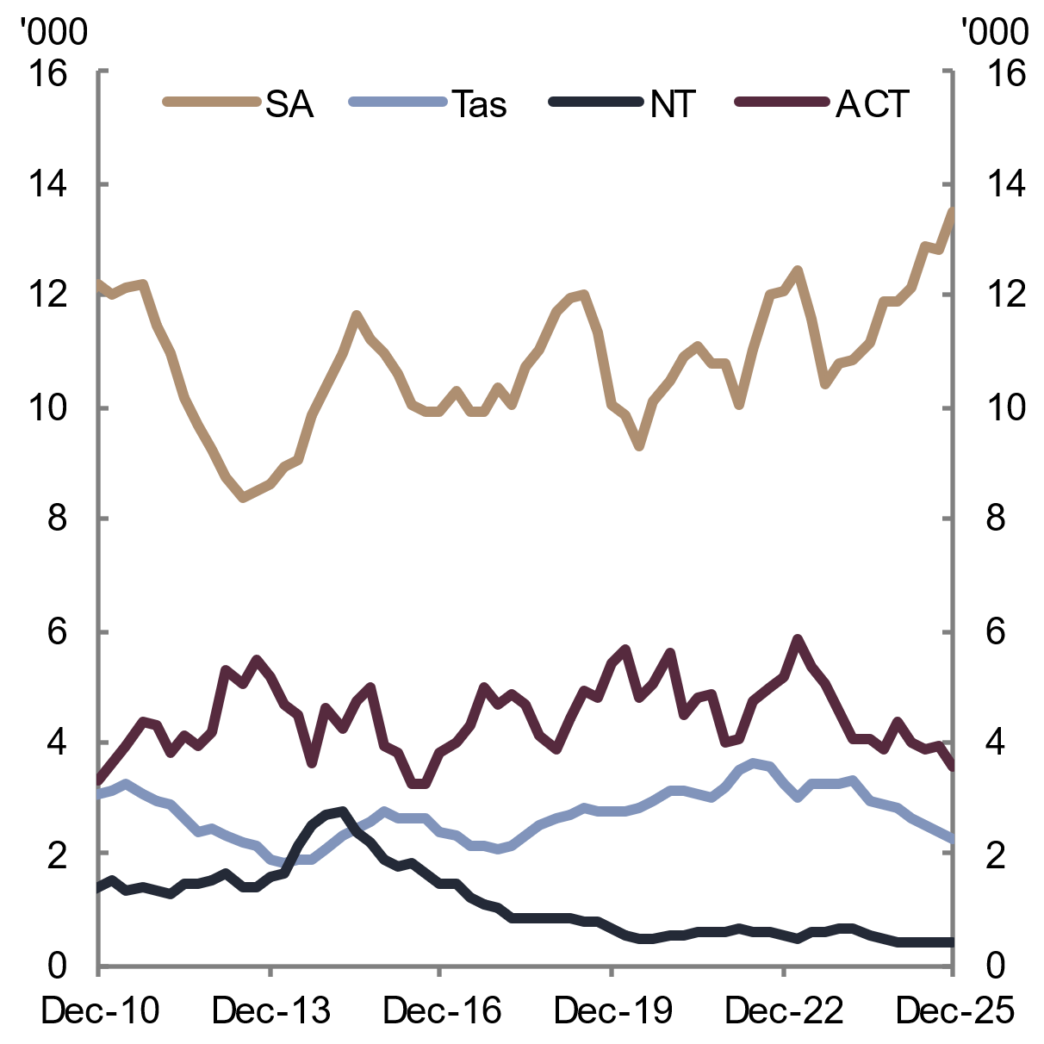
Note: Annual rolling sum of dwelling completions in the private and public sectors.  Source: ABS Building Activity 2026 | Note: Annual rolling sum of dwelling completions in the private and public sectors.  Source: ABS Building Activity 2026
Improvement in building approvals was broad based across states and territories. Almost all jurisdictions recorded growth in annual building approvals for dwellings well above their 15-year growth averages over the year to February 2026 (see Chart 2.21 and Chart 2.22). The strongest percentage growth in approvals was in the Australian Capital Territory, up 113.7 per cent to 4,786 dwellings approved in the year to February 2026 as approvals returned to their long-run average after a recent building downturn.
Mid-sized states also saw significant building approvals growth in percentage terms. Queensland saw growth of 16.8 per cent, South Australia grew by 12.3 per cent and Western Australia saw 10.4 per cent growth. New South Wales also saw strong growth of 10.8 per cent, while Victoria and Tasmania recorded falls in dwelling approvals over the year to February 2026. Approvals in the Northern Territory were up 18.8 per cent over the year to February 2026.
Chart 2.21 Dwelling approvals, by state | Chart 2.22 Dwelling approvals, by state
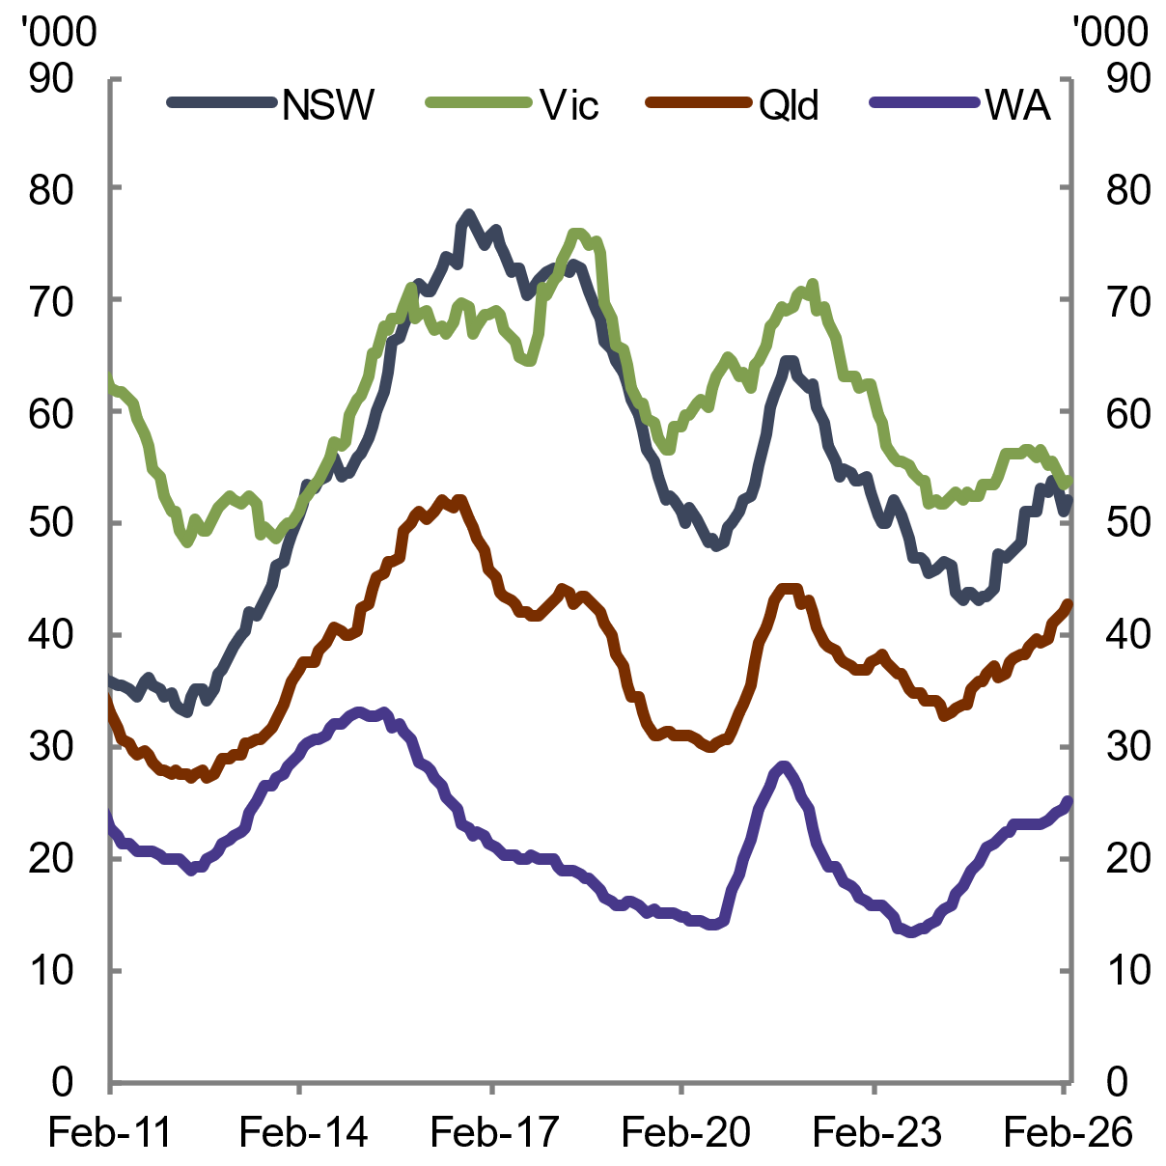 | 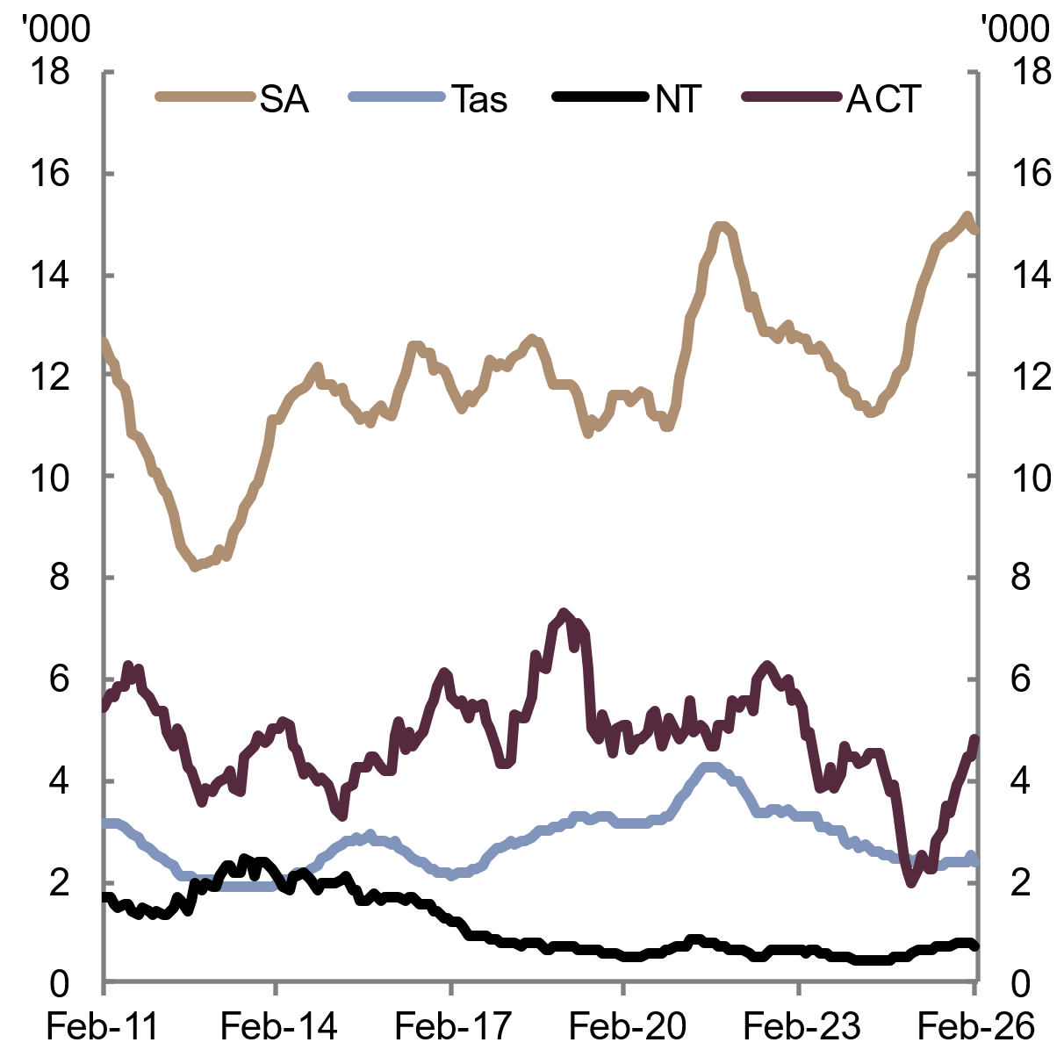
Note: Annual rolling sum of dwelling approvals in the private and public sectors.  Source: ABS Building Approvals 2026 | Note: Annual rolling sum of dwelling approvals in the private and public sectors. Original data used for NT and ACT.  Source: ABS Building Approvals 2026
  - Construction cost growth in 2025 was below recent peak growth rates
    - Construction costs
Dwelling construction costs continued to rise over 2025. While growth in construction costs eased substantially in the first half of the year, dwelling construction cost growth picked up towards the end of 2025 (see Chart 2.23 and Chart 2.24). Material cost growth has moderated since the pandemic, but labour cost growth remains high amid continued constraints in labour supply.
In per square metre terms , growth in construction costs moderated in 2024–25. In 2024–25, detached house construction costs per square metre rose 6.7 per cent (down from 11.0 per cent in 2023–24), while townhouse and apartment costs increased 9.8 per cent and 10.2 per cent respectively (down from 12.9 per cent and 18 per cent in 2023–24, respectively). Average floor space of new apartments and townhouses rose over 2024–25, while it was broadly unchanged for houses.
In per square metre terms, apartments have consistently cost more to build than townhouses and detached houses (see Chart 2.25). In 2024–25, average costs per square metre were $4,500 for new apartments, $2,500 for new townhouses and $2,000 for detached houses. Cost differences reflect the greater construction complexity and higher skill requirements needed to build apartments (AHURI 2025).
Chart 2.23 Construction costs, by dwelling type | Chart 2.24 Construction cost growth, by dwelling type
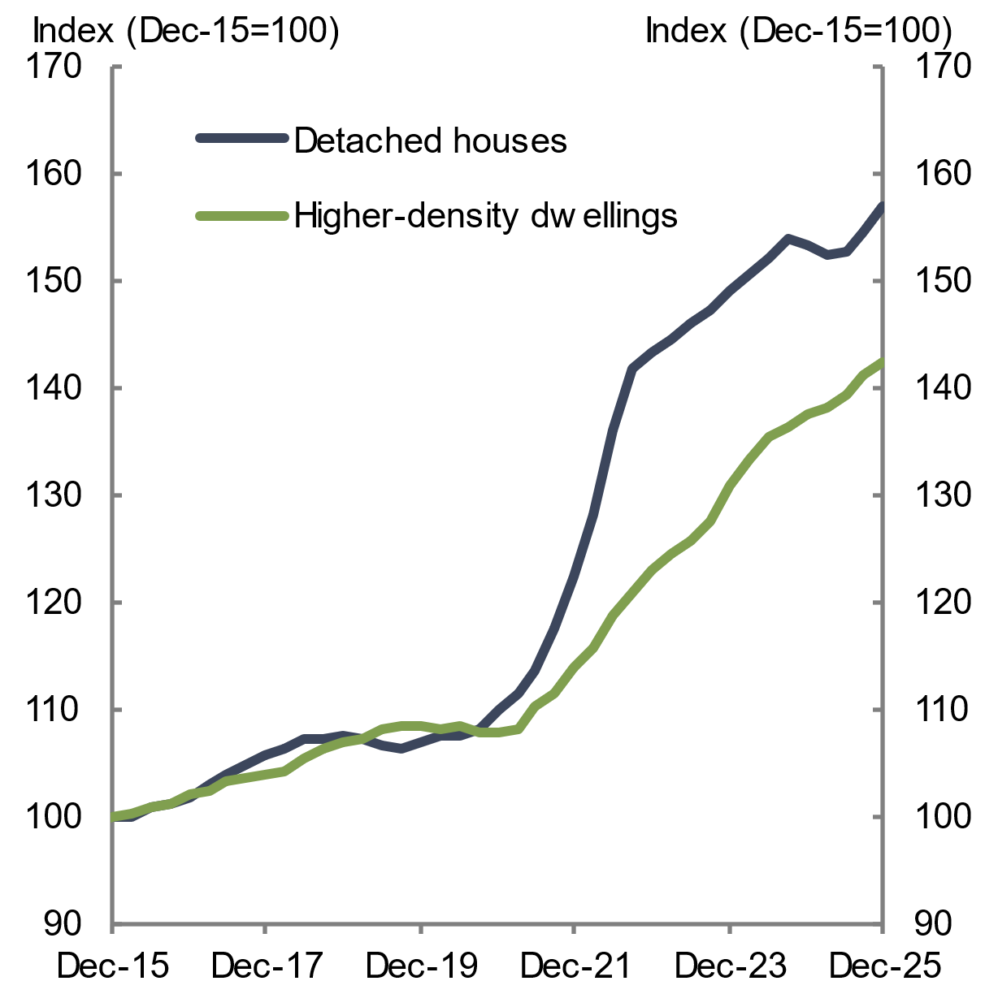 | 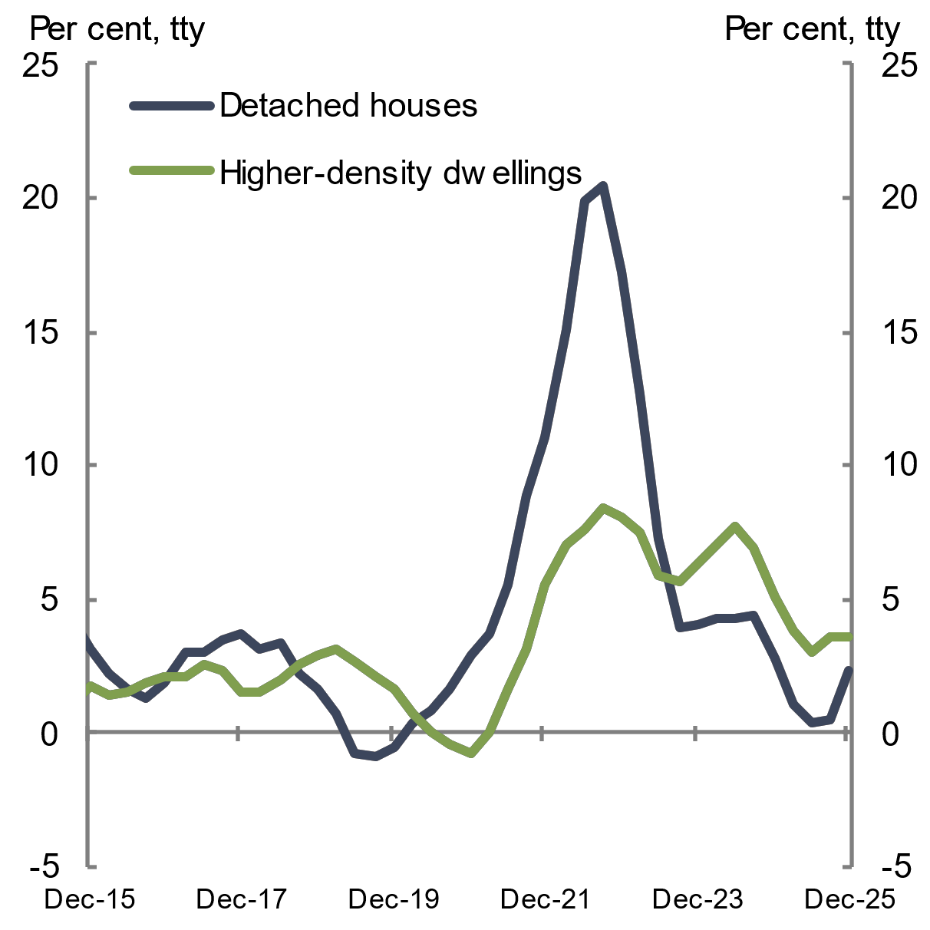
Note: Output of the construction industry indexes, which incorporates material costs, labour costs and margins.  Source: ABS Producer Price Indexes, Output to the construction industry 2026 | Note: Output of the construction industry indexes used for construction industry, which incorporates material costs, labour costs and margins.  Source: ABS Producer Price Indexes, Output to the construction industry 2026
Chart 2.25 Construction costs per square metre, by type
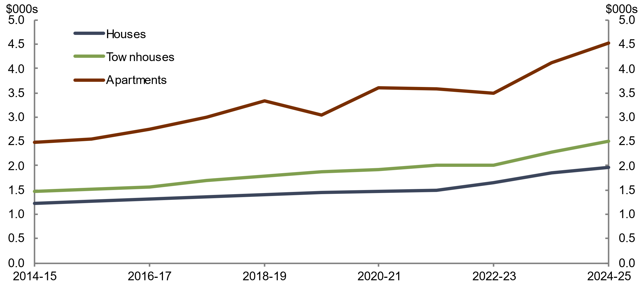
Source: ABS Building Activity 2026

Detached housing construction costs, by state and territory
Detached housing construction costs rose by 2.3 per cent over 2025 (see Chart 2.24). Cost growth was supported by an increase in demand for house construction which led builders to reduce promotional discounts (ABS 2025a).
Growth in detached housing construction costs was driven by the smaller and mid-sized jurisdictions, while larger states saw growth below their long-run averages in 2025 (see Chart 2.26). Increasing demand drove house construction prices higher, aided in some jurisdictions by pressure from material and labour prices (ABS 2026b). In Tasmania and the Northern Territory, price growth was partly driven by rising transport and logistics costs (Saunders 2025). Shortages in materials, particularly concrete sand in south-east Tasmania, have increased reliance on transported sand (Holmes 2025). Construction costs are higher in smaller jurisdictions (see Chart 2.27) and regional areas, which can be impacted by the additional cost of transporting building materials, smaller market scale and workforce supply constraints (Williams 2025; HIA 2026a).
Chart 2.26 Detached housing construction prices growth, by state | Chart 2.27 Average house construction cost per square metre, by state
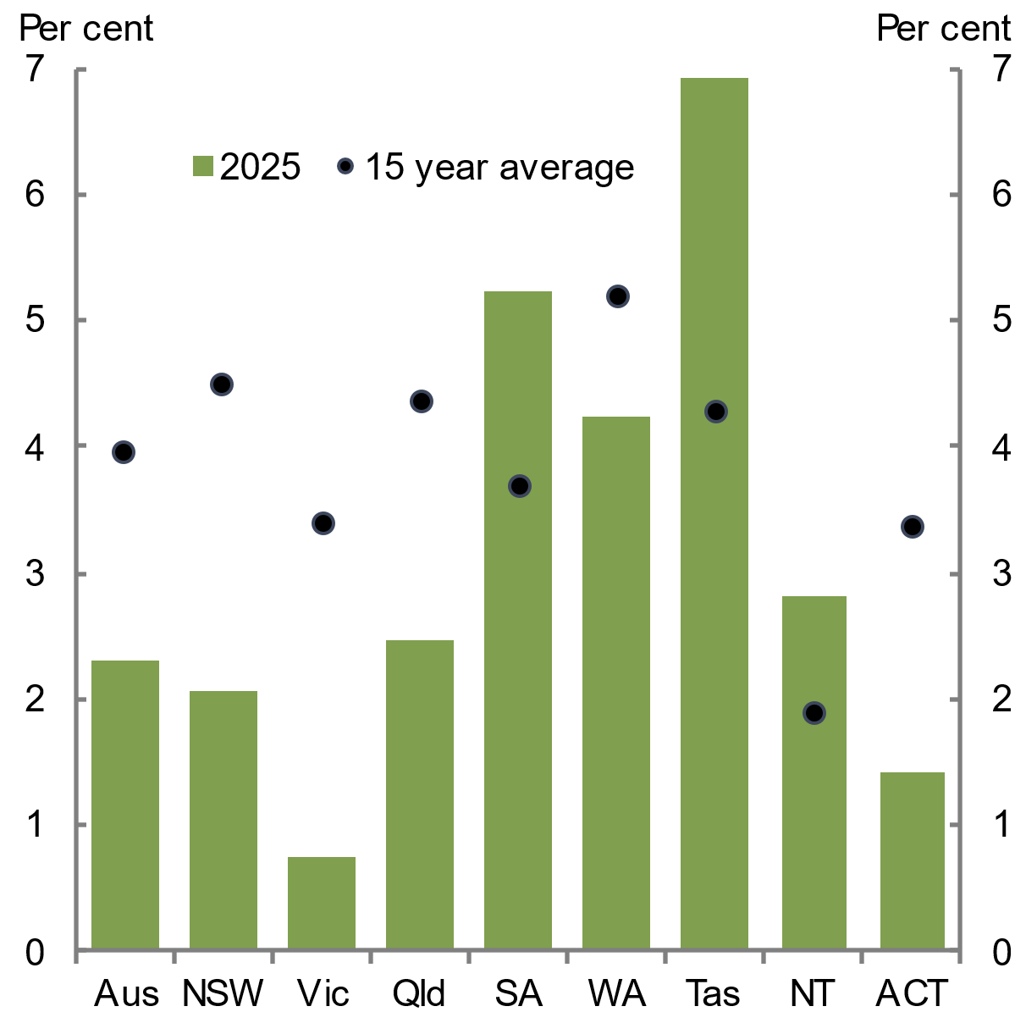 | 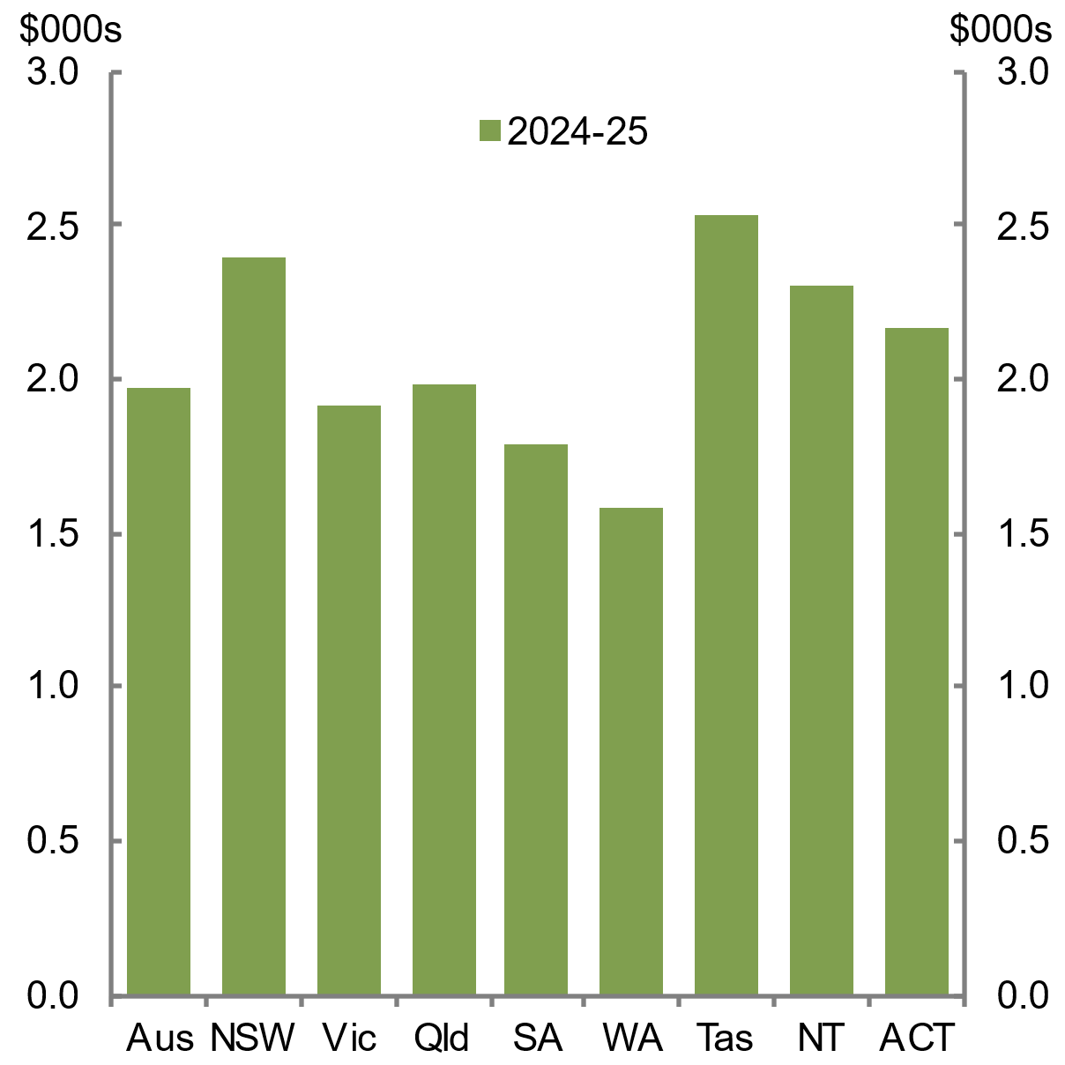
Note: The through-the-year growth rate to December 2025.  Source: ABS Producer Price Indexes, Output to the construction industry 2026 | Source: ABS 2026

Higher-density housing construction costs, by state and territory
Construction costs for higher-density housing rose by 3.6 per cent over 2025 (see Chart 2.24), with the strongest growth in Queensland, Western Australia and the Northern Territory (see Chart 2.28). Higher-density housing projects tend to be large, complex and time-consuming, and therefore vulnerable to input cost fluctuations and labour availability. Rising labour costs drove the higher-density costs growth due to ongoing constraints in labour supply, which both the residential and non-residential construction segments compete for (ABS 2025b). Western Australia and Queensland experienced the most difficulty with trade availability, due to strong labour competition from infrastructure and mining projects. The construction industry’s elevated insolvency rates and continuing skilled labour shortage have increased operational uncertainty. These factors have extended project completion times, particularly for larger and more complex projects, which builders have increasingly accounted for by pricing in higher risk premiums when tendering for higher-density projects (ABS 2025c).
Over the 15 years to 2024–25, apartment per square metre cost growth has been driven by a 74.1 per cent increase in construction costs, while average apartment floor space increased by 2.2 per cent. In 2024–25 apartment per square metre construction costs were highest in New South Wales and Queensland, rising by 5 per cent to $4,500 in New South Wales and by 21.2 per cent to $5,000 in Queensland (see Chart 2.29). There was increased demand for higher-density dwellings in Queensland, driven by population growth in south-east Queensland (Paris 2025) and strong activity and premium high-end developments on the Gold Coast and Sunshine Coast (RPM Group 2025). This increased demand coincides with a period of high infrastructure spending in the 2025–26 Queensland Budget, the most significant of all jurisdictions (Infrastructure Partnerships Australia 2025). Longer build times for apartments in New South Wales have increased labour and holding costs (MBA NSW 2025).‍
Chart 2.28 Higher-density dwellings construction prices growth, by state | Chart 2.29 Average apartment construction cost per square metre, by state
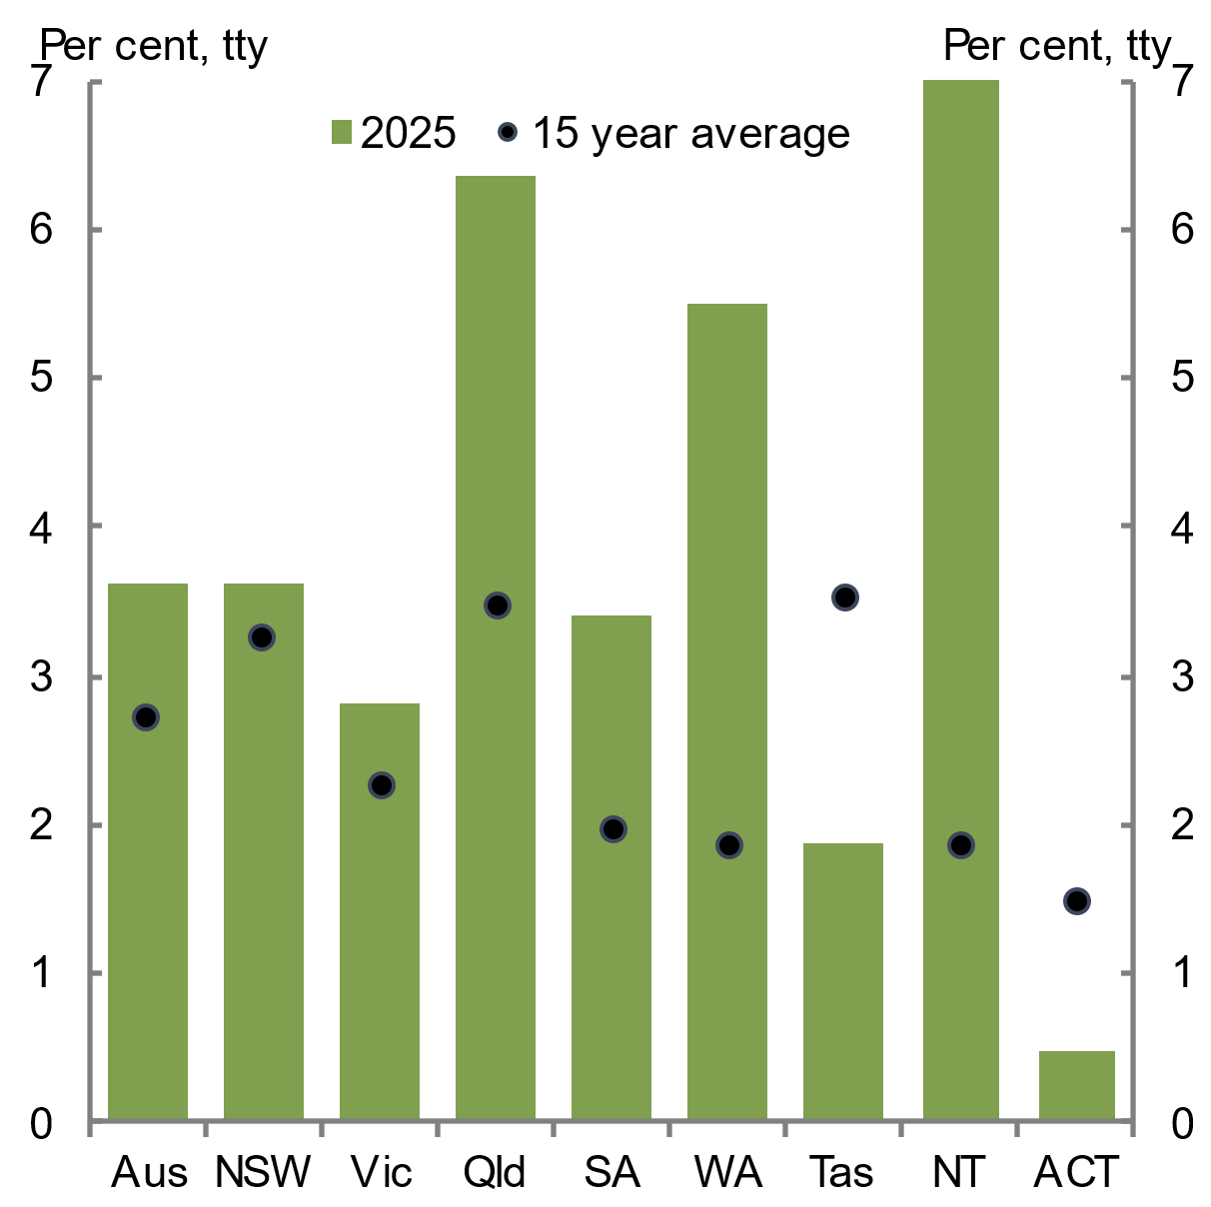 | 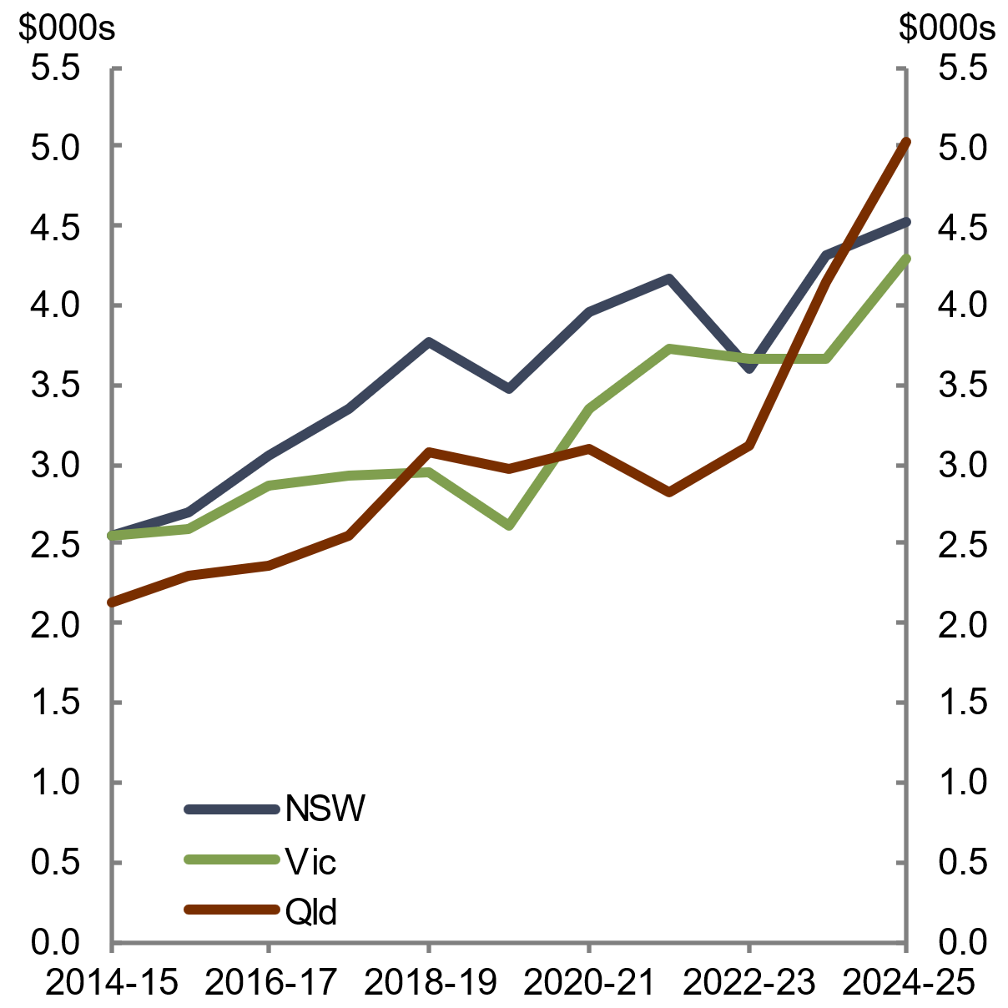
Note: The through-the-year growth rate to December 2025.  Source: ABS Producer Price Indexes, Output to the construction industry 2026 | Source: ABS 2026
    - Materials
Materials are a key component in the construction of dwellings. House construction material costs increased by 1.8 per cent over 2025, a growth rate slightly below its pre-pandemic 10-year average of 2.1 per cent (see Chart 2.30). Although growth has stabilised since the pandemic, the cost base is higher because of the pandemic-induced surge (Cotality 2025c).
Growth in material prices varied by component (see Chart 2.31). Concrete, cement and sand prices rose 1.6 per cent over the year to December 2025, driven by demand from sustained infrastructure activity (ABS 2026b; McSweeney and Bui 2026). Steel product prices fell 4.6 per cent due to weak demand from China and ample supply (McSweeney and Bui 2026). Price growth for electrical equipment softened to 0.8 per cent, while prices for structural timber, installed gas and electrical appliances grew steadily at 2.3 per cent over the year (ABS 2026b).
Chart 2.30 Material cost growth for house construction | Chart 2.31 Material cost growth for house construction, by selected components
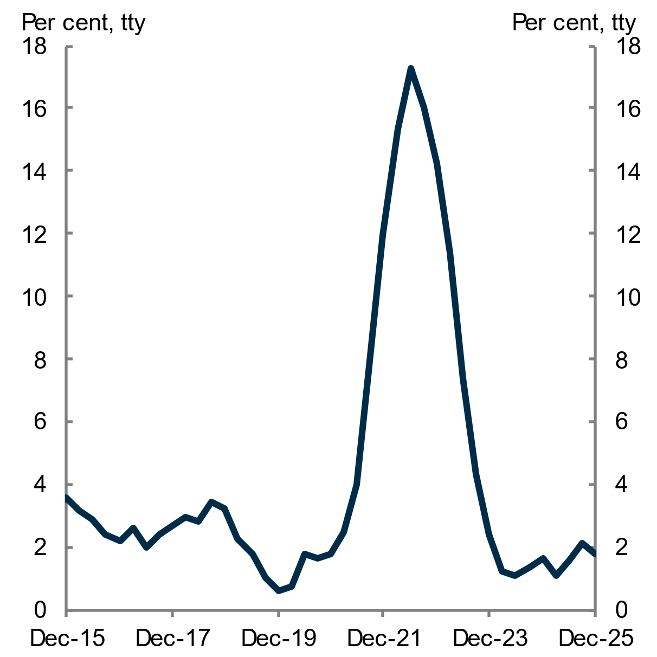 | 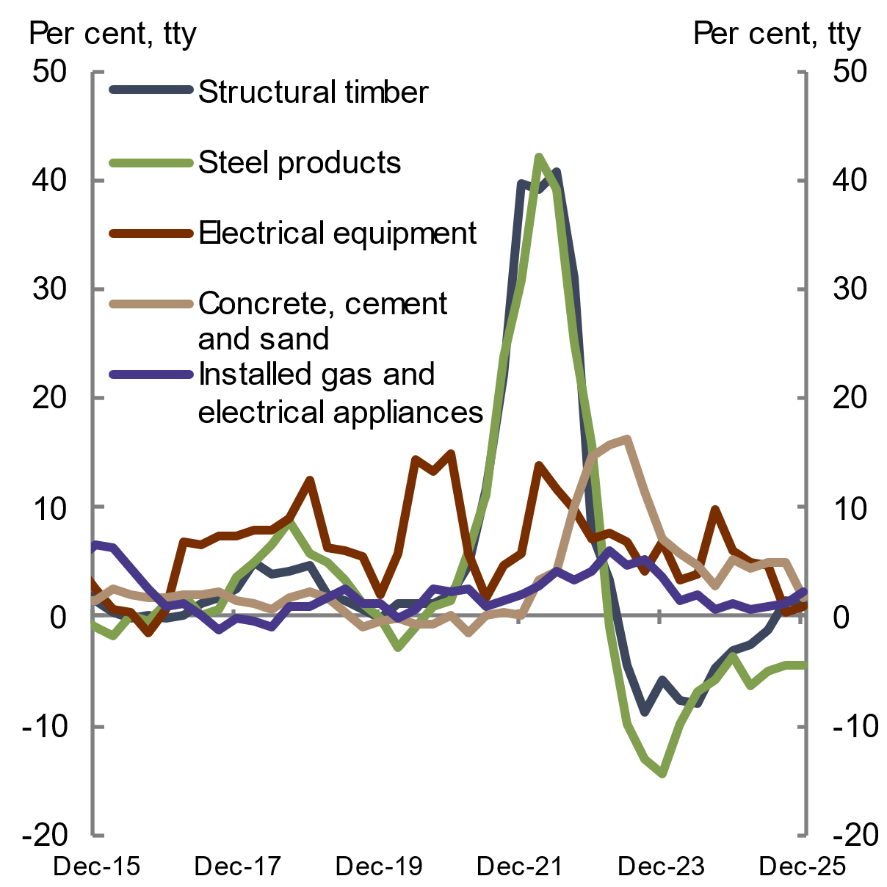
Note: The weighted average growth over the 6 state capital cities.  Source: ABS Producer Price Indexes, Input to the construction industry 2026 | Note: The subset inputs to the house construction price index.  Source: ABS Producer Price Indexes, Input to the construction industry 2026

    - Labour
Like materials, labour is a critical component of the dwelling construction process. In 2025, the residential construction industry continued to report labour shortages as strong construction activity increased the need for skilled workers (HIA 2026a).
The construction industry’s gender imbalance may be contributing to skill shortages, with analysis by Jobs and Skills Australia showing that occupations with a gender-skewed workforce are more likely to be in shortage (JSA 2025a). Construction remains the most male-dominated industry in Australia, with females comprising only 13.3 per cent of the workforce (ABS 2026c). Among those in the construction services sub-industry – which includes specialised trades such as electricians, plumbers and concreters – just 11.6 per cent of workers are women (ABS 2026c).
The HIA Trades Availability Index, which measures the industry’s perception of the availability of skilled trades, remained negative and below its long-run average in 2025 (see Chart 2.32). Labour shortages continued to be the most severe for trades such as bricklayers, tilers, roofers and carpenters in 2025 (HIA 2026a).
Chart 2.32 HIA Trades Availability Index | Chart 2.33 Wage growth
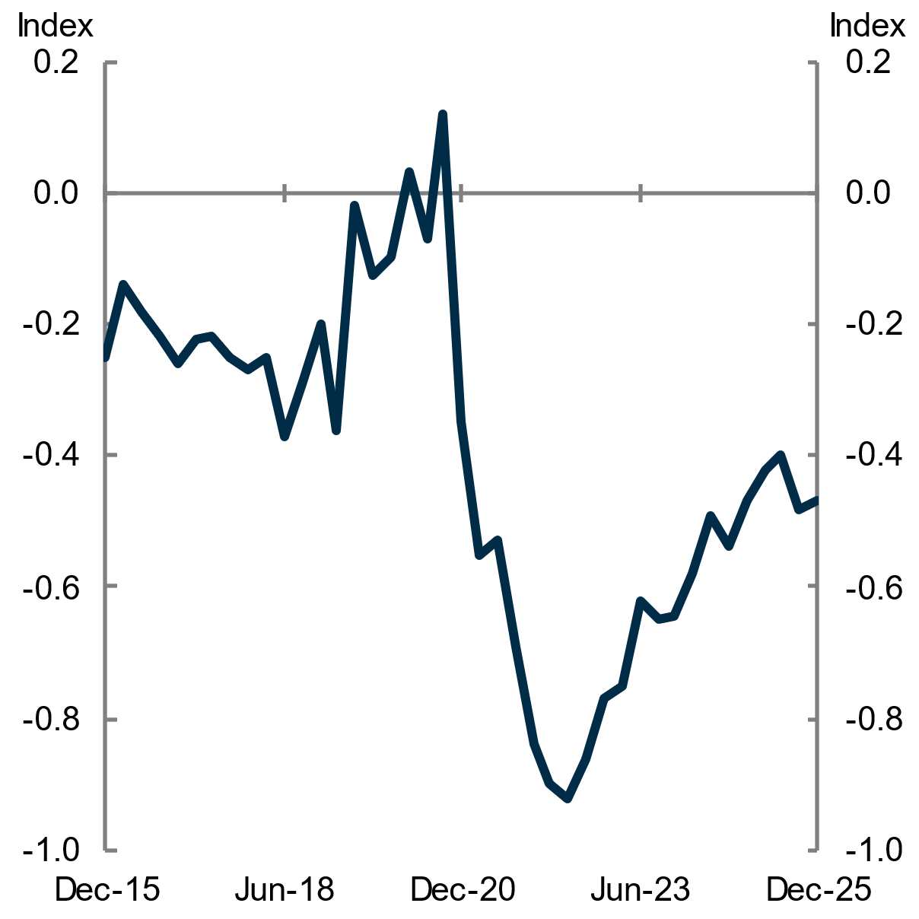 | 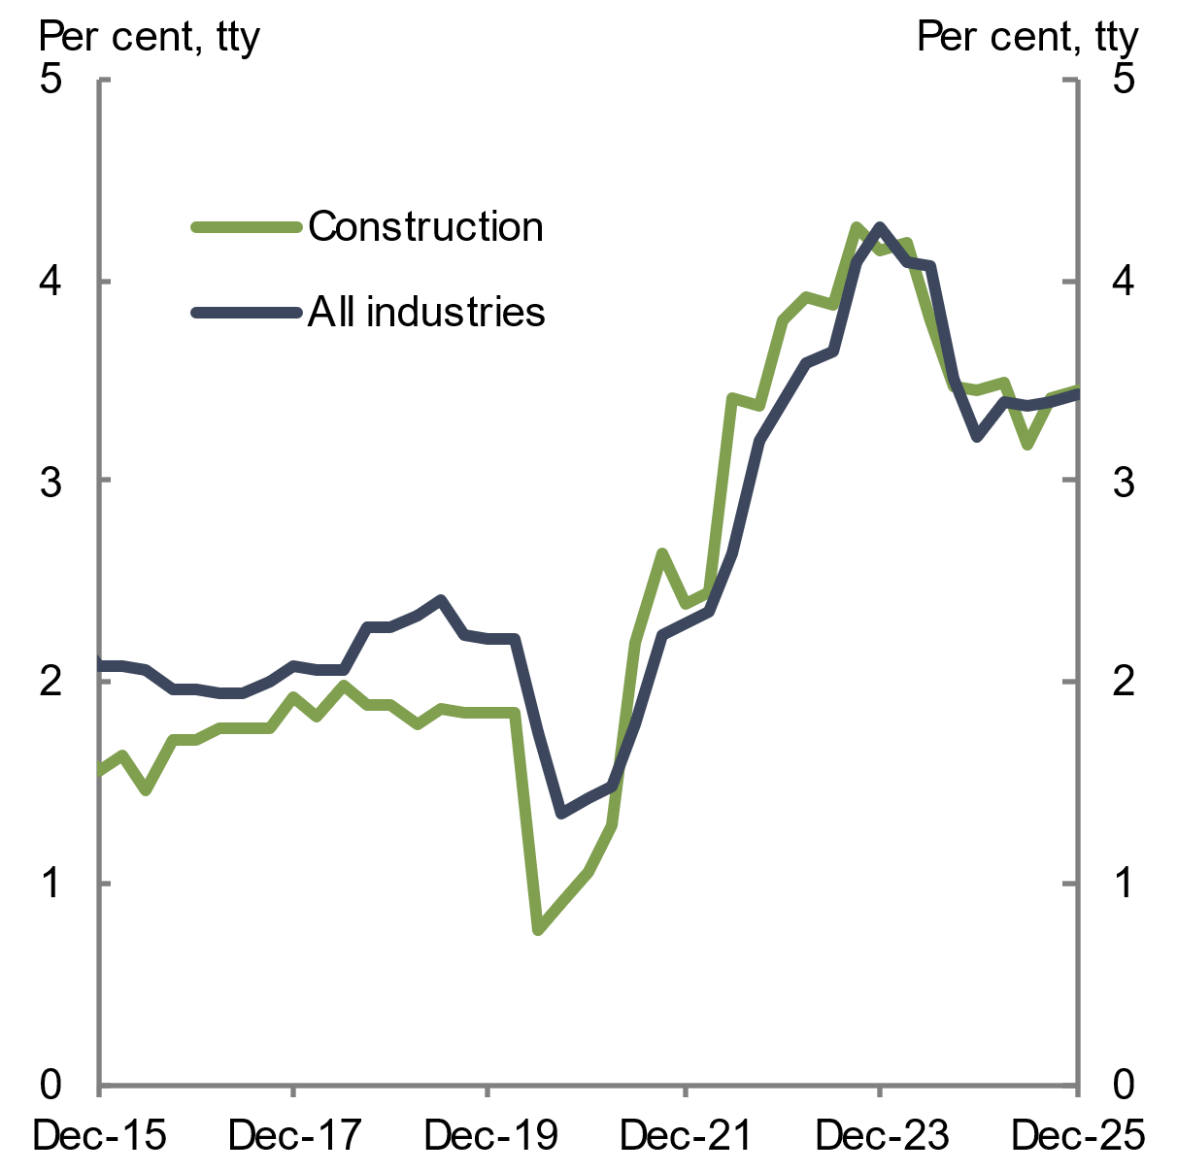
Note: The Trades Availability Index measures the industry’s perception of the availability of skilled trades.  Source: HIA 2025 | Note: Rolling annual growth rate; total hourly rates of pay excluding bonuses, private and public sectors.  Source: ABS Wage Price Index 2026
In 2025, construction industry recruitment difficulty worsened, and was more difficult than for the broader economy. Moreover, a greater share of construction employers hiring in capital cities reported recruitment difficulty compared to employers hiring in regional areas in 2024–25 (see Chart 2.34). This was the reverse of the previous financial year (JSA 2024), largely driven by an improvement in construction recruitment conditions in regional areas. Population growth in some regions, including coastal areas, may have helped address economy-wide labour supply shortages, supported by rising participation among workers aged 25–54 years (JSA 2025b).
Construction wage growth remained elevated relative to historical averages in 2025, rising by 3.5 per cent over the year to December 2025 (see Chart 2.33). Growth was in line with the broader economy and remained above the 15-year annual average of 2.7 per cent, consistent with ongoing labour market tightness across both the industry and the overall economy.
Chart 2.34 Recruitment difficulty, by region type, 2024–25 | Chart 2.35 Value of work yet to be completed, by construction type
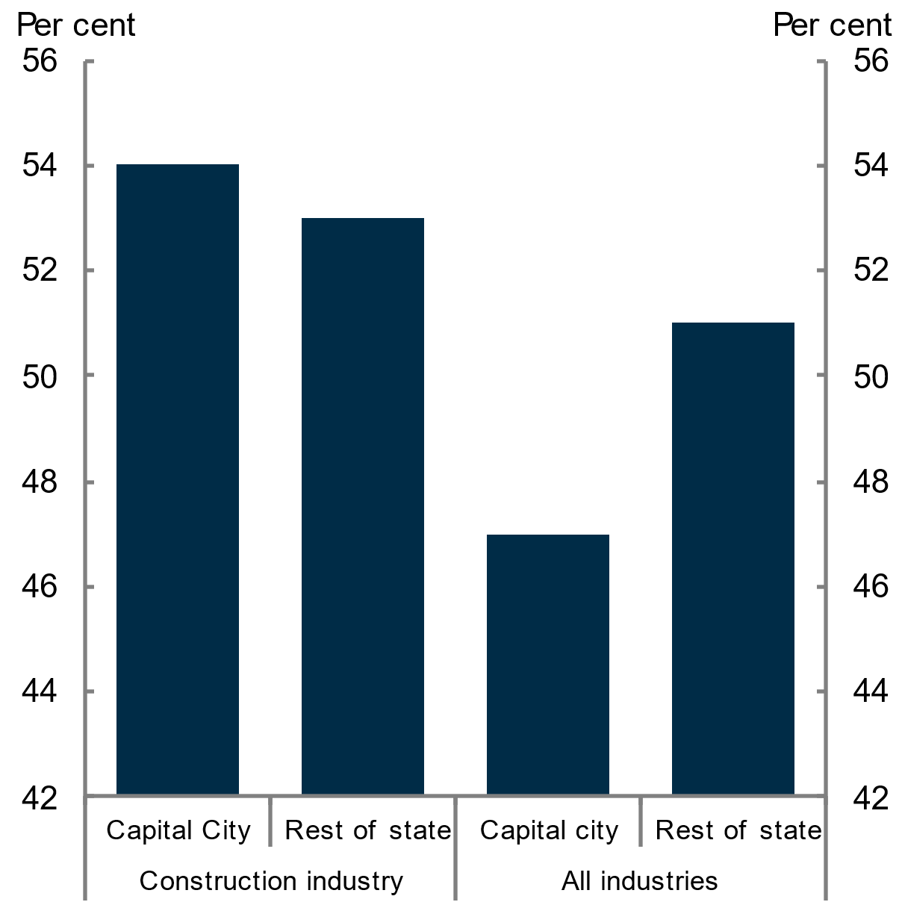 | 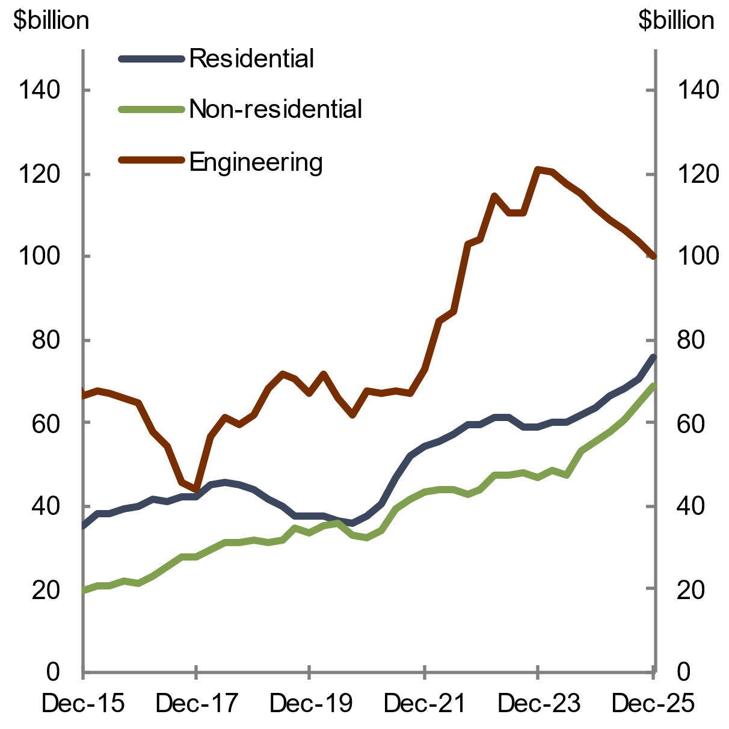
Note: The chart shows proportion of recruiting employers who report difficulty with recruiting in 2024-25, by region type and industry.  Source: Jobs and Skills Australia 2025 | Note: Residential and non-residential are value of work yet to be done by total sectors. Engineering is value of work yet to be done by the private sector.  Source: ABS Building Activity 2026; ABS Engineering Construction Activity 2026

Competition with other construction sectors
Skills in the construction industry are transferable between certain segments, such as the residential and non-residential building construction segments (HIA 2024). This enables some skilled construction workers to move between jobs in response to demand, given training and experience. For example, electricians, which are part of the construction services subdivision, are in demand across all segments (residential, non-residential and heavy and civil engineering) of the construction industry (HIA 2024). Industry stakeholders have indicated construction workers and subcontractors often prefer working on non-residential building and infrastructure projects, where remuneration is higher than in residential construction.
The pipeline of construction work remained elevated in 2025 across all construction segments (see Chart 2.35). The pipeline of residential and non-residential work both increased by around 20 per cent over the past year. These conditions suggest that competition for skilled labour will continue to pose a challenge for residential construction activity.

Training and skills
Low apprenticeship and traineeship levels have contributed to the shortage of construction workers, and also reduce the future availability of skilled labour (NCVER 2025). BuildSkills Australia’s Housing Workforce Capacity Study report found that to achieve the ambitious targets set by the Housing Accord, a substantial workforce expansion is required, with almost 140,000 extra workers needed to support the Housing Accord’s objectives (BuildSkills Australia 2025).
Apprenticeship and traineeship commencements in building construction declined by 13.7 per cent over 2024–25 (see Chart 2.36). However, recent data for the September 2025 quarter shows an uptick in construction trade apprenticeship commencements, following the introduction of $10,000 incentive payments under the Australian Government’s Key Apprenticeship Program on 1 July 2025 (NCVER 2026). In contrast, apprenticeship completions increased in 2024–25, likely as some of those who commenced an apprenticeship around the pandemic, possibly supported by the Boosting Apprenticeship Commencements and Completing Apprenticeships Commencements programs, completed their training (see Chart 2.36).
Employers in the construction industry are continuing to respond to labour shortages by hiring more skilled workers from abroad. The number of temporary skilled work visas for the construction industry remains elevated (see Chart 2.37). However, industry reports the hiring process is costly, slow and complicated. As these workers represent only a small proportion of the broader construction workforce, longer term solutions are needed to support the skills pipeline in the industry (see Chapter 1 Towards better housing outcomes for all Australians).
Chart 2.36 Building construction apprenticeships and traineeships | Chart 2.37 Temporary skilled visa holders in construction
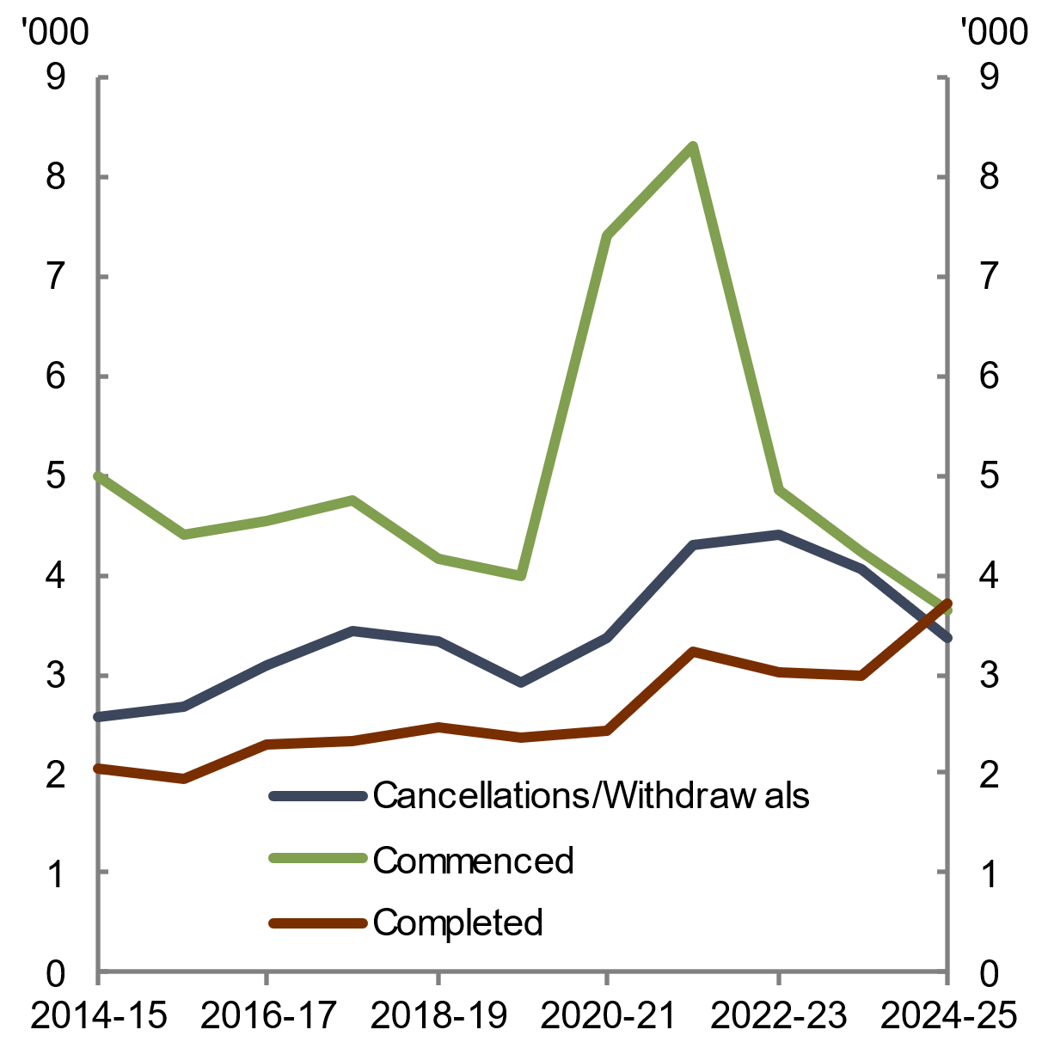 | 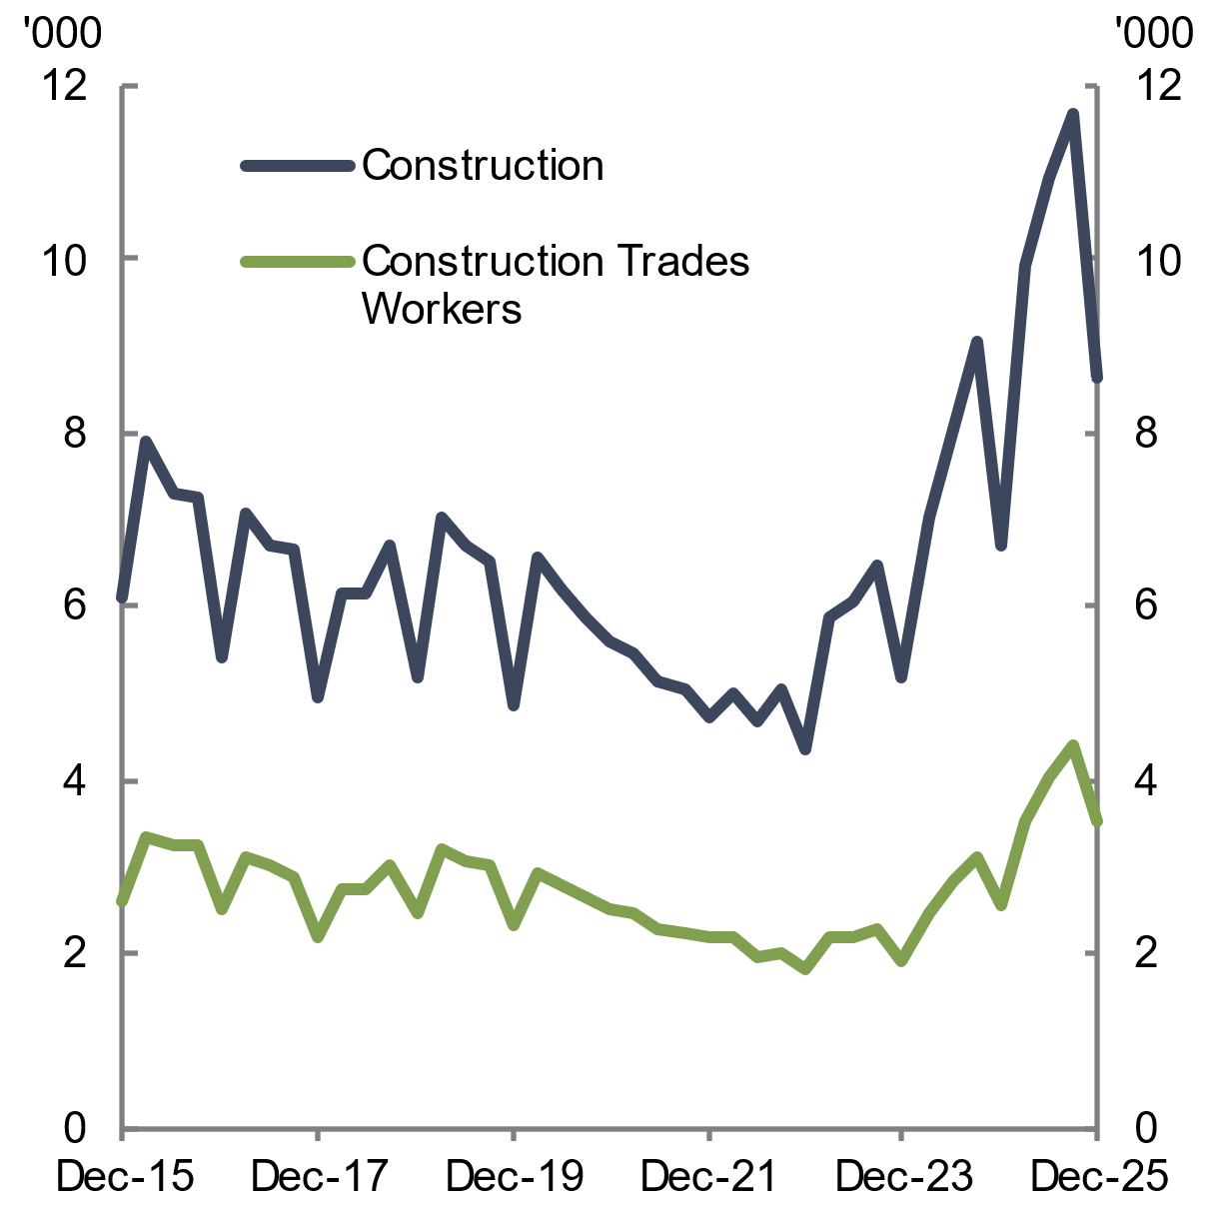
Source: National Centre for Vocational Education Research 2025 | Note: Construction trades workers include bricklayers, stonemasons, carpenters, roof tilers, wall and floor tilers, floor finishers, glaziers, painting trades workers, plasterers and joiners.  Source: Department of Home Affairs 2026
    - Productivity
The Productivity Commission’s 2025 report on construction productivity makes clear that productivity in the housing sector is a multifaceted challenge. The report highlights how regulation, fragmented industry structure, lack of innovation, and slow approval processes interact to drag down productivity, with labour-related issues such as workforce attraction, retention, mobility, and skill mismatches further compounding the problem. The combination of these drivers has led to low productivity in the construction sector becoming a structural feature of the industry for the last 30 years. The Queensland Productivity Commission (2025) identifies labour market operation, procurement policies, and building and land use regulation as crucial aspects to address in improving productivity.
The number of dwellings completed per hour worked has declined by 53 per cent over the last 30 years and highlights the scale of the productivity challenge that the sector faces (see Chart 2.38). When controlling for quality improvements and increases in housing sizes, dwelling construction labour productivity, measured as the gross value added for an hour of work, has declined compared to the broader economy over the last 30 years. By this measure, labour productivity fell by around 12 per cent for the dwelling construction industry but rose by 49 per cent for the whole economy. In annual terms, in 2024–25 the residential, non-residential and civil engineering construction industry labour productivity growth declined by 2.9 per cent, and multifactor productivity declined by 2.8 per cent, reflecting the strong growth in hours worked required to deliver large-scale infrastructure projects (ABS 2026d).
The industry’s productivity losses are impacted by persistent labour shortages, given the sector’s reliance on labour to expand output (JSA 2025b). They are also closely intertwined with broader systemic issues such as regulatory burden and constrained innovation. For example, the construction industry has consistently been one of the least innovative industries in the economy (PC 2025). The industry is also highly fragmented and is incentivised to be so (CEDA 2025). Lifting construction productivity will therefore require coordinated action across multiple fronts (see Chapter 1 Towards better housing outcomes for all Australians).
Average construction times are another potential indicator of construction productivity. In 2025, average construction times for houses and townhouses slightly shortened (see Chart 2.39). This is attributed to easing supply chain pressures and a soft easing of labour shortages in that time (MBA 2025). For higher-density housing, continued labour shortages from mid-2025 are pressuring completion times (ABS 2026b). More broadly, drawn-out construction timelines can be related to underlying inefficiencies in construction delivery and can tie up labour and capital for longer, reducing industry productivity (output per unit of input). These inefficiencies have contributed to weak productivity performance in the industry (CEDA 2025). Longer build times increase financing and labour costs, raise overall project risk, and reduce developers’ certainty about market conditions and their final financial position when projects conclude.
Chart 2.38 Total hours worked to complete a dwelling | Chart 2.39 Average construction time
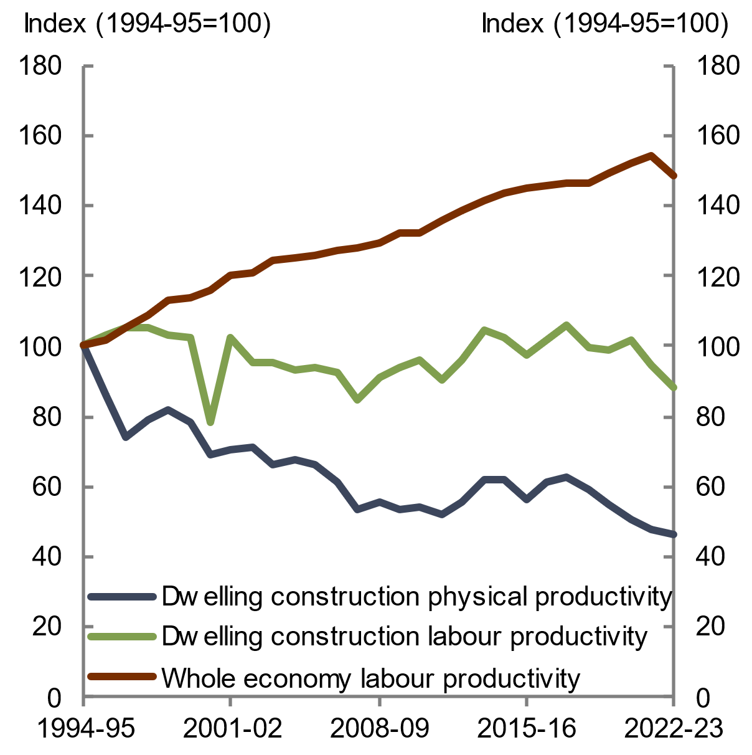 | 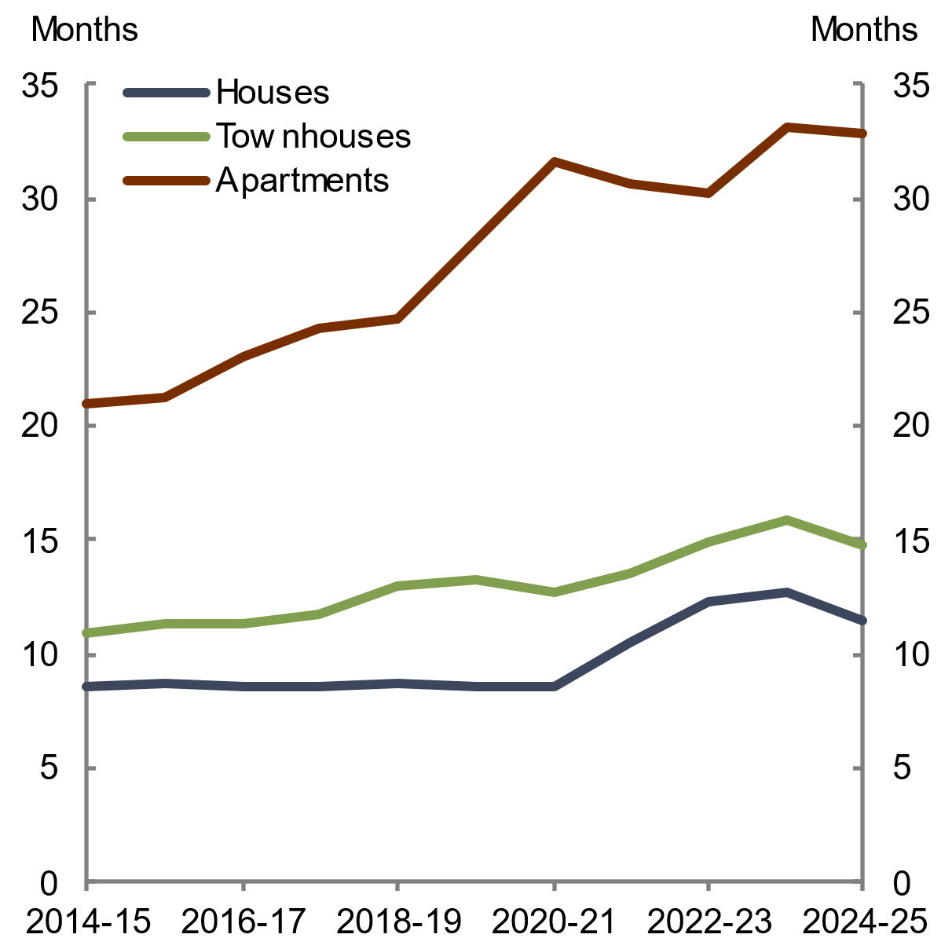
Note: Labour productivity is measured as GVA per hour worked; physical productivity is measured as dwellings completed per hour worked. Physical productivity does not account for changes in dwelling size and quality.  Source: Productivity Commission estimates using ABS National Accounts and ABS Labour Account data. See Productivity Commission for methodology | Note: The time from building approval to completion.  Source: ABS Building Activity 2025
    - Land supply
Land supply is regarded as a binding constraint on new home building (HIA 2026b). In 2025, the volume of greenfield land sales remained below the 10-year pre-pandemic average and continued to sit around its lowest levels (see Chart 2.40). Residential land sales data reflects greenfield lot sales zoned ‘residential’, irrespective of whether the purchaser is a household or developer. However, it does not include brownfield sites, given the difficulty in measuring their prices consistently, or land purchases for the purpose of infill development.
The median price of residential land in Australia reached a record high of $391,420 in the September quarter 2025 to be 10.3 per cent higher than the year prior (HIA-Cotality 2026). The shortage of land sales has contributed to higher prices.
Land price growth was stronger in capital cities compared to regional areas. In the capital cities, the median price of residential land per square metre was $1,161 in the September quarter 2025, 8.1 per cent higher than the previous year (see Chart 2.41). By contrast, the median price of residential land per square metre in regional areas have been relatively flat in recent years, although regional prices remain around record highs (HIA-Cotality 2026).
For infill development, land acquisition costs have been among the fastest‑growing cost component in recent years (The CIE 2024). Small and medium‑sized developers identify land costs as the primary constraint on infill development (CrowdProperty 2025).
Chart 2.40 Residential land sales, by price and volume, total of all states | Chart 2.41 Residential land sales price per square metre, by capital city, September 2025
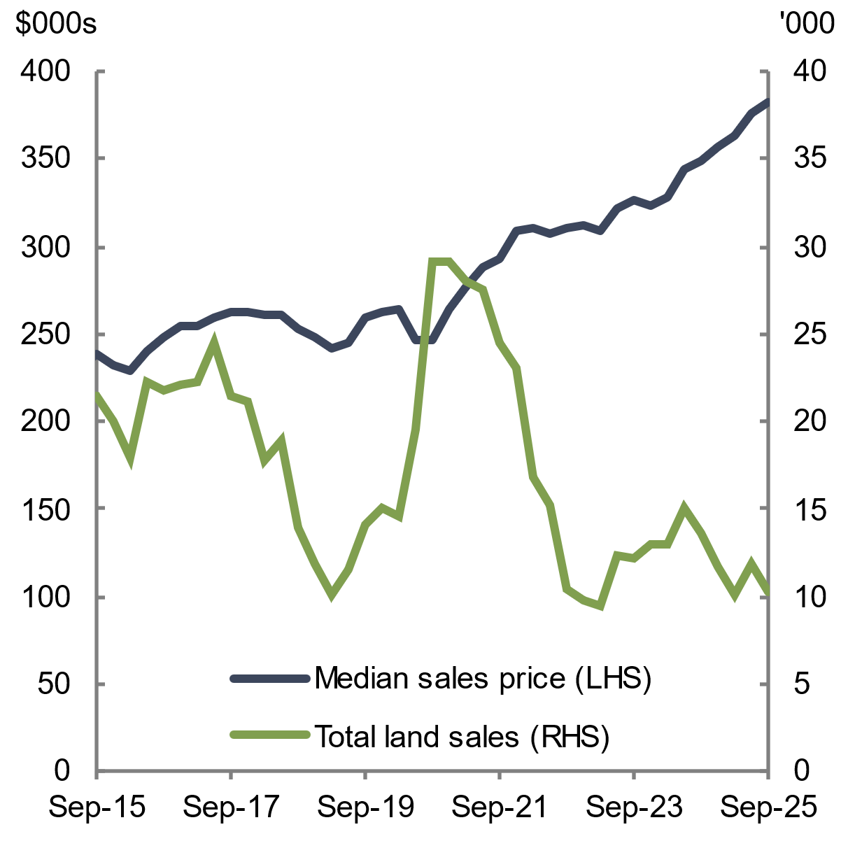 | 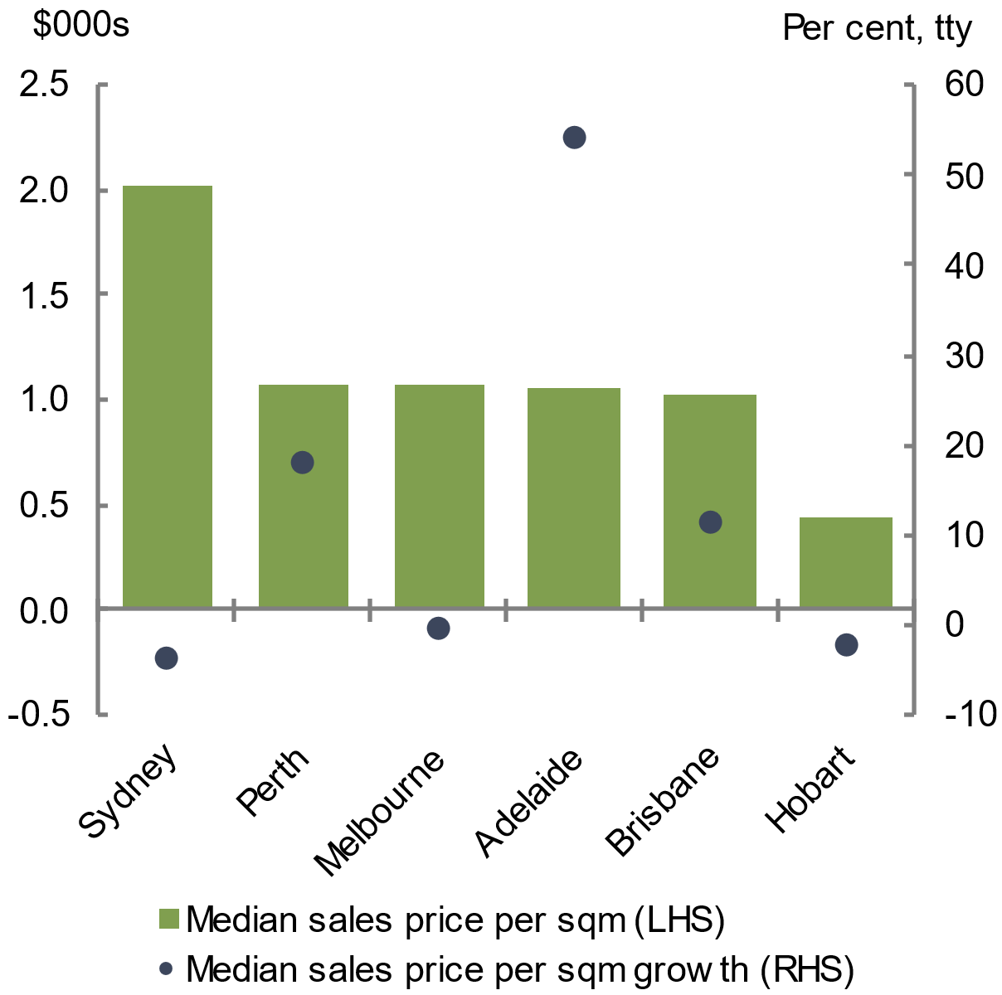
Note: Based on the most recent decade of quarterly sales activity data recorded across Australia’s 6 state capitals and non-capital regions, excluding the Northern Territory and the Australian Capital Territory.  Source: Housing Industry Association and Cotality 2026 | Note: Based on the most recent decade of quarterly sales activity data recorded across Australia’s 6 state capitals.  Source: Housing Industry Association and Cotality 2026
    - Project feasibility
Construction project feasibility remained challenging in 2025 and early 2026. The cost of inputs, fixed capital, labour, regulations and required developer returns remain elevated, reflecting high construction and land costs and heightened risks associated with cost volatility, potential delays and insolvencies. Challenges are most acute for higher‑density projects, consistent with infill development feasibility being most vulnerable to increased construction costs (The CIE 2024). Builders are increasingly pricing uncertainty, such as labour‑shortage risks, into tender prices (see section 2.3.3 Labour).
The two interest rate rises that have occurred in early 2026 are expected to worsen feasibility by increasing financing costs, compounding existing constraints. Recent evidence from the Centre for International Economics shows that rising financing costs were a key factor reducing the financial feasibility of new residential projects in Sydney in 2023, contributing both to the decline in mid‑rise apartment feasibility and to widening gaps between project costs and achievable sales prices (The CIE 2024).
Overall financing conditions eased over 2025, as business borrowing costs declined in line with the cash rate (see Chart 2.42). In particular, small and medium enterprises (SMEs), which dominate the construction industry (PC 2025), saw some improvement in 2025 in longstanding challenges to accessing finance (RBA 2025a; Harvey et al. 2025).
Research commissioned in 2025 by the Property Council of Australia concluded that it is more difficult to attract institutional investment in some states due to additional taxes imposed by those states on global institutional investors (Mandala 2025).
Feasibility can impact construction at any stage of the project: fewer approvals, delayed or cancelled commencements, and slower completions. This can contribute to ongoing weakness in completions despite recent uplift in approvals and commencements.
Chart 2.42 Business borrowing rates, by category | Chart 2.43 Firm insolvencies, by industry group
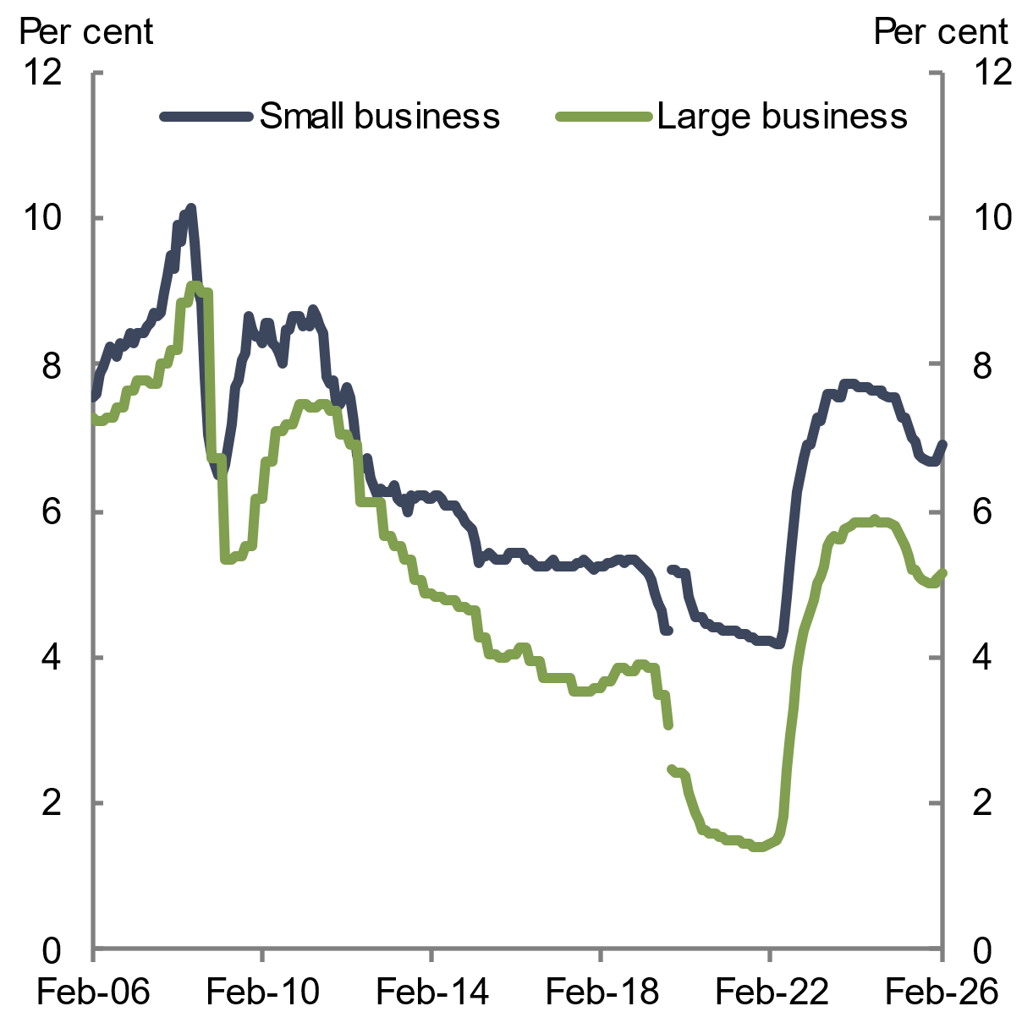 | 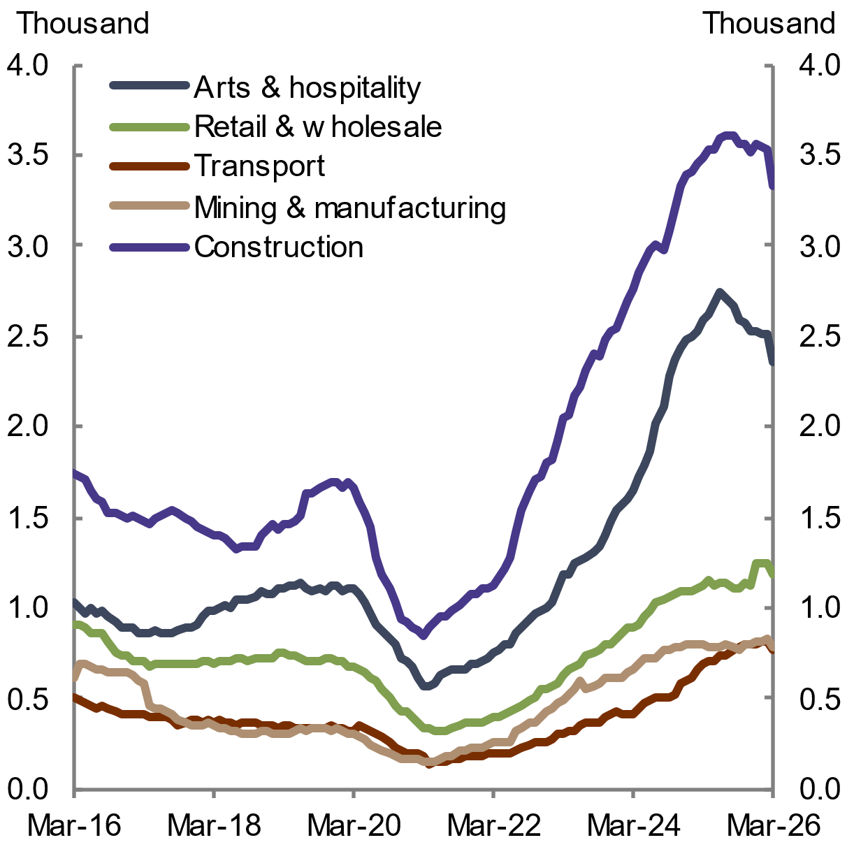
Note: The series break at September 2019 is due to changes in business size definitions. Interest rates prior to the series break are a weighted average rate on credit outstanding for large loans and fixed for 3 years for small loans, while interest rates post the series break are total outstanding variable loans.  Source: RBA Business Lending Rates 2026 | Note: Rolling annual figures used.  Source: ASIC Insolvency statistics 2026
    - Insolvencies
Insolvencies in the construction industry remain significantly elevated relative to both the overall economy and historical averages, but have moderated since the peak in mid-2025 (see Chart 2.43). In the 12 months to March 2026 there were 3,325 insolvencies in the construction industry, a decrease of 4.8 per cent compared to the 12 months to March 2025.
Still-high levels of insolvencies are attributable to thin operating margins in the construction industry (RBA 2025b). Most insolvencies in the construction industry were in New South Wales (44.4 per cent), followed by Victoria (28.7 per cent) and Queensland (16.0 per cent). High construction industry insolvencies place additional pressure on remaining firms to deliver housing and to complete unfinished projects left behind.
  - Demand for housing remained strong
‘New underlying demand’ is the primary measure of housing demand used in this report. It is a demographic measure of demand that reflects factors such as population growth and the age structure of the population. New underlying demand remained strong in 2025 but has eased from recent elevated levels, reflecting slowing population growth and a small increase in the average number of adults per household (see section 2.4.1 Population and section 2.4.2 Adults per household).
Economic factors such as affordability, household income and credit conditions also affect new underlying demand, particularly for market housing. Incorporating these factors into demand produces a measure known as ‘effective demand’. Easing interest rates and strong wages growth in 2025 resulted in increased real income and borrowing capacity for households, increasing effective demand in 2025 (see section 2.4.3 Household income and section 2.4.4 Household credit conditions).
    - Population
Population growth was steady at 1.6 per cent over the year to September 2025, to be in line with the long-run pre-pandemic average of 1.6 per cent (over December 2004 to December 2019). Population growth peaked at 2.5 per cent over the year to September 2023, following the reopening of national borders in 2022 (see Chart 2.44).
Chart 2.44 National population growth
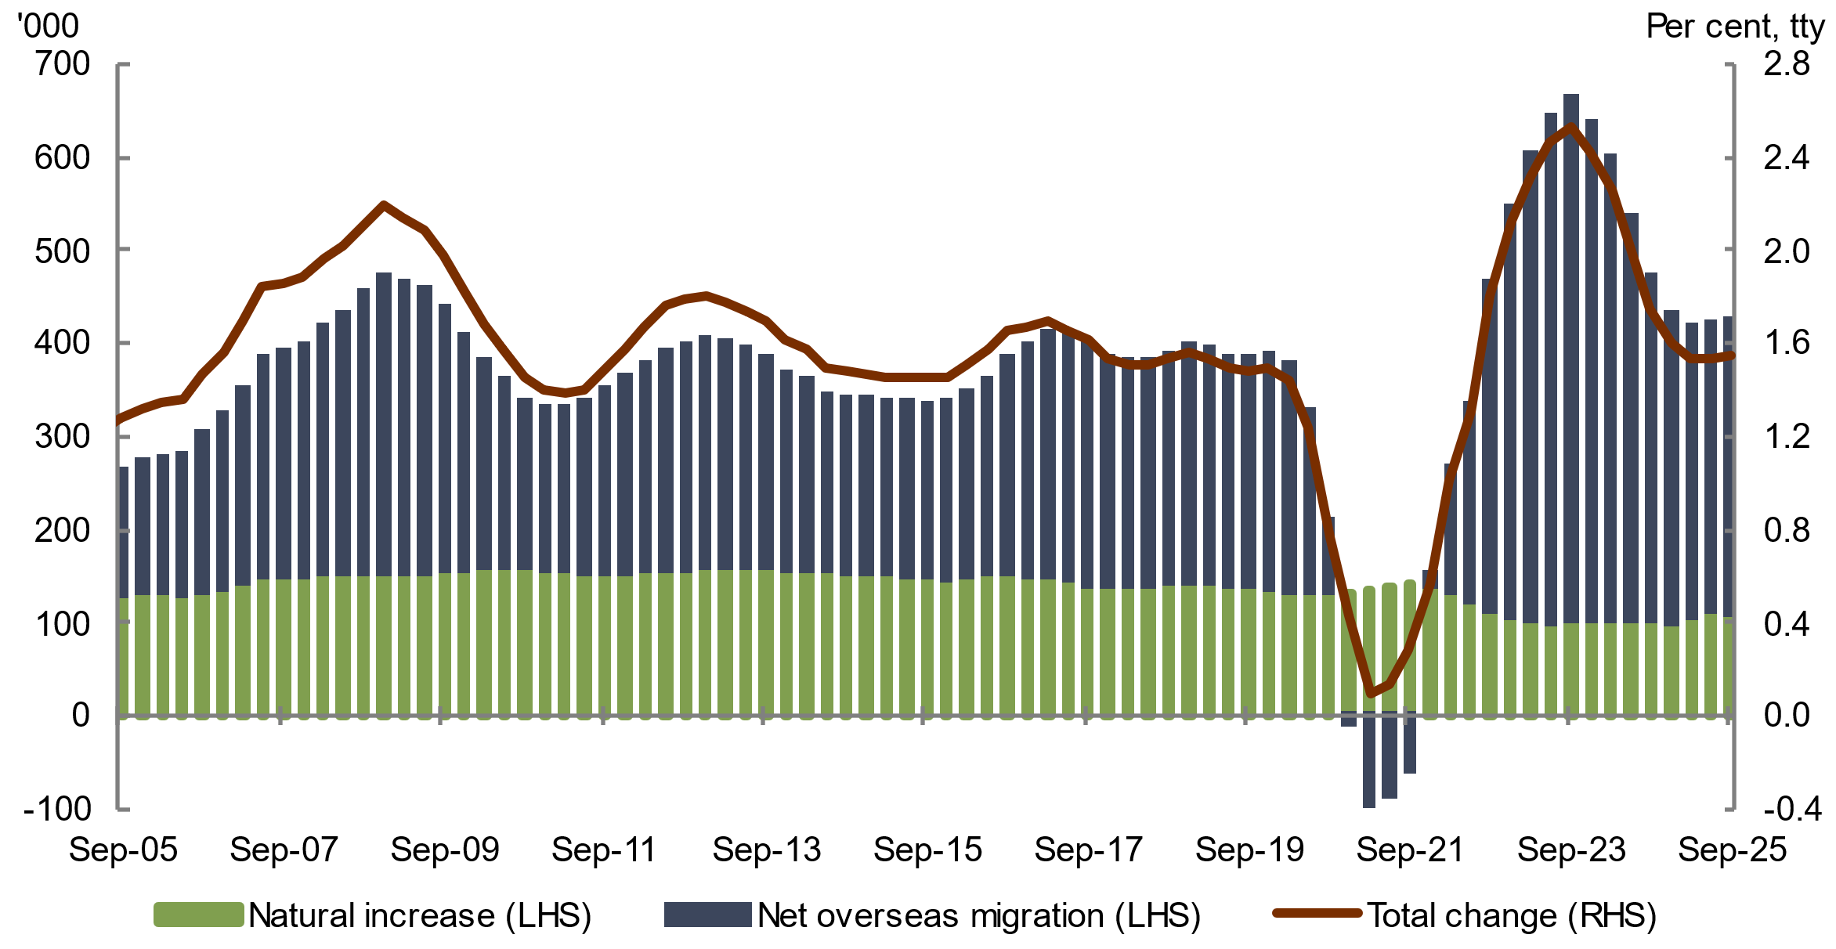
Note: The rolling annual sum.
Source: ABS National, state and territory population 2026
The moderation in population growth reflected an easing in net overseas migration. Annual net overseas migration was 311,000 over the year to September 2025, down from its peak of 556,000 over the year to September 2023 but still higher than its long-run pre-pandemic average (see Chart 2.44). Lower net overseas migration has been driven by fewer temporary migrant arrivals (Centre for Population 2026a).
Capital cities continued to record faster population growth than regional areas in 2024–25 (see Chart 2.45). While population growth remained high in capital cities, growth eased from its post-pandemic peak in 2022–23, to be slightly below growth observed prior to the pandemic. Population growth also eased slightly in the regional areas, although it has remained relatively steady compared to capital cities. Regional areas are less affected by overseas migration, as migrants tend to initially reside in capital cities (Centre for Population 2026a). However, net internal migration from capital cities continues to support population growth in regional areas (see Chart 2.46). Capital cities accounted for 68 per cent of Australia’s population in 2024–25 and are projected to grow nearly twice as fast as regional areas over the next decade (Centre for Population 2026a).
Population growth varied across states and territories over the year to September 2025 (see Chart 2.47). Population growth moderated in the three largest states, which recorded growth around their 15-year averages. Western Australia’s population growth exceeded its 15-year average, driven by strong overseas migration, and the state is expected to remain the fastest growing into the future (Centre for Population 2026b). Interstate migration saw many people move to Queensland and Western Australia, while New South Wales recorded the highest net interstate migration outflows (ABS 2026e). For smaller jurisdictions, population growth in the Northern Territory was above its 15-year average, driven by its significant infrastructure investment and strong economic growth (Territory Coordinator 2025b). Tasmania and the Australian Capital Territory both recorded below-average population growth, due to reduced net interstate and overseas migration (Centre for Population 2026b).
Chart 2.45 Population growth, by capital cities and regions | Chart 2.46 Net internal migration from capitals to regions, quarterly change
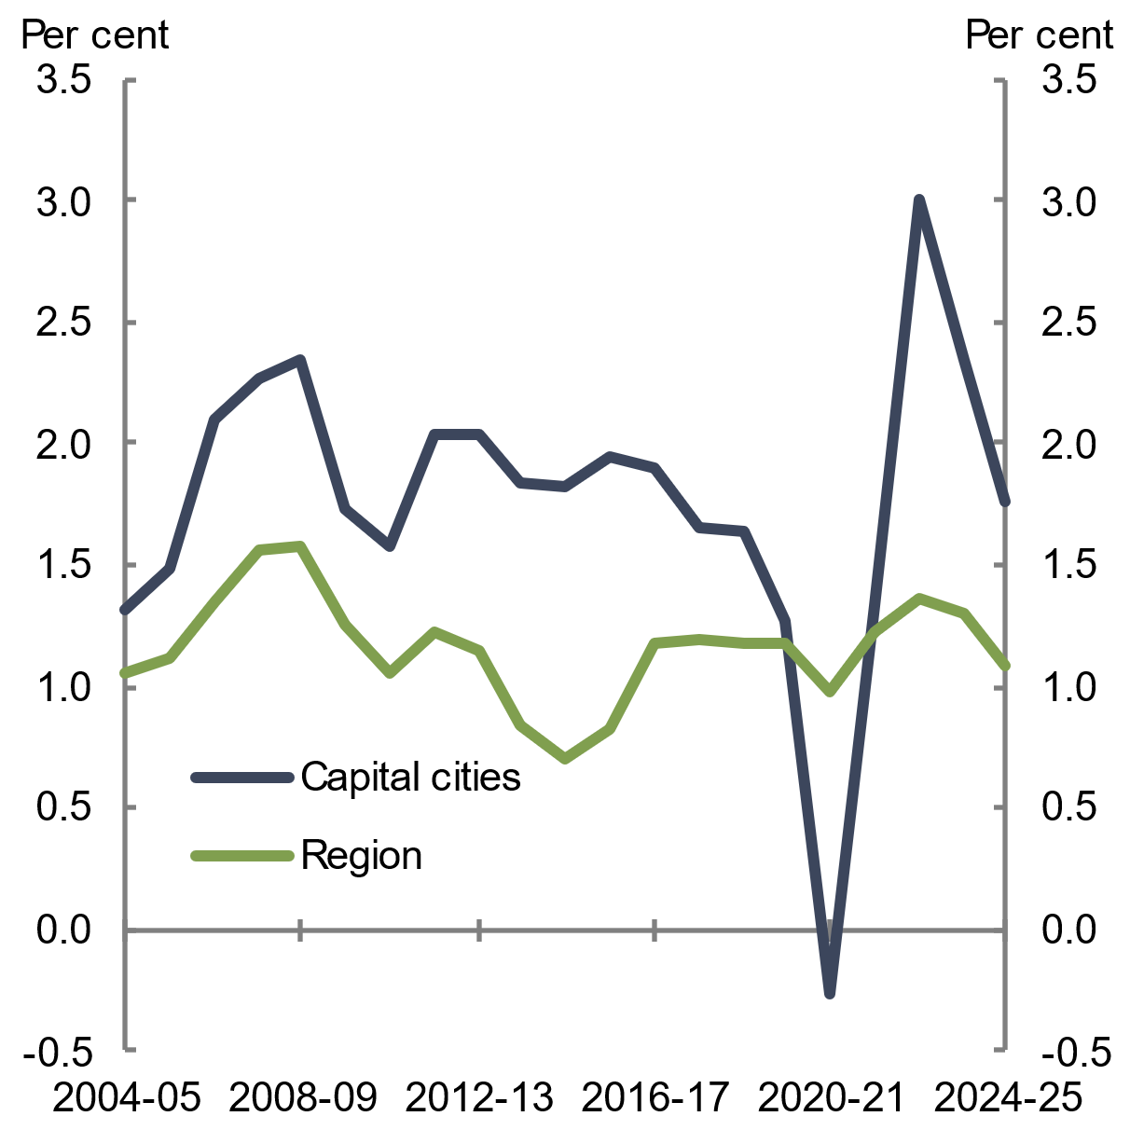 | 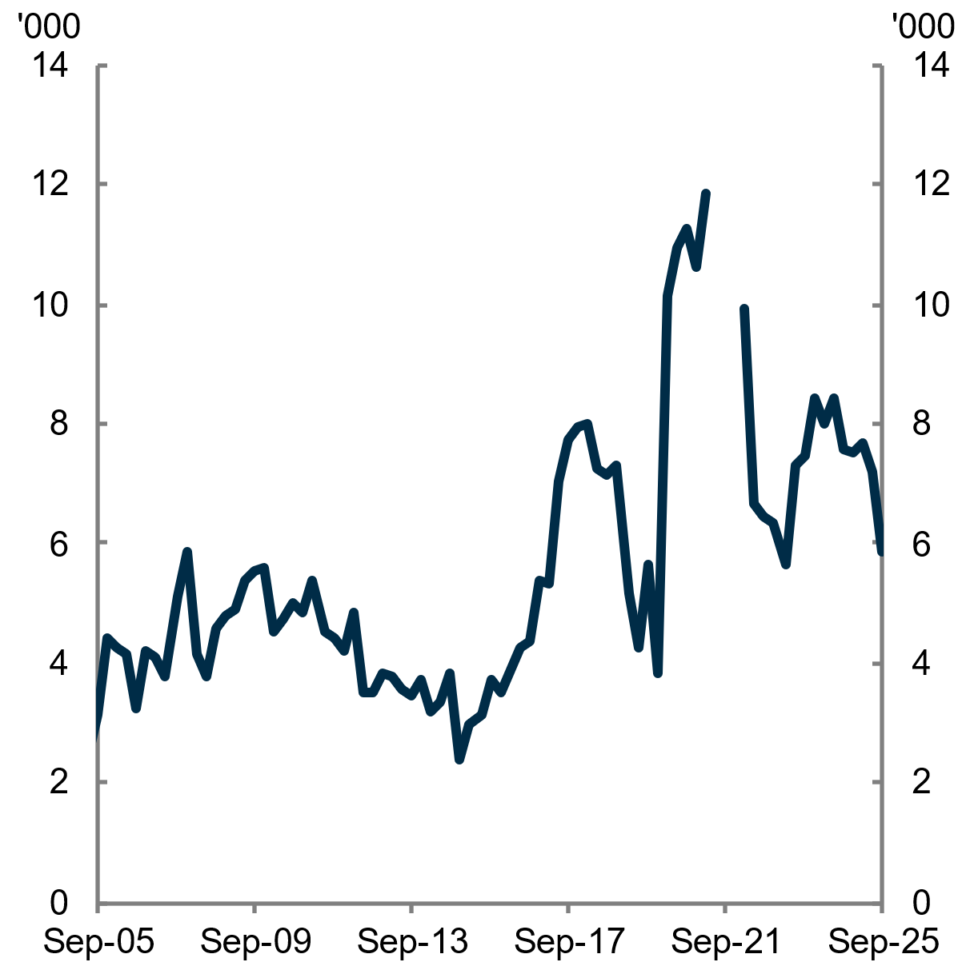
Note: Annual population growth as at June 30 each year.  Source: ABS Regional population 2026 | Note: ABS Regional internal migration estimates were not published between Q2 and Q4 in 2021.  Source: ABS National, state and territory population 2026

    - Adults per household
Adults per household is a key determinant of new underlying housing demand. All else equal, an increase in the number of adults per household for a given population reduces new underlying demand. While average household size is often used to measure household demand, adults per household is the main driver of dwelling demand because only adults form independent households. Changes in the number of children can shift average household size but typically do not generate additional dwelling demand. As a result, system pressures are best explained by how many adults there are and how they are distributed across households, rather than by average household size alone.
Australia’s average number of adults per household rose to 2.10 in July 2025 from 2.08 the year prior (see Chart 2.48). Adults are increasingly living in larger households in response to affordability constraints, with high living and housing costs contributing to adult children staying in the parental home for longer.
Chart 2.47 Population growth, by state | Chart 2.48 Adults per household
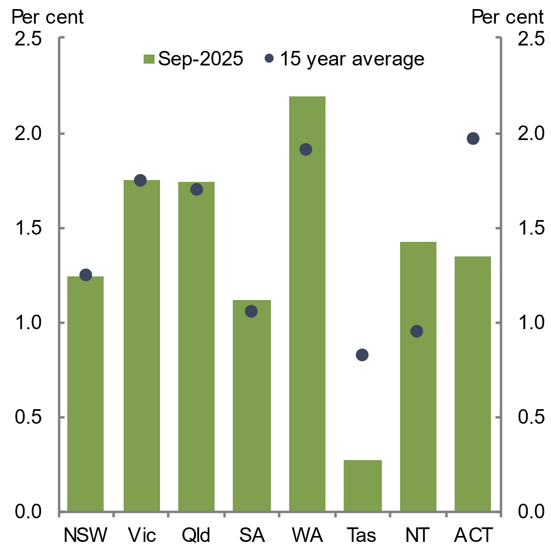 | 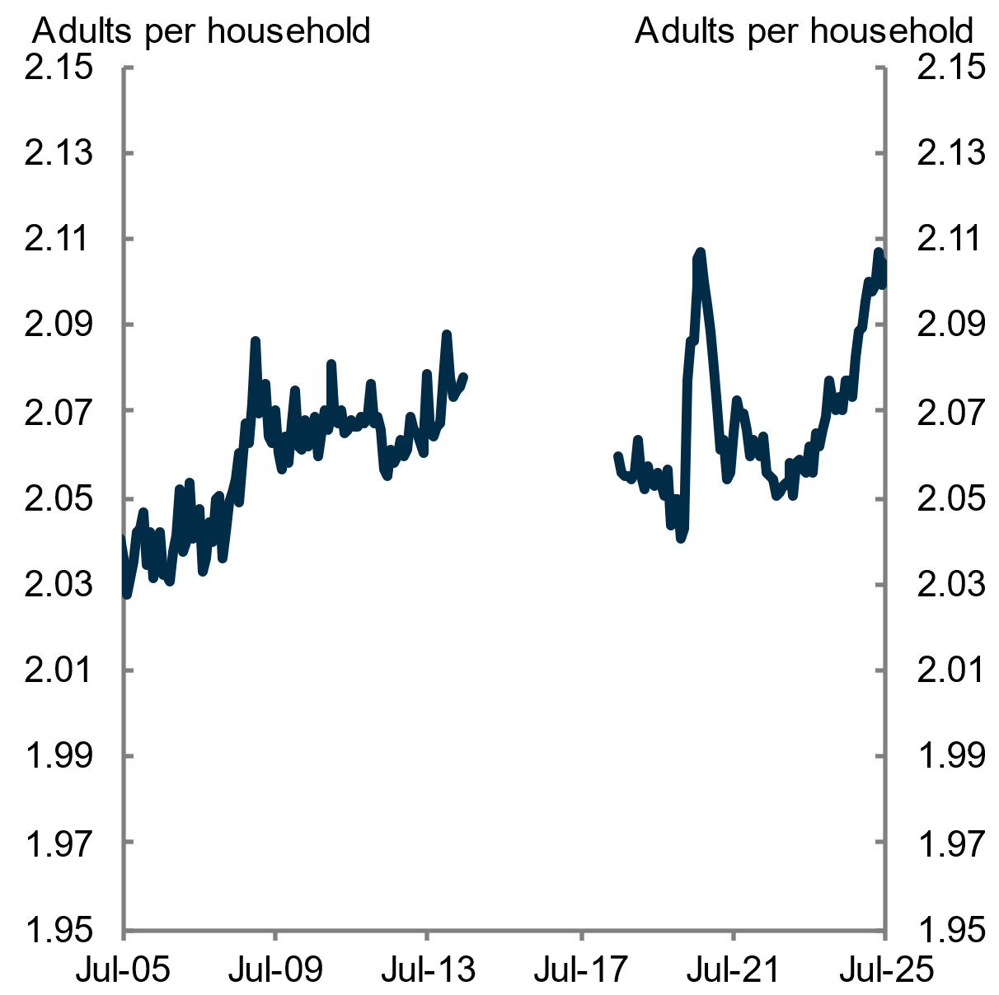
Note: The through the year growth to September 2025.  Source: ABS National, state and territory population 2026 | Note: Estimates unavailable between July 2014 and June 2018 due to processing errors in the ABS Labour Force statistics.  Source: ABS Labour Force 2025; ABS National, state and territory population 2025; Treasury 2025
    - Household income
Real household disposable income per capita rose by 2.2 per cent over 2025, boosting effective demand (see Chart 2.49). A continued strong labour market, although softening, and an easing of inflation over the first half of 2025 have supported the rise in real household incomes. Throughout 2025 and early 2026, the labour market remained tight, with the unemployment rate at around 4.3 per cent in February 2026, slightly higher than the last few years (see Chart 2.50). Strong wages growth has continued but has eased from its peak in 2023 (RBA 2025c).
Chart 2.49 Growth in real household disposable income per capita | Chart 2.50 Unemployment rate
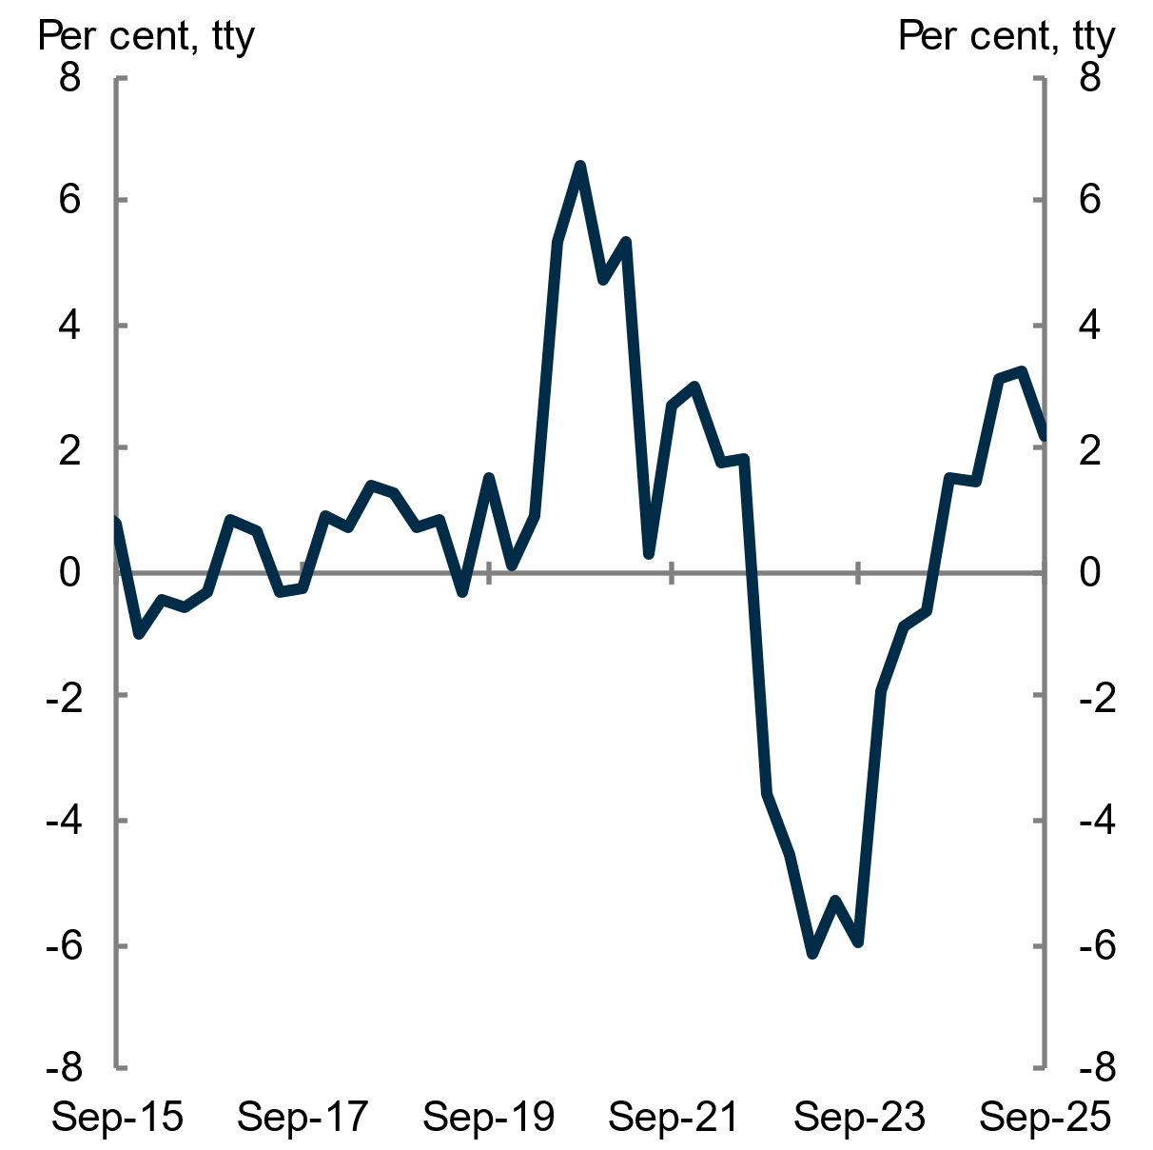 | 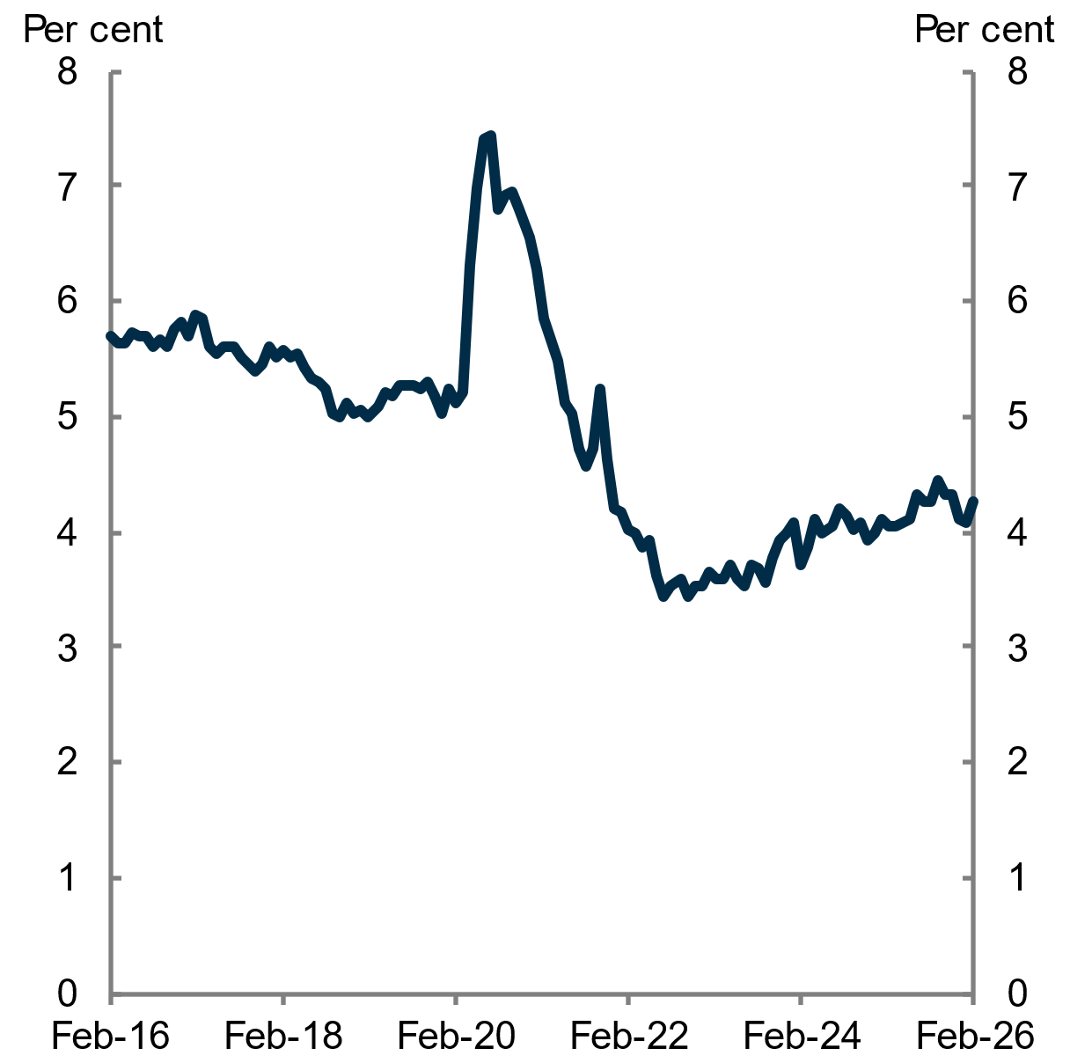
Note: Real total household disposable gross income.  Source: ABS National Accounts 2025; ABS National, state and territory population 2026; Treasury 2025 | Source: ABS Labour Force 2026
    - Household credit conditions
Over 2025, household credit conditions improved and supported an expansion in borrowing capacity. The RBA lowered the cash rate 3 times during the year, resulting in a reduction of 75 basis points from 4.35 per cent to 3.60 per cent between February 2025 and August 2025 (see Chart 2.51). Lower interest rates increase effective demand for housing by increasing the borrowing capacity of households and decreasing the relative attractiveness of saving. Household income growth has also contributed to greater borrowing capacity.
With improved borrowing capacity in 2025, new lending for housing increased over the past year, but growth was not as strong as in 2024 (see Chart 2.52). The annual number of new loan commitments for housing grew by 6.5 per cent over 2025, slowing from 12 per cent in 2024. The slower growth in new lending compared to 2024 may reflect reduced demand for housing due to slowing population growth and affordability constraints due to rising dwelling prices (see Chapter 3 Housing affordability).
Growth in investor loans remains strong, rising 11.7 per cent over 2025, albeit slowing from the sharp 22.2 per cent increase recorded over 2024. Despite the slower growth, investors were still attracted to the market, likely due to perceived opportunities for capital gains (Cotality 2026b). While rental yields remained flat over 2023, 2024 and 2025 (Cotality 2025b), the rental market remains historically tight and rent growth still exceeds historical average levels (see section 2.1.2 Rents and vacancy rates).
For owner-occupiers, new loan commitments excluding first home buyers rose 4.4 per cent over 2025. For first home buyers, loan commitments rose 2.2 per cent over the year. Despite rising dwelling prices, particularly on the more affordable side of the market, first home buyer activity has remained steady, supported by first home buyer support from governments (see Chapter 3 Housing affordability).
More recently, the RBA raised the cash rate by 50 basis points to 4.10 per cent between February 2026 and March 2026. The impact of these decisions is likely to not yet be reflected in many of the key indicators for housing conditions in this chapter.
Likewise, recent changes in macroprudential settings by Australian Prudential Regulation Authority (APRA) are yet to be meaningfully reflected in housing conditions. APRA recently implemented limits on high debt to income housing lending to mitigate the build-up of housing related financial risks. From 1 February 2026, no more than 20 per cent of new mortgage lending by authorised deposit-taking institutions is permitted at debt-to-income ratios of 6 or more, with the cap applied separately to owner occupiers and investors (APRA 2025). The measure represents a pre-emptive macroprudential response to rising housing prices, stronger credit growth and an increase in higher risk investor lending amid lower interest rates. It is intended to strengthen household and banking system resilience rather than constrain overall credit availability, and existing borrowers are unaffected unless they choose to refinance.
Chart 2.51 Interest rates on new home loans | Chart 2.52 New loan commitments
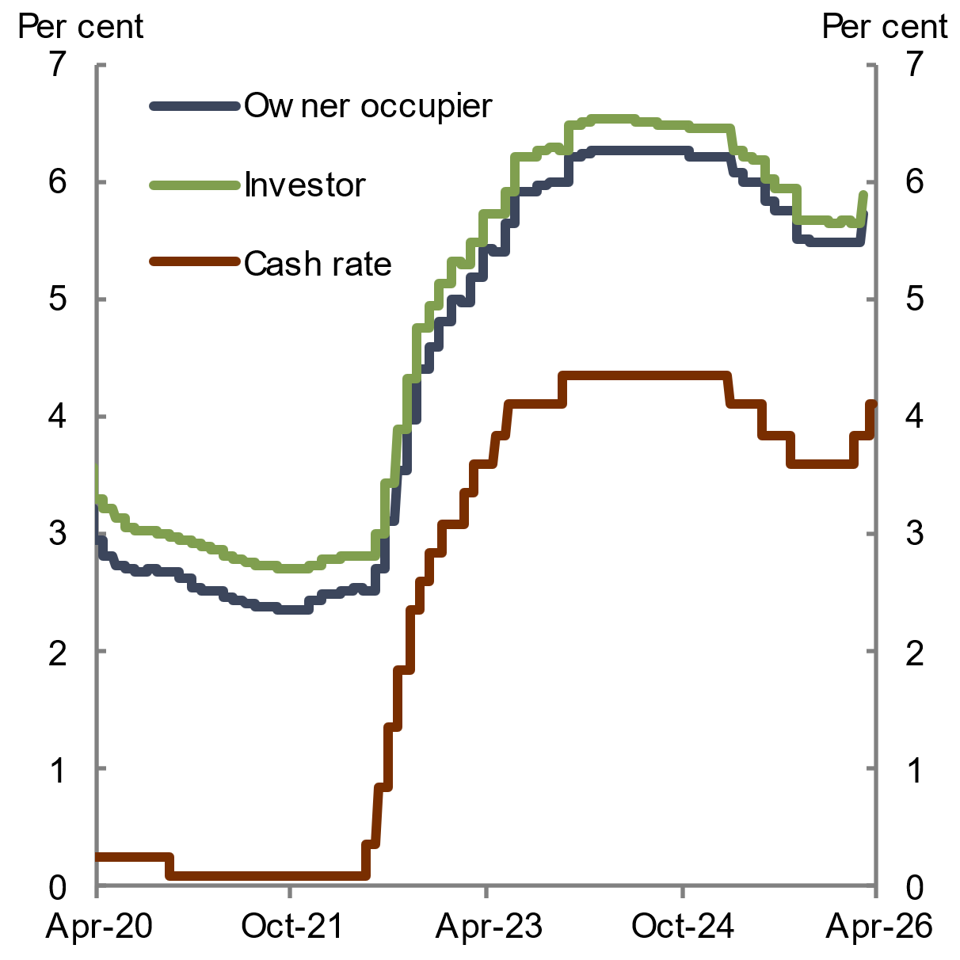 | 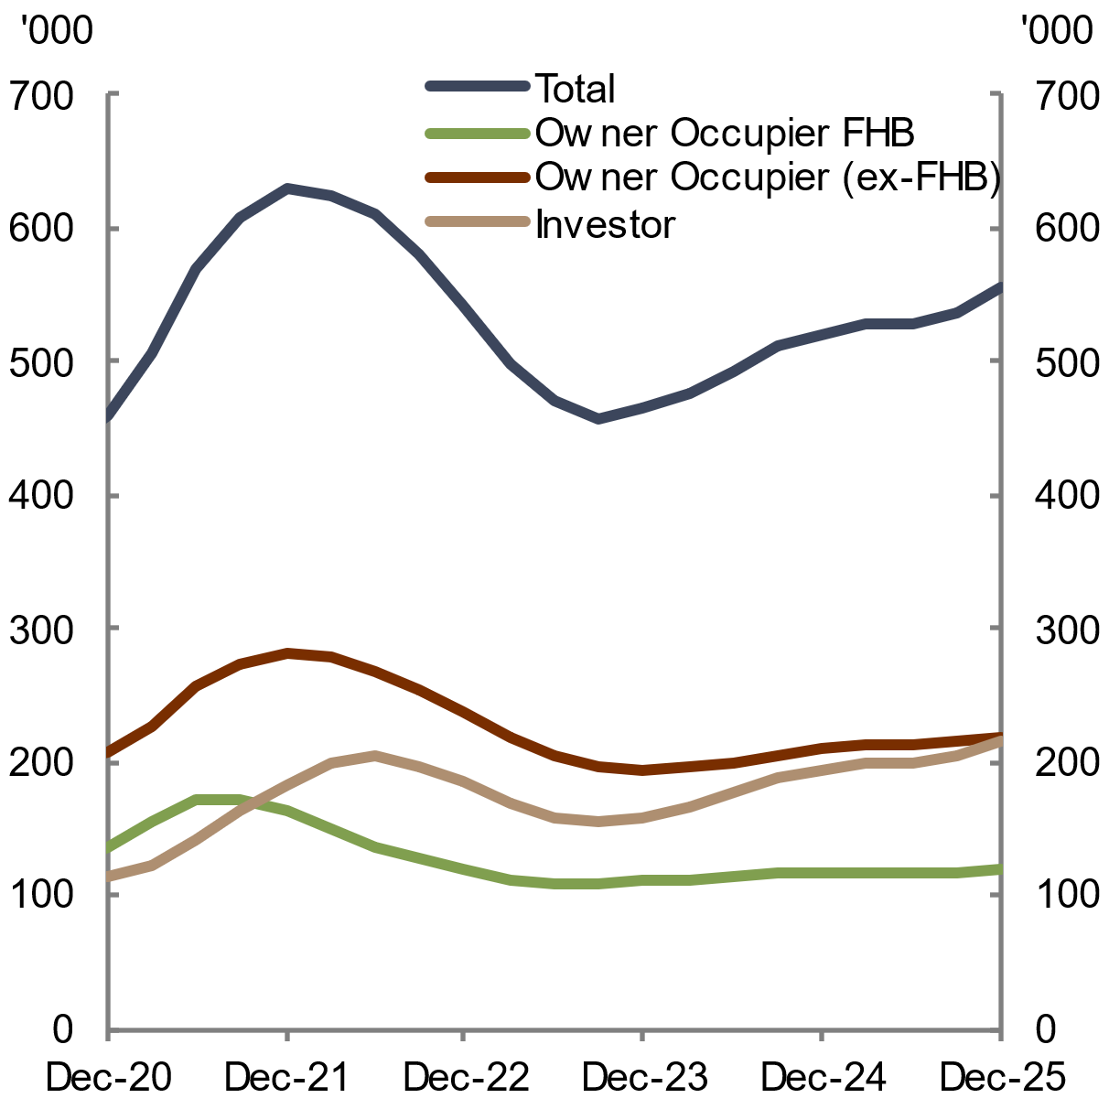
Note: The weighted averages of interest rates reported by lenders for new loans funded in the month.  Source: RBA Housing Lending Rates 2026 | Note: The rolling annual number of new loan commitments. Loan commitments to investors and owner-occupiers consist of total housing excluding refinancing. ‘FHB’ stands for first home buyer.  Source: ABS Lending Indicators 2026

  - Conditions in non-market housing and homelessness services remain challenging
Non-market housing – which includes social housing, affordable housing, crisis and transitional housing, and co-operative housing (see Box 2.1) – is a vital component of the housing system. Non-market housing accommodates people who cannot afford to purchase or rent a home at market prices, alleviates tenure insecurity for vulnerable cohorts, and reduces the incidence of homelessness and poverty.
Non-market housing is more than a residual safety net for the least advantaged in society, as it also generates economic and social benefits for the broader population (Kraatz et al. 2022). Non-market housing provides stable homes that support individual health, education and employment outcomes and helps enable these individuals to contribute productively to society (Infrastructure Australia 2019). Similarly, specialist homelessness services, which include accommodation and support services (such as case management, food provision, and medical treatment) are an essential support system for those experiencing, or who are at risk of, experiencing homelessness.
Over the past year, conditions for non-market housing and homelessness services have remained challenging. While need for social housing remains elevated, the stock of social housing has stagnated (see Chart 2.53). As a result, need for specialist homelessness services has also continued to outstrip the capacity of the sector to provide those services. This has coincided with an increase in public housing waiting lists and the rate of persistent homelessness among people accessing specialist homelessness services.
The Council notes that monitoring the stock and conditions of affordable housing within the non-market sector is significantly challenged due to the absence of one unified national definition, which was discussed in the State of the Housing System 2025 Report (NHSAC 2025). The Council believes that more needs to be done to track the stock of affordable housing nationally.
However, there are some positive signs that non-market housing and homelessness conditions will improve. In particular, significant investment in social and affordable housing will support an expansion in the stock of non-market housing over the next few years, with governments targeting the delivery of 55,000 new social and affordable homes by mid-2029. In particular, the Housing Australia Future Fund (HAFF) aims to support 40,000 social and affordable housing dwellings. In July 2025, Housing Australia confirmed Rounds 1 and 2 of the HAFF have committed funding to nearly 9,300 social housing dwellings and nearly 9,400 affordable housing dwellings. Round 3 of the HAFF will provide funding for the remaining 21,350 social and affordable dwellings, and will target regional areas and dwellings owned by First Nations housing providers (Housing Australia 2026). The $2 billion Social Housing Accelerator Payment (SHAP) will also deliver around 4,000 new, refurbished and acquired social homes. These programs have contributed to a 35 per cent increase in annual public housing commencements over the year to December 2025 (see Chart 2.55).
While most social housing tenants still live in dwellings that meet minimum acceptable standards (73.2 per cent for public housing, 59.7 per cent for state owned and managed Indigenous housing, and 83.0 per cent for community housing in 2025), the share of dwellings that meet these standards has declined since 2016, highlighting a growing maintenance and quality gap (PC 2026a). Ageing stock, maintenance backlogs and past under-investment in capital works has led to a growing share of social housing tenants living with some facilities-related or structural problems (PC 2026a; Infrastructure Australia 2019).
Box 2.1 Non-market housing definitions
Non-market housing: Housing provided at below-market prices, which includes social and affordable housing, crisis housing and transitional housing. Non-market housing also includes accommodation provided on a full or partial cost rent basis, such as common equity and limited equity co-operatives.
- Social housing: Low cost or subsidised rental housing provided by government or non-government (including not-for-profit) organisations. Social housing includes community housing, public housing, and state owned and managed Indigenous housing.
  - Public housing: Rental housing owned and/or managed by state and territory governments.
  - Community housing: Social housing provided for low- to moderate-income or special needs households at below-market rents that is owned or managed by community housing providers.
  - State owned and managed Indigenous housing (SOMIH): Housing administered by state and territory governments that is specifically targeted to Indigenous households.
  - Indigenous community housing (ICH): Housing that Indigenous community organisations own and/or manage. These organisations either directly manage the dwellings they own or sublease tenancy management services to the relevant state or territory housing authority or another organisation. ICH is available to households with at least one Indigenous member.
- Affordable housing: Housing provided at discounted market rents, typically to households in the second and third income quintiles (households that are part of the 20 to 60 per cent range of income, when ranked from lowest to highest income).
- Crisis and transitional housing: Short to medium term housing for people at risk of homelessness, including women and children experiencing family violence.
- Co-operative housing: A housing tenure where costs are shared through a collective ownership model.
    - Social housing
Social housing – which includes public housing and community housing (see Box 2.1) – provides secure rentals to people who have difficulty accessing the private rental market due to low incomes or for non-income-related reasons.
The number of social housing dwellings stagnated in 2024–25, after rising gradually over the past decade (see Chart 2.53). The stock of public housing declined by 1,143 rental units over the year, continuing a long-run downward trend. The stock of community housing also fell by 392 rental tenancy units, marking the first decline in community housing rental tenancy units in over a decade. The stock of state owned and managed Indigenous housing (SOMIH) rose by 1,295 dwellings in 2024–25. Data for Indigenous community housing (ICH) for 2024–25 will be published in mid-2026, and so is depicted as a gap in Chart 2.53. Overall, social housing (excluding ICH) remained low as a share of the total housing stock in 2024–25 (see Chart 2.54).
It is difficult to identify the reason for the stagnation in social housing over the past year, as detailed data on additions (purchases and new builds), removals (sales and demolitions) and repairs are not reported by all states and territories. As part of the Statement of Assurance template in the National Agreement on Social Housing and Homelessness (NASHH), social housing expenditure data must be reported for categories such as upgrades, renewals, acquisition costs, and repairs and maintenance for the 2024–25 year onwards, although this will only include financial data, not the number of dwellings it impacts. The Council notes that the Commonwealth, state and territory governments are working together under the NASHH Data Improvement Plan to deliver nationally consistent social housing and homelessness data, and welcomes ongoing improvements in data reporting to better identify how dwellings are being added and removed from the social housing stock.
Chart 2.53 Social housing stock, Australia | Chart 2.54 Social housing as a share of the total housing stock, Australia
Note: Data as at 30 June each year. ICH data for 2024–25 has not yet been published and will be released in mid-2026. Housing stock data counts the number of dwellings for each social housing type, except for community housing, which counts tenancy (rental) units.  Source: Steering Committee for the Review of Government Service Provision 2025, 2026 | Note: The ratio of social housing stock to total dwellings. Data as at 30 June each year. ICH data for 2023–24 will be released in mid-2026.  Source: Steering committee for the Review of Government Service Provision 2025, 2026; ABS Total Value of Dwellings 2026
Public housing is the largest component of social housing. Annual dwelling completions for public housing increased by 32 per cent over the year to December 2025, reaching their highest levels since September 2017 (see Chart 2.55). Annual dwelling approvals and commencements for public housing remained well above their 10-year average levels throughout 2025. Higher public dwelling approvals and commencements in 2025 suggest that public dwelling completions should continue to rise in 2026, which would support conditions for people in non-market housing or experiencing homelessness.
Chart 2.55 Public dwelling approvals, commencements and completions, Australia | Chart 2.56 Public housing waitlists, Australia
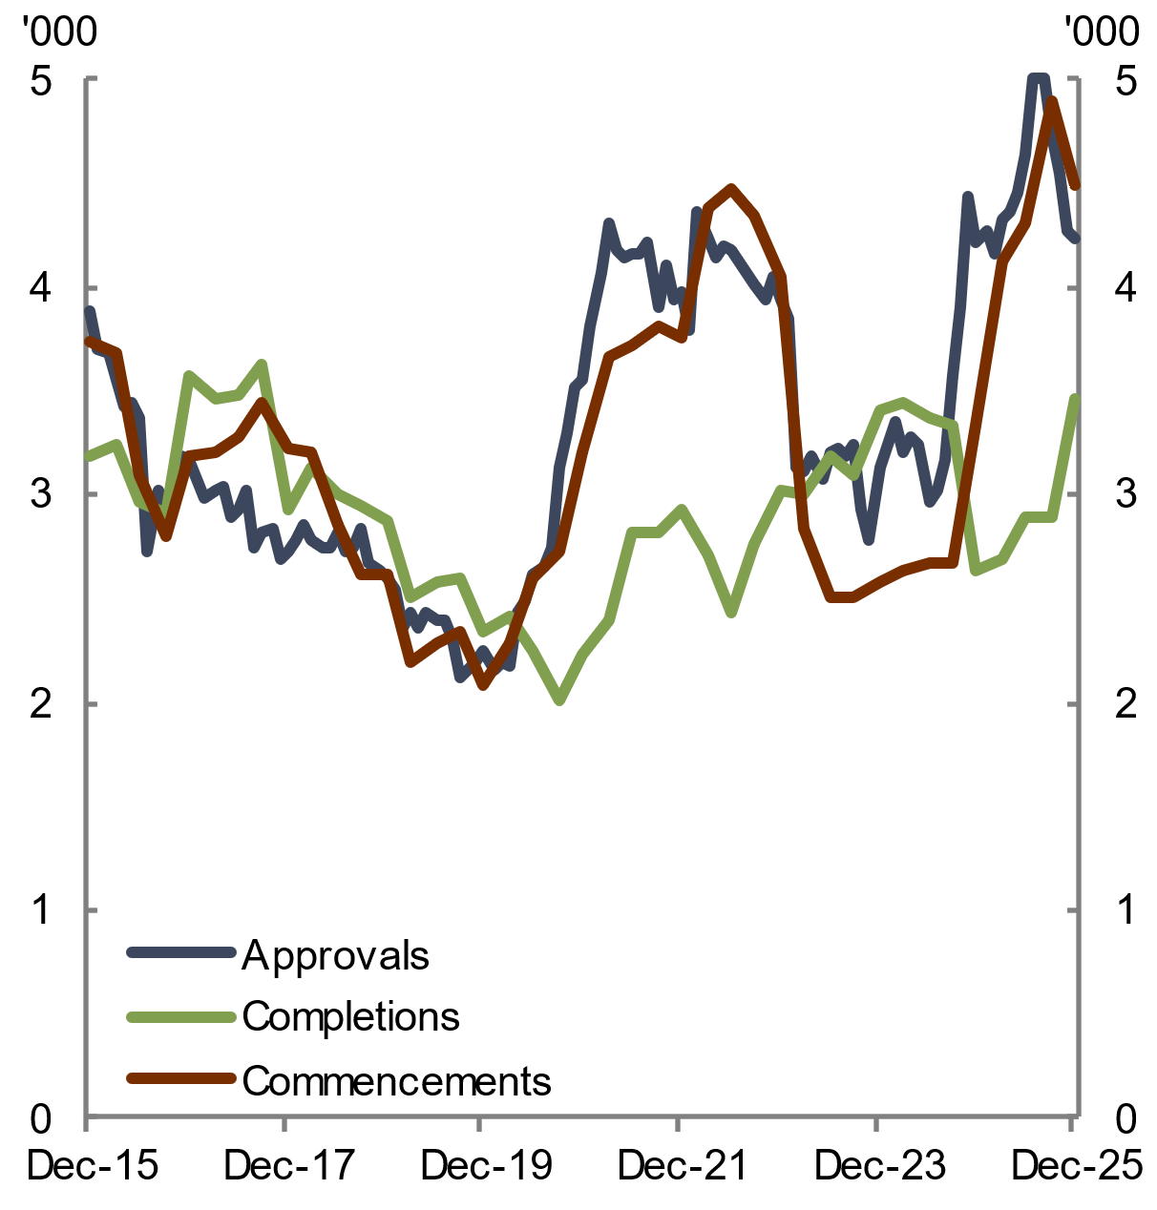 | 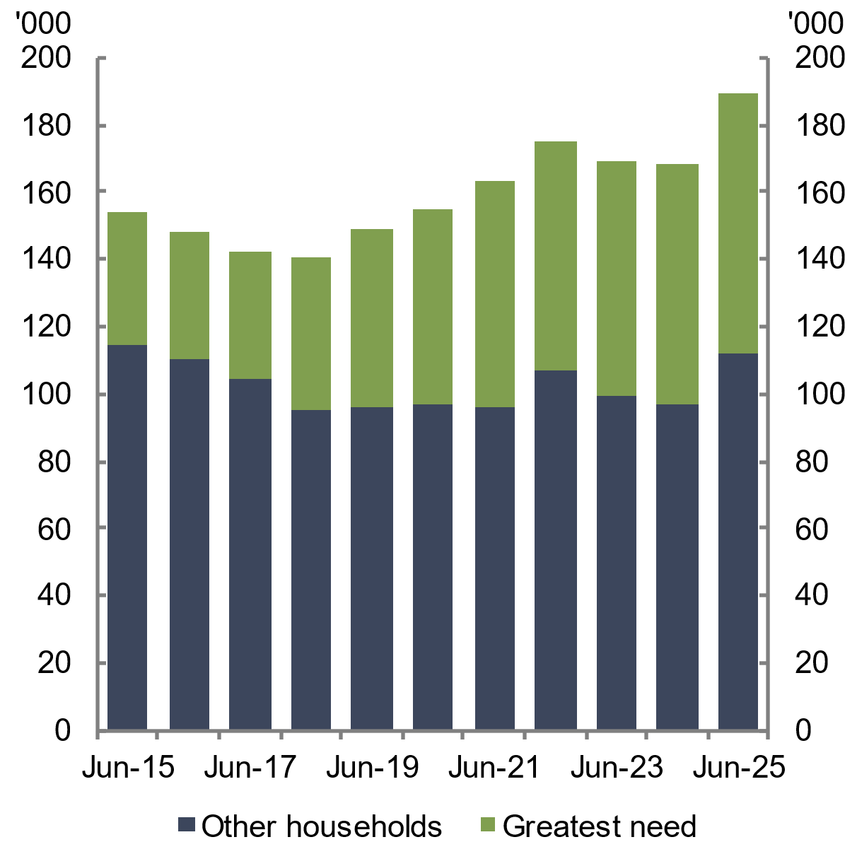
Note: The rolling annual number to December 2025.  Source: ABS Building Approvals 2026; Building Activity 2026 | Note: The number of households on waitlists.  Source: Steering Committee for the Review of Government Service Provision 2025, 2026
Weak conditions in the social and affordable housing sector, alongside a deterioration in rental affordability (see Chapter 3 Housing affordability), also placed pressure on social housing waitlists in 2025. Waitlists for public housing rose by nearly 21,000 households, representing the largest rise in over 10 years (see Chart 2.56). Around 5,800 of these were categorised as greatest need households, which are those that at the time of allocation are either: homeless; in housing that is inappropriate or is placing their life, health and safety at risk. The share of greatest needs households on waitlists increased from 26 per cent in 2015 to 41 per cent in 2025.
    - Specialist homelessness services
Specialist homelessness services (SHS) offer crisis accommodation and transitional housing to those who are experiencing – or who are at a high risk of experiencing – homelessness. Homelessness services also provide support services, including homelessness prevention, early intervention and crisis assistance, as well as related social, health, legal and community supports (NHSAC 2025).
The number of SHS clients increased in 2024–25, coinciding with weak conditions in the social and affordable housing sector and the deterioration in rental affordability. In 2024–25, the number of clients accessing specialist homelessness services rose by 8,900 to a 5-year high of 289,000 (see Chart 2.57). As SHS receive capped funding, any increase in clients supported reflects the capacity of the service system. Of the additional clients, over 7,000 had experienced family and domestic violence, nearly 6,500 were women, and 4,600 were Aboriginal or Torres Strait Islander. The number of SHS clients per 10,000 people rose slightly to 106.3 in 2024–25, although remains below the 10-year average (see Chart 2.57). Stakeholders noted that a growing number of middle-income people, such as essential workers, can no longer compete in the private rental market, and that SHS is increasingly being sought by people who previously did not need them.
SHS providers continue to operate at full capacity, as measured by unassisted requests for services, which occurs when a person seeks support from an SHS agency but does not receive it. Unassisted requests for services increased from 110,000 in 2023–24 to 129,000 in 2024–25. The most common reason requests went unassisted in 2024–25 was that no accommodation was available, accounting for around 127 unassisted requests each day (AIHW 2025a). Stakeholder engagement with service providers highlighted that a growing proportion of demand comes from clients who are either already homeless or those that have sought homelessness services before, limiting the sector’s capacity to take on new clients. Stakeholders emphasised that homelessness is fundamentally shaped by the availability of affordable housing, rather than the availability of homelessness services.
Chart 2.57 Homelessness services | Chart 2.58 Persistent homelessness
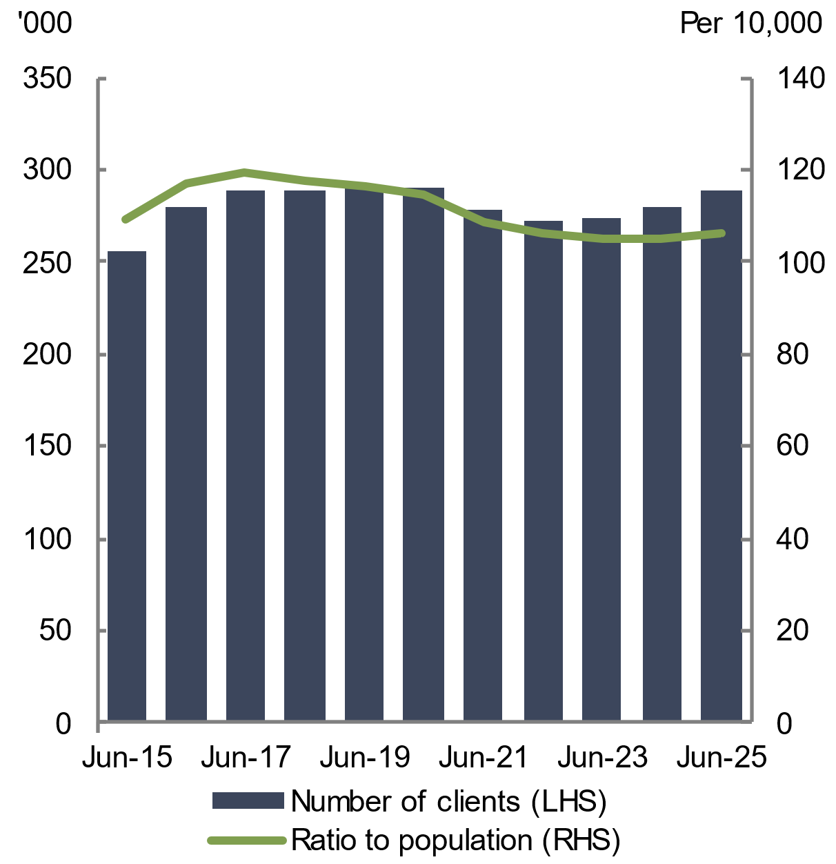 | 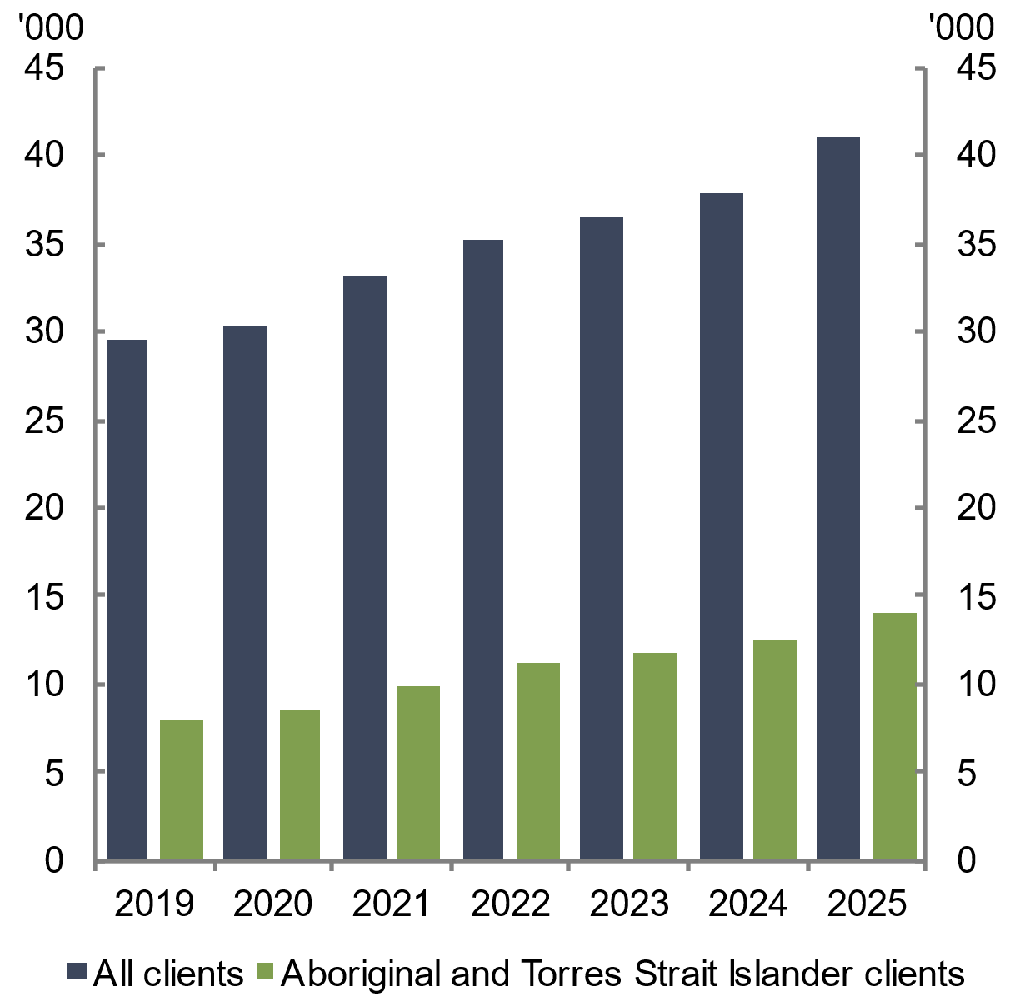
Note: Clients receiving homelessness support services. Financial year.  Source: Australian Institute of Health and Welfare 2025 | Note: Clients experiencing persistent homelessness. Financial year.  Source: Australian Institute of Health and Welfare 2025
The number of SHS clients experiencing persistent homelessness also increased in the year to 2024–‍25, rising by 3,300 to over 41,000 clients. This represents the largest annual increase since data was first recorded in 2018–19 (see Chart 2.58). All cohorts recorded an increase in persistent homelessness compared with the previous year. However, the rise was particularly large among Aboriginal and Torres Strait Islander clients (1,500 increase), those younger than 25 years old (1,400 increase), and women and children affected by family and domestic violence (1,400 increase) (noting categories are not mutually exclusive).

- Housing affordability

Chapter description
This chapter assesses housing affordability for renters, prospective homeowners, and homeowners with a mortgage in 2025. It tracks changes in housing affordability across capital cities and regional areas.
Key points
- Rental affordability continued to deteriorate across most capital cities and regions, with the share of median household income needed to rent a new lease rising to a record-high 33.1 per cent in 2025.
- Rental stress increased as a result of worsening rental affordability in recent years. In 2024, 29 per cent of renter households experienced rental stress, compared to 24 per cent in 2021.
- Home purchase affordability also continued to deteriorate, based on the number of years needed to save for a 20 per cent deposit rising to 11.2 years in 2025.
- Mortgage repayment affordability improved slightly, following three interest rate cuts in 2025. Despite this partial improvement, the share of median household income needed to service a new mortgage remains elevated at 45.9 per cent.

  - Housing affordability worsened for many people in 2025
Housing affordability continued to deteriorate for many people in 2025, as housing costs outpaced median income growth. In particular, housing affordability deteriorated to the worst level on record for renters and prospective homeowners, driven by rising rents and housing prices (see Chapter 2 Housing system conditions). Affordability for homeowners with mortgages improved slightly in 2025, due to falling interest rates. The Council will continue to monitor conditions in 2026, including the interest rate rises in early 2026, and their implications for housing affordability.
Nationally, 33.1 per cent of median household income was needed to meet rents for new rental leases, while 45.9 per cent of median household income was needed to meet repayments for new mortgages (see Chart 3.1). The time a median-income household needed to save for a 20 per cent deposit rose to 11.2 years, while the ratio of median household income to dwelling price also rose to 8.4 (see Chart 3.2).
The deterioration in housing affordability has been widespread. Affordability for both renters and homeowners with mortgages deteriorated in most capital cities and regional areas. In particular, the rise in rents and housing prices in Queensland, Western Australia and South Australia has driven the deterioration in affordability in these states (see Chapter 2 Housing system conditions).
Chart 3.1 Advertised rent affordability and mortgage repayment affordability | Chart 3.2 Home purchase affordability and dwelling price-to-income ratio
Note: Advertised rent-to-income ratio is the share of gross annual household income that a median-income household needs to pay for rent on a new lease.  New mortgage payment-to-income ratio is the share of gross annual household income that a median-income household needs to service a loan that is 80 per cent of the median dwelling value, paying the average discount variable mortgage rate for a term of 30 years.  Source: Cotality and ANU POLIS Centre for Social Policy Research 2026 | Note: Years to save a 20 per cent deposit assumes that 15 per cent of gross median household income can be saved annually for a deposit. Price-to-income ratio compares the median dwelling value to the median household income.  Source: Cotality and ANU POLIS Centre for Social Policy Research 2026
The deterioration in housing affordability over time has coincided with an increase in wealth inequality (Coates et al. 2025c). Rising housing prices increase the wealth of households that own housing assets relative to the wealth of households that do not own housing assets. Rising housing prices have also made accessing homeownership more challenging for people who cannot rely on inheritances or intra-family financial support (Whelan et al. 2023). As a result, there are growing concerns housing inequality may become entrenched, as housing assets become more concentrated among existing homeowners and further out of reach for renters.
  - Rental affordability deteriorated to record‍-low levels
Rental affordability – measured as the share of household income needed to rent a new lease –deteriorated in 2025. The rent-to-income ratio rose to 33.1 per cent in the December quarter 2025, significantly higher than the 10-year average of 29.1 per cent. The deterioration in rental affordability was primarily driven by rising rents (see Chapter 2 Housing system conditions).
Regions remain less affordable to rent in than capital cities. The rent-to-income ratio for a new lease rose to 35.4 per cent in regional areas and to 31.4 per cent in capital cities over the year to the December quarter 2025. Across the states and territories, rents on new leases were least affordable in regional New South Wales and regional Queensland (see Chart 3.3 and Chart 3.4). In contrast, rents on new leases were most affordable in Canberra, Darwin and Melbourne.
Rental affordability also remains especially poor for households on lower incomes. For lower-income households (defined here as those at the 30th percentile of income), only 2 per cent of advertised rentals would have been affordable in 2025 (Moore 2026). The least expensive rental properties also recorded the largest relative rental between 2018-19 and 2025-26, which has placed further pressure on lower-income rental households (Moore 2026).
Chart 3.3 Rent-to-income ratio for new leases, capital cities | Chart 3.4 Rent-to-income ratio for new leases, regional areas
Note: The share of gross annual household income a median-income household needs to pay for rent on a new lease.  Source: Cotality and ANU POLIS Centre for Social Policy Research 2026 | Note: The share of gross annual household income a median-income household needs to pay for rent on a new lease.  Source: Cotality and ANU POLIS Centre for Social Policy Research 2026
As rental affordability has deteriorated, demand for rental assistance, including Commonwealth Rent Assistance (CRA), has continued to rise. The number of CRA recipients increased by 4.2 per cent over the year to September 2025 to nearly 1.4 million recipients (see Chart 3.5). The number of First Nations CRA recipients rose by 9.3 per cent in the year to September 2025, to a series high of 108,770 recipients (see Chart 3.6).
Chart 3.5 CRA recipients | Chart 3.6 First Nations CRA recipients
Note: Data is at the last Friday in the mentioned quarter of the reference year. Data was reported annually (June quarter end) before shifting to a quarterly schedule after June 2024.  Source: Australian Institute of Health and Welfare 2026 | Note: Data is at the last Friday in the mentioned quarter of the reference year. Data was reported annually (June quarter end) before shifting to a quarterly schedule after June 2024.  Source: Australian Institute of Health and Welfare 2026
    - Rental stress has increased alongside the deterioration in rental affordability
As rental affordability has continued to deteriorate, the share of households in rental stress – defined as households in the lowest 2 income quintiles spending more than 30 per cent of income on rent – has increased. Analysis of data from the Household, Income and Labour Dynamics in Australia (HILDA) survey shows the share of renter households in rental stress has risen sharply, increasing from 24.9 per cent in 2014 to a series-high of 29.5 per cent in 2024 (see Chart 3.7).
Chart 3.7 Share of renters in rental stress
Note: The proportion of renter households in the two lowest equivalised disposable household income quintiles that are spending more than 30 per cent of their disposable income on rents. Data is population-weighted.
Source: HILDA Survey, Restricted Release 24; NHSAC 2026
  - Home purchase affordability deteriorated to record-low levels
Home purchase affordability – measured as the number of years needed to save for a 20 per cent deposit – has also deteriorated in line with increases in housing prices in 2025. It took 11.2 years for the median-income household to save for a 20 per cent deposit in the December quarter 2025, significantly above the 10-year average time period of 9.6 years (see Chart 3.2).
Across the states and territories, the time needed to save for a 20 per cent deposit was longest in Sydney and Adelaide, and shortest in Darwin and regional Northern Territory (see Chart 3.8 and Chart 3.9). The largest increases in the deposit hurdle over 2025 were generally reported in the capital cities and regional areas of South Australia, Queensland and Western Australia. This reflects the relatively strong rise in housing prices in these states (see Chapter 2 Housing system conditions). In contrast, smaller increases in the deposit hurdle were reported across Victoria, Tasmania and the Australian Capital Territory.
Chart 3.8 Years to save for a 20 per cent deposit, capital cities | Chart 3.9 Years to save for a 20 per cent deposit, regional areas
Source: Cotality and ANU POLIS Centre for Social Policy Research 2026 | Source: Cotality and ANU POLIS Centre for Social Policy Research 2026
The share of homes affordable to purchase – defined here as the share of homes sold at prices where mortgage repayments do not exceed 30 per cent of household income – also remained near record-low levels in 2024–25 (Moore 2025). Only 15 per cent of home sales were affordable for a median-income household in 2024–25, similar to 2023–24 levels and below pre-pandemic levels (see Chart 3.10). Among the states, Tasmania reported the lowest share of home sales affordable to the median-income household (8 per cent), while Victoria reported the highest share (18 per cent) (see Chart 3.10). Western Australia reported the biggest decline in the year, falling from a share of 25 per cent to 17 per cent in 2024–25 (see Chart 3.10).
Home purchase affordability remains the most challenging for lower-income households, with households at the 30th income percentile only able to afford 3 per cent of homes sold in 2024–25 (Moore 2025).
Chart 3.10 Share of home sales that are affordable for the median income household
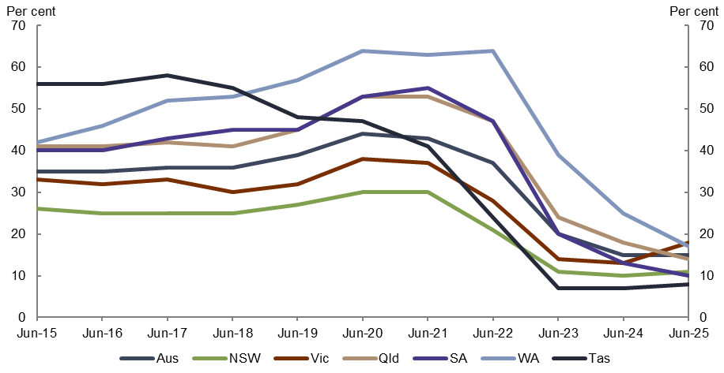
Note: Share of home sales that fall below the price that a household would spend 30 per cent of gross income on mortgage repayments, assumes 80 per cent loan-to-value ratio, 30-year loan term and 2.5 percentage point buffer.
Source: PropTrack Affordability Report 2025.
Despite the deterioration in home purchase affordability, first home buyer activity remained relatively steady in 2025, with an uptick recorded in the December quarter 2025. Around 120,000 new loan commitments were made to owner-occupier first home buyers in 2025 (see Chart 3.11). Although the number of first home buyers is lower than the pandemic-related peak in 2021, it is still higher than the 20-year average. Above-average first home buyer activity has been driven by above-average first home buyer activity in New South Wales and Victoria (see Chart 3.12).
Chart 3.11 New loan commitments for owner-occupier first home buyers, rolling annual | Chart 3.12 New loan commitments for owner-occupier first home buyers, annual, by state and territory
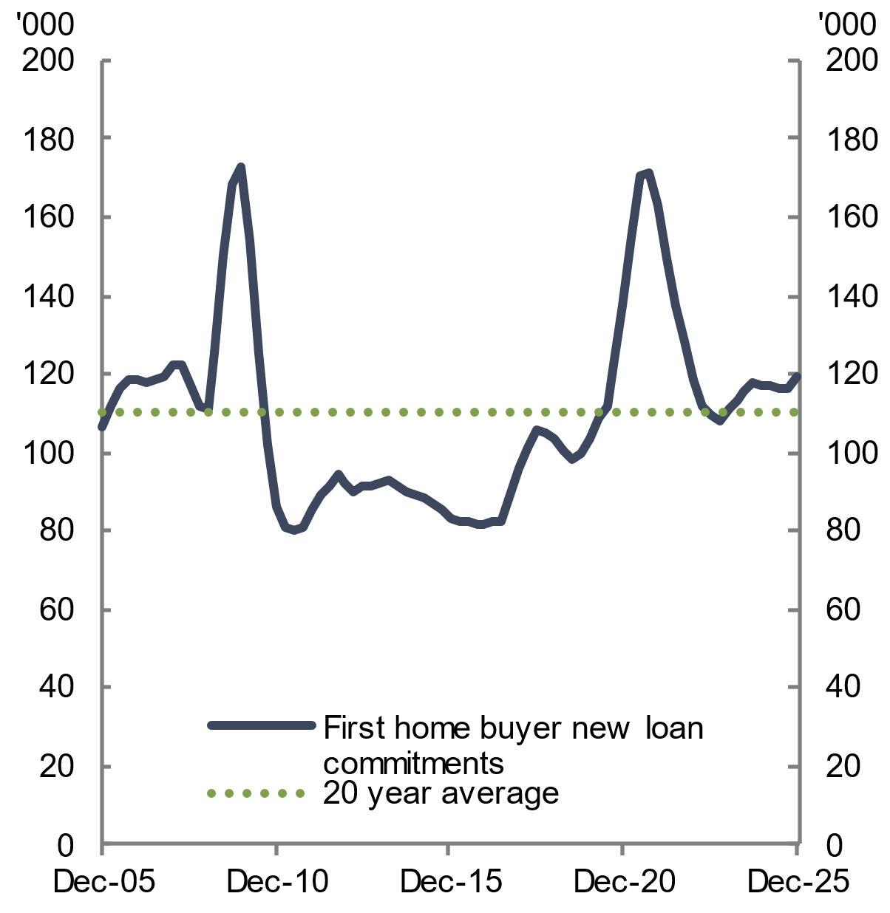 | 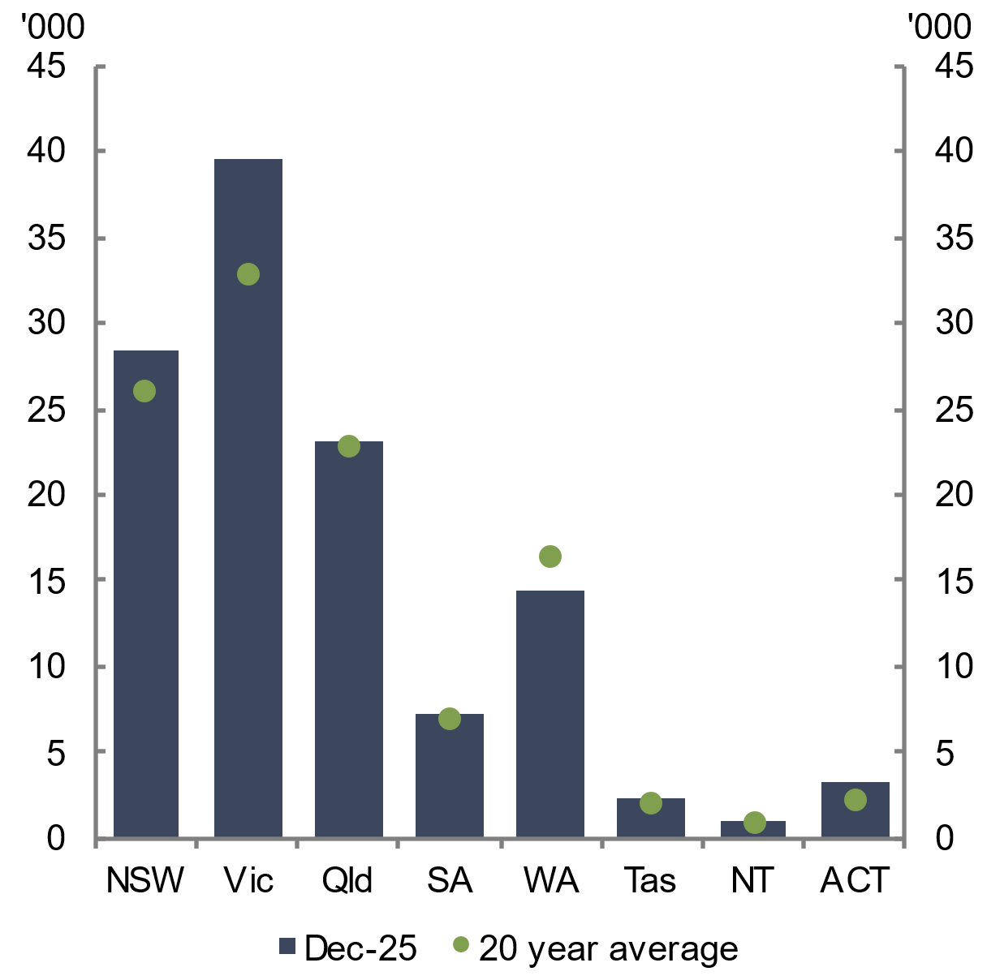
Note: The rolling annual number of new loan commitments for owner-occupier first home buyers (excluding refinancing).  Source: ABS Lending Indicators 2026 | Note: The annual number of new loan commitments for owner-occupier first home buyers (excluding refinancing).  Source: ABS Lending Indicators 2026
Australian governments have implemented a range of programs in recent years designed to support households enter into home ownership, including mortgage guarantee schemes and shared equity schemes. The 5% Deposit Scheme, for example, has enabled many people to bring forward the purchase of their first home by reducing the cost of purchasing a home without a 20 per cent deposit.
Nevertheless, the Council remains cautious about demand-side housing policies. While demand-side policies may benefit those who can access them, these policies may negatively impact affordability for first home buyers generally by placing upwards pressure on housing prices in the near term.
  - Mortgage repayment affordability improved slightly, but costs remain elevated
Mortgage repayment affordability improved slightly in 2025, supported by lower interest rates and strong income growth. A modest improvement in mortgage repayment affordability was recorded in most capital cities and regional areas, although a deterioration was recorded in Brisbane and Perth – where stronger housing price growth had offset interest rate reductions (see Chart 3.13 and Chart 3.14). Consistent with previous years, mortgage repayments were most affordable in Darwin and regional Northern Territory, and least affordable in Sydney.
Despite the slight improvement in mortgage repayment affordability, the cost-to-income ratio for new mortgages remains elevated in many areas. In Sydney, for example, the cost-to-income ratio for new mortgages was 54.7 per cent in December 2025, which is higher than the 10-year pre-pandemic average of 37.7 per cent.
Chart 3.13 New mortgage cost-to-income ratio, capital cities | Chart 3.14 New mortgage cost-to-income ratio, regional areas
Source: Cotality and ANU POLIS Centre for Social Policy Research 2026 | Source: Cotality and ANU POLIS Centre for Social Policy Research 2026

Although the share of median household income needed to service a new mortgage remains elevated, the share of existing mortgagors in severe financial stress continues to be low. Robust labour market conditions and a reduction in scheduled mortgage payments in 2025 improved the ability of mortgagors to service debts (RBA 2026a). As a result, mortgage arrears remain at very low levels, with the share of non-performing owner-occupier and investor loans remaining around 1.1 per cent and 0.8 per cent respectively in December 2025 (APRA 2026) (see Chart 3.15). Strong housing price growth has also strengthened the equity position of mortgagors, with fewer than 1 per cent of households in negative equity – a share lower than before the pandemic (RBA 2026a).
Chart 3.15 Share of loans that are non-performing
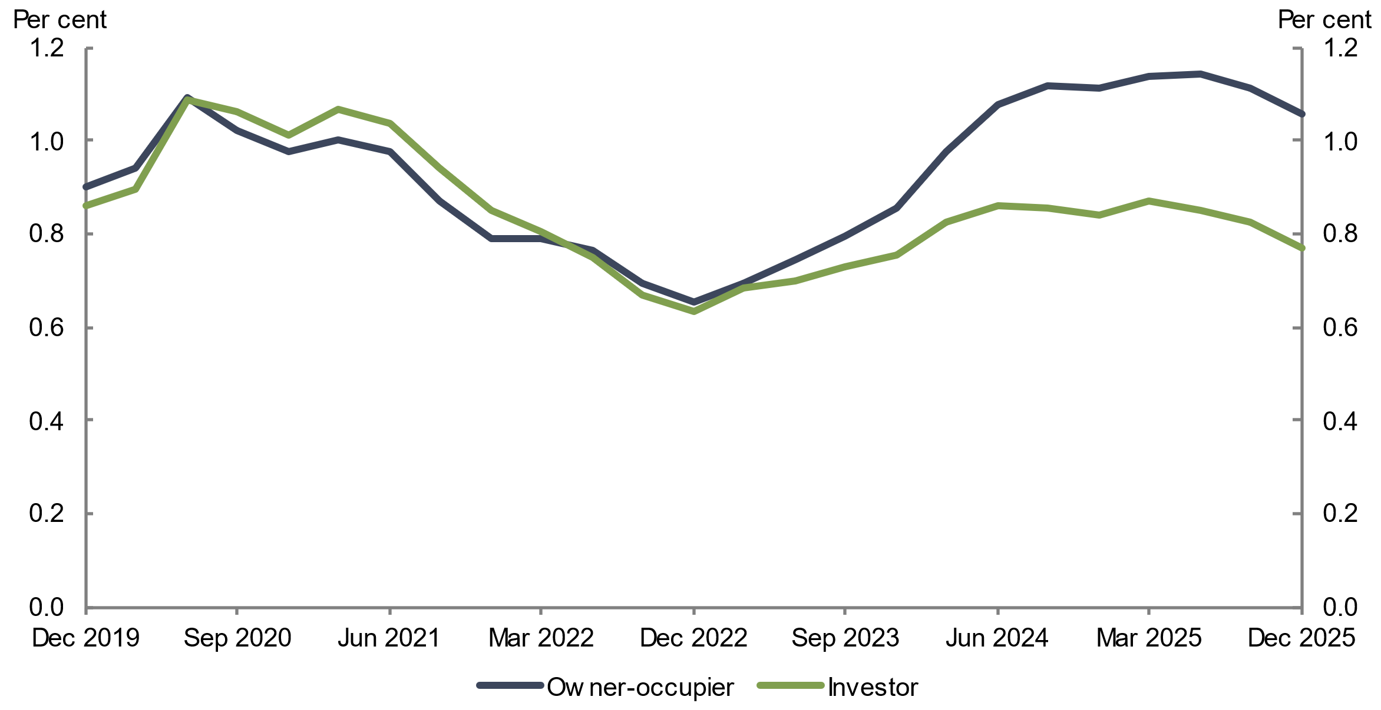
Note: Non-performing loans as a share of total authorised deposit-taking institution (ADI) credit outstanding, for owner occupiers and investors. A non-performing loan is defined as being at least 90 days past due, or if the lender does not expect the borrower to be able to repay the loan in full.
Source: APRA Quarterly authorised deposit-taking institution statistics 2026.
Although severe financial stress among mortgagors remains low, recent increases in interest rates are expected to raise financial pressures on many mortgagors in 2026. While arrears rates among lower-income mortgagors fell in 2025, lower-income borrowers remain more vulnerable to unexpected changes in interest rates, compared to other borrowers (RBA 2026a). Generally, however, existing household savings buffers should limit the impact on mortgage default rates (RBA 2026a).

- Housing system outlook

Chapter description
The chapter provides Council estimates of housing supply and demand based on data to early 2026 and before recent global disruptions, as part of its assessment of housing system conditions at that time. In the context of significant uncertainty arising from the conflict in the Middle East, the chapter also presents two scenarios for housing supply using assumptions on the potential cost increases facing the construction sector.
Key points
- Based on data to early 2026 and before recent global disruptions to commodity prices and supply chains, the Council was seeing an improvement in the outlook for housing supply.
- Growth in approvals and commencements, including associated with implementation of reforms, contributed to an improvement in estimated housing supply. In addition, the increase in feasibility, flowing from broader price trends in 2025, also contributed to higher supply.
- These indicators underpin Council estimates of gross new housing supply being 980,000 dwellings over 5 years to June 2029, in the absence of the conflict in the Middle East. This was 42,000 more dwellings than forecasted in the previous State of the Housing System 2025 Report. In addition, the Council was expecting the Housing Accord target of 1.2 million new homes to be reached by September 2030.
- The conflict in the Middle East is now leading to higher fuel and petrochemical prices, which are flowing through to higher transport and material costs, and also affecting product availability. Small businesses are particularly affected by these price increases. Market expectations of interest rate movements have also shifted, reflecting a range of factors.
- At the time of writing this report, there is significant uncertainty regarding the scale and length of the conflict. Two scenarios – a shorter term and more contained impact and a longer and more extensive impact – have been prepared in this chapter to illustrate the relationship between different conditions and housing supply. These scenarios focus on the implications for housing supply arising from the sector facing higher costs, which puts pressure on the feasibility of some projects.
- The shorter term scenario assumes a peak increase in construction costs faced by the sector of 6 per cent in mid-2026. Under this scenario, dwelling completions could be 10,000 lower over the Accord period, moderately below estimates based on conditions prior to the conflict.
- The more prolonged scenario assumes a peak increase in construction costs faced by the sector of 10 per cent in mid-2026. Under this scenario, dwelling completions could be 33,000 lower over the Accord period.
- The Council sees downside risks to these scenarios in the context of a high degree of uncertainty in broader economic conditions and potential broader impacts on housing conditions (such as sentiment), combined with previous experience of external shocks. The Council will continue to monitor the broader economic environment and prepare updated forecasts in mid-2026.

  - Housing market conditions are highly uncertain
This chapter provides estimates of the housing supply outlook just prior to the conflict in the Middle East. It also provides estimates for two scenarios of the potential impact of the Middle East conflict on housing supply. These scenarios aim to illustrate the relationship between potential increases in construction costs faced by the sector as a result of conflict and its subsequent impact on housing supply. The two scenarios are guided by the oil price scenarios discussed by the Treasurer in his address to the Australian Business Economists on 19 March 2026 (Chalmers 2026).
Estimates presented in this chapter for these scenarios have a higher degree of uncertainty than forecasts presented in previous State of the Housing System reports. The use of scenarios rather than forecasts recognises the significant uncertainty over the length of the conflict in the Middle East at the time of writing this report. This means it is unclear whether conditions will take the form of a short-term price spike or a longer-term shock. Further detail on the features and limitations of the Council’s modelling framework can be found in Box 4.1.
The Council continues to assess the 1.2 million new well-located homes target as suitable. The target is rightfully ambitious, highlighting the magnitude of the community’s challenges; communicating government policy intentions; galvanising and focusing effort across governments, industry and the community sector; and facilitating transparency, accountability and performance assessment. The target has sparked broader discussions within the industry and community about housing supply and been the catalyst for focused policy discussions.
  - National housing supply
    - Indicators of supply to early 2026
This section of the chapter provides estimates of the housing supply outlook just prior to the conflict in the Middle East, drawing on key data indicators to early 2026 and the broader economic outlook at that time.
Overall, conditions in early 2026 were showing improvement in the outlook for housing supply. In particular, the Council estimates that gross new housing supply would be 980,000 dwellings over the 5-year Housing Accord period, in the absence of global disruptions to commodity prices and supply chains (see Chart 4.1). This is 42,000 more homes than forecast in the State of the Housing System 2025. In these conditions, the 1.2 million target is estimated to be reached by September quarter 2030, slightly over a year beyond the Accord’s end date of June 2029.
Chart 4.1 Gross new housing supply, early 2026 outlook | Chart 4.2 Gross new housing supply, by dwelling type, early 2026 outlook
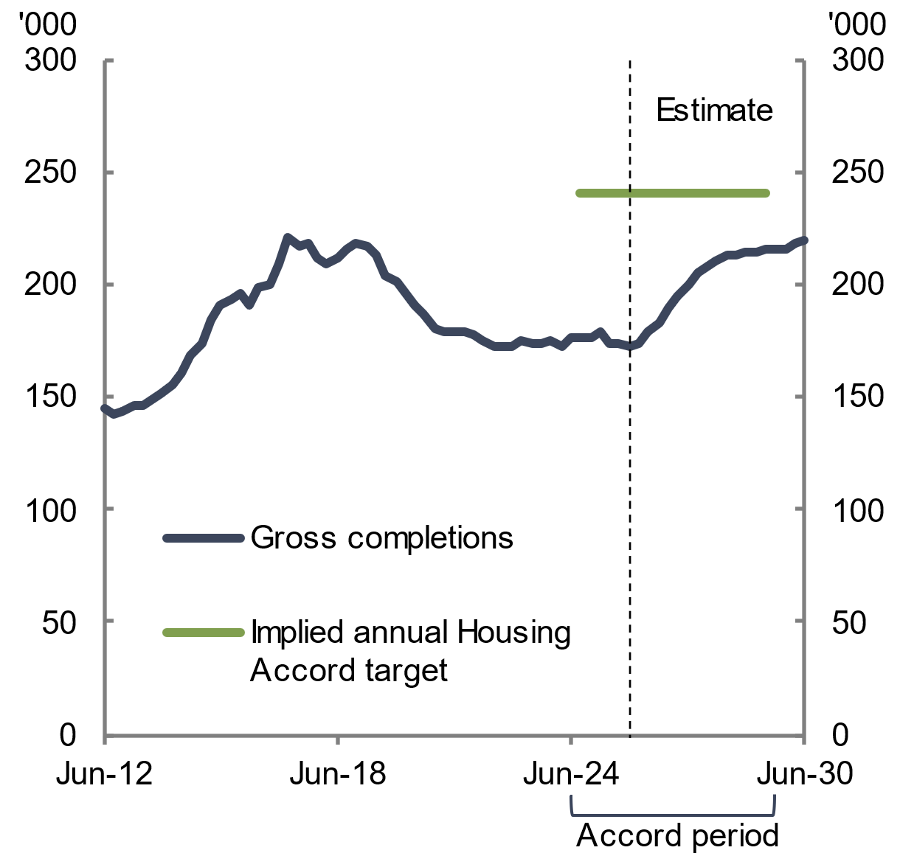 | 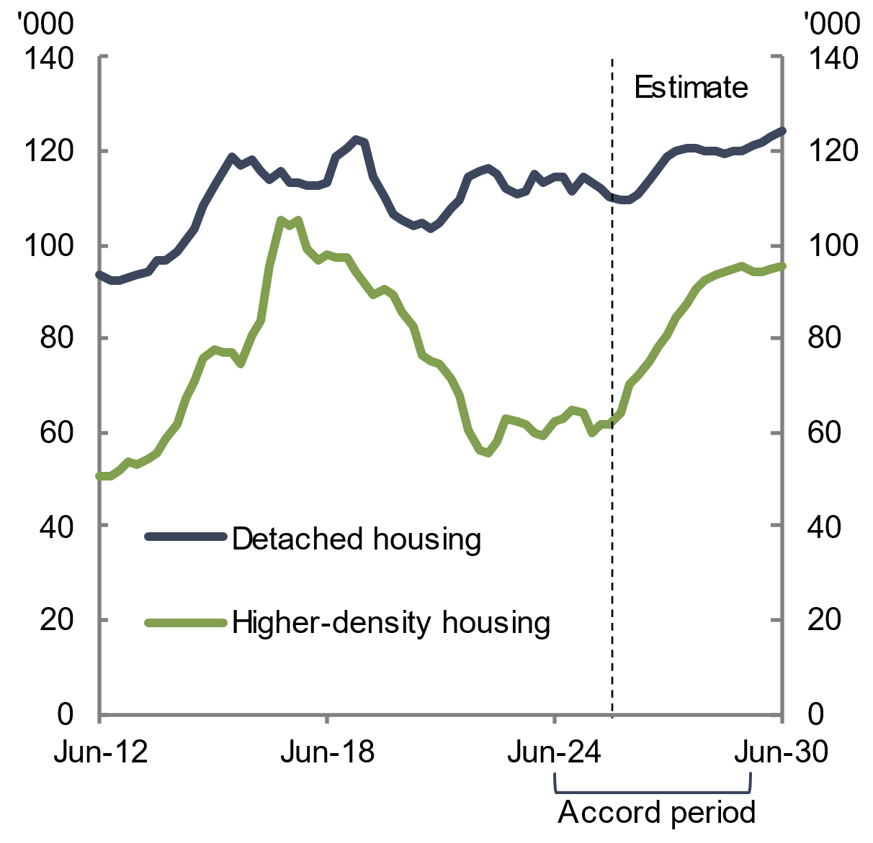
Note: The numbers shown are rolling annual totals. The implied annual Housing Accord target represents the Housing Accord target of 1.2 million completions distributed evenly over the 5-year Housing Accord period.  Source: ABS Building Activity 2026; NHSAC 2026 | Note: The numbers shown are rolling annual totals.  Source: ABS Building Activity 2026; NHSAC 2026
A number of factors contributed to the change in outlook between the previous report and conditions in early 2026. Building approvals and commencements, which are leading indicators of new housing supply, have trended upwards since early 2024 (see Chapter 2 Housing system conditions). In addition, the implementation of zoning reforms in two states is expected to further support supply. Finally, broader price trends throughout 2025 increased feasibility in the context of conditions in early 2026. Over time, this was estimated to contribute to an increase in housing supply. Estimates in these conditions were for supply growth to be stronger for higher-density housing (see Chart 4.2).
    - Housing supply under alternative conflict scenarios
Against the backdrop of indicators of underlying improvement, the conflict in the Middle East brings heightened uncertainty to the outlook for housing supply at the time of writing this report. Higher fuel and petrochemical prices have flow-on impacts on transport and material costs for construction, placing pressure on product availability and the operation and viability of small businesses. Market expectations for interest rates have also risen, reflecting a range of factors.
In this context, this report illustrates the potential impact of the Middle East conflict on housing construction costs and, in turn, housing supply. These scenarios are guided by two oil price scenarios discussed by the Treasurer in mid-March 2026 (Chalmers 2026). The first scenario discussed by the Treasurer was a shorter term conflict, where the oil price averages US$100 per barrel during the June quarter of 2026, and then gradually returns to pre-conflict prices by the end of the year. The second scenario considered a more prolonged conflict, where the oil price averages US$120 per barrel during the June quarter 2026, and then takes 3 years to return to its pre-conflict price.
The two housing supply scenarios in this chapter are guided by these conflict scenarios and apply assumptions of higher construction costs facing the sector that vary in scale and duration. These assumptions are illustrative of how changes in construction costs facing the sector could flow through to housing supply, based on historical relationships. The shorter term scenario assumes a peak increase in construction costs facing the sector of 6 per cent in mid-2026, returning to previous trends over 2 years. The prolonged scenario assumes a peak increase in construction costs facing the sector of 10 per cent in mid-2026, returning to previous trends over 6 years. The assumed construction cost shocks are relative to the early 2026 outlook and are informed by industry reporting and a range of data sources, including ABS input-output tables. Both scenarios also use recent market expectations of interest rates.
In the shorter-term scenario, gross new housing supply is estimated to be 10,000 dwellings lower over the Housing Accord period, compared to the early outlook (see Chart 4.3). This is still 32,000 above the Council’s forecast from State of the Housing System 2025. Short-term feasibility is expected to be lower and lead to lower building approvals and delayed commencements. The Council estimates lower completions in 2026–27 and 2027–28, compared to the early 2026 outlook. As supply and capacity constraints ease, feasibility is assumed to return to previous trends within two years.
In the more prolonged scenario, gross new housing supply is estimated to be 33,000 dwellings lower over the Housing Accord period (see Chart 4.4). Completions are estimated to be lower for longer than in the shorter term scenario.
On balance, the Council considers there are downside risks to the housing supply estimates presented in these scenarios, given the significant uncertainty facing the sector. Some impacts are not able to be explicitly factored into the scenarios, including delays and small business viability. Delays in construction timelines arising from disrupted construction product availability are likely to push back some dwelling completions. The viability of some small construction businesses facing higher costs is also under pressure, which could lead to higher rates of insolvencies. These delays and price shocks come on top of the construction sector already experiencing significantly elevated insolvencies (see section 2.3.7 Insolvencies). Price shocks could also potentially be more enduring, which was observed in a different context after the COVID-19 pandemic.
In addition, the scenarios focus on the relationships between construction costs, feasibility and housing supply. The scenarios do not take into account any potential impacts on housing supply arising from any changes in effective demand for housing, such as through changes in consumer sentiment, total household income and/or borrowing capacity. This also adds to downside risks.
The Council notes governments are working together, including through the National Fuel Security Plan, and implementing initiatives to ease pressure on small business and families. Key initiatives in the National Fuel Security Plan include reducing fuel excise and cutting Heavy Vehicle Road User Charge to zero for three months, as well as increasing fuel price monitoring. Other initiatives to support small business include the ATO providing temporary relief for businesses unable to meet their tax obligations due to fuel supply, and an extension to the Small Business Reasonable Lending Obligation exemption for a further 10 years.
Given the housing affordability challenge already facing Australia, all industry participants will need to play a role managing these cost pressures.
Chart 4.3 Gross new housing supply, shorter term scenario | Chart 4.4 Gross new housing supply, prolonged scenario
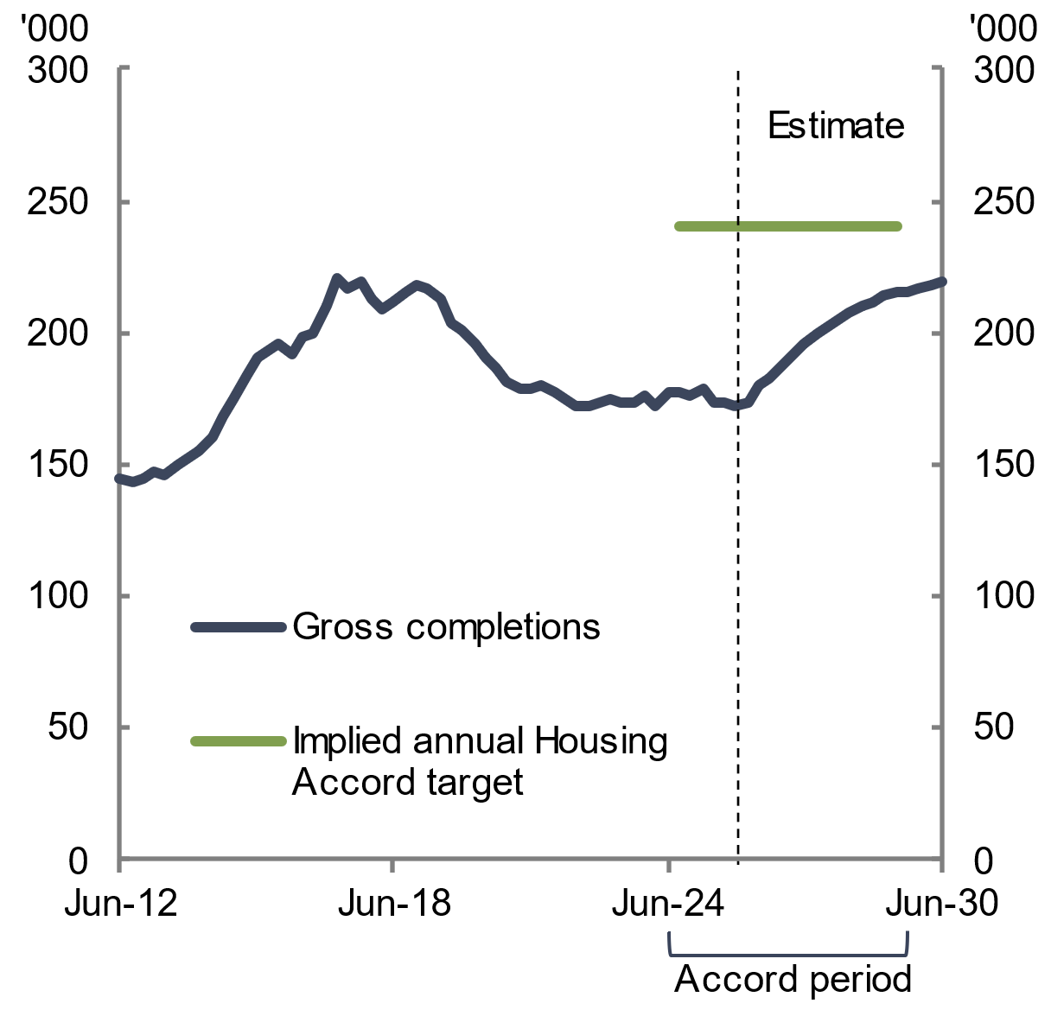 | 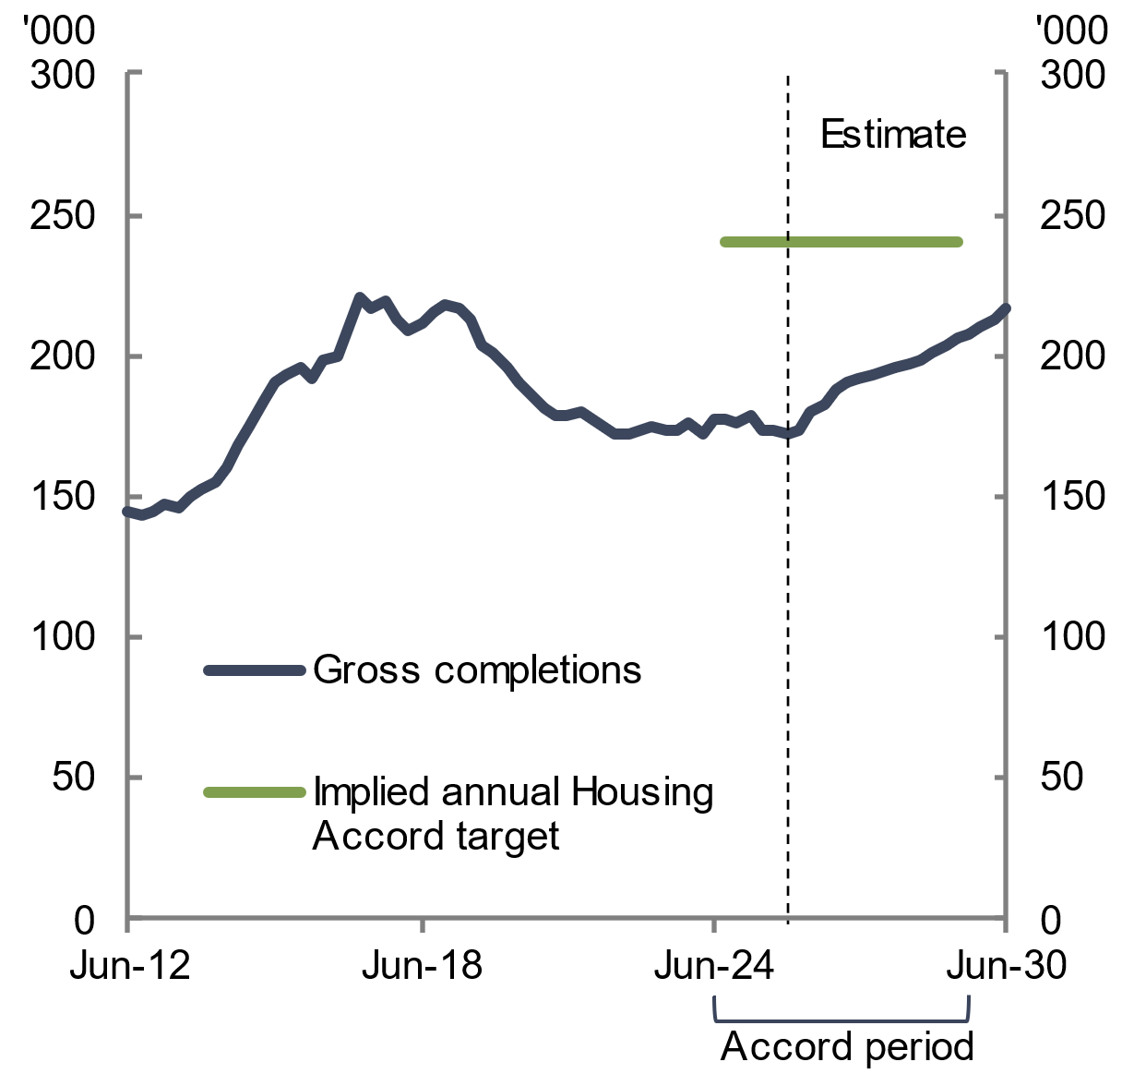
Note: The numbers shown are rolling annual totals. The implied annual Housing Accord target represents the Housing Accord target of 1.2 million completions distributed evenly over the 5-year Housing Accord period.  Source: ABS Building Activity 2026; NHSAC 2026 | Note: The numbers shown are rolling annual totals. The implied annual Housing Accord target represents the Housing Accord target of 1.2 million completions distributed evenly over the 5-year Housing Accord period.  Source: ABS Building Activity 2026; NHSAC 2026
  - Indicators of housing supply and demand for early 2026 outlook
This section of the chapter presents more detailed estimates of housing supply and demand using data available up to early 2026 and before disruptions to commodity prices and supply chains. The detailed tables complement the recent Quarterly Report, published by the Council in March 2026. The Quarterly Report provided estimates of when states and territories were expected to reach the Accord completion targets. This section of the chapter provides the detailed estimates supporting the Quarterly Report, updated where relevant for more recent data to February 2026.
Estimates of housing supply by state and territory have not been presented for the conflict scenarios. This recognises the higher degree of uncertainty of the scenarios and that the aim of the scenarios is to illustrate the relationship between construction costs faced by the sector and housing supply.
    - Housing supply by state and territory
The Council’s detailed estimates for the early 2026 outlook were for the Australian Capital Territory, Victoria and Western Australia to reach their share of the Accord target within or just after the end of the Accord period. Queensland was expected to reach the target by September quarter 2030, in line with the national average. The other remaining jurisdictions were expected to take longer. For South Australia, Tasmania and the Northern Territory, this partly reflects lower housing demand due to lower expected future population growth (Centre for Population 2026a).
Over the Housing Accord period, most jurisdictions were estimated in the early 2026 outlook to build more housing than in the previous five years (see Table 4.1). In New South Wales, Queensland, Western Australia, South Australia and the Northern Territory, gross new housing supply in the outlook in early 2026 was estimated to be higher than in the preceding 5 years.
Table 4.1 Gross new housing supply and population in the early 2026 outlook, by state and territory
State/ territory | Gross new housing supply,  2019‍–‍20 to 2023‍–‍24  (5 years prior to Accord)  Number | Gross new housing supply estimates,  2024‍–‍25 to 2028‍–‍29  Number | Population, December 2022*  Share of total (%) | Share of 1.2 million Housing Accord target*  Number | Gross new supply estimates as ratio to share of target*  Per cent | Estimated time range to meet share of the Accord target  Quarter
NSW | 251,000 | 258,000 | 31.4 | 376,000 | 69 | Jun-31
VIC | 306,000 | 287,000 | 25.5 | 306,000 | 94 | Dec-29
QLD | 166,000 | 204,000 | 20.5 | 246,000 | 83 | Sep-30
WA | 75,000 | 129,000 | 10.8 | 129,000 | 100 | Jun-29
SA | 54,000 | 66,000 | 7.0 | 84,000 | 78 | Mar-31
TAS | 16,000 | 13,000 | 2.2 | 26,000 | 51 | Dec-33
ACT | 24,000 | 22,000 | 1.8 | 21,000 | 103 | Jun-29
NT | 3,000 | 4,000 | 1.0 | 11,000 | 34 | After 2034
AUS | 896,000 | 980,000 | 100.0 | 1,200,000 | 82 | Sep-30
* The Council has apportioned the Housing Accord target to each state and territory by using their share of the national population in December 2022 (these were the latest population figures available when the 1.2 million Housing Accord target was agreed in August 2023). Of the available options for calculating jurisdictions’ share of the target, the Council has chosen this method because it is transparent and stable over time. Alternative approaches could be based on projected population growth over the Housing Accord period. The calculated target shares do not reflect formal agreement between the Australian and state and territory governments.
Notes: Housing supply data, projections and population-implied shares are rounded to the closest thousand. Totals, ratios and shares may not be consistent with component figures due to rounding. Results for the no conflict scenario are shown. The expected Accord completion date reflects when the Council has estimated that jurisdictions will reach their share of the Accord target for the outlook in early 2026.
Source: NHSAC 2026; ABS National, state and territory population 2023; ABS Building Activity 2026
    - Housing supply and demand
This section presents the Council’s estimates of new underlying demand and net new housing supply for conditions in early 2026, before recent global disruptions to commodity prices and supply chains.
Net new supply is a key measure of the overall change in the housing stock reported by the Council that adjusts for housing demolitions. In the absence of recent global disruptions to commodity prices and supply chains, Australian net new housing supply was projected to be 862,000 dwellings over the Housing Accord period. This is 37,000 higher than the forecast in State of the Housing System 2025 Report. The upgrade in net supply estimates is driven by the same factors as the upgrade to gross new housing supply.
Drawing on demographic forecasts by age group and geography from the 2025 Population Statement, and the historical propensity of these groups to form households, the Council estimates new underlying demand would come from 900,000 new households over the Accord period. In the near term, new underlying demand for housing is projected to remain elevated, with underlying demand for 182,000 dwellings in 2025–‍26 (see Chart 4.5 and Table 4.2). This is less than new underlying demand of 233,000 in 2023–‍24, reflecting a moderation of population growth towards its pre-pandemic rate (see Chart 4.6). From 2025–26 onwards, new underlying demand is projected to stabilise at around 175,000 new households per year.
Under the early 2026 outlook, new underlying demand was expected to exceed net new housing supply by 37,000 dwellings over the Accord period (see Table 4.2).
Chart 4.5 Annual net new housing supply and new underlying demand, early 2026 outlook | Chart 4.6 Population growth
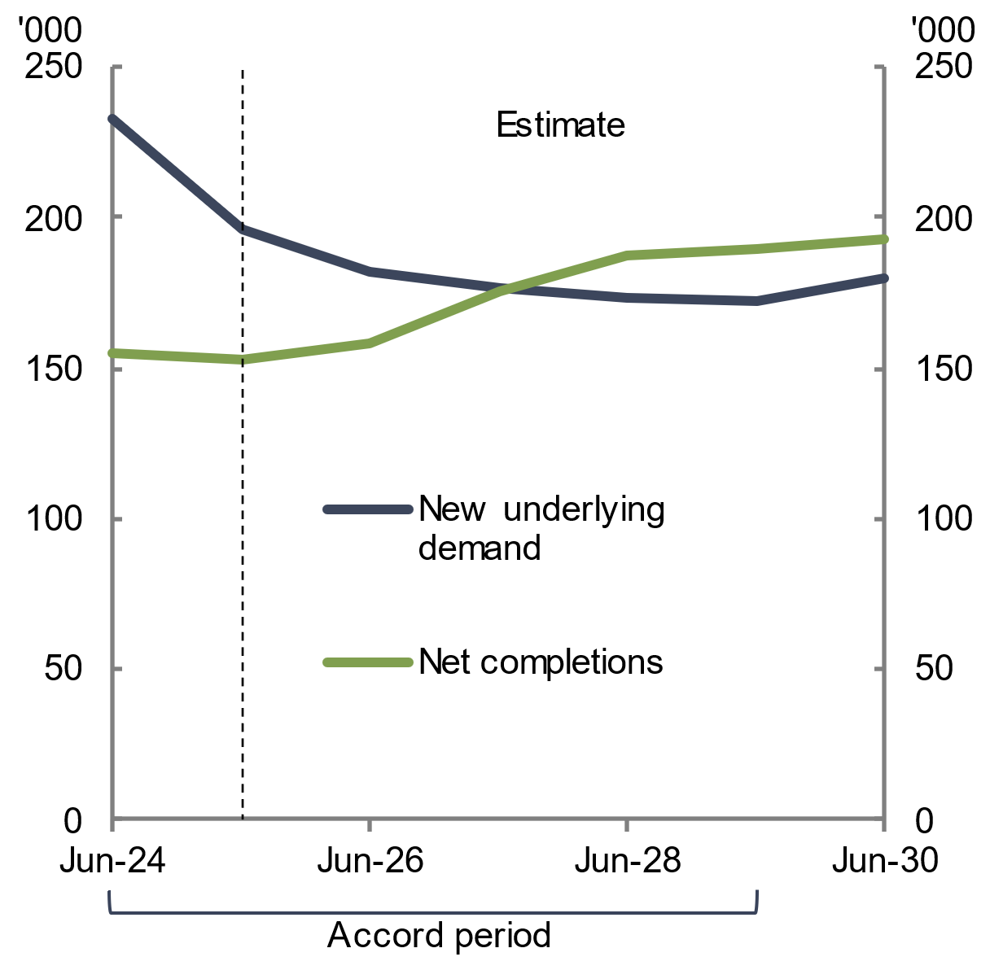 | 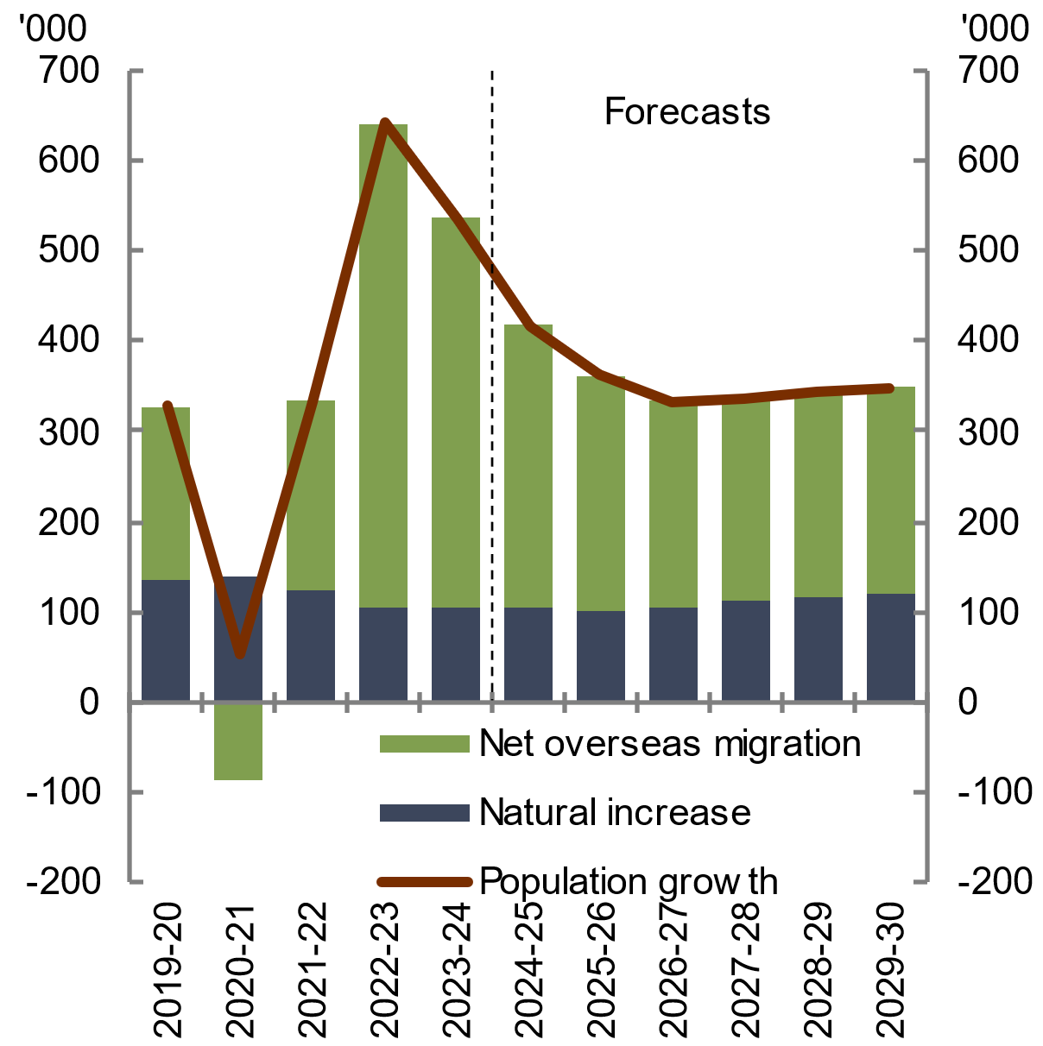
Note: Demand is measured as the number of new households that demographic trends imply would form. Supply is measured as the net number of dwelling completions. Figures are only given for the early 2026 outlook.  Source: NHSAC 2026; Centre for Population 2026 | Source: ABS National, state and territory population 2025; Centre for Population 2026
Table 4.2 New market supply, demand and net balance in the early 2026 outlook
Year | Gross new supply – early 2026 outlook | Net new supply – early 2026 outlook | New demand | Net balance (net new supply less new demand) – early 2026 outlook
2023–24 | 177,000 | 155,000 | 233,000 | -78,000
2024–25 | 174,000 | 153,000 | 196,000 | -43,000
2025–26 | 179,000 | 158,000 | 182,000 | -24,000
2026–27 | 199,000 | 175,000 | 176,000 | -1,000
2027–28 | 213,000 | 187,000 | 174,000 | 13,000
2028–29 | 215,000 | 190,000 | 172,000 | 17,000
2029–30 | 219,000 | 193,000 | 180,000 | 13,000
Total during the Accord period* | 980,000 | 862,000 | 900,000 | -37,000
* Reflects totals from 2024–25 to 2028–29, representing the total Housing Accord period.
Notes: This table is for estimates of supply for conditions in early 2026, before global disruptions to commodity prices and supply chains.
Shaded cells indicate the Housing Accord period. All figures are rounded to the closest thousand. Totals and differences may not be consistent with component figures due to rounding. Figures are only given for the early 2026 outlook.
Source: ABS Building Activity 2026; NHSAC 2026
    - Rental vacancy rates
This section presents the Council’s estimates of the rental vacancy rate under the early 2026 outlook. In the conditions prevailing at that time, the rental vacancy rate was expected to rise, reflecting the narrowing of the gap between new underlying housing demand and net new housing supply. The vacancy rate was still expected to remain below its historical average until towards the end of the Housing Accord period. This suggests that rental market conditions will remain tight, and landlords will continue to have relatively higher market power over renters.
The growth in rental costs paid by tenants, while easing from its recent peaks, is expected to remain above the RBA target band for inflation of 2.5 per cent in the near term. Advertised rents, which are a leading indicator of total (CPI) rents, have continued to show solid growth in recent months (see section 2.1.2 Rents and vacancy rates).
The implications of the conflict in the Middle East on key economic indicators, such as headline inflation and GDP, remains unclear. These broader conditions are anticipated to have flow on impacts to housing demand and, in turn, housing supply and rental vacancy rates. These conditions will be monitored by the Council over time.
Chart 4.7 Rental vacancy rate, early 2026 outlook
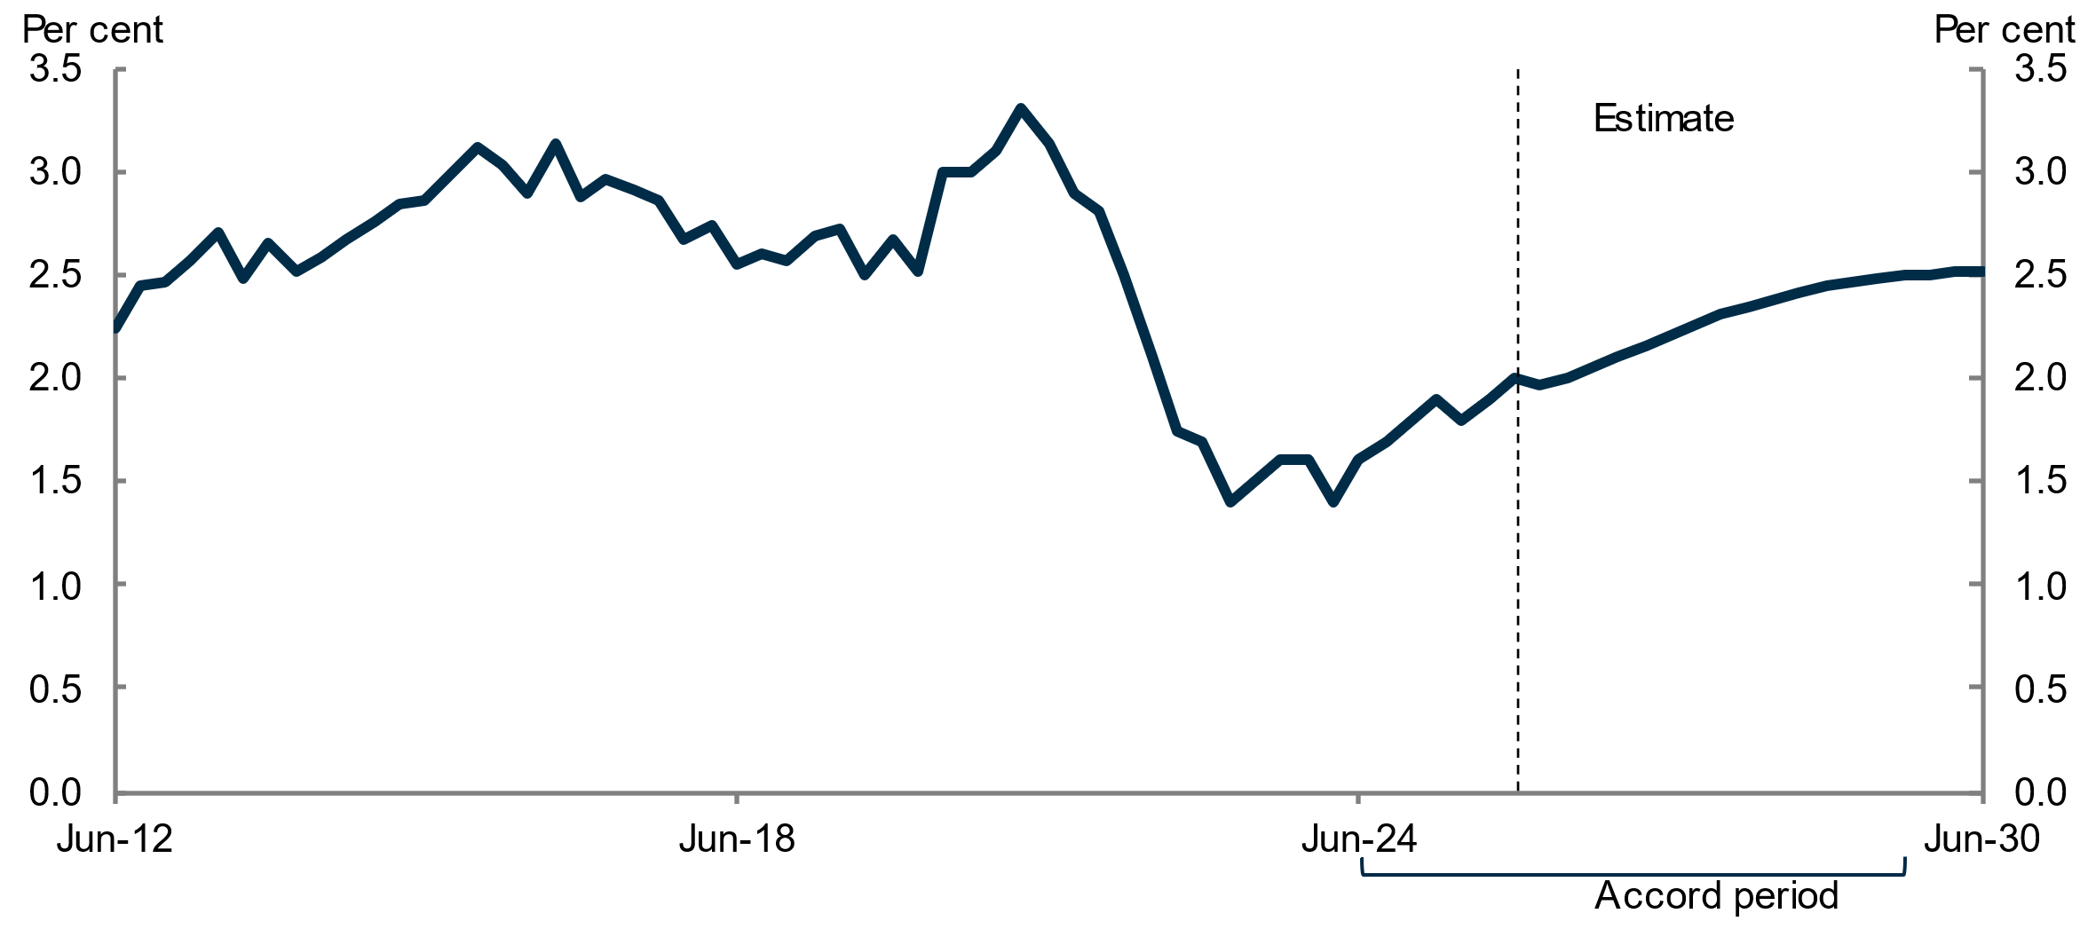
Note: Figures are only given for the early 2026 outlook, as the Council has not prepared projections of demand for the conflict scenarios.
Source: REIA Quarterly Vacancy Rates 2026; NHSAC 2026
Box 4.1 The NHSAC model of housing supply, demand and affordability
The housing system is complex. It comprises a diverse range of participants and interacts in a number of ways with other parts of the economy. The Council’s macroeconometric model identifies and extrapolates the key features of this system that drive the number of dwellings supplied and demanded by housing system participants. In particular, the model reflects most housing supply is commercially motivated. Around 4 decades of Australian data has been used to calibrate the relationships between key variables in the model. The model equations are also supplemented with projections and input assumptions, particularly for factors that have near-term trends that are anticipated to depart from long-run historical relationships.
The Council’s estimates are based on a model designed to capture the dynamics of housing supply and demand in Australia. The modelling framework is suited to answering questions about the rate at which new housing construction will take place in national, state and territory housing markets under different economic and demographic conditions and assumptions.
The model estimates newly constructed housing and new underlying demand. The Council’s estimates of supply and demand are, therefore, ‘flow’ concepts – they reflect changes to total demand (that is, the number of households) and total supply (that is, the stock of housing) in the system in any given year.
The model does not directly reflect the significant unmet need and affordability pressures that have already accumulated in the housing system, including unmet need for housing to address current levels of homelessness and to provide suitable homes for those who are marginally housed. The Council is undertaking work to address these questions using other data sources.
Projecting housing supply
The supply-side of the model largely replicates the Saunders-Tulip model (Saunders and Tulip 2019). This is summarised in Figure 4.1. The Council has made further extensions to this model, including by accounting for the Pandemic in estimates of historical relationships between variables, refining the treatment of construction costs, and incorporating (separately estimated) housing supply impacts of government support for new non-market housing.
Recent ABS data on dwelling approvals drive near-term projections for dwelling commencements and housing supply. These supply projections are considered along with the expected growth in the number of households (that is, new underlying demand) and the size of the existing housing stock to project rental vacancies and rents. The Council assumes that housing prices follow the median of the four largest Australian banks’ forecasts in 2026 and 2027, then grow alongside nominal GDP (as projected in the Mid-year Economic and Fiscal Outlook 2025–26) in later years. This assumption incorporates near-term expectations of market sentiment and interest rate expectations. It is assumed in the model that the dwelling price to income ratio continues increasing to 2029–30. The level of housing prices relative to construction costs has a relationship with new dwelling approvals.
continued on next page

Box 4.1 The NHSAC model of housing supply, demand and affordability (continued)
Figure 4.1 Simplified diagram of the NHSAC model
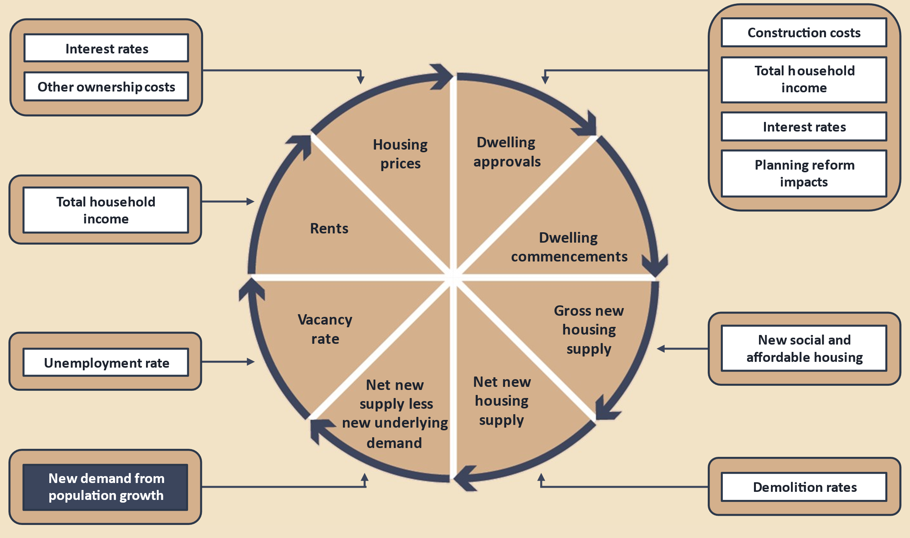
In an updated version of the model used for this report, supply estimates incorporate the estimated impact of the Transport Oriented Development and Low and Mid-Rise housing reforms in NSW, and the Townhouse Code and Activity Centres initiatives in Victoria. The Council drew on estimates of impacts on zoned capacity (Coates et al. 2025b), then assumed that 0.7 per cent of the additional zoned capacity would result in additional dwelling completions each year at maturity. This assumption draws on estimates from Coates et al. (2025b), based on research done by Greenaway-McGrevy (2025) and is consistent with the 0.5‍–‍1.0 per cent range found in other relevant literature (Maltman and Greenaway-McGrevy 2025; Rollet 2025; Murray and Limb 2022; Büchler and Lutz 2024). Further assumptions are then applied to recognise the impacts take time.
Forecasting housing demand
The demand side of the model is underpinned by the Australian Government Centre for Population’s projections of the population of individuals in 5-year age brackets and broad geographical regions. The Council’s model, based on Wilson’s sequential propensity model of household formation (Wilson 2013), is applied to convert these projections into households. It is represented by the blue box in Figure 4.1. The module converts projections at the individual level into a projection of household formation that is consistent with Australia’s evolving age structure and urbanisation rate i.e. a projection of underlying demand for housing.
continued on next page

Box 4.1 The NHSAC model of housing supply, demand and affordability (continued)
Model limitations
For housing supply to sustainably improve housing affordability, supply must grow in response to non price factors, such as technological improvements, lower regulatory compliance costs, increased competition, and an expanded construction workforce relative to the rest of the economy. The model’s projections do not explicitly account for all policy settings (except for zoning changes summarised above). This means that projections are not directly affected by policy initiatives to accelerate land releases or increase funding for enabling infrastructure. More broadly, there are several other types of policy changes that the housing supply projections do not directly respond to, such as those relating to taxes, lending regulations, building regulations and grants. These policy changes will only affect the model’s projections after their impacts are captured in the ABS’s dwelling approvals data.
Care should be taken when interpreting the Council’s estimates. The Council’s approach assumes that historical relationships between variables remain fixed into the future, whereas, in reality, they are likely to evolve over time.
Supply estimates prepared using data to early 2026 for each state and territory are subject to a higher degree of uncertainty than national estimates. Estimates for smaller jurisdictions need to be interpreted with caution and are particularly sensitive to volatility in underlying new dwelling approvals, commencements and completions data.
Data sources
Data sourced from the ABS includes dwelling approvals and activity, rents, housing stock, living arrangements, construction costs, income, consumer prices and unemployment. House price assumptions are sourced from relevant projections by banks and cash rate assumptions are derived from the overnight index swap curve. Population forecasts are sourced from the Australian Government Centre for Population’s 2025 Population Statement. Data on vacancy rates was obtained from the Real Estate Institute of Australia. Historic data on dwelling prices is from the Cotality Hedonic Home Value Index. Financial data is from the RBA’s statistical tables. Some of the components of housing user costs were taken directly from Saunders and Tulip (2019) and were assumed to be constant from the September quarter of 2017 onwards. Where suitable, the projections use projections of macroeconomic variables from the Australian Government’s 2025–26 MYEFO.

- First Nations housing

Chapter description
This chapter examines the housing experiences of First Nations people and the social factors influencing First Nations housing outcomes. It highlights the shared role of governments, industry and housing providers to work in partnership with First Nations people in improving First Nations housing outcomes across the housing spectrum.
Key points
- First Nations people experience significant barriers to accessing appropriate and affordable housing, leading to poorer housing outcomes than those of non-Indigenous Australians.
- First Nations people experience poorer health, education, and socioeconomic outcomes than non-Indigenous Australians, all of which are related to poorer housing outcomes. Poor housing outcomes, in turn, exacerbate these factors to entrench First Nations disadvantage.
- Improving First Nations housing outcomes is a critical public policy concern requiring sustained effort from governments, industry, and housing providers.
- First Nations housing outcomes should be a priority across the housing spectrum, from home ownership and private rental through to social housing and homelessness.
- Recent social and affordable housing initiatives such as the Housing Australia Future Fund Round 3 provide welcome dedicated funding, demonstrating that governments working in genuine partnership with First Nations people have potential to improve First Nations housing outcomes.

  - Assessment of the current situation
First Nations people are less likely to live in affordable, fit for purpose and secure housing than non-Indigenous Australians. This is a consequence of colonisation and subsequent government policies that have entrenched systemic racism and disadvantage, profoundly impairing First Nations housing outcomes (Pawson et al. 2020).
At the 2021 Census, First Nations people recorded lower rates of home ownership, higher participation in non-market housing, higher rates of overcrowding, and higher rates of homelessness than non-Indigenous Australians (see Table 5.1).
In particular, the rate of homelessness was almost 9 times higher for First Nations people than for non-Indigenous Australians, while the rate of severe overcrowding was around 15 times higher for First Nations people (see Box 5.1 for further discussion of overcrowding).
As a result, rental assistance and homelessness support is more commonly accessed by First Nations people than non-Indigenous Australians. The number of First Nations Commonwealth Rent Assistance (CRA) recipients rose to 108,770 as at September 2025, comprising 7.8 per cent of total CRA receipts and reflecting an annualised growth rate of 9.3 per cent (see section 3.2 Rental affordability deteriorated to record-low levels). Over the same period, 8 per cent of First Nations people accessed specialist homelessness services, compared to around 1 per cent of all Australians.
Table 5.1 Comparison of First Nations and non-Indigenous housing indicators
Outcome area | Indicator | First Nations households | Non-Indigenous households
Demographics | Count of households | 352,041 | 8,923,178
Demographics | Average household size (persons) | 3.12 | 2.53
Demographics | Multiple family households | 5% | 2%
Market housing | Home ownership rate | 42% | 68%
Market housing | Private rental rate | 35% | 26%
Non-market housing  Public and community housing | Public housing | 11% | 3%
Non-market housing  Public and community housing | State-owned and managed Indigenous housing | 4% | n/a
Non-market housing  Public and community housing | Community housing | 3% | 1%
Non-market housing  Public and community housing | Indigenous community housing | 5% | n/a
Housing support  Commonwealth Rent Assistance | Recipient income units | 108,770 | 1,289,745
Housing support  Commonwealth Rent Assistance | Recipients in rental stress | 37% | 43%*
Housing affordability | Median mortgage to income ratio | 0.17 | 0.16
Housing affordability | Median private rent to income ratio | 0.22 | 0.25
Homelessness | Homelessness (rate per 10,000) | 307 | 35
Homelessness | Severe overcrowding | 1.5% | 0.1%
Homelessness | Specialist Homelessness Services (SHS) clients (share of population) | 8% | 1.1%*
Homelessness | SHS clients in persistent homelessness | 17% | 14%*
Note: First Nations households are those where at least one resident identifies as Aboriginal and/or Torres Strait Islander. All data reflects household measures with the exception of homelessness measures, which are based on person records. Affordability measures are based on total household income and housing costs ranges as estimated at the 2021 Census, excluding households reporting negative or nil income, and are not directly comparable to housing affordability measures presented elsewhere in this report. Percentage figures may not sum to 100 due to rounding. Non-market housing indicators are estimates only, based on data as at June 2025 sourced from the Productivity Commission’s Report on Government Services (RoGS) 2026 publication.
* Reflects total population measure, as no cohort disaggregation is possible.
Source: ABS Census 2021 (demographics, market housing); Productivity Commission 2026, RoGS, Table 18A.4, Table 18A.5, Table 18A.7 (non-market housing); Productivity Commission 2026, RoGS, Table GA.6, Table GA.7, Table GA.10, Table GA.12 (housing support); NHSAC analysis of ABS Census 2021 (housing affordability); ABS Census 2021, AIHW 2026, Specialist Homelessness Services Annual Report 2024–25 (homelessness).
A higher proportion of First Nations people live in remote and very remote Australia compared to non-Indigenous people, in order to live on Country (Reconciliation Australia 2015). First Nations households in remote areas experience even larger barriers to accessing appropriate and affordable housing, leading to worse housing outcomes (see Table 5.2). Remote First Nations households exhibit lower rates of home ownership (22 per cent) and private renting (13 per cent) compared to capital city-based First Nations households (42 per cent and 41 per cent, respectively). Remote First Nations households are much more likely to live in social housing (65 per cent) than those residing in capital cities (17 per cent).
These differences reflect larger barriers to home ownership in remote areas and discrete communities, including higher dwelling construction costs, lower rates of land appreciation, and residential development controls on Native Title land (Fien and Charlesworth 2011; Moskos et al 2025). The majority of First Nations households in remote areas rent from state or territory housing authorities (see Table 5.2), with these properties not available for private purchase (Fien and Charlesworth 2011). This further reduces opportunities for home ownership, and makes the condition, security, and affordability of social housing a prime determinant of First Nations outcomes (Moran et al. 2016) (see section 5.2 Factors impacting First Nations housing and section 1.5 An outcomes framework will help guide effective housing policy).
The rate of First Nations people experiencing homelessness is over 11 times higher in remote areas than in capital cities. This difference is driven by high rates of severe overcrowding in larger, multiple family households (see Table 5.2, and Box 5.1 for further discussion of overcrowding).
Table 5.2 Comparison of First Nations housing indicators by location remoteness
Outcome area | Indicator | Greater Capital City | Inner Regional and Outer Regional | Remote and Very Remote
Demographics | Count of households | 163,377 | 155,735 | 32,928
Demographics | Average household size (persons) | 3.07 | 3.09 | 3.53
Demographics | Multiple family households | 4% | 4% | 13%
Market housing | Home ownership rate | 42% | 48% | 22%
Market housing | Private rental rate | 41% | 35% | 13%
Non-market housing | Public housing rate | 13% | 12% | 41%
Non-market housing | Community housing rate | 4% | 6% | 24%
Marginal housing | Homelessness (rate per 10,000) | 152 | 205 | 1,709
Marginal housing | Severe overcrowding | 0.3% | 0.5% | 10.3%
Note: First Nations households are those where at least one resident identifies as Aboriginal and/or Torres Strait Islander. All data reflects household measures with the exception of homelessness measures, which are based on person records. Percentage figures may not sum to 100 due to rounding.
Source: NHSAC analysis of ABS Census 2021
          - Closing the Gap in regional and remote Australia
The National Agreement on Closing the Gap is an agreement between all levels of Australian governments and Aboriginal and Torres Strait Islander representatives to commit to a new way of developing and implementing policies and programs that impact the lives of First Nations people (Australian Government 2020).
Outcome 9 of the National Agreement on Closing the Gap is for First Nations people to secure appropriate, affordable housing that is aligned with their priorities and needs. Under this Outcome, Target 9a is an increase in the proportion of First Nations people living in appropriately sized (not overcrowded) housing to 88 per cent by 2031. Although progress has been made, the Productivity Commission projects that the target is not on track to be met (PC 2026b).
Most states and territories are furthest from meeting Target 9a in remote areas (see Table 5.3). Only 53 per cent of the remote First Nations population reside in appropriately sized dwellings. It is estimated that over 10 per cent live in severely overcrowded dwellings (see Table 5.2).
Table 5.3 Share of First Nations people living in appropriate housing, by state and territory and remoteness region, 2021
 | NSW | Vic | Qld | WA | SA | Tas | ACT | NT | Aust
Total | 88 | 89 | 81 | 79 | 83 | 89 | 91 | 43 | 81
Greater Capital City | 88 | 90 | 88 | 86 | 86 | n/a | 91 | n/a | 88
Inner Regional | 87 | 88 | 85 | 85 | 88 | 88 | 63 | n/a | 87
Outer Regional | 87 | 86 | 77 | 81 | 86 | 90 | n/a | 79 | 82
Remote | 85 | 96 | 70 | 80 | 86 | 89 | n/a | 51 | 68
Very Remote | 79 | n/a | 62 | 57 | 50 | 89 | n/a | 26 | 45
Rating scale: Above target (88% or more); Below target (83% to 88%); Well below target (less than 83%)
Note: Values have been rounded to the nearest whole per cent.
Source: ABS Census 2021, Closing the Gap Table 9A.4
The high cost of delivering new housing supply in remote areas is a significant barrier to reducing overcrowding (Fien and Charlesworth 2011), as is the limited capacity of the local housing market to deliver new dwellings additional to those committed via existing federal housing initiatives.
  - Factors impacting First Nations housing
First Nations people have poorer health, education, and socioeconomic outcomes than non-Indigenous Australians, all of which can be linked to poorer housing outcomes. Poor housing outcomes, in turn, exacerbate these other outcomes, creating a cycle of disadvantage.
The underlying causes of poor housing outcomes for First Nations people include: racism (which also reduces their access to employment, education and healthcare); entrenched poverty; limited accessibility and appropriateness of social housing; and different cultural approaches to home ownership stemming from the importance of community resource sharing (AIHW 2025c; Brackertz and Wilkinson 2017). For further discussion of the impact of racism on First Nations market housing outcomes, see section 5.4.4 First Nations housing outcomes should be a priority across all tenure types, including market housing.
First Nations people, like all Australians, should have access to affordable, fit-for-purpose and secure housing. As outlined in previous State of the Housing System reports, access to adequate housing is critical to empowering First Nations individuals, families and communities. It is a key enabler of positive health, education, economic and social outcomes for First Nations people (Brackertz and Wilkinson 2017). First Nations Australians are much less likely than non-Indigenous people to live in dwellings of an acceptable standard, with the latest data indicating that 18 per cent of First Nations households – and 36 per cent of those in remote areas – live in dwellings with less than four working facilities or more than two major structural problems (ABS 2024).
    - Economic stability
Historical disconnection from land, culture, and family have affected the socioeconomic status of First Nations people. Before the 1967 Referendum, First Nations people could not freely own property across all states and territories (Reconciliation Australia 2025), precluding home ownership and entrenching economic marginalisation. These circumstances continue to prevent First Nations people from attaining housing outcomes that match their aspirations (Indigenous Business Australia 2024).
In particular, home ownership has been linked to improved employment outcomes for First Nations households (Brackertz and Wilkinson 2017), and the Council welcomes initiatives that support First Nations home ownership aspirations (see Box 5.4).
    - Education access and quality
First Nations people have poorer education opportunities and outcomes than non-Indigenous Australians, impacted by experiences of racism that limit their access to quality education services (Brackertz and Wilkinson 2017). This flows through to entrenched socioeconomic disadvantage and impaired housing outcomes for First Nations people.
First Nations children are at high risk of poor education outcomes as a result of poor housing quality, and are especially vulnerable to the negative effects of overcrowding and housing instability on their learning outcomes and resultant life trajectories (Brackertz and Wilkinson 2017). Education absenteeism, which is exacerbated by household overcrowding, homelessness and discrimination, also impairs education access for First Nations children. Lower-income First Nations families with children are particularly affected by unaffordable housing via impaired parental wellbeing (AIHW 2010). Stable and affordable social housing has a positive impact on First Nations children’s education outcomes (Brackertz and Wilkinson 2017).
    - Healthcare access and quality
First Nations Australians have poorer access to health services than non-Indigenous people, facing barriers including limited service availability, prohibitive costs, and a lack of culturally appropriate health services (AIHW 2025c). First Nations adults are more than twice as likely to experience high/very high psychological distress than non-Indigenous adults (ABS 2024; ABS 2025d), translating to reduced economic opportunities and structural disadvantage. This is impacted by housing insecurity, which limits access to health services and is associated with poor mental health and wellbeing outcomes for First Nations households (Brackertz and Wilkinson 2017).
Housing quality is a key determinant of First Nations health outcomes (Ware 2013), affecting residents through physical, economic, and social pathways at the time of exposure and throughout the lifecycle (AIHW 2011). Access to appropriate housing improves physical and mental wellbeing, especially among vulnerable populations including First Nations people (Brackertz and Wilkinson 2017). Interventions that target both housing quality and health practices through a policy environment that involves First Nations communities are the most effective in improving First Nations health outcomes (Ware 2013). Improving housing quality to ensure it is fit-for-purpose for First Nations households would support closing the gap on health outcomes between First Nations and non-Indigenous Australians (Brackertz and Wilkinson 2017).
First Nations households in remote areas are particularly at risk of poorer health outcomes due to severe overcrowding (see Table 5.2), exacerbated by housing design that often does not reflect their cultural requirements and is unresponsive to the needs of larger, multi-family households (Ware 2013). Overcrowded dwellings lead to poorer health outcomes for First Nations households via increased risk of infectious disease and impaired mental wellbeing, with significant whole-of-life socioeconomic impacts (Brackertz and Wilkinson 2017).
Culturally-appropriate housing design is also critical to enabling First Nations people to maintain their cultural identity and connection to kin and Country, which is deeply implicated in their experience of home. Housing design that facilitates this connection by reflecting customary cultural behaviours improves First Nations physical and mental health (Garnett et al. 2009) and housing outcomes (Moskos et al. 2025). Accessible housing design is also critical to alleviating the multiple disadvantages faced by First Nations people with a disability, especially in remote areas and discrete communities where residents face higher barriers to service access (Grant et al. 2017) (see section 1.5 An outcomes framework will help guide effective housing policy for further discussion).
  - Actions underway to improve First Nations housing outcomes
Governments have been working to improve First Nations housing outcomes for some time, with the Community Housing and Infrastructure Program supporting community leaders to establish Aboriginal and Torres Strait Islander Community Controlled Organisations (ATSICCOs) across states and territories in the 1970s. Targeted First Nations housing programs have been administered by state and territory governments since the 1990s, with the Commonwealth funding remote housing under the National Partnership Agreement on Remote Indigenous Housing (NPARIH) (2008–18).
The National Integrated Strategy for Closing the Gap was established in 2008 and renegotiated in 2019 in partnership with the Coalition of Aboriginal and Torres Strait Islander Community-Controlled Peak Organisations, establishing the National Agreement on Closing the Gap as a long-term government-community partnership model and priority reform agenda for improving First Nations socioeconomic outcomes. All Australian governments have responsibilities under the Closing the Gap framework, which acknowledges the important role that housing plays in improving life outcomes for First Nations Australians (Australian Government 2020).
However, the Productivity Commission’s 2024 review of the National Agreement on Closing the Gap found it was difficult to hold governments accountable for progress due to a range of factors. These factors include: lack of independent oversight; insufficient data to report on progress; and failure to describe how jurisdictions will be held accountable for their contributions to targets (PC 2024).
    - The Commonwealth has a key strategic coordination role to play through the National Agreement on Closing the Gap
As there is no single agency with overall responsibility for developing a strategic direction for First Nations housing policy and for comprehensively reporting on its outcomes, the Commonwealth has a key strategic role in coordinating government efforts under the National Agreement on Closing the Gap.
There has been a concerted increase in Commonwealth housing assistance in recent years, including social and affordable housing initiatives such as the National Agreement on Social Housing and Homelessness, Social Housing Accelerator Payment, Housing Australia Future Fund (HAFF), and efforts to centralise Commonwealth housing policy. The Commonwealth is also increasing housing supply and providing targeted housing support for First Nations people, particularly those in remote areas where overcrowding is worse. Initiatives include:
- The Partnership Agreement for Northern Territory Remote Housing and Homelands, which is an agreement between the Commonwealth, the Northern Territory Government, the four Northern Territory Land Councils, and Aboriginal Housing Northern Territory. It embeds shared decision making and commits all parties to working together to improve housing in remote Northern Territory communities and homelands.
- $2 billion, matched by the Northern Territory Government, for a total commitment of $4 billion over 10 years from 2024–25 for remote housing in the Northern Territory, aiming to build up to 2,700 houses to halve overcrowding and improve housing quality through the delivery of property, tenancy and management services.
- $220 million over 5 years from 2022–23 to deliver urgent repairs and upgrades to housing and essential infrastructure on Northern Territory homelands.
- $600 million in dedicated funding and access to additional concessional loans for projects delivered by, or in genuine partnership with, First Nations housing organisations through HAFF Round 3 (see section 5.3.3, HAFF Round 3’s dedicated funding is a welcome development for social and affordable housing for further discussion).
- An additional $70.9 million available for concessional loans through Indigenous Business Australia, to help First Nations individuals and families access home ownership (see Box 5.4).
Despite these developments, challenges remain in improving First Nations housing outcomes due to fragmented governance and resourcing (Moskos et al. 2025) and the absence of a national plan for First Nations housing and homelessness.
Although most states and territories have First Nations-specific housing strategies tied closely to implementing the National Agreement on Closing the Gap, few include estimates of future First Nations housing need or specify funding that should be reserved for work towards achieving a defined First Nations housing target.
The Victorian Aboriginal Housing and Homelessness Framework estimates First Nations housing need and sets out a 20-year agenda to guide work towards closing the gap in First Nations housing outcomes (Aboriginal Housing Victoria 2020). Queensland’s Homes for Queenslanders plan commits to delivering additional housing supply and home ownership support for First Nations people (Queensland Government 2024a). Queensland’s First Nations Housing and Homelessness Action Plan also proposes 27 actions to improve First Nations housing outcomes over the next four years (Queensland Government 2024b). The Tasmanian Government is currently developing a First Nations Housing Policy and Action Plan with the Tasmania Aboriginal Centre. The Commonwealth is providing $1 million to Aboriginal Housing Northern Territory to develop a strategic plan for transition to a community-controlled housing model, to expand First Nations-led governance of the housing system.
Box 5.2 Housing Policy Partnership efforts under Closing the Gap
The Housing Policy Partnership (HPP) was established in December 2022 as a forum for First Nations people to have a genuine say in the design and delivery of housing services. The HPP brings together the Commonwealth, state and territory governments, and First Nations representatives from all jurisdictions to establish a joined-up approach to address housing outcomes of First Nations people. The HPP can make recommendations on improving First Nations housing outcomes to the Joint Council on Closing the Gap.
The latest HPP Workplan, released in August 2025, provides direction on the priorities and activities of the HPP, including outputs aimed to improve measurement of housing need (HPP 2025). A data stocktake report will categorise the responsibilities, scope, and quality of existing data sources, helping establish frameworks to assess relevance, identify and address gaps, and use data to underpin shared-decision making and guide targeted investment. In December 2025, the Commonwealth committed an additional $6 million over two years from 2026–27 to continue the HPP, bringing total Commonwealth investment in HPP to $15.2 million since 2022–23.

    - Governments are improving measurement of First Nations housing need
Governments are working to address existing data gaps in order to measure progress against Closing the Gap Target 9b. Progress against Target 9b, which aims to ensure all First Nations households within discrete Aboriginal and Torres Strait Islander communities receive essential services that meet or exceed the relevant jurisdictional standard, has hitherto been unreported due to a lack of data on households receiving essential services. Progress against this measure is critically important to First Nations health determinants in remote communities, and therefore requires increased attention. To this end, the HPP has established a dedicated working group to develop indicators to measure progress against Target 9b.
Governments can also continue to improve responses to First Nations housing need, including defining minimum direct ATSICCO funding. Clause 55b of the National Agreement on Closing the Gap, which establishes that a meaningful proportion of funding should be allocated to ATSICCOs with relevant expertise where initiatives service the broader population, is not currently being consistently implemented. Governments should work to define a nationally-consistent methodology for calculation of minimum direct ATSICCO funding. A unified approach based on a common dataset would allow for consistent application of meaningful funding proportionality in ongoing funding arrangements, supporting sector development and ATSICCO capacity-building.
Box 5.3 The Council welcomes Victoria’s Statewide Treaty
On 13 November 2025, the Victorian Statewide Treaty Act 2025 was signed, marking the first treaty between a government and First Nations people in Australia (First Peoples' Assembly of Victoria Ltd and the State of Victoria 2025). The Statewide Treaty establishes Gellung Warl as an ongoing First Peoples representative and deliberative body, with functions including:
- to exercise decision-making powers by representing First Peoples in Victoria, and represent them in Statewide Treaty negotiations with the State
- to advise the Parliament and the State government in relation to matters that affect First Peoples
- to hold the State government accountable for its commitments to and actions for First Peoples
- to provide for ongoing truth-telling and healing (First Peoples' Assembly of Victoria Ltd and the State of Victoria 2025).
The Victorian Government and Gellung Warl have agreed that Gellung Warl will establish a First Peoples Infrastructure Fund from 1 July 2026, to provide grants to ATSICCOs for community infrastructure, including for First Nations housing projects.

    - HAFF Round 3’s dedicated funding is a welcome development for social and affordable housing
In line with the Commonwealth’s commitment to Closing the Gap, HAFF Round 3 includes a dedicated funding stream to improve First Nations housing outcomes and strengthen the community‑controlled housing sector (Housing Australia 2026). The package includes:
- $600 million in dedicated funding and access to additional concessional loans for projects delivered by, or in genuine partnership with, First Nations housing organisations.
- A 10 per cent First Nations tenancy target across social housing delivered under HAFF Round 3.
- A First Nations concierge function within Housing Australia, to support providers through the application and delivery process and help build the long‑term capacity of the community‑controlled sector.
- Updates to Housing Australia’s Investment Mandate to embed Closing the Gap priorities.
This provision of dedicated funding and support for First Nations housing organisations is a positive development that was welcomed by stakeholders, demonstrating tangible achievements that can be made when governments work in genuine partnership with First Nations people.
Supporting First Nations housing organisations to capitalise on HAFF Round 3’s dedicated funding is critical for securing positive housing outcomes for First Nations people. There must be a coordinated approach between the Commonwealth and state and territory governments to make optimal use of funding opportunities. Indeed, governments have a coordination and de-risking role to play in supporting the First Nations housing sector, which faces challenges to HAFF participation. These challenges include: high costs of housing delivery and maintenance in remote areas; limited equity held by most organisations; and onerous administrative requirements on organisations that are already resource constrained. As the First Nations concierge function within in Housing Australia matures, it will provide some assistance for the First Nations housing sector with administrative requirements and support coordination efforts.
State and territory governments working in genuine partnership with First Nations housing organisations are eligible for funding under the HAFF First Nations stream, which will incentivise governments to support ATSICCOs to access funding. Governments have expressed appetite to engage with First Nations housing organisations to support the sector’s development and deliver housing through partnership models. The South Australian Government recently funded the establishment of an Aboriginal housing peak body to drive development of capability in the sector.
Organisations in remote areas have difficulty accessing HAFF funding due to high local costs impacting the value for money of applications. As such, it will be important to support First Nations housing organisations with housing maintenance costs (for example, through a subsidy for providers of affordable housing) to free up capital for new housing supply.
ATSICCOs with larger existing portfolios should be supported to capitalise on HAFF Round 3 funding, as these organisations are better-placed to take on bids with significant debt obligation. This approach should be balanced against the ongoing need to empower smaller First Nations housing organisations to build their capacity over time.
The 10 per cent First Nations tenancy target across social housing delivered under HAFF Round 3 will encourage the mainstream community housing sector to consider the needs of First Nations people in their proposals and ensure First Nations people benefit from the full scale of this housing investment.
  - Targeted intervention to improve First Nations housing outcomes
    - Governments can do more to expedite Closing the Gap progress
Closing the Gap priority reform progress could be expedited through attaching budget measures to the framework and clarifying agency responsibilities. The Australian Housing and Urban Research Institute (AHURI) observes that self-determination in the governance of First Nations housing can also be enhanced through permanent resourcing to housing peak bodies (Benedict et al. 2026).
    - A First Nations housing strategy is required to focus government efforts
Current governance arrangements in the First Nations housing system are complex and poorly coordinated (Benedict et al. 2026), and a comprehensive national First Nations housing strategy is required to align governance mechanisms and policies (Moskos et al. 2026). A future strategy would require Commonwealth and state and territory governments to embrace a different approach to First Nations housing support that goes beyond business-as-usual measures, and should include adequate funding commitments to address unmet housing need (Moskos et al. 2026).
A First Nations housing framework should also be developed in each state and territory to guide policies and actions in each jurisdiction. Such frameworks could provide overarching direction for procurement, data collection, governance, and project development – ensuring national consistency and accountability. Policy performance and outcome measures should also be attached to these frameworks to track jurisdictional performance against common goals.
    - First Nations housing should be a priority for all housing providers – not just First Nations housing organisations
Improving First Nations housing outcomes is a responsibility that should be spread among all stakeholders, including mainstream housing providers. The significant economic, social and cultural benefits of First Nations-led organisations – who service the most disadvantaged clientele in Australia – are not adequately recognised relative to the mainstream community housing sector.
The mainstream community housing sector should support First Nations housing organisations, particularly ATSICCOs, through partnership models designed to benefit First Nations communities, with appropriate controls and contract levers to govern mainstream partner organisation involvement. As mainstream organisations increasingly enter the First Nations housing sector, it will be important to ensure that these organisations are held accountable for delivering genuine housing outcomes for First Nations people.
    - First Nations housing outcomes should be a priority across all tenure types, including market housing
Supporting First Nations-led responses across the housing spectrum enhances self-determined housing choice and tenure security in alignment with governments’ commitment to economic self-determination (Benedict et al. 2026), and should be prioritised to improve First Nations housing outcomes.

Supporting First Nations home ownership and secure rental tenancy is an important part of the policy mix
First Nations people are not accessing home ownership at the same rate as non-Indigenous people (see Table 5.1) due to a range of challenges. These include: racial discrimination in the private housing market; entrenched poverty; lack of appropriate housing in areas with high First Nations populations; and different cultural approaches to home ownership stemming from the importance of community resource sharing.
First Nations people commonly face both interpersonal and systemic racial discrimination in the rental market (Australian Human Rights Commission 2020; Stone et al. 2021; NHSAC 2024; AIHW 2025c). First Nations women, especially single mothers heading large families, are particularly vulnerable to housing discrimination (Australian Human Rights Commission 2020).
Discrimination in the private rental market increases reliance on non-market housing tenures and contributes to higher rates of First Nations’ homelessness (Moskos et al. 2022). Indigenous Business Australia found that significantly more First Nations households would be able to access market housing if non-income and non-demographic barriers, including discrimination, were removed (Indigenous Business Australia 2024).
Housing markets are under-developed in remote areas, and price signals are not operating effectively. The high cost of constructing remote housing, combined with comparatively low demand among the broader population, yields many instances of newly-constructed housing being worth less than it cost to deliver. This limits supply of appropriate and affordable housing, constraining the ability of First Nations people in these communities to transition from social renting to private renting or ownership. Governments can mitigate this issue by targeting direct procurement with ATSICCOs (which will also support their capacity-building) and by providing expanded private rental and home ownership support pathways. The banking sector can also better support First Nations people into home ownership, with potential avenues including specialised loan products for co-operative housing and tailoring of lending products to better suit aspiring homeowners in remote areas.
Issues with meeting identification and credit history requirements can also be a barrier to private market housing access for First Nations people. The Northern Territory Government is currently working to streamline support for First Nations people in overcoming this barrier.
Box 5.4 The Council welcomes support for First Nations market housing
First Nations home ownership support programs have been successful in overcoming barriers (Moskos et al. 2022), and should be expanded to meet increasing demand.
A number of First Nations home ownership support schemes are currently in place, including Indigenous Business Australia’s Home Ownership Program and Victoria’s First Peoples Home Ownership Program.
Case Study: Indigenous Business Australia’s Home Ownership Program
Indigenous Business Australia offers specialised First Nations housing products and services, including concessional home loans. The Home Ownership Program improves First Nations access to affordable finance, and is especially impactful for single income and women-led households to build intergenerational wealth and long term financial security.
Indigenous Business Australia exceeded annual targets in approving 583 concessional home loans in 2024–25, enabling more First Nations families to achieve home ownership and financial independence (Australian Government 2026).
Case Study: Victoria’s First Peoples Home Ownership Program
The First Peoples Home Ownership Program, part of Victoria’s Big Housing Build and Regional Housing Fund , offers prospective homebuyers a range of grants and assistance navigating home ownership pathways (Homes Victoria 2026).
Support products offered through the program include:
- a 1:1 deposit matching contribution up to $20,000.
- a grant contribution of up to $10,000 for land transfer duty costs.
- an additional $5,000 contribution for purchasers of newly constructed homes.
- $2,500 grants to assist applicants with legal and administrative costs.

- Glossary
Term | Definition
Aboriginal and Torres Strait Islander Community Controlled Organisation (ATSICCO) | An organisation that delivers services to build the strength and empowerment of Aboriginal and Torres Strait Islander communities and people, defined under Clause 44 of the National Agreement on Closing the Gap as: incorporated under relevant legislation; not-for-profit; controlled and operated by Aboriginal and/or Torres Strait Islander people; connected to the community, or communities, in which they deliver the services; and governed by a majority Aboriginal and/or Torres Strait Islander governing body.
Acceptable dwelling standard | A dwelling is of an acceptable standard if there are 4 working facilities (for washing people, for washing clothes or bedding, for storing and preparing food, and sewerage) and no more than 2 major structural problems.
Affordable housing | Housing provided at discounted market rents, typically to households in the second and third income quintiles (households that are part of the 20 to 60 per cent range of income, when ranked from lowest to highest income).
Appropriately sized housing | Dwellings where no extra bedrooms are required to adequately house the usual residents, defined under the Canadian National Occupancy Standard.
Average household size | The average number of people living in a dwelling.
Community housing | Social housing provided for low- to moderate-income or special needs households at below-market rents that is owned or managed by community housing providers.
Community housing provider (CHP) | A not-for-profit organisation that aims to provide safe, secure, affordable and appropriate rental housing. This may include community housing, affordable housing, specialist disability accommodation or transitional housing.
Construction productivity | The amount of construction output produced for a given set of inputs, particularly labour and capital.
Commute time | The time spent travelling to and from work in a typical week divided by the usual number of days worked per week in the main job.
Co-operative housing | A housing tenure where costs are shared through a collective ownership model.
Crisis and transitional housing | Short to medium term housing for people at risk of homelessness, including women and children experiencing family violence.
Discrete community | A geographic location, bounded by physical or legal boundaries, with a population of (but not limited to) 50 or more Aboriginal and Torres Strait Islander people, which is inhabited or intended to be inhabited predominantly by Aboriginal or Torres Strait Islander peoples, with housing or infrastructure that is managed on a community basis.
Dwelling | A building primarily used for long-term residential purposes. Used interchangeably with ‘housing’ or ‘home’.
Dwelling approval | A formal approval for new dwelling construction, alteration or addition to existing buildings, non-structural renovation, installation of integral fixtures; or demolition of dwellings provided by local government or other approving authorities.
Dwelling commencement | The commencement of a new dwelling construction, alteration or addition to existing buildings, non-structural renovation and installation of integral building fixtures. A dwelling is commenced when the first physical building activity has been performed on site in the form of materials fixed in place and/or labour expended (this includes site preparation but excludes delivery of building materials, the drawing of plans and specifications and the construction of non-building infrastructures, such as roads).
Dwelling completion | The completion of a new dwelling construction, alteration or addition to existing buildings, non-structural renovation and refurbishment, and installation of integral building fixtures. A dwelling is completed when building activity has progressed to the stage where the dwelling can fulfil its intended function.
Effective demand | A measure of housing demand that includes underlying demand as well as economic factors, such as household income and credit conditions.
Enabling infrastructure | Enabling infrastructure for housing refers to the infrastructure required to enable the development of housing. Infrastructure projects include the development or upgrading of roads and intersections; water, gas, sewerage, stormwater, telecommunications and electricity connections; and the building of wastewater treatment plants and electrical substations.
Essential infrastructure | Spatially fixed durable capital that is required for societies to function efficiently, such as housing, transport and electricity networks.
First Nations people | People who have identified themselves, or have been identified by a representative (for example, their parent or guardian), as being of Aboriginal and/or Torres Strait Islander origin. ‘First Nations people’ is the consistent term used in this report to refer to Indigenous Australians and Aboriginal and Torres Strait Islander people. However, where particular datasets, reports or organisations have referred specifically to these terms instead, they have been adopted in the report.
Gross new housing supply | The number of new dwelling completions in a given time period.
Higher-density dwellings | Non-freestanding houses, which include apartments, duplex houses, flats, high rises and semi-detached houses.
Homelessness | There is no singular definition of homelessness among OECD countries. The Australian Bureau of Statistics defines homelessness as affecting those whose living arrangements are in an inadequate dwelling; who lack or have no security of tenure; or who have a lack of privacy, safety or ability to control one’s living space. The AIHW defines homelessness as those living in non-conventional accommodation or sleeping rough, in short-term or emergency accommodation, due to a lack of other options.
Homelessness services | Programs that offer support to clients who are experiencing, or who are at risk of, homelessness. Support may include the provision of crisis accommodation, assistance to sustain housing, mental health services and other specialist services and general assistance.
Home ownership | Having rights (for example, rights to the capital appreciation) and responsibilities (for example, liability to pay land taxes) associated with ownership of a dwelling.
Housing assistance | May include enabling access to non-market housing (such as social housing) and providing targeted financial assistance.
Housing affordability | The relationship between housing costs (such as mortgage costs and rent costs) and household income.
Housing outcomes | The impacts of the housing system on households and individuals.
Housing stress | Housing stress can include mortgage stress and rental stress. Common measures of housing stress include the housing cost-to-income ratio exceeding 30 per cent, and the housing cost-to-income ratio for lower-income households (those in the 2 lowest income quintiles) exceeding 30 per cent (the ‘30/40 rule’). The most extreme form of housing stress is homelessness.
Housing system | Includes the production, consumption, exchange and regulation of housing, as well as government policy, for private housing, non-market housing, marginal housing and those experiencing homelessness.
Household formation | The change in the number of households from one year to the next.
Indigenous community housing (ICH) | Any community housing that is owned or managed by an Indigenous Community Housing Organisation (ICHO). These organisations may either directly manage the dwellings they own or sublease tenancy management services to the relevant state/territory housing authority or another organisation. Services include managing tenancy arrangements, collecting rent, providing subsidised rent and performing housing maintenance. This type of housing is available to households with at least one First Nations member.
Institutional investment | Entities through which investors collectively invest large quantities of capital for the long term, typically by spreading their funds across a diverse range of investments. In the housing market, institutional investment typically refers to equity finance invested in a collection of related dwellings to provide rental services at scale. It can also include debt finance provided by non-bank lenders.
Market housing | Housing provided in the private market.
Modern methods of construction (MMC) | Innovative building techniques that enhance the efficiency, quality and sustainability of work in the construction industry, such as prefabricated building or modular construction.
Net new housing supply | The number of new dwelling completions in a given time period less the number of dwellings that are demolished or destroyed in that period.
Net overseas migration (NOM) | The difference between the number of overseas migrant arrivals and the number of overseas migrant departures. An overseas migrant arrival occurs when a non-resident enters Australia and remains for 12 months or more during the subsequent 16-month period. An overseas migrant departure occurs when a resident leaves Australia to remain overseas for 12 months or more during the subsequent 16-month period.
New underlying demand | An estimate of the number of dwellings that would be required to accommodate the population based on its demographic characteristics, which influence the way individuals group themselves to form various living arrangements.
Non-Indigenous | A term used to describe people who have indicated that they are not of Aboriginal or Torres Strait Islander origin.
Non-market housing | Housing provided at below-market prices, which includes social and affordable housing, crisis housing and transitional housing. Non-market housing also includes accommodation provided on a full or partial cost rent basis, such as common equity and limited equity co-operatives.
Overcrowding | The requirement of one or more additional bedrooms in a household to meet occupancy standards. Occupancy standards are calculated by the ABS according to the Canadian National Occupancy Standard.
Pandemic | Refers to COVID-19, which was declared a worldwide pandemic by the World Health Organisation on 11 March 2020. Australia’s Chief Medical Officer declared COVID-19 to no longer be a Communicable Disease Incident of National Significance in October 2023.
Persistent homelessness | Clients of specialist homelessness services who have been homeless for more than 7 months in the preceding 24-month period.
Planning system | The system under which land is made available and regulated, including for housing development.
Project feasibility | Assessment of whether a housing construction project can proceed given the expected sale price exceeds total project costs, including construction costs, land costs, financing costs and required developer returns.
Public housing | Rental housing owned and/or managed by state or territory governments.
Real | Adjusted for inflation.
Shared equity scheme | A scheme whereby the home buyers shares the capital cost of purchasing a home with an equity partner, such as the government.
Social housing | Low cost or subsidised rental housing provided by government or non-government (including not-for-profit) organisations. Social housing includes community housing, public housing, and state owned and managed Indigenous housing.
State-owned and managed Indigenous housing (SOMIH) | Housing administered by state and territory governments that is specifically targeted to Indigenous households.
Supply shortfall | New underlying demand less net new housing supply in a given time period.
The Council | The National Housing Supply and Affordability Council.
The National Housing Accord | An Australian Government initiative that brings together all levels of government, investors and the residential development, building and construction sectors to unlock quality, affordable housing supply over the medium term. Includes an aspirational target to build 1.2 million new well-located homes over 5 years from mid-2024 together with immediate and longer-term actions for all parties to support the delivery of more affordable homes.
Unmet housing need | An estimate of the number of households without access to adequate, suitable and affordable housing. This includes households on low incomes paying more than 30 per cent of their income on rent and households that would be formed by the homeless population if their housing needs were met (this can be estimated by dividing the homeless population by the average household size).
Vacancy rate | The proportion of inhabitable rental premises which are vacant.

- The Council’s work over the year

Council activity in 2025–26
Under the National Housing Supply and Affordability Council Act 2023, the National Housing Supply and Affordability Council (the Council) is required to report to the Minister each financial year on the research into housing supply and affordability it has undertaken, and any findings, conclusions or recommendations resulting from that research. The results of the Council’s 2025–26 research are included in this report.

Stakeholder event 2025
On 1 July 2025, the Council held a stakeholder event to publicly release the State of the Housing System 2025 Report. The theme of the stakeholder event was ‘From crisis to action: Moving towards a healthier housing system’. The event aimed to communicate the findings of the 2025 Report to stakeholders and engage in a policy debate with leaders across the housing ecosystem. A recording of the Chair’s keynote speech can be found on the Council’s website.

Australian Government Roundtables
The Chair of the Council participated in two of the Minister for Housing’s housing construction productivity roundtables.
- 5 August 2025: Industry housing construction productivity roundtable
- 6 August 2025: Local government roundtable.
The Chair of the Council participated in all of the Treasurer’s Economic Reform Roundtables.
- 19 August 2025: Resilience
- 20 August 2025: Productivity
- 21 August 2025: Budget sustainability and tax reform.
In addition, on 12 March 2026, the Council met with the Director General of Housing Group within the Department of the Treasury. The meeting provided an opportunity for Council members to share views on housing policy.

Quarterly Report
The National Housing Supply and Affordability Council released its first Quarterly Report on 25 March 2026. The Quarterly Report shows how Australia is progressing towards the National Housing Accord target. It is available on www.nhsac.gov.au.

Conferences and events
The Chair and Council members have represented the Council at conferences and events.
Table B.1 Conferences and events attended by Council members
Event | Council member | Date
Planning Institute of Australia | Dr Marcus Spiller | 16 July 2025
National Shelter Council | Dr Marcus Spiller | 30 July 2025
Planning Institute of Australia Queensland | Dr Marcus Spiller | 4 August 2025
Affordable Housing Australasia (Marcus Evans) | Mr Michael Lennon | 11 August 2025
ANREV Australia Conference (Asian Association for Investors in Non-listed Real Estate Vehicles) | Ms Susan Lloyd-Hurwitz AM | 20 August 2025
Australian Financial Review Property Summit | Ms Susan Lloyd-Hurwitz AM | 2 September 2025
Modern Methods of Construction Showcase (NSW Government, Building 4.0 CRC) | Ms Susan Lloyd-Hurwitz AM | 5 September 2025
2025 Australian Co-operative Housing Alliance Summit | Dr Marcus Spiller | 18 September 2025
National Housing Conference (Australian Housing and Urban Research Institute) | Mr Michael Lennon | 16 October 2025
Leaders’ Summit of the Business Council of Co-ops and Mutuals | Dr Marcus Spiller, Mr Michael Lennon | 24 October 2025
Australian Community Housing Conference 2025 | Ms Susan Lloyd-Hurwitz AM | 25 November 2025
UDIA Western Australia Annual Conference (Urban Development Institute of Australia) | Ms Gail McGowan PSM | 26 February 2026
Building 4.0 Cooperative Research Centre Lunch | Ms Susan Lloyd-Hurwitz AM, Ms Helen Waters Silvia | 10 March 2026
Note: In addition to conference and events attending the 2025–26 reporting period, Mr Michael Lennon presented at the Academy of the Social Services Workshop on 7 May 2025 and Ms Carolyn Viney presented at the Urban Development Institute Australia’s Brisbane Infrastructure Summit on 18 June 2025.

Council meetings
Under the National Housing Supply and Affordability Council Act 2023, the Council is required to convene at least six meetings each financial year.
Table B.2 Council meeting dates
Meeting | Location | Date
Council meeting | Melbourne | 30 June 2025
Council meeting | Virtual | 12 August 2025
Council meeting | Virtual | 16 September 2025
Council meeting | Melbourne | 17 November 2025
Council meeting | Sydney | 3 February 2026
Council meeting | Melbourne | 20 February 2026
Council meeting | Virtual | 24 March 2026
Council meeting | Virtual | 10 April 2026

Data and modelling
The Council further developed its housing system model to better support its responsibilities as an independent body providing advice and building the evidence base for housing policy making.
Specifically, the Council has continued to maintain the model and adjust model estimates based on recent housing and macroeconomic conditions. The Council also continued to expand its analytical capability including by working with the Adelaide University on housing need. The Council will continue to develop its analysis of housing demand in the next year.

Suitability of the national new homes housing target
Under the National Housing Accord, the Council is required to regularly advise on the suitability of the 1.2 million national new homes target in consultation with the states and territories, and in response to ongoing monitoring of the capacity of the residential building industry. This report maintains the Council’s advice of the suitability of the national housing target.

Managing declarations of interest
Council members are statutory officials and are bound by legislation related to conflicts of interest. To manage potential or perceived conflicts of interest, the Council has established processes to declare and manage these interests, including maintaining an annual disclosure register and updates at each Council meeting.

Annual disclosure register
To uphold best practice in managing conflicts of interest, the Council provides an annual letter to the Minister, noting how the Council manages its conflict of interests, and an annual disclosure register that lists relevant private interests declared by members. If members have a material declaration that occurs in between these annual updates, the Minister will be notified, as per requirements under the Public Governance, Performance and Accountability Act 2013. Declarations are revised and resubmitted whenever there is a change in personal circumstances and/or a change in work responsibilities that could involve a new real or apparent conflict of interest.
On 5 November 2025, the Council provided an updated annual disclosure register to the Minister for Housing, the Hon Clare O’Neil.
Table B.3 Disclosed positions
Council member | Positions
Ms Susan Lloyd-Hurwitz AM (Chair) | Non-Executive Director, Macquarie  Non-Executive Director, Rio Tinto  Member, INSEAD Global Board  Trustee, Sydney Opera House  Fellow, University of Sydney Senate  Chair of the Australian Centre for Gender Equality and Inclusion @ Work Advisory Board  Chair, Industry Steering Group Working for Women Research Program, Australian Centre for Gender Equality and Inclusion at Work, USyd Business School  Chair, Future Directions Committee, Abbotsford Convent
Dr Marcus Spiller (Deputy Chair) | Director, Principal and Partner, SGS Economics and Planning  Director, Snomere Pty Ltd
Mr Michael Lennon | Interim Chief Executive Officer of Housing Choices Australia  Industry Professor of Regional Housing and Planning, University of South Australia  Treasurer, Biodiversity McLaren Vale  Chair, Assemble / Housing Choices Australia Joint Venture Board  Michael Lennon Professional Services  Proprietor, Starry Sky Vineyard and Wines
Professor Rachel Ong Viforj | John Curtin Distinguished Professor at the School of Accounting, Economics and Finance, Curtin University  Managing Editor, Australian Economic Papers  Member, External Reference Group for the HILDA Survey  Member, CEDA Council on Economic Policy  Australian representative and Vice-Chair, Steering Committee for the Asia-Pacific Network for Housing Research
Ms Helen Waters Silvia | Director, National Service Delivery, YWCA Australia
Ms Gail McGowan PSM | Chancellor of Murdoch University  Chair, Botanic Gardens and Parks Authority  Director, Mid-West Ports Authority WA  Director, Foundation Housing WA  Director, Western Australian Cricket Association  Local Government Monitor, City of South Perth
Ms Carolyn Viney | Chief Executive Officer, Assemble  Member of the Victorian Premier’s Business Council  Division Councillor, Property Council of Australia (Victorian Division)
Mr Neil Willmett | Chief Executive Officer, Aboriginal and Torres Strait Islander Housing Queensland  Member, Queensland Government Housing Minister Advisory Council
Ms Kerren Crosthwaite (ex-officio) (to 28 September 2025) | Acting Deputy Secretary, Housing Group, Department of the Treasury
Mr Ben Rimmer (ex-officio) (from 29 September 2025) | Director-General Housing, Department of the Treasury

Disclosure at each Council meeting
At the beginning of each Council meeting, the Chair asks members to declare any conflicts of interest relating to items on the agenda and to advise of any necessary changes in circumstances. Should a member be conflicted with an item on the agenda, they may be recused from the discussion. If this was to occur, it would be recorded in the meeting minutes and appropriate steps would be taken to manage the risk. Any additional declarations made at the meeting are recorded in the meeting minutes and updated in the Disclosure Register, which would then be provided to the Minister as an update to the annual record.
- Report Methodology
The Council’s State of the Housing System 2026 provides an overview of the state of the housing system in 2025–26, including housing demand, supply and affordability.

Timeline and process
Under the National Housing Supply and Affordability Council Act 2023, the Council is required to submit an annual State of the Housing System report to the Minister no later than 10 months after the end of the financial year. The 2025–26 report was provided to the Minister for Housing, the Hon Clare O’Neil on 22 April 2026.
The Council led the report’s development with the assistance of the Office of the National Housing Supply and Affordability Council (the Office). The Office is staffed by Australian Public Service employees, who are made available to the Council by the Department of the Treasury. The Office works under the direction of the Council.
Table C.1 National Housing Supply and Affordability Council members
National Housing Supply and Affordability Council members
Ms Susan Lloyd-Hurwitz AM (Chair)
Dr Marcus Spiller (Deputy Chair)
Mr Michael Lennon
Professor Rachel Ong Viforj
Ms Helen Waters Silvia
Ms Gail McGowan PSM
Ms Carolyn Viney
Mr Neil Willmett
Ms Kerren Crosthwaite (ex-officio) (from 19 May 2025 to 28 September 2025)
Mr Ben Rimmer (ex-officio) (from 29 September 2025)

Information sources
The Council used a range of information sources to inform its research and analysis, including existing housing literature (see references at Appendix D), government and non-government data, and insights from stakeholder consultations.

Bilateral interviews and roundtable discussions
The Council convened a series of bilateral interviews and roundtable discussions between December 2025 and February 2026. These consultations consisted of:
- bilateral interviews with representatives from all state and territory governments, and 6 stakeholder organisations
- 8 roundtable discussions with organisations in a range of groups, including: academics and think tanks, local government and planning, housing industry, community housing and First Nations housing.
- The Council is grateful to all stakeholders who contributed their time and insights to aid the development of the Report (see Table C.2).
Table C.2 Stakeholder consultations
State and territory government agencies
State / territory | Government agency
Australian Capital Territory | Chief Minister, Treasury and Economic Development Directorate  City and Environment Directorate  Health and Community Services Directorate  Suburban Land Agency
New South Wales | Department of Planning, Housing and Infrastructure  NSW Treasury  The Cabinet Office
Northern Territory | Department of Chief Minister and Cabinet  Department of Housing, Local Government and Community Development  Department of Land, Planning and Environment  Department of Treasury and Finance
Queensland | Department of Housing and Public Works  Department of State Development, Infrastructure and Planning  Queensland Treasury
South Australia | Department for Housing and Urban Development  South Australian Housing Trust
Tasmania | Department of Premier and Cabinet  Department of State Growth  Department of Treasury and Finance  Homes Tasmania
Victoria | Department of Families, Fairness and Housing  Department of Premier and Cabinet  Department of Transport and Planning  Department of Treasury and Finance  Homes Victoria
Western Australia | Department of Housing and Works  Department of Treasury and Finance

Table C.2 Stakeholder consultations (continued)
Stakeholder organisations
Stakeholder organisation
Aboriginal Community Housing Industry Association NSW
Aboriginal Community Housing Limited
Aboriginal Hostels Limited
Aboriginal Housing Northern Territory
Aboriginal Housing Office
Aboriginal Housing Victoria
Adelaide University
Anglicare Australia
Australian Alliance to End Homelessness
Australian Banking Association
Australian Community Housing
Australian Housing and Urban Research Institute
Australian Investment Council
Australian Local Government Association
Australian National University
City of Sydney
Committee for Economic Development of Australia
Cotality
Curtin University
e61
Grattan Institute
Homelessness Australia
Housing Australia
Housing Industry Association
Hutchinson Builders
Master Builders Association
Melbourne Institute
National Aboriginal and Torres Strait Islander Housing Association
National Indigenous Australians Agency
National Shelter
Planning Institute of Australia
Property Council of Australia
REA Group
Shelter NSW
Umpi Korumba Aboriginal and Torres Strait Islanders Corporation for Housing
University of Melbourne
University of New South Wales (City Futures Research Centre)
University of Technology Sydney
Urban Development Institute of Australia

Disclaimers

HILDA Survey Disclaimer
This paper uses unit record data from Household, Income and Labour Dynamics in Australia Survey (HILDA) conducted by the Australian Government Department of Social Services (DSS). The findings and views reported in this paper, however, are those of the authors and should not be attributed to the Australian Government, DSS, or any of DSS’ contractors or partners. DOI: 10.26193/GMYVPW

Cotality Disclaimer
This publication contains data, analytics, statistics, results and other information licensed to us by RP Data Pty Ltd trading as Cotality Asia Pacific (Cotality Data).
© Copyright 2025. RP Data Pty Ltd trading as Cotality Asia Pacific (Cotality) and its licensors are the sole and exclusive owners of all rights, title and interest (including intellectual property rights) subsisting in the Cotality Data reproduced in this publication. All rights reserved.
The Cotality Data provided in this publication is of a general nature and should not be construed as specific advice or relied upon in lieu of appropriate professional advice.
While Cotality uses commercially reasonable efforts to ensure the Cotality Data is current, Cotality does not warrant the accuracy, currency or completeness of the Cotality Data and to the full extent permitted by law excludes all loss or damage howsoever arising (including through negligence) in connection with the Cotality Data.
- References
ABCB (Australian Building Codes Board). (2022). Livable Housing Design Standard. Canberra: Australian Building Codes Board. Retrieved January 2026, from https://ncc.abcb.gov.au/sites/default/files/resources/‌2023/Livable-Housing-Design-Standard-2022-1.3.pdf
Aboriginal Housing Victoria. (2020). The Victorian Aboriginal Housing and Homelessness Framework Overview. Aboriginal Housing Victoria. Retrieved from https://vahhf.org.au/wp-content/uploads/2023/09/‌victorian-aboriginal-housing-and-homelessness-framework_overview_26_02_20.pdf
ABS (Australian Bureau of Statistics). (2020, April 15). Characteristics of new residential dwellings – A 15 year summary. Retrieved March 2026, from Australian Bureau of Statistics: https://www.abs.gov.au/articles/‌characteristics-new-residential-dwellings-15-year-summary
ABS. (2022, June 28). Aboriginal and Torres Strait Islander people: Census (2021). Retrieved December 2025, from Australian Bureau of Statistics: https://www.abs.gov.au/statistics/people/aboriginal-and-torres-strait-islander-peoples/aboriginal-and-torres-strait-islander-people-census/2021
ABS. (2022, July 29). Housing Mobility and Conditions (2019–20 financial year). Retrieved December 2025, from Australian Bureau of Statistics: https://www.abs.gov.au/statistics/people/housing/housing-mobility-and-conditions/2019-20
ABS. (2023, March 22). Estimating Homelessness: Census (2021). Retrieved February 2026, from Australian Bureau of Statistics: https://www.abs.gov.au/statistics/people/housing/estimating-homelessness-census/2021
ABS. (2024, November 26). National Aboriginal and Torres Strait Islander Health Survey (2022–23 financial year). Retrieved December 2025, from Australian Bureau of Statistics: https://www.abs.gov.au/statistics/people/aboriginal-and-torres-strait-islander-peoples/national-aboriginal-and-torres-strait-islander-health-survey/2022-23
ABS. (2025, October 15). Building Activity, Australia (June 2025). Retrieved January 2026, from Australian Bureau of Statistics: https://www.abs.gov.au/statistics/industry/building-and-construction/building-activity-australia/jun-2025
ABS. (2025, January 29). Consumer Price Index, Australia (December Quarter 2024). Retrieved March 2026, from Australian Bureau of Statistics: https://www.abs.gov.au/statistics/economy/price-indexes-and-inflation/consumer-price-index-australia/dec-quarter-2024
ABS. (2025a, October 31). Producer Price Indexes, Australia (September 2025). Retrieved March 2026, from Australian Bureau of Statistics: https://www.abs.gov.au/statistics/economy/price-indexes-and-inflation/producer-price-indexes-australia/sep-2025
ABS. (2025b, May 2). Producer Price Indexes, Australia (March 2025). Retrieved March 2026, from Australian Bureau of Statistics: https://www.abs.gov.au/statistics/economy/price-indexes-and-inflation/producer-price-indexes-australia/mar-2025
ABS. (2025c, August 1). Producer Price Indexes, Australia (June 2025). Retrieved March 2026, from Australian Bureau of Statistics: https://www.abs.gov.au/statistics/economy/price-indexes-and-inflation/producer-price-indexes-australia/jun-2025
ABS. (2025d, September 15). Mental Health. Retrieved March 2026, from Australian Bureau of Statistics: https://www.abs.gov.au/statistics/measuring-what-matters/measuring-what-matters-themes-and-indicators/healthy/mental-health
ABS. (2026, April 8). Building Activity, Australia (December 2025). Retrieved April 2026, from Australian Bureau of Statistics: https://www.abs.gov.au/statistics/industry/building-and-construction/building-activity-australia/dec-2025
ABS. (2026, March 3). Building Approvals, Australia (February 2026). Retrieved March, 2026, from Australian Bureau of Statistics: https://www.abs.gov.au/statistics/industry/building-and-construction/building-approvals-australia/feb-2026
ABS. (2026, February 25). Construction Work Done, Australia, Preliminary (December 2025). Retrieved March 2026, from Australian Bureau of Statistics: https://www.abs.gov.au/statistics/industry/building-and-construction/construction-work-done-australia-preliminary/dec-2025
ABS. (2026, January 28). Consumer Price Index, Australia (December 2025). Retrieved March 2026, from Australian Bureau of Statistics: https://www.abs.gov.au/statistics/economy/price-indexes-and-inflation/‌consumer-price-index-australia/dec-2025
ABS. (2026, March 23). Consumer Price Index, Australia (February 2026). Retrieved March 2026, from Australian Bureau of Statistics: https://www.abs.gov.au/statistics/economy/price-indexes-and-inflation/consumer-price-index-australia/feb-2026
ABS. (2026, March 25). Engineering Construction Activity, Australia (December 2025). Retrieved March 2026, from Australian Bureau of Statistics: https://www.abs.gov.au/statistics/industry/building-and-construction/engineering-construction-activity-australia/dec-2025
ABS. (2026, February 11). Lending indicators (December Quarter 2025). Retrieved March 2026, from Australian Bureau of Statistics: https://www.abs.gov.au/statistics/economy/finance/lending-indicators/dec-quarter-2025
ABS. (2026, March 31). Regional population (2024–25 financial year). Retrieved March 2026, from Australian Bureau of Statistics: https://www.abs.gov.au/statistics/people/population/regional-population/2024-25
ABS. (2026, March 10). Total Value of Dwellings (December Quarter 2025). Retrieved March 2026, from Australian Bureau of Statistics: https://www.abs.gov.au/statistics/economy/price-indexes-and-inflation/total-value-dwellings/dec-quarter-2025
ABS. (2026, February 18). Wage Price Index, Australia (December 2025). Retrieved March 2026, from Australian Bureau of Statistics: https://www.abs.gov.au/statistics/economy/price-indexes-and-inflation/wage-price-index-australia/dec-2025
ABS. (2026a, March 4). Australian National Accounts: National Income, Expenditure and Product (December 2025). Retrieved March 2026, from Australian Bureau of Statistics: https://www.abs.gov.au/‌statistics/economy/national-accounts/australian-national-accounts-national-income-expenditure-and-product/dec-2025
ABS. (2026b, January 30). Producer Price Indexes, Australia (December 2025). Retrieved March 2026, from Australian Bureau of Statistics: https://www.abs.gov.au/statistics/economy/price-indexes-and-inflation/producer-price-indexes-australia/dec-2025
ABS. (2026c, March 26). Labour Force, Australia (February 2026). Retrieved March 2026, from Australian Bureau of Statistics: https://www.abs.gov.au/statistics/labour/employment-and-unemployment/labour-force-australia/feb-2026
ABS. (2026d, February 6). Estimates of Industry Multifactor Productivity (2024–25 financial year). Retrieved March 2026, from Australian Bureau of Statistics: https://www.abs.gov.au/statistics/industry/industry-overview/estimates-industry-multifactor-productivity/2024-25
ABS. (2026e, March 19). National, state and territory population (September 2025). Retrieved March 2026, from Australian Bureau of Statistics: https://www.abs.gov.au/statistics/people/population/national-state-and-territory-population/sep-2025
AHURI (Australian Housing and Urban Research Institute). (2025, March 24). Does higher density deliver more affordable housing? Retrieved March 2026, from AHURI: https://www.ahuri.edu.au/analysis/brief/does-higher-density-deliver-more-affordable-housing
AIHW (Australian Institute of Health and Welfare). (2010). Shelter: development of a Children’s Headline Indicator. Canberra: Australian Institute of Health and Welfare. Retrieved January 2026, from https://www.aihw.gov.au/getmedia/feeab8f2-ebf0-4005-b46f-a236e06f0bdf/11730.pdf?v=‌20230605183020&inline=true
AIHW. (2011). Health and the environment: a compilation of evidence. Canberra: Australian Institute of Health and Welfare. Retrieved January 2026, from https://www.aihw.gov.au/getmedia/0567e647-f152-4aa9-9e4f-f0404b139574/11937.pdf.aspx?inline=true%5C
AIHW. (2024, May 3). National social housing survey 2023. Retrieved December 2025, from Australian Institute of Health and Welfare: https://www.aihw.gov.au/reports/housing-assistance/national-social-housing-survey-2023/contents/about
AIHW. (2025a, December 4). Specialist homelessness services annual report 2024–25. Retrieved April 2026, from Australian Institute of Health and Welfare: https://www.aihw.gov.au/reports/homelessness-services/specialist-homelessness-services-annual-report/contents/about
AIHW. (2025b, December 4). Homelessness and homelessness services. Retrieved March 2026, from Australian Institute of Health and Welfare: https://www.aihw.gov.au/reports/australias-welfare/homelessness-and-homelessness-services
AIHW. (2025c). Aboriginal and Torres Strait Islander Health Performance Framework Summary Report. Australian Government. Retrieved March 2026, from https://www.indigenoushpf.gov.au/‌getattachment/36db9308-d7ed-47b9-945c-5ceebb956528/hpf_summary-report-june-2025.pdf
AIHW. (2026). Australia's Disability Strategy 2021–2031 Outcomes Framework: 4th annual report. Australian Institute of Health and Welfare. Retrieved April 2026, from Australian Institute of Health and Welfare: https://www.aihw.gov.au/getmedia/7936ac1f-cf99-4212-89e3-69338e0b7d96/aihw-ads-7.pdf?v=‌20260212142411&inline=true
Albanese, A. (2023, August 16). Meeting of National Cabinet – Working together to deliver better housing outcomes. Retrieved March 2026, from Prime Minister of Australia: https://www.pm.gov.au/media/‌meeting-national-cabinet-working-together-deliver-better-housing-outcomes
APRA (Australian Prudential Regulation Authority). (2025, November 27). APRA to limit high debt-to-income home loans to constrain riskier lending. Retrieved March 2026, from APRA: https://www.apra.gov.au/‌news-and-publications/apra-to-limit-high-debt-to-income-home-loans-to-constrain-riskier-lending
APRA. (2026, March 12). Quarterly authorised deposit-taking institution statistics. Retrieved April 2026, from APRA: https://www.apra.gov.au/quarterly-authorised-deposit-taking-institution-statistics
ASIC (Australian Securities and Investments Commission). (2026). Insolvency Statistics. Retrieved March 2026, from ASIC: https://www.asic.gov.au/about-asic/corporate-publications/statistics/insolvency-statistics/
Australian Government. (2020). National agreement on Closing the Gap, July 2020. Retrieved January 2026, from Closing the Gap: https://www.closingthegap.gov.au/national-agreement/national-agreement-closing-the-gap
Australian Government. (2026). Commonwealth Closing the Gap 2025 Annual Report. Canberra: Commonwealth of Australia. Retrieved February 2026, from https://www.niaa.gov.au/sites/default/‌files/documents/2026-02/CTG-2025-26-AR-IP.pdf
Australian Human Rights Commission. (2020). Wiyi Yani U Thangani (Women’s Voices): Securing Our Rights, Securing Our Future Report. Australian Human Rights Commission. Retrieved February 2026, from https://humanrights.gov.au/resource-hub/by-resource-type/publications/uncategorised/wiyi-yani-u-thangani
Baker, E., Beer, A., Leishman, C., Vij, A., Stone, W., Morey, C., Veeroja, P., Indraratna, K., Dunn, J. & Pomeroy, S. (2024). Planning for a two-tenure future. Melbourne: Australian Housing and Urban Research Institute. Retrieved February 2026, from https://www.ahuri.edu.au/research/final-reports/431
Benedict, R., Dockery, M., Grealy, L., Isherwood, L., Milligan, V., Moskos, M., Murray, G. & Phillips, R. (2026). The Indigenous housing system in Australia: case study evidence. Melbourne: Australian Housing and Urban Research Institute. Retrieved February 2026, from https://www.ahuri.edu.au/sites/default/files/‌documents/2026-02/AHURI-Final-Report-456-The-Indigenous-housing-system-in-Australia_case-study-evidence.pdf
Brackertz, N., & Wilkinson, A. (2017). Research synthesis of social and economic outcomes of good housing for Aboriginal and Torres Strait Islander People. Australian Housing and Urban Research Institute. Retrieved from https://www.niaa.gov.au/sites/default/files/documents/publications/research-synthesis-social-economic-outcomes-housing.pdf
Büchler, S., & Lutz, E. (2024). Making housing affordable? The local effects of relaxing land-use regulation. Journal of Urban Economics, 143(C), 1–11. doi:https://doi.org/10.1016/j.jue.2024.103689
BuildSkills Australia. (2025). Housing Workforce Capacity Study. BuildSkills Australia. Retrieved March 2026, from https://cdn.sanity.io/files/7v56p0it/production/f61240319e437c5ee9f723dd653a4fd46‌eff9730.pdf
CEDA (Committee for Economic Development of Australia). (2025). Size matters: Why construction productivity is so weak. CEDA. Retrieved March 2026, from https://cedakenticomedia.blob.core.windows.net/‌cedamediatest/kentico/media/research-team/ceda-construction-productivity-2025-final.pdf
Centre for Population. (2026a). 2025 Population Statement. Canberra: Commonwealth of Australia. Retrieved March 2026, from https://population.gov.au/sites/population.gov.au/files/2026-03/population-statement-2025.pdf
Centre for Population. (2026b). 2025 Population Statement – State and territory snapshots. Retrieved March 2026, from Australian Government Centre for Population: https://population.gov.au/‌publications/snapshots/2025-population-statement-state-and-territory-snapshots
Chalmers, J. (2026, March 19). Address to the Australian Business Economists, Melbourne. Retrieved April 2026, from Ministers: Treasury portfolio: https://ministers.treasury.gov.au/ministers/jim-chalmers-2022/‌speeches/address-australian-business-economists-melbourne
The CIE (The Centre for International Economics). (2024). Cost and feasibility estimates for supplying new residential dwellings in New South Wales. Canberra: Centre for International Economics. Retrieved March 2026, from https://www.nsw.gov.au/sites/default/files/noindex/2025-09/cie-report-cost-and-feasibility-estimates-for-supplying-residential-dwellings.pdf
Coates, B., Bowes, M., & Moloney, J. (2025a). Renting in retirement: why Rent Assistance needs to rise. Grattan Institute. Retrieved March 2026, from https://grattan.edu.au/wp-content/uploads/2025/02/Renting-in-retirement-Why-Rent-Assistance-needs-to-rise-Grattan-Report.pdf
Coates, B., Moloney, J., & Bowes, M. (2025b). More homes, better cities – Letting more people live where they want. Grattan Institute. Retrieved from https://grattan.edu.au/wp-content/uploads/2025/11/More-homes-better-cities-Grattan-2025-report.pdf
Coates, B., Moloney, J., & Bowes, M. (2025c, March 28). Housing is less affordable than ever. Retrieved March 2026, from Grattan Institute: https://grattan.edu.au/news/housing-is-less-affordable-than-ever/
Cotality. (2025a, October 15). Monthly Housing Chart Pack – October 2025. Retrieved March 2, 2026, from Cotality: https://www.cotality.com/au/insights/articles/australian-property-market-approaches-12-trillion-as-national-price-momentum-builds
Cotality. (2025b). Home Value Index. Cotality. Retrieved March 2, 2026, from https://discover.cotality.com/‌hubfs/Article-Reports/Cotality_HVI_December.pdf
Cotality. (2025c, October 16). Annual growth in construction costs falls to lowest level in decade. Retrieved March 2026, from Cotality: https://www.cotality.com/au/press-releases/annual-growth-in-construction-costs-falls-to-lowest-level-in-decade
Cotality. (2025d). Housing Affordability Report – November 2025. Cotality. Retrieved from https://discover.cotality.com/hubfs/Article-Reports/2511-Cotality-Housing-Affordability-Report-November-FINAL.pdf
Cotality. (2026). HVI March 2026. Cotality. Retrieved April 2026, from https://discover.cotality.com/hubfs/‌Article-Reports/COTALITY%20HVI%20APR%202026%20FINAL.pdf
Cotality. (2026a, February 18). Regional property markets surge as capital city growth cools. Retrieved March 2026, from Cotality: https://www.cotality.com/au/insights/articles/regional-property-markets-surge-as-capital-city-growth-cools
Cotality. (2026b, February 2). Housing values up in January despite affordability strain. Retrieved March 2026, from Cotality: https://www.cotality.com/au/insights/articles/housing-values-continued-to-rise-in-january-despite-affordability-squeeze-and-renewed-cost-of-living-pressures
Cotality and ANU POLIS Centre for Social Policy Research. (2026). Housing Affordability metrics to December 2025. [unpublished data]. Cotality.
Council on Federal Financial Relations. (2024). National agreement on Social Housing and Homelessness. Commonwealth of Australia. Retrieved March 2026, from https://federalfinancialrelations.gov.au/sites/‌federalfinancialrelations.gov.au/files/2024-06/nashh-final.pdf
CrowdProperty. (2025, August 18). Land and financing costs block crucial urban infill development. Retrieved March 2026, from CrowdProperty: https://www.crowdproperty.com.au/blog/land-and-financing-costs-block-crucial-urban-infill-development
CSIRO (Commonwealth Scientific and Industrial Research Organisation). (2025). Energy Rating – National Overview. Retrieved March 2026, from https://ahd.csiro.au/dashboards/energy-rating/energy-rating-national-overview/
Daley, J., Coates, B., & Wiltshire, T. (2018). Housing Affordability: Re-imagining the Australian Dream. Grattan Institute. Retrieved from https://grattan.edu.au/wp-content/uploads/2018/03/901-Housing-affordability.pdf
Daniel, L., Lang, M., Barlow, C., Phibbs, P., Baker, E., & Hamilton, I. (2024). A national roadmap for improving the building quality of Australian housing stock. Melbourne: Australian Housing and Urban Research Institute. doi: 10.18408/ahuri3232301
Department of Home Affairs. (2026). BP0014 Temporary Work (skilled) visas holders report as at 2025-09-30. Australian Government. Retrieved March 2026, from https://www.data.gov.au/data/dataset/visa-temporary-work-skilled/resource/d839508a-1f4c-43cd-ba06-1a539bc70286
Domain Insight. (2025, October 23). Australian house prices are rising at their fastest rate in four years. Retrieved March 2, 2026, from Domain Insight: https://insight.domain.com.au/research-insights/industry-news/australian-house-prices-are-rising-at-their-fastest-rate-in-four-years/
DPS (Department of Parliamentary Services). (2025). Implications of declining home ownership. Commonwealth of Australia. Retrieved March 2026, from https://parlinfo.aph.gov.au/parlInfo/‌download/library/prspub/10290517/upload_binary/10290517.pdf
DSS (Department of Social Services). (2024). Australia's Disability Strategy 2021–2031: 2024 update. Department of Social Services. Retrieved December 2025, from https://www.disabilitygateway.gov.au/‌sites/default/files/documents/2025-01/5831-dss3513-ads-strategy-2021.pdf
Fien, J., & Charlesworth, E. (2011). 'Why isn't it solved?': Factors affecting improvements in housing outcomes in remote Indigenous communities. Habitat International, 1–6. Retrieved April 2026, from https://doi.org/10.1016/j.habitatint.2011.05.002
First Peoples' Assembly of Victoria Ltd and The State of Victoria. (2025). Statewide Treaty. Retrieved April 2026, from https://www.treatyvictoria.vic.gov.au/sites/default/files/2025-11/Victorias-Statewide-Treaty-SIGNED.pdf
Garnett, S., Sithole, B., Whitehead, P., Burgess, C., Johnston, F., & Lea, T. (2009). Healthy Country, Healthy People: Policy Implications of Links between Indigenous Human Health and Environmental Condition in Tropical Australia. The Australian Journal of Public Administration, 68(1), 53–66. doi:10.1111/j.1467-8500.2008.00609.x
Garvin, N., La Cava, G., Moore, A., & Wong, A. (2024). Stepped on by stamp duty: the effect of housing transfer taxes on home purchases and people movement. e61 Institute. Retrieved December 2025, from https://e61.in/wp-content/uploads/2024/02/Stamp-duty-effects-on-purchases-and-moves.pdf
Grant, E., Zillante, G., Srivastava, A., Tually, S., & Chong, A. (2017). Housing and Indigenous disability: lived experiences of housing and community infrastructure. Melbourne: Australian Housing and Urban Research Institute. Retrieved from https://www.ahuri.edu.au/sites/default/files/migration/documents/‌AHURI-Final-Report-283-Housing-and-Indigenous-disability-lived-experiences-of-housing-and-community-infrastructure.pdf
Greenaway-McGrevy, R. (2025). Can zoning reform increase housing construction? Evidence from Auckland. Auckland : Economic Policy Centre, The University of Auckland Business School. Retrieved March 2026, from https://www.auckland.ac.nz/assets/business/our-research/docs/economic-policy-centre/EPC-WP017.pdf
Harvey, N., Lai, S., & Spiller, J. (2025). Small Business Economic and Financial Conditions. Reserve Bank of Australia. Retrieved March 2026, from https://www.rba.gov.au/publications/bulletin/2025/oct/pdf/‌small-business-economic-and-financial-conditions.pdf
HIA (Housing Industry Association) – Cotality. (2026). HIA-Cotality Residential Land Report. Housing Industry Association. Retrieved March 2026, from https://hia.com.au/our-industry/economics/data-forecasts/‌resource/residential-land-report
HIA. (2024). All Hands on Deck: Construction workforce requirements. Housing Industry Association. Retrieved March 2026, from https://hia.com.au/our-industry/advocacy/workforce-requirements
HIA. (2026a). HIA Trades Report, December quarter 2025. Housing Industry Association. Retrieved March 2026, from https://hia.com.au/our-industry/newsroom/economic-research-and-forecasting/2026/03/skilled-labour-remains-a-constraint
HIA. (2026b, February 17). Land prices a massive constraint on home building in Victoria. Retrieved March 2026, from Housing Industry Association: https://hia.com.au/our-industry/newsroom/industry-policy/‌2026/02/land-prices-a-massive-constraint-on-home-building-in-victoria
Holmes, T. (2025). A study of the sand inventory of southeastern Tasmania. Mineral Resources Tasmania. Retrieved March 2026, from https://mrt.stgro-2780.saas.squiz.cloud/mrtdoc/dominfo/download/‌TR46/00%20A%20study%20of%20the%20sand%20inventory%20of%20southeastern%20Tasmania.pdf
Homes Victoria. (2026). First Peoples Home Ownership. Retrieved January 2026, from Homes Victoria: https://www.homes.vic.gov.au/first-peoples-home-ownership
Housing Australia. (2026, January). Funding Round 3: Housing Australia Future Fund (HAFF), Stream 1 – First Nations Fact Sheet. Retrieved March 2026, from Housing Australia: https://www.housingaustralia.gov.au/sites/default/files/2026-02/ha_htb-first_nations_fact_sheet_1_‌of_4-jan_30_0.pdf
HPP (Housing Policy Partnership). (2025). Housing Policy Partnership Workplan. Australian Government. Retrieved April 2026, from https://www.achiansw.org.au/wp-content/uploads/2025/08/Housing-Policy-Partnership-Workplan.pdf
Indigenous Business Australia. (2024). Aboriginal and Torres Strait Islander Pathways Through Housing. Indigenous Business Australia. Retrieved January 2026, from https://www.ahuri.edu.au/sites/default/‌files/documents/2025-01/AHURI-IBA-Report_Aboriginal-and-Torres-Strait-Islander-pathways-through-housing_0.pdf
Infrastructure Australia. (2019). Australian infrastructure Audit 2019. Infrastructure Australia. Retrieved April 2026, from https://www.infrastructureaustralia.gov.au/sites/default/files/2019-08/Australian%20‌Infrastructure%20Audit%202019%20-%206.%20Social%20Infrastructure.pdf
Infrastructure Partnerships Australia. (2025). Australian Infrastructure Budget Monitor – 2025–26 Edition. Infrastructure Partnerships Australia. Retrieved March 2026, from https://infrastructure.org.au/wp-content/uploads/2025/12/Australian-Infrastructure-Budget-Monitor-2025-26.pdf
JSA (Jobs and Skills Australia). (2024). REOS spotlight: Recruitment experience in the Construction industry. Australian Government. Retrieved April 2026, from https://www.jobsandskills.gov.au/sites/default/‌files/2024-10/reos_spotlight_-_recruitment_experiences_in_the_construction_industry_0.pdf
JSA. (2025a). 2025 Occupation Shortage List – Additional Insights Report. Australian Government. Retrieved March 2026, from https://www.jobsandskills.gov.au/sites/default/files/2025-10/2025_osl_‌additional_insights_report.pdf
JSA. (2025b). Connecting for impact – The Jobs and Skills Report 2025. Canberra: Commonwealth of Australia. Retrieved March 2026, from https://www.jobsandskills.gov.au/publications/jobs-and-skills-report-2025
Kraatz, J. A., Reid, S., Rowlinson, L., & Caldera, S. (2022). Housing as critical social and economic infrastructure: A decision-making framework. IOP Conference Series: Earth and Environmental Science, 1101, 1–12. doi:10.1088/1755-1315/1101/4/042023
Laß, I., Botha, F., Peyton, K., & Wilkins, R. (2025). The Household, Income and Labour Dynamics in Australia Survey: Selected Findings from Waves 1 to 23. Melbourne: Melbourne Institute of Applied Economic and Social Research, The University of Melbourne. Retrieved December 2025, from https://melbourneinstitute.unimelb.edu.au/__data/assets/pdf_file/0010/5387806/2025-HILDA-Statistical-Report.pdf
Malo, J. (2026, January 13). What the home renovation market has in store during 2026. Retrieved March 2026, from Domain: https://www.domain.com.au/news/what-the-home-renovation-market-has-in-store-during-2026-1472192/
Maltman, M., & Greenaway-McGrevy. (2025). Going it alone: The impact of upzoning on housing construction in Lower Hut. Journal of Housing Economics, 67(C), 1–21. doi:https://doi.org/10.1016/j.jhe.2024.102032
Mandala. (2025). Attracting international capital. Mandala. Retrieved March 2026, from https://mandalapartners.com/uploads/Attracting-International-Capital.pdf
MBA (Master Builders Australia). (2025, October 20). Turning point in home building times. Retrieved March 2026, from MBA (Master Builders Australia): https://masterbuilders.com.au/turning-point-in-home-building-times/
MBA NSW (Master Builders Association NSW). (2025, October 20). Long NSW build times contributing to housing crisis. Retrieved March 2026, from Master Builders Association New South Wales: https://www.mbansw.asn.au/media/industry-news/long-nsw-build-times-contributing-housing-crisis
McSweeney, N., & Bui, C. (2026, February 19). Australian construction price outlook – Q4 2025. Retrieved March 2026, from Altus Group: https://www.altusgroup.com/insights/australian-construction-material-price-outlook/
Moore, A. (2025). PropTrack Housing Affordability Report 2025. PropTrack. Retrieved April 2026, from https://rea3.irmau.com/site/pdf/0b327f05-69bd-4e05-b90a-b090e7cbef46/PropTrack-Housing-Affordability-Report-2025.pdf
Moore, A. (2026). Rental Affordability Report 2026. REA Group. Retrieved April 2026, from https://cdn.rea-group.com/wp-content/uploads/2026/03/21001513/realestatecomau-Rental-Affordability-Report-2026.pdf
Moran, M., Memmott, P., Nash, D., Birdsall-Jones, C., Fantin, S., Phillips, R., & Habibis, D. (2016). Indigenous lifeworlds, conditionality and housing outcomes. Melbourne: Australian Housing and Urban Research Institute (AHURI). Retrieved January 2026, from https://www.ahuri.edu.au/sites/default/files/‌migration/documents/AHURI_Final_Report_No260_Indigenous-lifeworlds%2C-conditionality-and-housing-outcomes.pdf
Moskos, M., Isherwood, L., Dockery, M., Baker, E., & Pham, A. (2022). 'What works' to sustain Indigenous tenancies in Australia. Melbourne: Australian Housing and Urban Research Institute (AHURI). Retrieved from https://www.ahuri.edu.au/research/final-reports/374
Moskos, M., Milligan, V., Benedict, R., Habibis, D., Isherwood, L., & van den Nouwelant, R. (2025). Indigenous housing support in Australia: the lay of the land. Melbourne: Australian Housing and Urban Research Institute (AHURI). Retrieved from https://www.ahuri.edu.au/sites/default/files/documents/2025-02/‌AHURI-Final-Report-434-Indigenous-housing-support-in-Australia_the-lay-of-the-land.pdf
Moskos, M., Milligan, V., Benedict, R., Phillips, R., Dockery, M., Isherwood, L., Grealy, L., Habibis, D., Murray, G. & van den Nouwelant, R. (2026). A framework for the future of Aboriginal and Torres Strait Islander housing in Australia. Melbourne: Australian Housing and Urban Research Institute. Retrieved from https://www.ahuri.edu.au/sites/default/files/documents/2026-02/AHURI-Final-Report-457-A-framework-for-the-future-of-Aboriginal-and-Torres-Strait-Islander-housing-in-Australia.pdf
Murray, C., & Limb, M. (2022). We Zoned for Density and Got Higher House Prices: Supply and Price Effects of Upzoning over 20 Years. Urban Policy and Research, 41(2), 129–147. doi:https://doi.org/10.1080/‌08111146.2022.2124966
NatHERS (Nationwide House Energy Rating Scheme). (2026). Thermal Star Rating. Retrieved January 2026, from Nationwide House Energy Rating Scheme: https://www.nathers.gov.au/Thermal-Star-Rating
NCVER (National Centre for Vocational Education Research). (2025, December 18). New apprenticeships data out now. Retrieved March 2026, from NCVER: https://www.ncver.edu.au/news-and-events/media-releases/new-apprenticeships-data-out-now-june-quarter-2025
NCVER. (2026, March 30). New apprenticeships data out now. Retrieved April 2026, from NCVER: https://www.ncver.edu.au/news-and-events/media-releases/new-apprenticeships-data-out-now-september-quarter-2025
NHSAC (National Housing Supply and Affordability Council). (2024). State of the Housing System 2024. National Housing Supply and Affordability Council. Retrieved from https://nhsac.gov.au/reports-and-submissions/state-housing-system-2024
NHSAC. (2025). State of the Housing System 2025. Canberra: National Housing Supply and Affordability Council. Retrieved from https://nhsac.gov.au/sites/nhsac.gov.au/files/2025-05/ar-state-housing-system-2025.pdf
NHSAC. (2026). Quarterly Report – March 2026. National Housing Supply and Affordability Council. Retrieved March 2026, from https://nhsac.gov.au/reports-and-submissions/quarterly-report-march-2026
Northern Territory Government. (2022). NT Infrastructure Strategy 2022 to 2030. Darwin: Department of Infrastructure, Planning and Logistics. Retrieved March 2, 2026, from https://infrastructure.nt.gov.au/_‌resources/documents/infrastructure-plan/nt-infrastructure-strategy2022.pdf
NSW PC (NSW Productivity Commission). (2023). Building more homes where infrastructure costs less. NSW Government. Retrieved December 2025, from https://www.nsw.gov.au/sites/default/files/‌noindex/2025-09/nsw-pec-building-more-homes-where-infrastructure-costs-less_accessible.pdf
NSW PC. (2024). What we gain by building more homes in the right places. NSW Government. Retrieved December 2025, from https://www.nsw.gov.au/sites/default/files/noindex/2025-09/nsw-pec-what-we-gain-by-building-more-homes-in-the-right-places.pdf
OECD (Organisation for Economic Co-operation and Development). (2024). An Agenda for Housing Policy Reform. Organisation for Economic Co-operation and Development. Retrieved December 2025, from https://www.oecd.org/content/dam/oecd/en/publications/reports/2024/10/an-agenda-for-housing-policy-reform_450b3a9a/ddb57031-en.pdf
Ong ViforJ, R., Singh, R., Baker, E., Bentley, R., & Hewton, J. (2022). Precarious housing and wellbeing: a multi-dimensional investigation. Melbourne: Australian Housing and Urban Research Institute. Retrieved March 2026, from https://www.ahuri.edu.au/sites/default/files/documents/2022-02/AHURI-Final-Report-373-Precarious-housing-and-wellbeing-a-multi-dimensional-investigation.pdf
Paris, T. (2025, October 16). Queensland Apartment Pipeline Hits Historic Low. Retrieved March 2026, from The Urban Developer: https://www.theurbandeveloper.com/articles/queensland-apartment-pipeline-hits-historic-low
Pawson, H., Milligan, V., & Yates, J. (2020). Housing Policy in Australia: A Case for System Reform. Singapore: Palgrave Macmillan. Retrieved from https://doi.org/10.1007/978-981-15-0780-9
PC (Productivity Commission). (2024). Review of the National Agreement on Closing the Gap: Study report. Canberra: Productivity Commission. Retrieved January 2026, from https://www.pc.gov.au/inquiries-and-research/closing-the-gap-review/report/
PC. (2025). Housing construction productivity: Can we fix it? Canberra: Commonwealth of Australia. Retrieved December 2025, from https://assets.pc.gov.au/research/completed/housing-construction/housing-construction.pdf
PC. (2026, February 10). Report on Government Services. Retrieved March 2026, from Australian Government Productivity Commission: https://www.pc.gov.au/ongoing/report-on-government-services/
PC. (2026a, January 29). Report on Government Services 2026 – 18 Housing. Retrieved December 2026, from Australian Government Productivity Commission: https://www.pc.gov.au/ongoing/report-on-government-services/housing-homelessness/housing/
PC. (2026b). Closing the Gap Data Dashboard – Socio-economic outcome area 9. Retrieved from Australian Government Productivity Commission: https://www.pc.gov.au/closing-the-gap-data/‌dashboard/outcome-area/housing/
Queensland Government. (2024a). Homes for Queenslanders. Queensland Government Department of Housing, Local Government, Planning and Public Works. Retrieved January 2026, from https://www.housing.qld.gov.au/__data/assets/pdf_file/0022/48163/homes-for-queenslanders.pdf
Queensland Government. (2024b). Our place: a First Nations housing and homelessness action plan 2024–2027. Queensland Government. Retrieved January 2026, from https://www.housing.qld.gov.au/__data/‌assets/pdf_file/0021/51663/our-place-a-first-nations-housing-and-homelessness-roadmap-to-2031.pdf.pdf
Queensland Productivity Commission. (2025). Opportunities to Improve Productivity of the Construction Industry Interim report. Queensland Productivity Commission. Retrieved March 2026, from https://www.qpc.qld.gov.au/docs/construction-productivity/Summary%20Report%20-%20‌Opportunities%20to%20improve%20productivity%20of%20the%20construction%20industry%201.pdf
RBA (Reserve Bank of Australia). (2025a, August). Statement on Monetary Policy – August 2025. Retrieved March 2026, from Reserve Bank of Australia: https://www.rba.gov.au/publications/smp/2025/aug/
RBA. (2025b, October). Financial Stability Review – October 2025. Retrieved December 2025, from Reserve Bank of Australia: https://www.rba.gov.au/publications/fsr/2025/oct/resilience-of-australian-households-and-businesses.html
RBA. (2025c, November 4). Statement by the Monetary Policy Board: Monetary Policy Decision. Retrieved March 2026, from Reserve Bank of Australia: https://www.rba.gov.au/media-releases/2025/mr-25-31.html
RBA. (2026a). Financial Stability Review – March 2026. Reserve Bank of Australia. Retrieved from https://www.rba.gov.au/publications/fsr/2026/mar/pdf/financial-stability-review-2026-03.pdf
RBA. (2026). Lenders' Interest Rates. Retrieved March 2026, from Reserve Bank of Australia: https://www.rba.gov.au/statistics/interest-rates/
Reconciliation Australia. (2015, March 12). Living on Country represents more than a 'lifestyle choice'. Retrieved April 2026, from Reconciliation Australia: https://www.reconciliation.org.au/living-on-country-represents-more-than-a-lifestyle-choice/
Reconciliation Australia. (2025). The 1967 Referendum. Retrieved March 2026, from https://www.reconciliation.org.au/wp-content/uploads/2025/04/The-1967-Referendum.pdf
REIA (Real Estate Institute of Australia). (2026). Quarterly Vacancy Rates. Real Estate Institute of Australia. Retrieved April 2026, from https://www.reia.com.au/research/reia-data-subscription--remf-11
Rollet, V. (2025). Zoning and the Dynamics of Urban Redevelopment. Massachusetts Institute of Technology. Retrieved March 2026, from http://doi.org/10.2139/ssrn.5205801
RPM Group. (2025). South East Queensland Apartments Report – October 2025. RPM Group. Retrieved March 2026, from https://issuu.com/rpmrealestategroup/docs/rpm_seq_apartments_report_-_‌october_2025?fr=sMWU3NzgzNTcxNDE
Saunders, L. (2025, November 14). New House Build Costs Rising Faster Than Inflation. Retrieved March 2026, from The Urban Developer: https://www.theurbandeveloper.com/articles/construction-cost-build-home-australia-2025-rises
Saunders, T., & Tulip, P. (2019). A Model of the Australian Housing Market. Reserve Bank of Australia. Retrieved March 2026, from https://www.rba.gov.au/publications/rdp/2019/2019-01/
Slade, L. (2026, March 22). Melbourne homes rate long-term for investors, just not right now. Retrieved April 2026, from Financial Review: https://www.afr.com/property/residential/melbourne-homes-rate-long-term-for-investors-just-not-right-now-20260316-p5oavp
Stone, W., Goodall, Z., Peters, A., & Veeroja, P. (2021). Aboriginal Private Rental Access in Victoria: "Excluded from the Start". Melbourne: Centre for Urban Transitions, Swinburne University of Technology. Retrieved February 2026, from https://files.rentingcommissioner.vic.gov.au/2022-10/Aboriginal%20‌Private%20Rental%20Access%20%28APRA%29%20report.pdf
Stone, W., Rowley, S., Parkinson, S., James, A., & Spinney, A. (2020). The housing aspirations of Australians across the life-course: closing the 'housing aspirations gap'. Melbourne: Australian Housing and Urban Research Institute. Retrieved March 2026, from https://www.ahuri.edu.au/sites/default/files/‌migration/documents/AHURI-Final-Report-337-The-housing-aspirations-of-Australians-across-the-life-course-closing-the-housing-aspirations-gap.pdf
Territory Coordinator. (2025a). Strategic Budget Delivers Economic Growth for NT. Retrieved March 2026, from https://territorycoordinator.nt.gov.au/news-and-insights/strategic-budget-delivers-economic-growth-for-nt
Territory Coordinator. (2025b, August 6). Territory Economy Gains Speed. Retrieved March 2026, from Territory Coordinator: https://territorycoordinator.nt.gov.au/news-and-insights/territory-economy-gains-speed
The Treasury. (2023). Measuring What Matters. Commonwealth of Australia. Retrieved March 2026, from https://treasury.gov.au/sites/default/files/2023-07/measuring-what-matters-statement‌020230721_0.pdf
Ware, V.-A. (2013). Housing strategies that improve Indigenous health outcomes. Canberra: Australian Institute of Health and Welfare. Retrieved from https://www.aihw.gov.au/getmedia/cfff298b-726d-477d-bf31-69f5052b6b04/ctgc-rs25.pdf.aspx
Whelan, S., Pawson, H., Troy, L., Ong ViforJ, R., & Lawson, J. (2023). Financing first home ownership: opportunities and challenges. Melbourne: Australian Housing and Urban Research Institute. Retrieved March 2026, from https://www.ahuri.edu.au/sites/default/files/documents/2023-09/AHURI-Final-Report-408-Financing-first-home-ownership-opportunities-and-challenges.pdf
Williams, M. (2025, November 14). Investors hit hard as buiding costs explode. Retrieved March 2026, from SPI: https://www.smartpropertyinvestment.com.au/investor-strategy/27203-investors-hit-hard-as-building-costs-explode
Wilson, J. (2026, March 8). Energy rating scheme to reduce bills and improve household resilience. Retrieved March 2026, from Commonwealth of Australia: https://minister.dcceew.gov.au/wilson/media-releases/energy-rating-scheme-reduce-bills-and-improve-household-resilience
Wilson, T. (2013). The sequential propensity household projection model. Demographic Research, 28(24), 681–‍712. Retrieved March 2026, from https://doi.org/10.4054/DemRes.2013.28.24
- Selected housing data financial year, 2019–20 to 2024–25
Table E.1 Selected housing data financial year, 2019–20 to 2024–25
Indicator | 2019-20 | 2020-21 | 2021-22 | 2022-23 | 2023-24 | 2024-25 | Change 1y | Change 5y
Dwelling approvals⁽¹⁾ | 173,631 | 221,034 | 203,055 | 177,778 | 165,416 | 189,701 | 14.7% | 9.3%
Houses | 104,567 | 146,978 | 125,426 | 107,293 | 106,507 | 113,044 | 6.1% | 8.1%
Higher-density | 69,064 | 74,056 | 77,630 | 70,487 | 58,908 | 76,656 | 30.1% | 11.0%
Public housing | 2,609 | 4,164 | 4,178 | 3,205 | 2,961 | 4,631 | 56.4% | 77.5%
Dwelling completions⁽²⁾ | 191,881 | 180,172 | 172,858 | 174,393 | 177,683 | 174,752 | -1.6% | -8.9%
Houses | 105,168 | 104,646 | 115,799 | 111,058 | 114,460 | 113,560 | -0.8% | 8.0%
Higher-density | 85,472 | 74,520 | 56,151 | 62,620 | 62,297 | 60,158 | -3.4% | -29.6%
Public housing | 2,250 | 2,824 | 2,432 | 3,180 | 3,376 | 2,891 | -14.4% | 28.5%
Net new dwellings^{(a)(3)} | 166,535 | 154,850 | 144,954 | 152,772 | 155,481 | 152,807 | -1.7% | -8.2%
Housing prices ($)^{(b)(4)} | 543,154 | 592,500 | 709,398 | 717,581 | 764,016 | 819,082 | 7.2% | 50.8%
Capital cities ($) | 626,730 | 671,238 | 789,608 | 782,776 | 839,756 | 901,898 | 7.4% | 43.9%
Regional areas ($) | 387,502 | 434,132 | 546,620 | 581,298 | 610,775 | 660,904 | 8.2% | 70.6%
Advertised rents ($)^{(c)(4)} | 409 | 426 | 455 | 517 | 580 | 610 | 5.2% | 49.3%
Capital cities ($) | 431 | 440 | 461 | 530 | 603 | 639 | 5.9% | 48.3%
Regional areas ($) | 358 | 385 | 433 | 473 | 508 | 548 | 8.0% | 53.4%
Rental vacancy rate (%)^{(d)(5)} | 2.7 | 3.1 | 2.6 | 1.6 | 1.6 | 1.8 | 0.3pp | -0.9pp
Mortgage cost-to-income ratio, new mortgage (%)^{(e)(6)} | 26.6 | 26.8 | 30.5 | 39.3 | 45.1 | 46.1 | 1.0pp | 19.5pp
Rent-to-income ratio, new lease (%)^{(f)(6)} | 26.6 | 26.7 | 28.2 | 30.0 | 31.7 | 32.8 | 1.1pp | 6.2pp
Years to save a 20% deposit^{(g)(5)} | 8.6 | 9.1 | 10.4 | 10.0 | 10.2 | 10.6 | 3.8% | 23.9%
Homelessness^{(h)(7)} |  |  | 122,494
Homelessness services^{(i)(8)} | 290,462 | 278,275 | 272,694 | 273,648 | 280,078 | 288,970 | 3.2% | -0.5%
House construction material costs (index)^{(j)(9)} | 119.0 | 121.9 | 138.0 | 154.7 | 158.2 | 160.5 | 1.4% | 34.9%
Construction sector wages (index)^{(k)(10)} | 132.3 | 134.0 | 137.6 | 142.8 | 148.7 | 153.7 | 3.4% | 16.2%
RBA cash rate target (%)^{(l)(11)} | 0.25 | 0.10 | 0.85 | 4.10 | 4.35 | 3.85 | -50 bps | 360 bps
Population (‘000)^{(m)(12)} | 25,649 | 25,685 | 26,019 | 26,660 | 27,194 | 27,614 | 1.5% | 7.7%
Adults per household⁽¹³⁾ | 2.09 | 2.06 | 2.05 | 2.06 | 2.08 | 2.10 | 1.3% | 0.9%

Notes:
- Net new dwellings is dwelling completions minus dwelling demolitions.
- Financial year average, national estimated median sales value.
- Financial year average, national median advertised weekly rental rate (rolling 3 month period).
- Financial year average.
- Percentage of gross household income needed to service a new mortgage, financial year average.
- Percentage of gross household income needed for rent on new lease, financial year average.
- Financial year average.
- Homelessness figures released on a 5 year basis at Census.
- Clients assisted by specialist homelessness services.
- Input costs to house construction index, financial year average.
- Private sector construction wage index, financial year average.
- Cash rate target as of 30 June each year.
- Estimated resident population.
Source:
- ABS Building Approvals.
- ABS Building Activity.
- ABS Building Activity; NHSAC
- Cotality.
- REIA.
- Cotality and ANU.
- ABS 2021 Census.
- Productivity Commission; Australian Institute of Health and Welfare.
- ABS Producer Price Indexes.
- ABS Wage Price Index.
- RBA.
- ABS National, state and territory population.
- ABS Labour force status of families; Treasury.

This report draws on Cotality and ABS housing data. Cotality distinguishes between ‘houses’, which refer to properties on a Torrens title (including detached and semi-detached dwellings), and ‘units’, which refer to properties on a strata title (including townhouses and apartments). The ABS distinguishes between ‘detached houses’ and ‘higher-density dwellings’, where the latter refer to all non-freestanding dwellings (including semi-detached houses and high-rises).
Construction costs per square metre have been calculated using ABS data on the average cost of new dwellings and the average floor area of new dwellings. The cost of a building is defined as the total value of the dwelling at its completion and includes direct costs of materials, labour, engineering and fittings (ABS 2020). It does not include costs associated with land purchase and landscaping (for further information on land costs see section 2.3.5, Land Supply). The floor area of a building is defined as the quantity of useable space within the dwelling at its completion (ABS 2020).
This chapter uses advertised rents rather than Consumer Price Index (CPI) rents as the basis of rental affordability (see Chapter 2 Housing system conditions for a comparison of different measures of rents in Australia). As such, it reflects the affordability of renting an advertised rental property, rather than a currently rented property.
The scenarios in this chapter focus on the relationship between construction costs, feasibility and housing supply. Potential changes in the effective demand for housing, such as via changes in total household income and borrowing capacity, have not been considered in these illustrative scenarios.
The scenarios use recent market expectations, where the cash rate is expected to rise 4.7 per cent by the end of this year. The early 2026 outlook uses market expectations from earlier in 2026, where the cash rate is expected to rise to only 4.2 per cent by the end of the year.
The ABS sources building approvals and activity from regular monitoring and surveying in building control zones (BCZs) in the Northern Territory. To measure dwellings outside of BCZs, the Northern Territory Housing Program Office informs the ABS monthly for homes built as a part of the “Home Build” and “Room to Breathe” programs.
Reflects sum of ‘Remote’ and ‘Very Remote’ regions under the Australian Statistical Geography Standard.
A ‘meaningful proportion’ is an amount that considers the capacity of First Nations organisations and the service demands of First Nations people, including through the views of ATSICCOs.
Many ATSICCOs are also providers of other critical human services, limiting their financial capability to deliver new housing supply without support. Additional legislative requirements and compliance activities also create further costs that constrain the capacity of these organisations.
Co-operative housing models – which enable shared community ownership of housing assets – may be a readily applicable financing model for First Nations households, particularly for those in remote communities where shared resource ownership is of significant cultural importance.
The Big Housing Build and Regional Housing Fund is a $6.3 billion program to deliver 13,300 social and affordable homes across Victoria, including a 10 per cent First Nations housing target.

